# **Problem 3 – Terran**

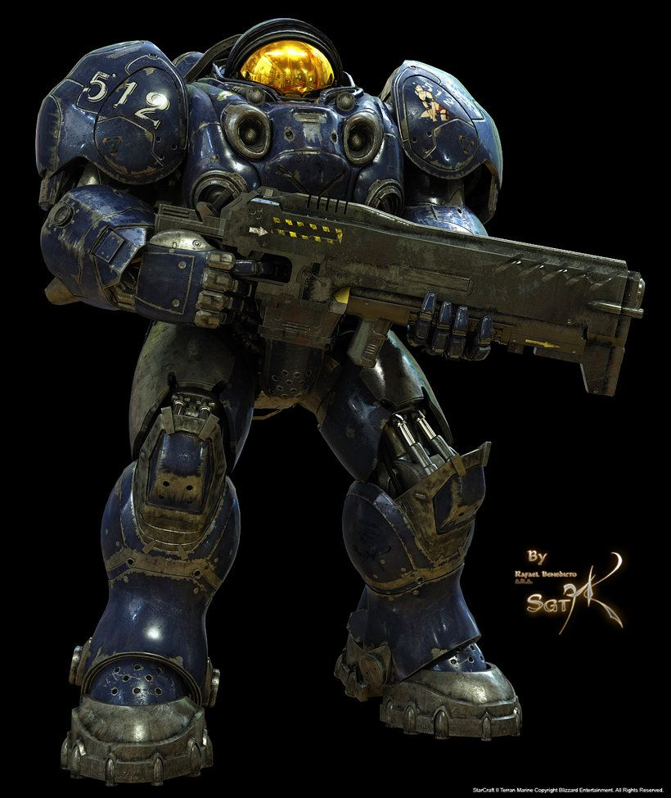The Terrans are a young species with psionic potential. The Terrans of the Koprulu sector descend from the survivors of a disastrous 23rd century colonization mission from Earth. Compared to the Protoss and Zerg, the Terrans are highly factionalized and endure frequent wars amongst themselves in addition to the more recent conflicts with their alien neighbors. Nevertheless, Terrans stand as one of the three dominant species of the galaxy.

Regarded as foundational units, marines compose the bulk of most Terran front-line forces, ranging from officially government-sanctioned units, local militias, private security firms, to pirates, renegades and mercenaries.

A war is coming, and your task is to order your marine troops in a straight line and find the total number of ways you can sort the units, depending on their combat suit color. For example, if you have 5 marines, from which 3 are blue and 2 are yellow, you can order them in 10 different unique ways:



#### Input

* The input data should be read from the console.
* You will receive exactly one line, containing capital Latin letters. Each letter corresponds to a color. The total number of marines are the total number of letters in the input line.
* The input data will always be valid and in the format described. There is no need to check it explicitly.

#### Output

* The output should be printed on the console.
* Output the total number of ways you can order the given marines.

#### Constraints

* The total number of marines will be between 1 and 30, inclusive.
* The total number of colors will be between 1 and 5, inclusive.
* Allowed working time for your program: **0.1 seconds**. Allowed memory: **64 MB**.

#### Examples

|  |  |  |  |
| --- | --- | --- | --- |
| **Input** | | **Output** | **Comment** |
| BYYBB | | 10 | See the image above. |
| **Input** | **Output** | | **Comment** |
| RYYRYBY | 105 | | - |