# **Problem 4 – Xel’naga**

The Xel'naga were a highly advanced race. Described as "the most powerful species the universe has ever known," the Xel'naga have been referred to as "wanderers from afar," but it has also been described as being their true name. The Protoss referred to the Xel'naga as the "Ihan-rii", the "Great Teachers", the "Makers", and the "Guardians", during the Aeon of Strife, and prior to it, worshipped them as gods. Some Protoss still refer to them as such.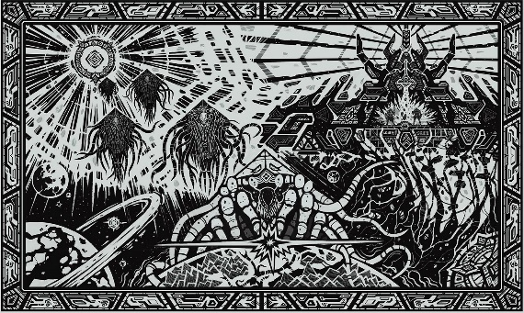

This time, however, the Xel’naga need to count the different species in the galaxy by considering their true age. They went to the Milky Way and asked **some** (not all of them) of the species the following question: **“Without counting your own species, how many other species exist in the galaxy, which has the same age as you?”**. Since every living being fears the Xel’naga, all species answered fairly, and the provided data was absolutely correct. **No species was asked more than once.**

Write a program, which **finds the minimum possible number of species in the galaxy**.

#### Input

* The input data should be read from the console.
* You will receive exactly one line – the answers of the different species, separated by a space, ending with “-1”, indicating the end of input.
* The input data will always be valid and in the format described. There is no need to check it explicitly.

#### Output

* The output should be printed on the console.
* Output the minimum possible number of species in the galaxy.

#### Constraints

* The total number of asked species will be between 1 and 50, inclusive.
* Each answer will be between 1 and 1 000 000, inclusive.
* Allowed working time for your program: **0.4 seconds**. Allowed memory: **16 MB**.

#### Examples

|  |  |  |
| --- | --- | --- |
| **Input** | **Output** | **Comment** |
| 1 1 2 2 -1 | 5 | In the worst case, there are two species with the same age and both were asked by the Xel’naga. There are also three other species with the same age, and only two of them were asked. 5 in total. |
| 0 -1 | 1 | Only one species exists in the galaxy. |
| 2 2 44 2 2 2 444 2 2 -1 | 499 | - |