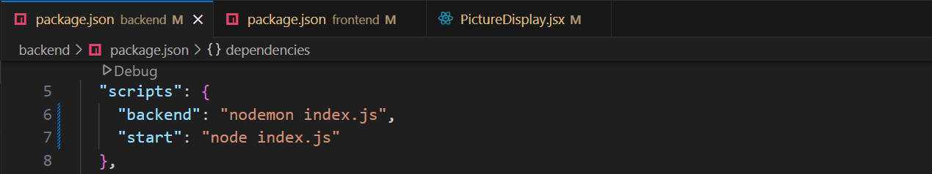
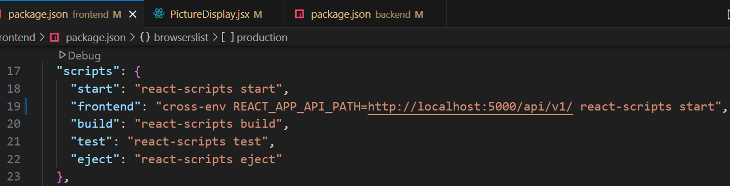

cd backend
npm run backend

New Terminal : +
cd frontend
npm run frontend
