

**DataPLANT’s QuickStart on ARCs**

V1.1, 2022

We are very happy that you chose our tools and infrastructure to create and share your own ARCs. In this QuickStart we focus on how to use the ARC Commander and SWATE to store your data and enrich it with metadata. Text formatted **like this** represents commands to copy/paste into the command line.

This document is work in progress: If you experience any inconsistencies, have questions or would like to suggest additions to it, please feel free to send a message to: info@nfdi4plants.org

# ARC initialization

*Please download the newest version for your operating system* [*here*](https://github.com/nfdi4plants/arcCommander/releases) *and install it according to* [*these instructions*](https://github.com/nfdi4plants/arcCommander#install-and-start)*. Prerequisites for using the ARC Commander are* [*git*](https://git-scm.com/downloads) *and* [*git LFS*](https://git-lfs.github.com/)*.*

1. Head over to your local folder in which you want to initialize an ARC. Open your command line of choice (windows: cmd, powershell; linux and mac: terminal). The following picture shows exemplary how to open a powershell on windows in the designated ARC folder by entering *powershell* into the explorer path: Graphical user interface, application

   Description automatically generated
2. To test if the ARC Commander is functional, run the command **arc**, displaying a list of options:  
    Text

   Description automatically generated
3. Initialize your ARC by executing the command **arc init**. This will create the general ARC folder structure: Graphical user interface, application

   Description automatically generated  
   Graphical user interface, text, application

   Description automatically generated
4. Add the ISA investigation sheet, allowing you to record administrative metadata of your project, with the command **arc i create**. This will open a text editor, where you need to enter an identifier, e.g. “20220302_QuickStart” and a title for your investigation sheet. Close the editor window and save the input.
5. The isa.assay.xlsx workbook enables you to annotate your experimental data. To add the isa.assay.xlsx, use the command **arc a add**. Again, a text editor will open. Here you need to enter an identifier for your ISA study, e.g. “QuickStartStudy”, and an identifier for your ISA assay, e.g. “QuickStartAssay”. After you closed and saved the input, the ARC Commander will add subdirectories to the *studies* and *assays* folder. Your ARC should look similar to this now:   
   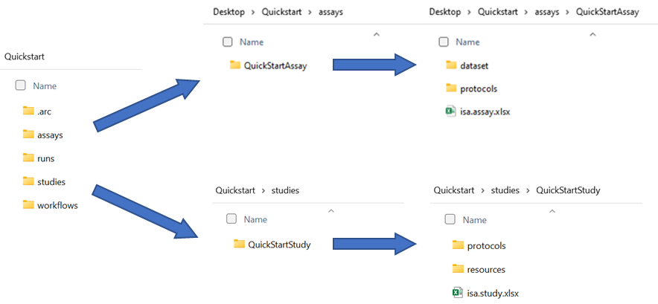
6. Step number 4 can be repeated to add as many assays as needed. Accordingly, more subdirectories in addition to “QuickStartAssay” will be added. Multiple assays can be grouped in a study when the same StudyIdentifier in the text editor window is used. Place the data for each assay in the respective dataset folder.

# ARC sharing

*In case you are not a member of DataPLANT yet, please visit* [*https://register.nfdi4plants.org*](https://register.nfdi4plants.org) *to register. Afterwards, you will be granted access to DataPLANT’s DataHUB, available under* [*https://git.nfdi4plants.org*](https://git.nfdi4plants.org)*, to share your ARCs with lab or project partners.* Graphical user interface, text, application, chat or text message

1. After successful registration, please visit the [DataHUB](https://git.nfdi4plants.org) to set an access token for ARC Commander synchronization.
   1. Sign-in in the top right corner. Click on your profile picture in the top right corner and go to *Preferences -> Access Tokens.*
   2. Create an api access token with a name of your choice. These tokens grant read and write access to all of your groups and projects. Make sure you save your access token upon successful creation, as this is the only time you will have access to the token (in case you lose the token, you can simply create a new one).

1. Open the ARC Commander within your ARC as described above. Synchronize your ARC with the DataHUB using the command **arc sync**. The ARC Commander will ask for your credentials, where you need to enter your DataHUB handle (displayed on the DataHUB when clicking on your profile picture) and the newly generated access token.
   1. If you did not connect your local ARC with a remote one so far, you can specify the remote address with the flag -r in combination with a URL, e.g.,  
      **arc sync -r https://git.nfdi4plants.org/martinkuhl/QuickStart**  
      Graphical user interface, text, application

      Description automatically generated
   2. In case you want to create a new remote repository at this URL, it needs to be **assembled like the following example:**https://git.nfdi4plants.org/***YourUserName***/***NameOfLocalFolder***  
      If no repository exists under the given URL, the ARC Commander will produce an error ensuring that you spelled the URL correctly.Use **arc sync -f** to force synchronization to the specified URL. Text

      Description automatically generated
2. **Note:** In case you did not set your git user name and email address you might get a warning to do so. These are needed for displaying them on the git commits. You can update the settings with the following commands:  
   **git config --global user.name “Martin Kuhl”**  
   **git config --global user.email “kuhl@rhrk.uni-kl.de”**
3. Check if the upload was successful by visiting the respective URL. **Note:** Empty folders will not be synchronized by the ARC Commander. Dummy text files can be added to folders to avoid this.Graphical user interface, text, application, email

   Description automatically generated
4. You can invite lab-colleagues or project partners to join your ARC for collaborative work. While inside your ARC on the DataHUB, click on *Project information -> Members* in the left navigation panel. Search for registered researchers and select a role for each individually. These roles come along with different rights. In short:  
   *Guest:* Have the least rights. Advised to use this for people you are asking for consultancy. *Developer:* The choice for most people you want to invite to your ARC. Developers have read and write access, but cannot maintain the project on the DataHUB, e.g. inviting others.  
   *Maintainer:* Gives the person the same rights as you have (except of removing you from your own project). This is recommended for inviting PIs or group leaders allowing them to add their group members for data upload or analysis to the project as well.   
   A screenshot of a computer

   Description automatically generated

*A detailed usage instruction for the ARC Commander can be found* [*here*](https://github.com/nfdi4plants/arcCommander/wiki/Detailed-usage-instruction)*.*

# Data annotation

1. Your ARC should now contain one isa.investigation.xlsx and one or more isa.study.xlsx and isa.assay.xlsx file(s), respectively. Use the isa.study.xlsx to describe the characteristics of your samples, e.g. how you grew your plant, and isa.assay.xlsx to annotate experimental analyses. DataPLANT provides the Excel Add-In SWATE to support you in the annotation. Download and install the newest SWATE version according to [these instructions](https://github.com/nfdi4plants/Swate/wiki/docs01-installing-Swate#desktop-installation). In case you are using an older Excel version than Excel 2019, please install [SWATE for Excel online](https://github.com/nfdi4plants/Swate/wiki/docs01-installing-Swate#quickstart).
2. Use the *create annotation table* button in the yellow pop-up box (this only appears if you start SWATE on an Excel worksheet without an existing annotation table). An annotation table with the building blocks *Source Name* and *Sample Name* will be generated.  
   Graphical user interface, text, application, Excel

   Description automatically generatedGraphical user interface, application, table, Excel

   Description automatically generated
3. Annotate your table with help of the [annotation principles](https://nfdi4plants.github.io/AnnotationPrinciples/). In short, *Characteristics* are used for study descriptions and describe inherent properties of the source material (e.g. a certain strain). *Parameters* describe steps in your experimental workflow (e.g. an instrument model or a growth chamber), and *Factors*describe independent variables that result in a specific output (e.g. the light intensity).
   1. The combination of ISA (Characteristics, Parameter, Factor) and a biological or technological ontology (e.g. temperature, strain, instrument model) gives the flexibility to display an ontology term, e.g. temperature, as a regular process parameter or as the factor your study is based on (Parameter [temperature] or Factor [temperature]).
4. Customize your table by adding building blocks:
   1. Choose the type of building block you want to add (A).
   2. If you chose a descriptive building block type (building blocks besides Sample Name, Source Name, and Data File Name), use search field (B) to search for an Ontology Term. SWATE accesses the SwateDB with a list of established external ontologies designated suitable for use in plant science. In addition, we feature our own ontology NFDI4PSO to extend the DB with missing, but necessary terms.
   3. If you want to add a building block with a unit, check box (C) and use search field (D) to look for a fitting unit term, e.g. degree Celsius as unit for Parameter [temperature].
   4. If you could not find a fitting term, you can use the Advanced Term Search with the blue links above the *Add building block* button. If you still could not find a fitting term, use free text input.  
       Graphical user interface, application

      Description automatically generated
   5. For more information on customizing your annotation table click [here](https://github.com/nfdi4plants/Swate/wiki/Docs03-Building-Blocks).
5. Alternatively, you can also use one of DataPLANT’s [SWATE templates](https://github.com/nfdi4plants/Swate/wiki/Docs05-Templates). You can find them under the *Protocol Insert* tab in SWATE.  
   Graphical user interface, text, application

   Description automatically generated
6. Fill the cells beneath each building block with ontology terms to note the respective *Characteristics, Parameter,* and *Factor* values of your experiment. Using the ontology term search function, you can fill multiple cells at once.
   1. When *Use related term directed search* (A) is enabled, SWATE will suggest a selection of suitable terms within the ontology for the column header, e.g. *TripleTOF* *5600* for *instrument model.*
   2. When term directed search (A) is disabled, SWATE will still suggest ontology terms, but without relation to the column header.
   3. If you could not find a fitting term, use free text input.

**(A)**

*More information on how to use SWATE can be found* [*here*](https://github.com/nfdi4plants/Swate/wiki/Docs05-Templates)*.*

**In case you need further assistance also visit our** [**Helpdesk**](https://support.nfdi4plants.org)**.**