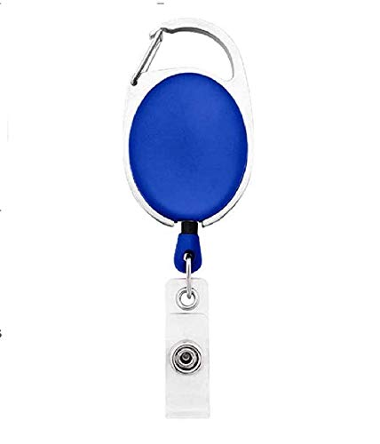



|  |  |
| --- | --- |
| **Sarah Neighbors** | PHOTO |
| **Purchase** |
| **03/14/2022** |
| **B +ve** |
| **22137** |

Questions / Queries – Drop an email to martin.githinji.maina@gmail.com