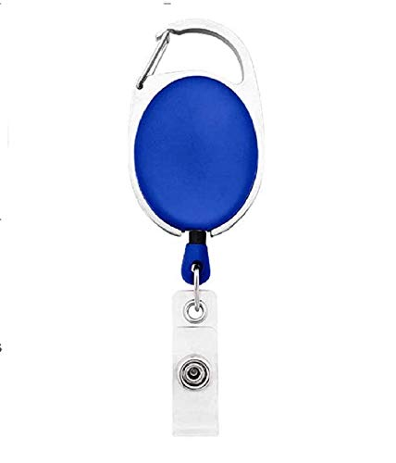

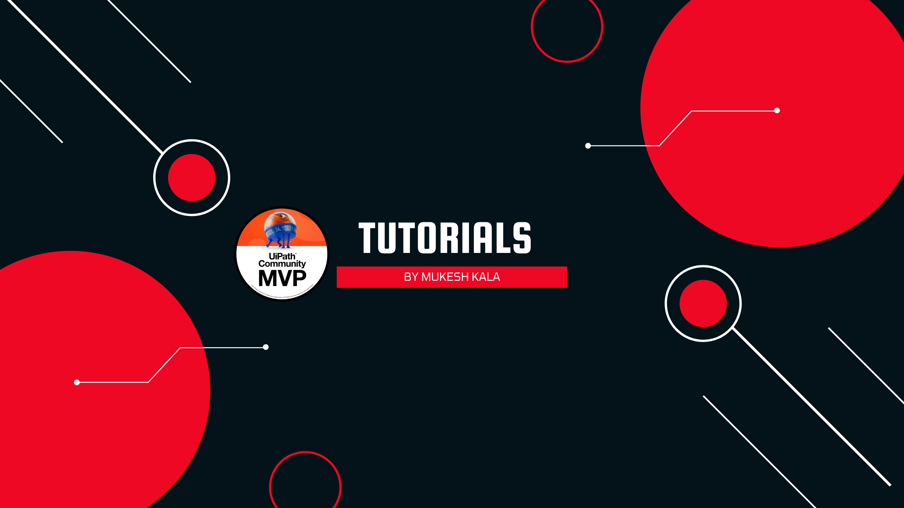

|  |  |
| --- | --- |
| **William Middlebrooks** | PHOTO |
| **Purchase** |
| **02/12/2022** |
| **A +ve** |
| **28438** |

Questions / Queries – Drop an email to martin.githinji.maina@gmail.com