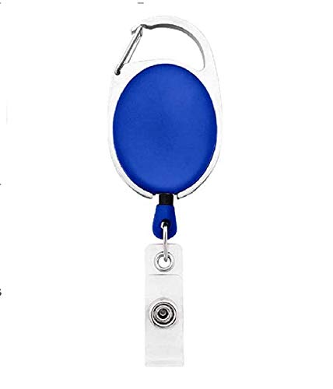



|  |  |
| --- | --- |
| **Daniel Padillo** | PHOTO |
| **Finance** |
| **03/16/2022** |
| **AB +ve** |
| **39636** |

Questions / Queries – Drop an email to martin.githinji.maina@gmail.com