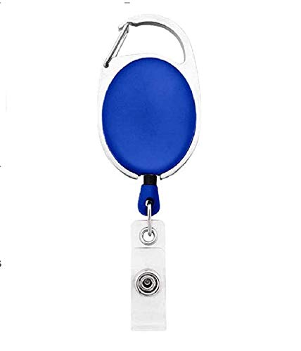



|  |  |
| --- | --- |
| **Robert Conner** | PHOTO |
| **Marketing** |
| **02/20/2022** |
| **O -ve** |
| **46141** |

Questions / Queries – Drop an email to martin.githinji.maina@gmail.com