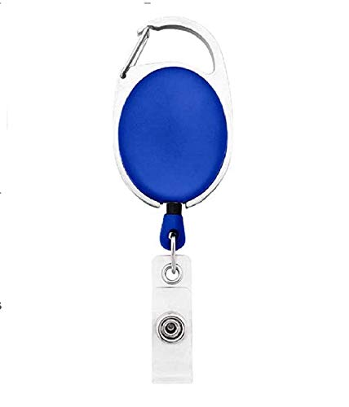



|  |  |
| --- | --- |
| **Marie Burgess** | PHOTO |
| **Marketing** |
| **03/02/2022** |
| **O +ve** |
| **56066** |

Questions / Queries – Drop an email to martin.githinji.maina@gmail.com