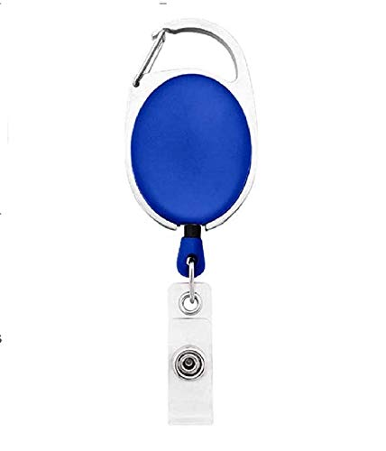



|  |  |
| --- | --- |
| **Sharon Becerra** | PHOTO |
| **Finance** |
| **02/17/2022** |
| **O +ve** |
| **67564** |

Questions / Queries – Drop an email to martin.githinji.maina@gmail.com