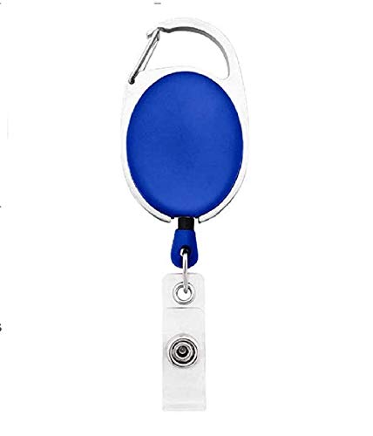

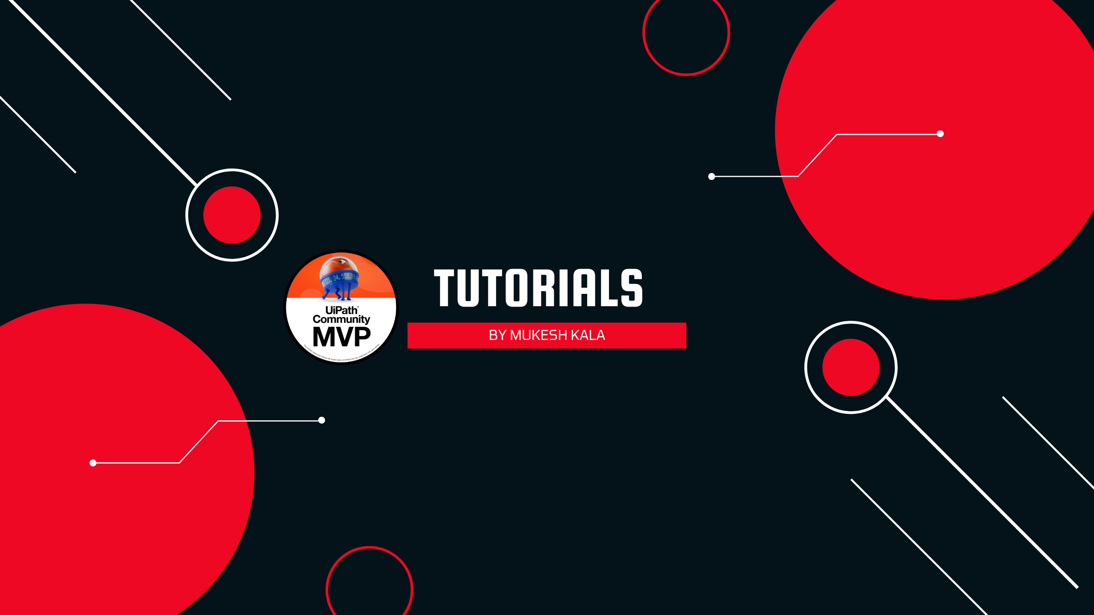

|  |  |
| --- | --- |
| **Angelia Cartee** | PHOTO |
| **Sales** |
| **02/21/2022** |
| **AB -ve** |
| **94396** |

Questions / Queries – Drop an email to martin.githinji.maina@gmail.com