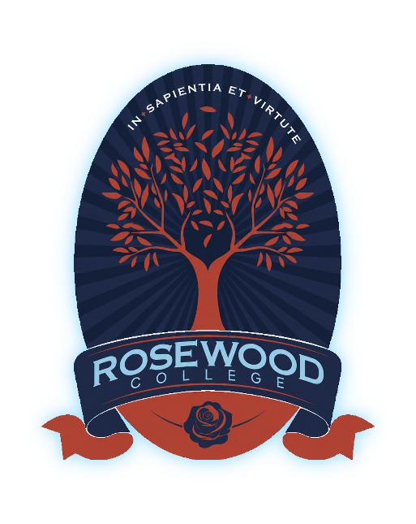

108-134 Alfred Road,
Cobblebank Victoria, 3338

Enrolment Procedure
Exported on 30 Jun 2026
Table of Contents
1. Purpose 3
2. Scope 3
3. Procedure 3
3.1 Enrolment Enquiries 4
3.2 Application for Enrolment 4
3.3 Assessment of Applications 4
3.4 Consultation and Interview (where Applicable) 4
3.5 Enrolment Decision 5
3.6 Offer of Enrolment 5
3.7 Acceptance of Enrolment 5
3.8 Enrolment Agreement 5
3.9 Deferral and Withdrawal 5
3.10 Lapsed Offers and Enrolment Progression 6
3.11 Enrolment Decision Appeal 6
3.12 Administrative Responsibilities 6
3.13 Enrolment Status 6
3.14 Collection and Management of Information 7
3.15 Enrolment Records and Register 7
4. Implementation 7
5. Review 7
6. Related Documents 8

Document | Enrolment Procedure
Document Type | Procedure
Owner | Principal
Approval Authority | Principal
Version | 1.0
Status | approved
Approval Date | 25 Apr 2026
Review Cycle | 2 years
Next Review | 25 Apr 2028
- Purpose
This procedure sets out the process for managing student enrolment at Rosewood College, including the handling of enquiries, applications, assessment, offers, and acceptance of enrolment.
This procedure supports and implements the Enrolment Policy and ensures that enrolment practices are conducted in a consistent, fair, and transparent manner, and in accordance with applicable legislative requirements.
This procedure ensures that enrolment decisions are applied consistently, that appropriate information is obtained to support decision-making, and that accurate records of enrolment are maintained.
This procedure supports compliance with applicable State and Commonwealth legislation, including laws relating to discrimination, privacy, and student enrolment requirements.
- Scope
This procedure applies to all staff involved in the administration and management of student enrolment at Rosewood College, including the Principal and any staff delegated responsibility for enrolment processes.
This procedure applies to all applications for enrolment of domestic students and covers all stages of the enrolment lifecycle, including initial enquiries, application submission, assessment, decision-making, offers of enrolment, acceptance, and the creation and maintenance of enrolment records.
This procedure operates in conjunction with the Enrolment Policy and must be applied consistently in all enrolment-related activities.
- Procedure
The enrolment process at Rosewood College is managed through the following stages:
  - Enrolment Enquiries
- All enrolment enquiries must be recorded and managed by the College.
- Prospective families are to be provided with information about the College, its educational philosophy, the enrolment process, and relevant enrolment timelines.
  - Application for Enrolment
- Applications must be submitted using the approved Enrolment Application Form.
- Applicants must provide all required supporting documentation.
- Incomplete applications may not be assessed until all required information has been provided.
- The College may verify information and documentation provided as part of the application.
Supporting documentation may include personal information, prior educational records, medical or well-being information, and any other information relevant to the student’s application.
  - Assessment of Applications
- Applications are to be assessed in accordance with the Enrolment Policy.
- The College may request additional information where necessary to assess the application.
- Consideration is given to:
  - eligibility criteria
  - available number of places
  - the capacity of the College to meet the student’s educational and support needs, including the provision of reasonable adjustments where required by law
  - whether siblings of the applicant are currently enrolled at the College
  - the relationship of the family to the school community
  - the extent to which the family supports the educational philosophy, mission, values, and religious ethos of the College, where permitted by law
  - Consultation and Interview (where Applicable)
- The College may require an interview with the student and parents/carers as part of the enrolment assessment process.
- The purpose of the interview is to:
  - clarify information provided in the application
  - assess the family’s understanding of and alignment with the educational philosophy and expectations of the College
  - understand the student’s educational, pastoral, and support needs
  - determine the suitability of the enrolment
  - Enrolment Decision
- Enrolment decisions are made by the Principal in accordance with the Enrolment Policy.
- The College is not obliged to offer enrolment where places are limited or where, after reasonable consideration, the College determines that it cannot meet the needs of the student.
  - Offer of Enrolment
- Successful applicants will be provided with a formal Offer of Enrolment.
- The offer will include:
  - the Enrolment Agreement
  - relevant College policies and key information
  - any conditions of enrolment
  - the deadline for accepting the offer and completing enrolment requirements
  - Acceptance of Enrolment
- Enrolment is confirmed only when:
  - the Enrolment Agreement is signed and returned by the parent / guardian
  - any required fees are paid
  - any stated conditions of enrolment are met
  - any required forms and supporting information are provided
- Failure to meet these requirements within the timeframe specified in the Offer of Enrolment may, at the Principal’s discretion, result in the offer being withdrawn.
  - Enrolment Agreement
Parents or guardians of each student enrolled at Rosewood College must enter into a formal Enrolment Agreement with the College.
The Enrolment Agreement sets out the rights and responsibilities of the College and the parents or guardians and may include fees and charges, expectations of families, relevant College policies, and the circumstances under which the agreement may be terminated by either party.
  - Deferral and Withdrawal
A request to defer commencement or withdraw an application or accepted place must be made in writing by the parent or guardian. Requests for deferral will be considered by the Principal, having regard to place availability, intake timing, and the circumstances of the application.
Where a family withdraws after accepting an offer, any consequences will be managed in accordance with the Enrolment Agreement and any applicable College policies.
  - Lapsed Offers and Enrolment Progression
The College may determine that an offer has lapsed, or may decline to proceed with an offer, where:
- required documentation has not been provided
- information requested by the College has not been supplied within the required timeframe
- requirements stated in the offer have not been completed
- required fees or deposits have not been paid by the due date
Where a place has already been secured through a signed Enrolment Agreement, any termination or withdrawal will be managed in accordance with the Enrolment Agreement and applicable College policies.
  - Enrolment Decision Appeal
A parent or guardian may request a review of an enrolment decision by submitting a written request to the Principal within a reasonable timeframe of being notified of the decision.
The review is conducted by the Governing Authority or its delegate, having regard to this procedure and the information available at the time of the original decision.
The outcome of the review is communicated to the applicant, and the decision following review is final.
  - Administrative Responsibilities
The Principal is responsible for implementing this procedure and ensuring that enrolment processes are conducted in accordance with the Enrolment Policy and applicable legal requirements.
The Principal may delegate responsibility for the administration of enrolment processes to designated staff or other authorised personnel.
Staff involved in enrolment administration must act in accordance with the Enrolment Policy, this procedure, privacy obligations, anti-discrimination requirements, obligations relating to reasonable adjustments, and student recordkeeping requirements.
For administrative and recordkeeping purposes, the College may use status descriptors such as applicant, offered, accepted, current, deferred, and withdrawn.
  - Enrolment Status
For administrative purposes, student enrolment status may be recorded as one of the following:
- Applicant – application received and under consideration
- Offered – formal offer issued
- Accepted – offer accepted and enrolment requirements being finalised
- Current – student enrolled and attending the College
- Deferred – offer accepted but commencement approved for a later date
- Withdrawn – enrolment withdrawn by parent/carer before or after commencement
  - Collection and Management of Information
- The College collects and manages enrolment information in accordance with applicable privacy and legislative requirements.
- Information provided by parents/carers must be accurate, complete and current.
- The College may require updated or additional information where necessary and ensures that enrolment information is accurate, complete and securely maintained.
  - Enrolment Records and Register
- The Enrolment Register is maintained in accordance with regulatory requirements.
- Records of enrolment, including applications, supporting documentation, assessment records, offers, acceptances and Enrolment Agreements, are retained as part of the student record.
- Implementation
The Principal is responsible for the implementation of this procedure and for ensuring that enrolment processes are conducted in accordance with the Enrolment Policy and applicable legislative requirements.
The Principal may delegate responsibility for the administration of enrolment processes to appropriate staff. All staff involved in enrolment must apply this procedure consistently and maintain appropriate records to support enrolment decisions.
Enrolment processes are supported by appropriate systems, documentation and record-keeping practices, including the maintenance of an Enrolment Register and associated student records.
The Principal is responsible for monitoring the effective implementation of this procedure and ensuring that enrolment practices remain consistent, fair, and transparent.
- Review
This procedure will be reviewed at least every two years, or more frequently if required due to changes in legislation, regulatory requirements, or College operations.
The Principal is responsible for initiating and overseeing the review of this procedure and for recommending any required updates to ensure ongoing compliance and effective implementation.
- Related Documents
Related documents include:
- Disability Discrimination Policy
- Enrolment Agreement
- Enrolment Application Form
- Enrolment Policy
- Fee Schedule
- Offer of Enrolment
- Privacy Collection Statement

