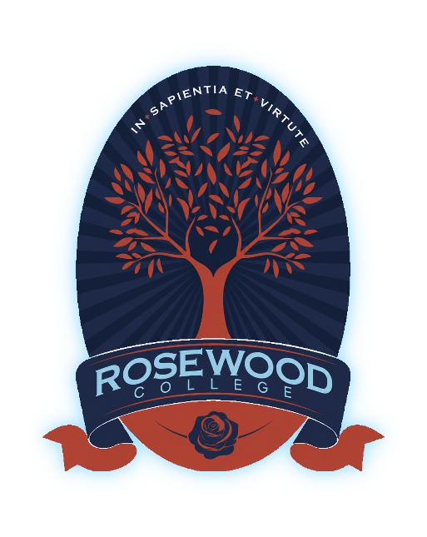

108-134 Alfred Road,
Cobblebank Victoria, 3338

Privacy Policy
Exported on 30 Jun 2026
Table of Contents
1. Purpose 3
2. Scope 3
3. Collection of Personal Information 4
4. Use and Disclosure of Personal Information 4
5. Storage and Security of Personal Information 4
6. Access to and Correction of Personal Information 5
7. Retention and Disposal of Personal Information 5
8. Privacy Statements 6
9. Data Breaches 6
10. Complaints 6
11. Implementation 7
12. Review 7
13. Related Documents 8
14. Appendix A: Full Privacy Collection Statement 8
15. Appendix B: Shortform Privacy Collection Statement 8

Document | Privacy Policy
Document Type | Policy
Owner | Principal
Approval Authority | Governing Authority
Version | 1.0
Status | approved
Approval Date | 07 Apr 2026
Review Cycle | 3 years
Next Review | 07 Apr 2029
- Purpose
The purpose of this policy is to set out the principles governing how Rosewood College collects, uses, stores, discloses, retains, and manages personal and sensitive information in the course of its operations.
This policy supports the College’s commitment to lawful, transparent and responsible information handling in accordance with applicable privacy legislation and related record-keeping obligations. It establishes the College’s expectations for the protection of personal information relating to current and prospective students, parents and guardians, staff, volunteers, contractors, service providers, and other members of the school community.
This policy also supports Rosewood College’s enrolment, student record management, child safety, wellbeing, governance, employment and administrative functions by providing a whole-of-school framework for privacy and information management.
- Scope
This policy applies to all members of the school community, including:
- students and prospective students
- parents, guardians and families
- members of the Governing Authority
- the Principal and all College staff
- volunteers, contractors and service providers
- any other individuals whose personal information is collected or held by the College
This policy applies to all forms of personal information, whether collected directly from individuals or from third parties, and whether held in physical or electronic form.
This policy applies to all school activities, including enrolment, student administration, education and wellbeing, employment, governance, and operational functions.
- Collection of Personal Information
Rosewood College collects personal and sensitive information that is reasonably necessary for the conduct of its educational, administrative, and operational functions.
Personal information may be collected directly from individuals or their authorised representatives, or from third parties where permitted by law. This includes information collected during the enrolment process and throughout a student’s enrolment at the College.
The College collects personal information to:
- assess applications for enrolment
- provide educational services and support student learning and wellbeing
- communicate with students, families and the school community
- meet legal, regulatory, and reporting obligations
- ensure the safety, health, and wellbeing of students and staff
Where required, the College provides a Privacy Collection Statement at or before the point of collection.
- Use and Disclosure of Personal Information
Rosewood College uses personal information for the primary purpose for which it was collected and for related purposes that would reasonably be expected.
The College may disclose personal information where permitted or required by law, including to:
- government departments and agencies for regulatory, funding, and reporting purposes
- other educational institutions in connection with student transfers
- health professionals and service providers to support student wellbeing
- contractors and service providers engaged by the College
- other parties where authorised or required by law
The College does not disclose personal information for secondary purposes without consent unless permitted or required by law.
- Storage and Security of Personal Information
Rosewood College takes reasonable steps to protect personal information from misuse, interference, loss, unauthorised access, modification, or disclosure.
Reasonable steps may include:
- using device passwords or biometric security
- keeping software up to date
- avoiding unnecessary local copies
- not sharing personal information through informal channels unless necessary
- using blind copy for group emails where appropriate
- limiting access to authorised persons
- transferring records to an approved College system when available
- deleting duplicate or unnecessary copies when no longer required
Personal information is stored in secure physical and electronic systems with access limited to authorised personnel who require the information for legitimate College business purposes.
The College maintains appropriate data security practices through the following:
- controlled access to records and systems
- staff training and awareness in privacy obligations
- secure storage and record-keeping systems
- processes to manage and review privacy risks; and
- reasonable safeguards where information is transferred, hosted or stored using third-party systems or outside Victoria or Australia, where applicable
Personal relationships with prospective families or supporters do not remove the need to protect personal information, respect confidentiality, limit use and disclosure to appropriate College purposes, and take reasonable steps to prevent unauthorised access, loss, misuse or disclosure.
- Access to and Correction of Personal Information
Individuals may request access to personal information held about them and request correction of information that is inaccurate, incomplete, or out of date.
Requests for access or correction must be made in accordance with the College’s procedures.
The College responds to such requests in accordance with applicable privacy legislation and may refuse access where permitted by law.
- Retention and Disposal of Personal Information
Rosewood College retains personal information in accordance with applicable legal, regulatory and record-keeping obligations and only for as long as necessary to fulfil the purposes for which it was collected or as otherwise required by law.
When personal information is no longer required, the College takes reasonable steps to securely destroy or de-identify the information, in accordance with applicable record retention and disposal requirements.
- Privacy Statements
The College maintains appropriate privacy statements, collection notices, or related privacy information made available through relevant channels, including the College website where appropriate.
These statements explain, in general terms:
- the College’s functions and the kinds of personal information it collects
- how that information is used and disclosed
- whether the collection is required or authorised by law, where relevant
- how the information is stored and protected
- how individuals may request access or correction, or make a complaint
- Data Breaches
Rosewood College maintains documented procedures for the identification, containment, assessment, escalation, notification, investigation and review of actual or suspected data breaches.
All actual or suspected data breaches must be reported immediately to the Principal or delegated Privacy Officer and recorded in the College’s incident management records.
Where required by law, affected individuals and relevant authorities are notified in accordance with applicable legislative obligations.
In the event of an eligible data breach, the College acts in accordance with the Notifiable Data Breaches scheme and any other applicable legal obligations, including notifying affected individuals and relevant authorities where required.
All staff, contractors and volunteers must promptly report any actual or suspected privacy breach or data breach in accordance with College procedures.
- Complaints
Complaints about the handling of personal information may be made in accordance with the College’s Complaints and Grievances Policy.
The College investigates and responds to complaints in a fair and timely manner. Where appropriate, individuals may refer complaints to the Office of the Australian Information Commissioner or other relevant regulatory authority.
- Implementation
The Governing Authority is responsible for approving this policy and any substantive amendments.
The Principal is responsible for the implementation of this policy and for ensuring that the College’s practices relating to the collection, use, storage, and management of personal information are consistent with this policy and applicable legislation.
The Principal may delegate responsibility for administering privacy and information management processes to designated College staff, including administrative and leadership personnel, and may appoint a Privacy Officer or other responsible staff member to assist with privacy compliance and complaint handling.
All staff, contractors, and volunteers who have access to personal information are required to:
- handle personal and sensitive information in accordance with this policy and applicable privacy legislation
- maintain confidentiality and protect the privacy of individuals
- take reasonable steps to ensure the accuracy and security of personal information
- report any actual or suspected data breaches in accordance with College procedures
- participate in privacy training or awareness activities as required
The College implements appropriate systems, processes and training to support compliance with this policy.
- Review
This policy will be reviewed at least every three years, or earlier if required due to changes in legislation, regulatory requirements, technology, College operations, or privacy risks.
The Principal is responsible for initiating the review of this policy and providing recommendations to the Governing Authority.
Any amendments to this policy must be approved by the Governing Authority.
The review process will consider:
- changes to relevant State and Commonwealth privacy, health records and record-keeping legislation
- guidance issued by regulatory authorities
- the effectiveness of the College’s privacy and information management practices
- any privacy incidents, complaints, or data breaches
- feedback from members of the school community
- Related Documents
Related documents include:
- Complaints and Grievances Policy
- Data Breach Response Procedure
- Information Security Procedure
- Records Management Policy
- Appendix A: Full Privacy Collection Statement
Rosewood College collects personal and sensitive information for the primary purposes of assessing enrolment applications, determining eligibility for enrolment, considering any support or reasonable adjustments that may be required, providing educational services, supporting student wellbeing, and maintaining student records.
The information collected may include personal information about students and parents/guardians, as well as sensitive information such as health information, religious affiliation, and information relating to learning needs.
This information is collected in accordance with applicable privacy legislation, including the Privacy Act 1988 (Cth), the Privacy and Data Protection Act 2014 (Vic), and other relevant laws applicable to schools.
If the requested information is not provided, Rosewood College may be unable to assess an application for enrolment or provide appropriate educational and support services.
Personal information may be disclosed to relevant authorities and organisations where required or authorised by law, including government departments, regulatory authorities, health service providers, and service providers engaged by the College to support its operations.
Rosewood College takes reasonable steps to ensure that personal information is stored securely and protected from misuse, loss, unauthorised access, modification, or disclosure.
Parents and guardians may request access to, or correction of, personal information held by the College by contacting the College office or the Privacy Officer.
Further information about how Rosewood College manages personal information is available in the College’s Privacy Policy.
- Appendix B: Shortform Privacy Collection Statement
Rosewood College collects personal and sensitive information, including health information, to support the student’s health, safety and wellbeing and to enable the College to provide appropriate care and support.
This information may be disclosed to relevant staff and, where necessary, to health professionals or emergency services.
All information is handled in accordance with the College’s Privacy Policy and Privacy Collection Notice, which are available from the College.

