**Worksheet 1 – Web Design & Development – Y2Sem1**

**Using html elements to create a very basic set of pages**

Over the first few weeks of the semester as part of the lab workshops - we will look to build a very simple website for Clubs & Societies in a 3rd level institution called ATUS.

Things that are relevant for a site such as this are the clubs themselves (event timetable, contact details, News, Calendar, Contact.

We will keep it simple and straightforward but use it as the basis for applying and learning some of the techniques from class.

For the 1st week - we reference at a very, very high level - some of the material you would have covered in the Year 1 module “Web Design Fundamentals”.

They key thing here is to get you back using your code editor, writing html code, having problems, fixing them.

**Make sure you save your work on your OneDrive**

- All of the work from your lab tutorials should be saved on OneDrive.

- create a directory called WDD

- within that create a directory called Lab1

- so you should have something like OneDrive/Year2/WDD/Lab1” or similar - whatever works for you..

**Task A**

**1. Add basic html elements to a file called index.html**

The main html file in your site should be called index.html - all web browsers will understand this as being the default file - so when you preview your site (for example <http://127.0.0.1:60037/>) in Brackets - the default file shown will be index.html - you do not have to type it in.

Copy in the basic content below to a new file - you can see most of the html elements are in lower case. It does not make any difference if it is lower or uppercase - the browser will still render the content. Its best to keep them lower case - easier to read.

--begin

<!DOCTYPE html>

<head>

</head>

<body>

<p>Here we have all of the information you need as a student for clubs and societies in ATUS<p>

</body>

</html>

--end

**2. Create sub folders from where your index.html is stored**

Create the following subfolders at the same level of where your index.html is stored - this means that you keep your source code nice and tidy.

\css

\images

\js

**3. Add an unordered list (navigation)**

* Add an [unordered list](https://www.tutorialspoint.com/html/html_lists.htm) after the opening <body> element. This will eventually serve as main navigation for this site.
* This will contain links to the main areas of the site : Home, Clubs, Register Club, Contact - add these items to your unordered navigation list.

Review

You should now see a basic bulleted list appear horizontally. This will become our main navigation.

**4. Add header**

* Add a [H1 element](https://www.tutorialspoint.com/html/html_basic_tags.htm) to your page just after the unordered list element in the previous step - this will contain the words “Welcome to ATUS Clubs & Societies”.
* In previous years before HTML5 it was recommended that there only should ever be one <h1> element per page. Now though this is no longer the case; If you are using HTML5 you can have as many <h1> elements on the page as are required.

**5. Download image, save it and reference it from index.html**

* Download a relevant generic club/society image from a university. Make sure you save it in /images folder.
* Now reference the image with an img element - you might need to use img width and height if it us ungainly..
* Review
* Does your image appear? It is sized for the page?

**6. Add a footer**

* Add a [div element](https://www.tutorialspoint.com/html/html_div_tag.htm) (<div) that contains the following below:

<p>&copy; 2019 ATUS Clubs & Societies</p>

Review

You should see the copyright symbol in the footer - this is known as an html character entity.

**7. Add title element to the header**

* Add a [title element](https://www.w3schools.com/html/html_head.asp) in the <head> section of the file
* This title should have the text “Clubs & Societies - ATUS”

Review

What has changed from step 1 to step 2? Why is that a good thing?

**9 Add links for main navigation**

We are doing this step before we actually create our pages; that way when we copy index.html to be new navigation pages - the links will already be in place - we save ourselves some work!

So for each of the items in the unordered list - add [hyperlink](https://www.w3schools.com/html/html_links.asp) element for each of the of the pages outlined in step 10 below.

**10. Add new pages to the site**

Now we want to add new html files for each of these pages in what will be the main navigation. Easiest way to do this is copy index.html to each of these filenames in turn

* Clubs.html
* Register.html
* Contact.html

Review

* Test all of the links on your site?
* Do they work?
* Maybe they look as if they are working but they all look the very same!!
* What are you going to do about this to improve it?

**10. Apply some CSS to the main navigation**

Create a file called style.css in the /css directory. Into this file add the following code :

ul {

  list-style-type: none;

  margin: 0;

  padding: 0;

  overflow: hidden;

  background-color: #333;

}

li {

  float: left;

}

li a {

  display: block;

  color: white;

  text-align: center;

  padding: 14px 16px;

  text-decoration: none;

}

li a:hover {

  background-color: #111;

}

Now link this stylesheet to index.html with the following code - drop this before the ending </head> in the file

<link rel="stylesheet" href="css/style.css">

Review

* Refresh your browser. Can you see a change?
* Goto another page of the site - is there a problem?
* How are you going to fix that problem?
* Discussion with your colleagues - What are the obvious flaws with the way the site looks now? How would you improve it?

Your site structure should look like the following:

Your site should look like this some of the pages shown below:

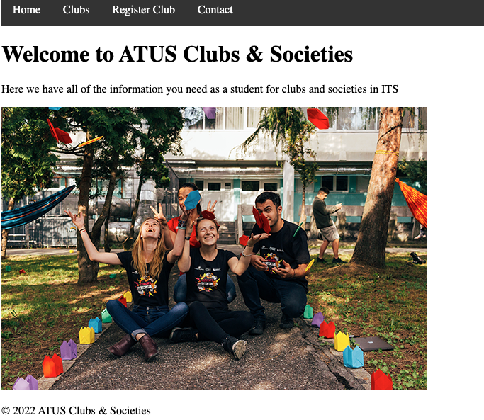

**Task B - Sketch a wireframe**

So now we have a very high level, simple navigation, and sitemap for our site. Looking to other colleges and universities we have an idea of the type of content that is required (that is informative and useful to the student)

You should now sketch a wireframe of how you propose the site should look - on a mobile phone and on a desktop; this is a first version, a low fidelity output.

The wireframe will show the following:

* main chunks of content
* draws the outline and the layout structure
* depicts the most basic UI

[Wireframe, Mockup, Prototype: What is What?](https://uxplanet.org/wireframe-mockup-prototype-what-is-what-8cf2966e5a8b)

 You are paying attention to the structure and functionality and content hierarchy rather than the look and feel; the latter can come with the generation of a mockup – which will introduce finer elements of the UI like fonts, colours and imagery. A Prototype would be a further step which would show how the user interacts with the pages and the pages flow from one to another.

Review

* Take the time out to review the work of the colleague beside you?
* Have they added things in?
* Have they left anything out?
* Do you have any comments for them?