OOD – Project

## Object Oriented Development (COMP06241)

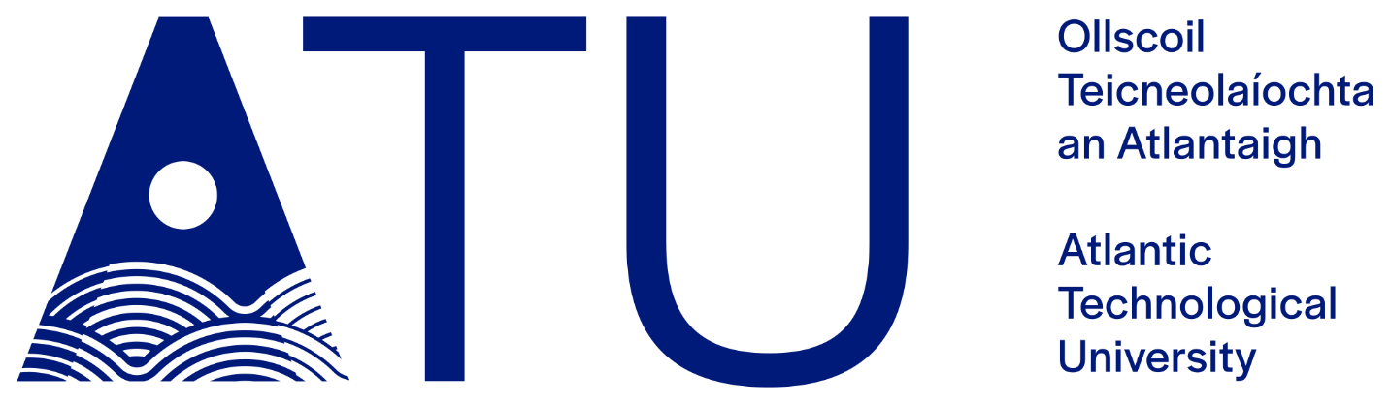

# Martin Strelec

# S00256070

# Software Development Y2

# Introduction

The key goal of this project is to create an timetable/live tracking app for the Ireland’s public transportation using an API from National Transport Authority. App will support a search function that will automatically decide the best route for the entered endpoints. After displaying all matching trips the user will be able to display the details of the trip including live tracking of the current vehicle on the route, delays and the reason of the delay.

