Larry Martin
Home Lab Project
Martin Enterprise Network Documentation
Covering Goals, Specifications, and Build Details
March 3, 2026
July 28, 2026

Lab Goals:
One cannot wait around for an entry level position to obtain hands on experience. Networking engineering is in my blood; I can feel the currents surging through my vein. This is where my home lab come into place. I will use this home lab to not only build on theoretical knowledge, but cultivate hands on skills regarding switching, routing and enterprise networking. With that being said: Learning must be structure when there is a concrete end-goal in mind. Therefore, I have 7 specific goals, for this home lab, that will aid me in my Network Engineering Journey:
- Network engineering practice – practice mock scenarios/ building and breaking processes, functions and directories. “The nitty-gritty.”
- Practice VLANs and inter-switch trunking – Core concepts that should be solidified for network engineering.
- STP/RSTP testing – spanning tree protocols are crucial fundamentals in switching and routing.
- Firewall and routing practice – How can one be a Network Engineer and not be familiar with Firewall configurations and routing protocols?
- Server/VM hosting – network segmentation and virtualization are fundamentals and a segue into cloud-networking/ cloud-computing
- Cybersecurity monitoring – implementing security best practices, and security tools will aid in familiarity and strengthen my knowledge in these arenas.
- Resume-ready projects – The end goal is network engineering mastery so I can contribute to a strong Network Operation Center, and/or Enterprise Corporation

Physical Topology:
 |  | ISP Home/Router
GMK M5 Ultra 1
(pfSense Router)
TP-Link Switch 1
(Core Switch)
TP-Link  Switch 2  (Access Switch) |  |  | NETGEAR  Switch 3 (Lab Switch) |  |  |  | GMK M5 Ultra 2  (Proxmox Server)
Endpoints |  |  | Raspberry pi 4
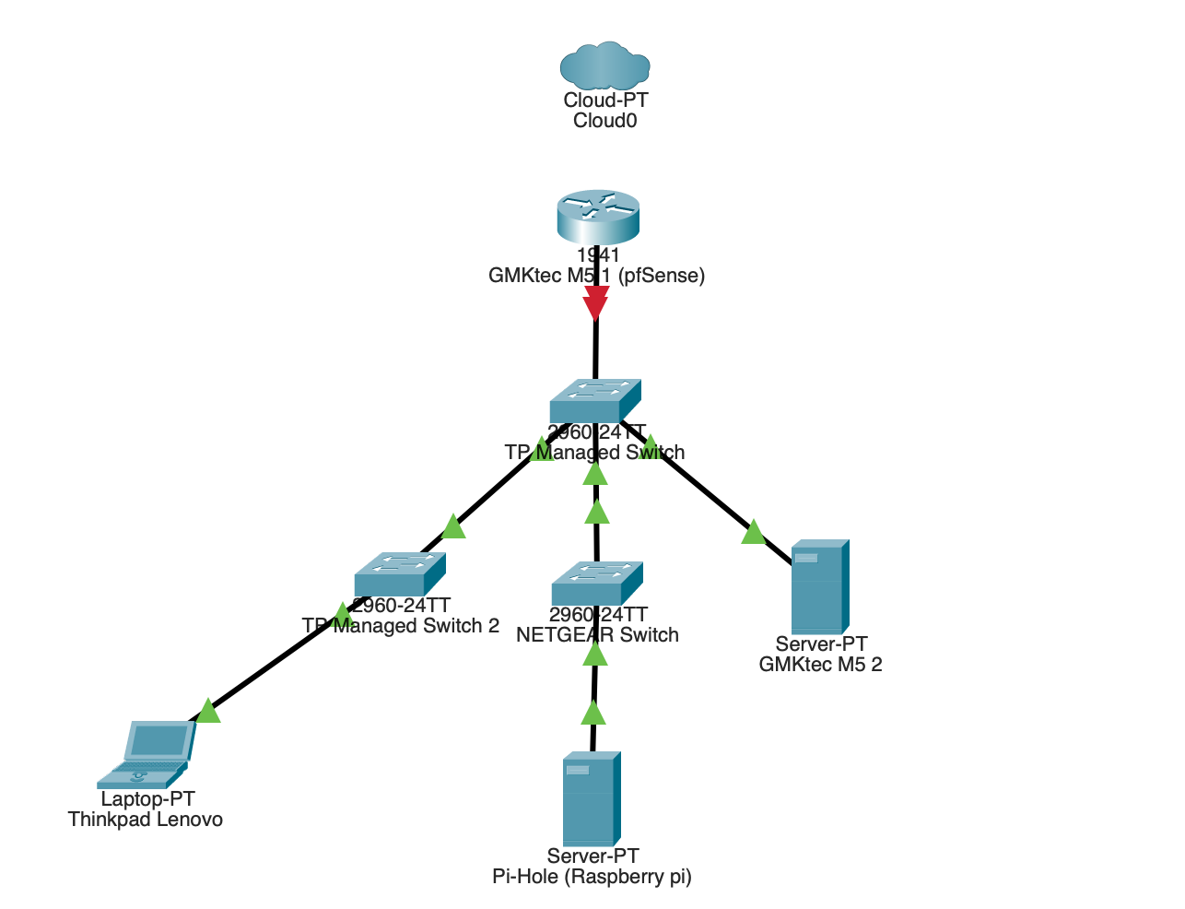

Device Roles:
GMKtec #1 | Virtual Router/Firewall using pfSense
GMKtec #2 | Proxmox Virtualization Server
Raspberry Pi 4 | Lightweight Server/ DNS/ Uptime Kuma Monitoring
TP-Switch #1 | Core Switch
TP-Switch #2 | Access for End points
NETGEAR Switch 3 | Lab Testing Switch
UPS | Battery backup for Router, Core Switch, and Proxmox server
PDU | Rack Power Distribution
MINIX Monitor | Initial Set up display

Logical Network Design:
VLAN | Name | Subnet | Purpose
VLAN 10 | Management | 192.168.10.0/24 | Switches, Proxmox, Admin Access
VLAN 20 | Servers | 192.168.20.0/24 | VMs, Raspberry Pi Services
VLAN 30 | Users | 192.168.30.0/24 | Laptops/End Devices
VLAN 40 | Security | 192.168.40.0/24 | Kali, Wazuh, SIEM Scanning Tools
VLAN 50 | Lab/Testing | 192.168.50.0/24 | Break, Fix, Experiments
VLAN 99 | Native | 192.168.99.0/24 | Unused Native VLAn

Software Stack:
GMK M5 Ultra 1 – Router w/Firewall
Installing pfSense, I will be applying VLAN routing, DHCP, Firewalls Rules, DNS Forwarding, VPN later, IDS/IPS later Suricata.
GMK M5 Ultra 2 – Proxmox
Installing Proxmox VE:
VM | Purpose
Ubuntu Server | Webserver, Docker, Linux Admin
Windows Server Evaluation | Active Dir, DNS, DHCP practice
Kali Linux | Security Testing
Wazuh Server | SIEM/ Security Monitoring
Ubuntu Desktop | End Point Simulation

Raspberry Pi
Primarily will be used for DNS filtering (Pi-hole) and Uptime Kuma monitoring

STP/RSTP Practice design:
Understanding Each Switch’s Functionality:
- Switch 1 – Root Bridge
- Switch 2 – Secondary
- Switch 3 – Edge/Lab
Set Switch Priority Levels:
- Switch 1 Priority = 4096
- Switch 2 Priority = 8192
- Switch 3 Priority = 32768
With these configurations Test:
- Redundant switch links
- Root bridge election
- Port blocking
- Link failure recovery
- RSTP convergence

Build Phase Order:
- Mount Racks, PDUs, UPS, Switches
- Install pfSense on GMKtec 1
- Configure LAN and Internet
- Create VLANS on pfSense
- Configure Core Switch VLAN/Trunks
- Install Proxmox on GMKtec 2
- Create Ubuntu Server VM
- Add Raspberry Pi to Server VLAN
- Add Kali/Wazuh
- Document Screenshots, Configurations, and Diagrams

Hardware:
- GMKtec M5 Ultra
Ram Memory | 16GB (64GB Max) DDR4 | Processor Series | AMD Ryzen 7  4.5 GHz (max speed)  8 Count
Cache Memory | 16MB | Processor  Socket | M.2 2280 PCIe 3.0
Memory Clock Speed | 4.5 GHz
Graphics RAM | 16GB GDDR4 (Integrated) | Display | 72 in (screen size)  4096x2160 (Res)  7680x4320px (Max Res)  4K UHD  16:9 (aspect ratio)
Graphics Coprocessor | AMD Radeon Graphics 8 Cores 2000 MHz
 |  | Ports | 5 USB ports  1 HDMI ports  3 Component Outputs  Wireless (2.4GHz, 5Ghz, 5.8GHz)
Hard Disk | SSD  PCIE x4 | Power | USB C (power plug)  25W
Hardware  Interface | 3.5mm audio  802.11ac/b/g/n  Bluetooth 5  PCIEx16,  USB 3.2  Gen 2

- GMKtec M5 Ultra
Ram Memory | 16GB (64GB Max) DDR4 | Processor Series | AMD Ryzen 7  4.5 GHz (max speed)  8 Count
Cache Memory | 16MB | Processor  Socket | M.2 2280 PCIe 3.0
Memory Clock Speed | 4.5 GHz
Graphics RAM | 16GB GDDR4 (Integrated) | Display | 72 in (screen size)  4096x2160 (Res)  7680x4320px (Max Res)  4K UHD  16:9 (aspect ratio)
Graphics Coprocessor | AMD Radeon Graphics 8 Cores 2000 MHz
 |  | Ports | 5 USB ports  1 HDMI ports  3 Component Outputs  Wireless (2.4GHz, 5Ghz, 5.8GHz)
Hard Disk | SSD  PCIE x4 | Power | USB C (power plug)  25W
Hardware  Interface | 3.5mm audio  802.11ac/b/g/n  Bluetooth 5  PCIEx16,  USB 3.2  Gen 2

- Raspberry Pi 4 Cana Kit
Ram Memory | 4GB (32GB Max) LPDDR4 | Processor Series | Tegra  1.5 GHz (max speed)  4 Count  Broadcom (processor band)
Cache Memory | 16MB | Processor  Socket
Memory Clock Speed
Graphics RAM |  | Display | HDMI compatible
Graphics Coprocessor
 |  | Ports | 4 USB ports  1 HDMI ports  Bluetooth Compatible  GPIO Connectivity
Hard Disk | Samsung EVO + Micro SD Card | Power | USB C (power plug)
Hardware
Interface

- TP-Link 8 Port Gigabit Switch
Ports | 8
Voltage | 9V (DC) | Switch Type | Rotary
Max Power | 3.68W
>Temp Rating | 40 Degrees Celsius
Data Transfer Rate | 1000 Mbits/s
Current Rating | 1Amps

- TP-Link 8 Port Gigabit Siwtch
Ports | 8
Voltage | 9V (DC) | Switch Type | Rotary
Max Power | 3.68W
>Temp Rating | 40 Degrees Celsius
Data Transfer Rate | 1000 Mbits/s
Current Rating | 1Amps

- NETGEAR 5 Port PoE Gigabit Switch
Ports | 5
Voltage | 9V (DC) | Switch Type | Limit
Max Power | 4W | Platform | All
>Temp Rating | 60 Degrees Celsius | Interface | PoE
Data Transfer Rate | 1000 Mbits/s
Current Rating | 1Amps

- APC UPS Battery Backup
Volts | 120 V input  120 V output
Amps | 1.5 output
Number of Outlets | 7
Max Power | 330 Watts
Surge Protection | 490 Joules
Battery | 10 hr charge time  23 min average life  3 min run time  Sealed Led Acid (Cell Type)  Compact Form Factor
Connector | USB type A  USB type B 3 – pin

- 10” Rack PDU
Volts | 110 V input  110 V output
Amps | 15 output
Number of Outlets | 4
Max Power | 330 Watts
Surge Protection | 490 Joules
Connector | USB type B 3 – pin

- 6U/10” Network Rack
Dimensions | 7.87” Depth  11.02” Width  14.53” Height
Size | 6U  10”

- MINIX SF10T Portable Monitor
Ratios | 3:2 (Aspect)  1500:1 (Contrast)
Refresh Rate | 60Hz
Display type | IPS
View Angle | 178 Degrees
Built in Media | - 20V 1.5A Power Adaptor  -10.5” Monitor  -HDMI to MiniHDMI cable  -USBC to USBC power calble  -Magnetic Mount  -MicroUSB to USB A Adaptor
Additional | Built In speakers

- 10x 0.5 Feet Cat 6A Ethernet Patch Cables
- 10x 1 Foot Cat 6A Ethernet Patch Cable

