Determining a country

This document will focus on determining a country which would serve as the point of entry for a mobile-banking application meeting their needs. This will be determined on this document:

<https://docs.google.com/spreadsheets/d/1dpcEDlH6g_KuUUhuDEnyo0NsG8Bs1czOC5lMpIUQC5A/>

as well as a look into the economy, population and other specifics of the specific countries such as geography.

# Burundi

Burundi is a very poor country, the poorest of the ones I’ve selected. 50% of their GDP comes from aggriculture with 90% of the population working in this sector. 90% of the aggriculture is subsistence, meaning that it is done to cover needs of themselves and their families.

Burundi is too poor to meet the needs for a bank, barely covering their own needs with only 35% saving any money at all within the last year of the global findex report. 60% of those aged 15+ had borrowed money within the past year.

**Conclusion**

Not worth investigating further

# Central African Republic (CAR)

CAR is the second poore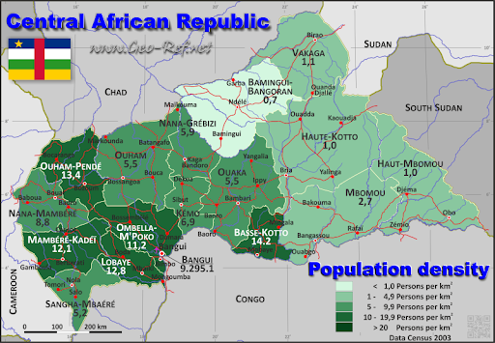st of the selected countries with a GDP per capita of $580.70. 13.7% of the population is banked with 0% of them being in mobile banking. It is one of the least dense countries with a 4.75M population size spread across 623,000km2, mostly distributed in the western end of the country. The only highly dense area in the country is in the capital, Bangui, which accounts for 11,000/km2.

The country has years of conflicts on their back and is currently in an ongoing civil war. CAR suffers from constant instability, this got further heated with a recent election in december 2020. CAR has ranked amongst the top of the global hunger index, and the last time they were measureable, in 2019, CAR scored a 53.6, an increase from their score in 2017 of 50.9, ranking them as number 1.

The population note the common reasons for not obtaining a financial account:

38% - distance.

41% - expense costs

42% - lack of identification

24% - Lack of trust in financial institutions

65% - Insufficient funds

**Conclusion**

The country is very poor, its in the middle of a civil war and only has a dense population in the capital.

Not worth investigating further currently.

# Chad

Chad is a country living in uncertainty and hunger. Over 80% of the population relies on subsistence aggriculture. It is ranked 187 on the human development index (HDI) only beaten by CAR and Niger. The country has been affected by a humanitarian crisis since at least 2001. The country heavily relies on humanitarian aid for survival, becoming further problematic since organizations such as Save the Children have suspended their activities due to killing of aid workers.

8.8% are financially included through banks, 15.2% through mobile banking.

48% of the population in chad has a cellular subscription and only 6.5% utilizes internet.

**Conclusion**

Not worth investigating further, the country is extremely poor and has access to Airtel mobile banking.

# DRC

The Democratic Republic of Congo is the largest of the selected countries with a surface area of more than 2.3M km2. Spread over this area is a population of 76,79M. It is a poor country with a GDP per capita of $580.7.

15% of the population is in a traditional financial institution and 16.1% in mobile banking, covering a total of 25.8% of the population. It is the most literat of the selected countries, with the longest average years of schooling and an above average understanding of financial skills and financial management.

42.77% of the country has a cellular subscription, with only 8.62% utilizing internet.

The country has suffered from large amounts of corruption. In 1965 the ruler, Mobutu Sese Seko ruled the DRC and renamed it Zaire. With his 32 years in office before he died, he managed ot steal as much as $4-5 billion.

The country has had two recent wars, one from 1996-1997 and another from 1998-2003 and is still suffering from the impacts of these.

It is the African country with the highest amoung of internally displaced people.

The population note the common reasons for not obtaining a financial account:

35% - distance.

40% - expense costs

27% - lack of identification

26% - Lack of trust in financial institutions

75% - Insufficient funds

**Conclusion**

I think there’s potential for mobilebanking in DRC, already proven by M-Pesa and EcoCash, but I believe there’s a better country to pursue.

# Ethiopia

Ethiopia has had one of the fastest growing economies since 2004. It has a GDP per capita of $855.8. Due to its growth, Ethiopia has had, and still has, inflation issues due to loose monetary policies, large civil service wage increases and high food prices.

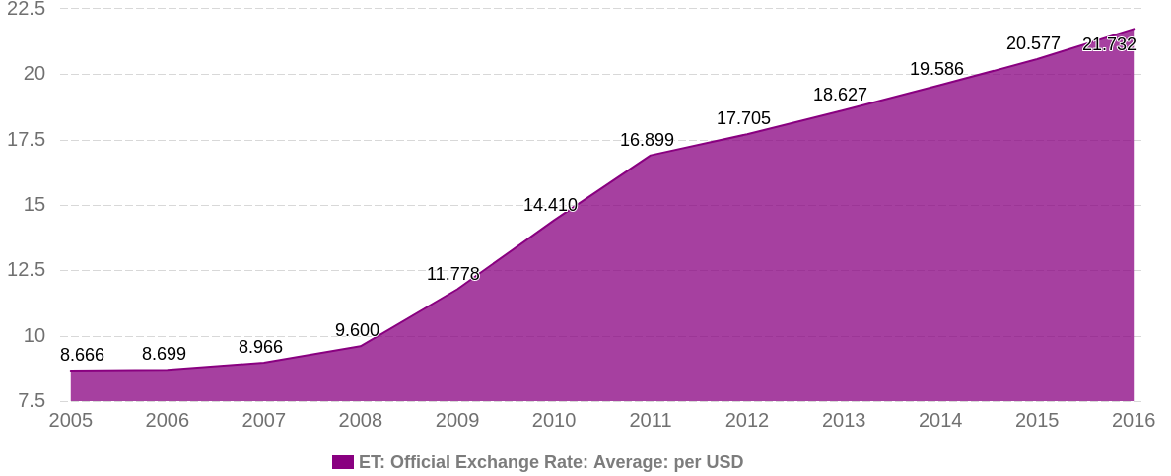50% of the population is under the age of 18 meaning that the country has to create thousands of jobs yearly to keep up with population growth.

The country considers financial services strategic sectors and are therefore expected to be under state control for the forseeable future. Just last year however, they opened up for mobile banking services assuming they can meet the $1.6M Ethiopian Birr ($38,600) requirement.

34.8% of the population is part of a financial institution, with 0.3% of them also being in mobile banking. Because of this, the country is financially literate.

Ethiopia has only 37.22 cellular subscriptions per 100 population. The country however has an above average internet penetration of 18.62%.

The country is fairly densely populated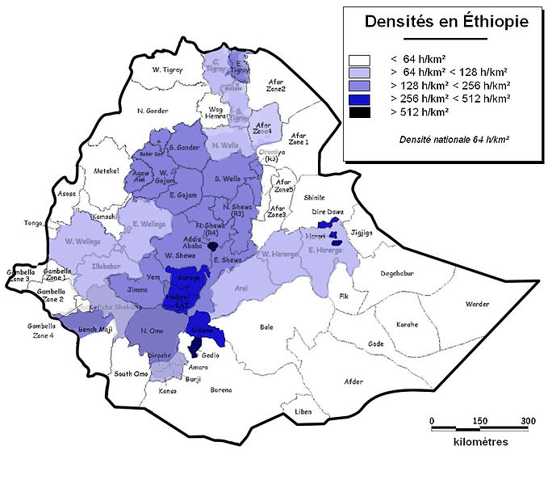, with majority of the population living in central / west Ethiopia.

The population note the common reasons for not obtaining a financial account:

20% - distance.

5% - expense costs

11% - lack of identification

2% - Lack of trust in financial institutions

85% - Insufficient funds

**Conclusion**

Ethiopia will likely become a good candidate for mobile banking.

* It is fairly dense which depending on the technical solution can be a major factor for widespread adoption.
* It has had and still has a growing economy.
* A third of the population is already banked, however close to noone is mobile banked

Getting users might be difficult however, since the expense of ordinary banking is only a problem for 5% of the surveyed. Distance could be a benefit for mobile banking since its 20% of the surveyeds reason why they’re not banked.

Due to inflation issues, a secondary currency might be worth including as a bank service.

Also only 37% has a cellular subscription, meaning other methods might be needed.

# Guinea

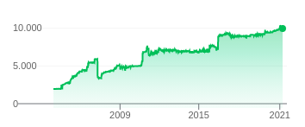Similar to Ethiopia, Guinea has faced inflation issues.

Government bereaucracy and pervasive corruption hampers economic growth though conditions are improving.

Its the richest of the countries we’ve looked at so far, with a GDP per capita of $962.8.

14.6% are part of traditional financian institutes with 13.8% in mobile banking through Orange Money (1,5M users, 6800 agents) or MTN Mobile Money Guinea (600,000 users, 1200 agents).

The country is fairly illiterate, with only 2.6 average years of schooling.

Guinea has more than 100% cellular subscriptions to benefit from the multiple mobile network operators, additionally they have a 21.83% internet penetration rate.

The population note the common reasons for not obtaining a financial account:

30% - distance.

30% - expense costs

38% - lack of identification

15% - Lack of trust in financial institutions

74% - Insufficient funds

**Conclusion**

Guinea is a great country to develop mobile banking in. Some of the problems mentioned can be managed by mobile money, additionally they already have mobile phones and the greatest internet penetration rate of the selected countries. The problems we’d face going with Guinea, is the illiteracy issue, meaning any product needs to be well-articulated and have great UI/UX. Additionally, there are already two competitors so our product would have to stand out.

Product specifications:

* UI/UX to facilitate literacy level
* Allow multiple currencies to prevent inflation

I’ll need to look into how Orange Money and MTN works to see how our product would stand out as well as regulation requirements and cultural norms similar to how its normal for kenyans to travel to to move to cities and then send money back home to their families. Additionally it will need to be discovered how the lack of identification can be solved.

# Madagascar

Madagascar is extremely poor, its secluded on the east cost of Africa and is the target of extreme weather conditions. Scoring a 41.5 on the GHI, it is among CAR and Chad. The country relies heavily on international aid organizations.

9.6% have a financial institution account, 12.1% have a mobile bank account

They’re schooled on average for 6.1 years and are fairly literate, and the most financially literate of the selected countries.

40.57% have cellular subscriptions, with only 4.71% utilizing internet.

The population note the common reasons for not obtaining a financial account:

51% - distance.

52% - expense costs

50% - lack of identification

24% - Lack of trust in financial institutions

82% - Insufficient funds

**Conclusion**

It is most likely not worth pursuing mobile banking in Madagascar at the current moment. The country is extremely poor, less than half have cellular subscriptions, close to no internet is being utilized, additionally 50% no identification.

# Mauritania

Mauritania is the richest of the selected countries with a GDP per capita of $1,679.40 with most of its economy coming from resources like iron. Additionally it is the least dense. However when looking at a density map we can see that they are fairly gathered nonetheless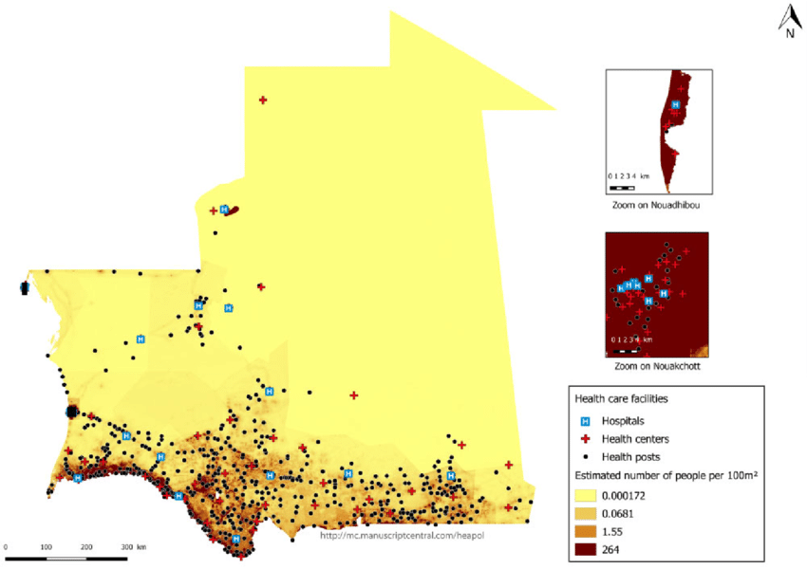.

19% of the country has a financial account, with only 4% having a mobile bank account.

The people in Mauritania have a literacy level of 53. Above average for the selected countries, but still quite low.

Their financial literacy is at 33, also above average.

The country has more than 100% cellular subscription coverage as well as a 20.8% internet penetration rate.

The population note the common reasons for not obtaining a financial account:

16% - distance.

24% - expense costs

19% - lack of identification

9% - Lack of trust in financial institutions

51% - Insufficient funds

**Conclusion**

Mauritania might be worth pursuing due to their econonomy and their SIM/internet coverage, however the country doesn’t note a particular need for mobile banking.

# Niger

Niger is a highly religious country with more than 99% of the people being muslim. It has a GDP of $553.9.

Niger faces serious issues such as high fertility rates resulting in overpulation. Low lvels of education, lack of infrastructure, poor healthcare and environmental degredation seeing how majority of the country is part of the Sahara Desert. It has ranked lowest on the HDI in 2019 and 2020.

9.5% of the population owns a financial account and an additional 8.7% utilizes mobile banking. It is an illiterat country (score 35) with 2 years of average schooling. They are average financially literate compared to these other selected countries.

40.64% have cellular subscriptions with only 5.25% utilizing internet.

The population note the common reasons for not obtaining a financial account:

30% - distance.

30% - expense costs

32% - lack of identification

11% - Lack of trust in financial institutions

74% - Insufficient funds

and notably 21% does not have an account because of religious reasons.

**Conclusion**

I find that it will be incredibly tough to enter this market. Not only is more than half without mobile phones, but the country is very poor and has not seen economic growth in a long time. Additionally 21% note that they can’t take part in mobile banking because it’s illegal in muslim believes.

# Sierra Leone

Sierra Leone is a poor country, ranking 182 out of 187, still recovering from civil war in 2002.

They have a good infrastructure, with 86.13% of the population covered by cellular subscription and a 13.24% internet penetration rate.

The people of Sierra Leone are in school for 3.5 years and have a low level of literacy at 43. Additionally, they are very financially illiterat with a score of 21.

12.4% have financial accounts, 11.0% have bank accounts with a financial inclusion rate of 19.8%

The population note the common reasons for not obtaining a financial account:

18% - distance.

28% - expense costs

29% - lack of identification

10% - Lack of trust in financial institutions

78% - Insufficient funds

**Conclusion**

Sierra Leone is extremely poor and the population is highly illiterat, regardless of this, with the majority of bank accounts being mobile banks, it goes to show that mobile banking can be developed anywhere with a decent mobile network infrastructure.

# South Sudan

South Sudan is a fairly rich country compared to others that have been dissected, with a GDP of $1,119.7, mainly accounted for by oil which took a dive in 2020 due to the covid-19 pandemic.

The country has had years of conflicts which has destroyed livelihoods. More than 7.5 million are in need of humanitarian assistance

8.6% have a financial account, with noone having a mobile bank account.

The people are fairly schooled for a 4.8 years average, however they have a below average level of literacy at 35. Additionally they have the lowest level of financial literacy at 20 among the selected countries.

The country has poor infrastructure for mobile banking, with only 20.09% of the population having cellular subscriptions and 7.98% utilizing internet.

The population note the common reasons for not obtaining a financial account:

23% - distance.

25% - expense costs

26% - lack of identification

17% - Lack of trust in financial institutions

62% - Insufficient funds

**Conclusion**

The lack of SIM/internet availability in South Sudan is a major killer for potential adoption, coupled with an unstable economy consisting of oil and the extreme need for humanitarian aid, South Sudan have other problems to face before mobile banking will be adopted.

# Conclusion

There are three potentially good countries where I can find a need for mobile banking:

* Guinea
  + Low levels of financial accounts
  + 13.8% already in mobile account (contested market)
  + Literacy issues (scored 32)
  + Financial literacy issues (scored 30)
  + Good infrastructure, more than 100% cellular subscriptions, more than 21% utilizing internet
  + Inflation problems
* Ethiopia
  + Low cellular subscriptions
  + Inflation problems
  + Barely any mobile banks on the market
  + more than one third is already banked, and the surveyed people who aren’t banked mainly have problems with insufficient funds
* Mauritania
  + Decent literacy level (scored 53)
  + Good infrastructure, more than 100% cellular subscriptions, more than 20% utilizing internet
  + 19% in financial accounts, 4% in mobile bank accounts