PRODUCT REQUIREMENTS DOCUMENT · 产品需求文档
KOI Recall Consumer Email Trigger PRD
KOI 召回 消费者邮件触发 PRD
Defines when consumers receive transactional email, what business event creates each message, and how delivery is accepted.
定义消费者何时收到事务性邮件、每封邮件由哪个业务事件触发，以及投递结果如何被确认。
About this bilingual edition. 关于本双语版。
The English text is the authoritative original; the Chinese rendering is a reference translation provided for review convenience. Where the two differ, the English text governs. 英文为权威原文，中文为便于评审提供的参考译文；如两版有出入，以英文为准。

Document type  文档类型 | PRD / workflow specification  PRD／工作流规范
Version  版本 | v1.0
Date  日期 | 2026-09-01
Status  状态 | Review Draft  评审稿
Scope  范围 | KOI Recall consumer communications; code changes are not included  KOI 召回消费者沟通；不包含代码变更
Edition  版本形态 | Bilingual (English–Chinese)  中英双语对照

Decision: Use five consumer communication classes expanded into nine reusable templates. Do not send a separate “review started” email; update the existing public copy so it no longer promises one.
决策：采用五类消费者沟通场景，并扩展为九个可复用模板。不单独发送“审核已开始”邮件，同时更新现有公开文案，使其不再作出此类承诺。

1. Context and current gap 背景与现状缺口
The current backend creates an encrypted Communication and a pending Outbox event only when a Claim is submitted successfully. Admin status transitions, Resolution approval/completion, and Case closure record domain events but do not create consumer email tasks.
当前后端只在索赔（Claim）提交成功时，才创建一条加密的沟通记录（Communication）和一条 pending 状态的 Outbox 事件。管理端状态流转、处置方案（Resolution）的批准/完成、以及案件（Case）结案，目前只记录领域事件，不会创建消费者邮件任务。
The consumer status copy currently tells users to check email for additional-information and rejection details. This is a contract gap: the text promises messages that the implementation does not yet produce.
消费者状态页文案目前引导用户去邮箱查收补充材料与拒绝详情。这是一个契约缺口：文案承诺了实现尚未产出的邮件。
Current implementation  当前实现 | Target design  目标设计
Implemented: claim_confirmation is queued at Claim submission. Delivery still depends on Resend configuration and an invoked Outbox worker.  已实现：索赔提交时将 claim_confirmation 入队。投递仍取决于 Resend 配置以及 Outbox worker 被调度执行。 | Required: every consumer-visible action or terminal decision creates a versioned Communication + Outbox event in the same transaction as the business change.  目标：每一个消费者可见的动作或终局决定，都在与业务变更相同的事务中创建带版本的 Communication + Outbox 事件。

2. Goals and non-goals 目标与非目标

Goals 目标
- Give consumers timely, plain-language notice when they must act or when KOI makes a material decision.
当消费者需要采取行动、或 KOI 作出重大决定时，及时以平实语言通知消费者。
- Keep email claims consistent with the authoritative Case and Resolution state.
保证邮件中的表述与权威的案件（Case）和处置方案（Resolution）状态一致。
- Prevent duplicate messages during API retries, worker retries, and provider ambiguity.
在 API 重试、worker 重试以及供应商结果不明确的情况下，防止重复发送。
- Avoid exposing incident narratives, internal notes, raw audit data, or unnecessary PII.
避免泄露事件经过描述、内部备注、原始审计数据或不必要的个人身份信息（PII）。
- Make delivery status observable from queue creation through provider outcome.
让投递状态从队列创建到供应商最终结果全程可观测。

Non-goals 非目标
- Marketing campaigns, newsletters, promotional content, or consent-based lifecycle messaging.
营销活动、新闻通讯、促销内容或基于订阅同意的生命周期消息。
- Automatic CPSC reporting or legal determinations.
自动化的 CPSC（美国消费品安全委员会）上报或法律判定。
- Real-time ERP, WMS, carrier, or finance execution; email reflects only facts confirmed in KOI systems.
实时的 ERP、WMS、承运商或财务系统执行；邮件只反映 KOI 系统内已确认的事实。
- Treating “sent” or “delivered to mail server” as proof that a person opened or read the message.
把“已发送”或“邮件服务器已接收”当作收件人已打开或已阅读的证明。

3. Consumer communication lifecycle 消费者沟通生命周期
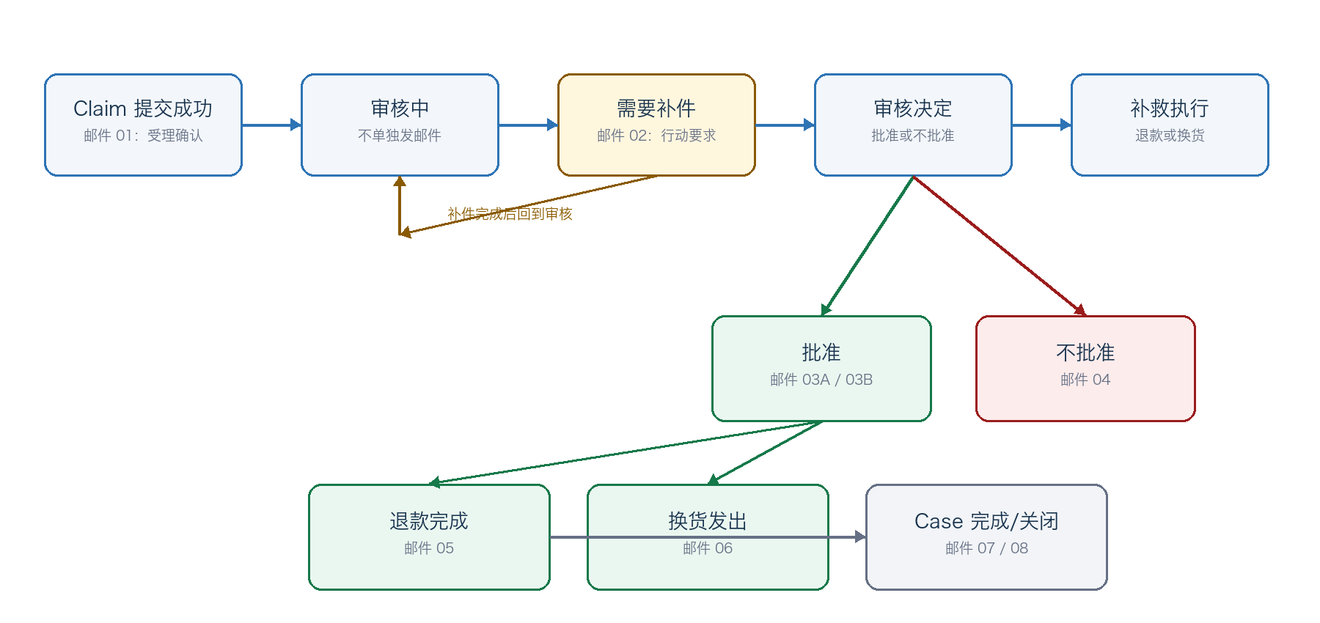
Noise-control rule: triage and under_review status changes remain visible in the status portal but do not generate a new email unless they also create an action-required or decision event.
噪音控制规则：初审（triage）和审核中（under_review）的状态变化仍在状态查询页可见，但除非同时产生“需要行动”或“决定”事件，否则不生成新邮件。

4. Trigger catalogue 触发目录
ID  编号 | Authoritative trigger  权威触发条件 | Consumer email  消费者邮件 | Timing  时机 | Delivery status  实现状态
01 | claim.submitted | Claim received  索赔已受理 | Immediately after transaction commit  事务提交后立即 | Implemented; template rendering gap  已实现；缺模板渲染
02 | case.status -> need_info | Additional information required  需要补充材料 | Immediately  立即 | New  新建
03A | resolution.approved  + type=refund | Refund approved  退款已批准 | Immediately  立即 | New  新建
03B | resolution.approved  + type=replacement | Replacement approved  补发已批准 | Immediately  立即 | New  新建
04 | case.status -> rejected  / duplicate | Claim not approved  索赔未获批准 | Immediately after reason approval  原因文案批准后立即 | New  新建
05 | resolution.  externally_completed  (refund) | Refund completed  退款已完成 | After external reference recorded  记录外部参考号之后 | New  新建
06 | replacement.shipped | Replacement shipped  补发商品已发货 | After carrier/tracking confirmation  承运商/运单号确认之后 | Requires a shipment fact/event  需要发货事实/事件
07 | case.status -> closed  after remedy | Case completed  案件已完成 | After closure gates pass  结案闸门全部通过后 | New  新建
08 | case.status ->  withdrawn / closed  without remedy | Case closed  案件已关闭 | Immediately after controlled reason recorded  受控原因记录后立即 | New  新建

5. Trigger requirements 触发要求
Requirement  要求 | Specification  具体规定
Business truth first  业务事实优先 | Create the Communication and Outbox row only after all validation passes, inside the same database transaction as the Case/Resolution change.  只有在全部校验通过后，才在与 Case/Resolution 变更相同的数据库事务中创建 Communication 与 Outbox 行。
Deduplication  去重 | One business event version produces at most one message key. Recommended key: email/{templateType}/{caseId}/{eventVersion}  一个业务事件版本最多产生一个消息键。推荐键格式：email/{templateType}/{caseId}/{eventVersion}
Recipient  收件人 | Use the normalized email attached to the submitted Case. Do not silently switch to an account-profile address.  使用提交的 Case 上登记的规范化邮箱。不得静默切换为账号资料中的地址。
Template version  模板版本 | Pin the campaign version, locale, template type, and active template version at enqueue time.  在入队时即固定（pin）召回活动版本、语言、模板类型与生效模板版本。
Required variables  必填变量 | Validate every variable before enqueue or before provider send; missing required values must fail closed and remain operationally visible.  入队前或供应商发送前校验每一个变量；必填值缺失时必须失败关闭（fail closed），并保持运营可见。
Safe content  内容安全 | No medical narrative, attachment URL, full address, operator note, fraud signal, or CPSC reportability opinion in consumer email.  消费者邮件中不得包含医疗过程描述、附件链接、完整地址、运营备注、欺诈信号或 CPSC 上报判断。
Status alignment  状态一致 | The status lookup page and email must derive from the same public-state mapping and approved-resolution fact.  状态查询页与邮件必须来自同一份公开状态映射和已批准处置方案事实。
No review-start email  不发“审核已开始”邮件 | Change received-status copy to “We will email you if we need information or when a decision is made.”  将受理状态文案改为“如需补充材料或作出决定，我们会通过邮件与您联系。”

6. Event-to-template contract 事件与模板的契约
Recommended Outbox payload (identifiers only) / 推荐 Outbox 载荷（仅含标识符）

{
"eventType": "case.consumer_email.requested",
"eventVersion": 1,
"caseId": "uuid",
"communicationId": "uuid",
"templateType": "action_required",
"locale": "en-US",
"occurredAt": "ISO-8601"
}

- The Outbox payload must not contain the raw recipient, subject, body, incident details, mailing address, or attachment paths.
Outbox 载荷不得包含原始收件人、主题、正文、事件经过详情、邮寄地址或附件路径。
- Template variables are resolved from authorized database reads at processing time or stored in a separately encrypted immutable snapshot when business history must be frozen.
模板变量在处理时通过经授权的数据库读取来解析；当业务历史必须被冻结时，则存入单独加密的不可变快照。
- A message event must carry a monotonically increasing eventVersion when the same template type may legitimately be sent more than once.
当同一模板类型可能被合法地多次发送时，消息事件必须携带单调递增的 eventVersion。

7. Ownership and review gates 职责分工与评审关卡
Owner  责任方 | Approval responsibility  审批职责
Product/Operations  产品/运营 | Trigger timing, consumer next action, service-level expectation  触发时机、消费者下一步动作、服务时效预期
Customer Service  客服 | Action-required instructions and approved consumer reason text  “需要行动”类指引，以及经批准的面向消费者的原因文案
Finance  财务 | Refund completion fact and external reference availability  退款完成事实与外部参考号的可获得性
Logistics  物流 | Replacement shipment fact and tracking availability  补发商品发货事实与运单号的可获得性
Compliance/Legal  合规/法务 | Recall terminology, decision/closure wording, privacy and regulatory review  召回术语、决定/结案措辞、隐私与合规审查
Engineering  工程 | Atomic enqueue, rendering, provider integration, retries, observability  原子入队、渲染、供应商集成、重试、可观测性

8. Acceptance criteria 验收标准
- Each of the nine trigger branches has a positive integration test and a duplicate/retry test.
九个触发分支各自具备一条正向集成测试和一条重复/重试测试。
- No email is generated for draft creation, document upload, triage, or ordinary under-review transitions.
草稿创建、材料上传、初审以及普通审核中状态流转，均不产生邮件。
- Action-required, not-approved, and closed emails cannot be generated without an approved consumer-visible reason/instruction.
未经批准的消费者可见原因/指引，不得生成“需要行动”“未获批准”“已关闭”类邮件。
- Refund-completed email requires an externally completed Refund Resolution and a recorded external reference when one exists.
“退款完成”邮件要求存在外部已完成的退款处置方案（Resolution），且在外部参考号存在时已记录在案。
- Replacement-shipped email requires a shipment event; approval alone cannot claim shipment.
“补发已发货”邮件要求存在发货事件；仅凭批准不能声称已发货。
- Email content renders all required variables; unresolved {{...}} markers fail the worker and never reach Resend.
邮件内容渲染所有必填变量；存在未解析的 {{...}} 占位符时 worker 必须失败，绝不发送到 Resend。
- The provider request carries an idempotency key; replaying the same Outbox event does not produce a duplicate email.
供应商请求携带幂等键；重放同一 Outbox 事件不会产生重复邮件。
- Webhook signatures, duplicates, delayed delivery, bounce, complaint, suppression, and failure paths are tested.
Webhook 签名、重复投递、延迟送达、退信、投诉、抑制与失败路径均有测试覆盖。
- Staging evidence includes a real message ID, persisted sent/delivered state, and visual review in major desktop/mobile clients.
预发环境证据包括真实消息 ID、持久化的 sent/delivered 状态，以及主流桌面/移动客户端的视觉走查。

9. Implementation priority 实施优先级
Priority  优先级 | Work  工作内容
P0 | Template variable rendering; Provider idempotency; scheduled Outbox drain; action-required and decision emails  模板变量渲染；供应商幂等；Outbox 定时消费；“需要行动”与“决定”类邮件
P1 | Refund/replacement execution emails; stale-lock recovery; dead-letter operations; complete webhook event model  退款/补发执行类邮件；过期锁恢复；死信运营；完整的 webhook 事件模型
P2 | Localization expansion, richer delivery analytics, optional account notification preferences for non-essential updates  多语言扩展、更丰富的投递分析、面向非必要更新的可选账号通知偏好

Repository evidence 仓库参考
Current architecture overview: 当前架构总览 README.md 及 docs/phase-1/01-server-architecture.md（仓库内文档）
Current trigger implementation: 当前触发实现 src/modules/cases/drizzle-case-service.ts
Current public status copy: 当前公开状态文案 src/contracts/case-status-lookups.ts
Current workflow state machine: 当前工作流状态机 src/modules/workflow/policy.ts

