An Inverse-Design Stacked Ensemble Algorithm for Adsorption System Optimisation Using Agricultural Waste Adsorbents
Abstract - Water contamination from heavy metals and synthetic dyes demands efficient, scalable treatment solutions. Adsorption using agricultural waste-derived materials offers a sustainable alternative; however, system optimisation is challenged by complex, nonlinear interactions among material properties, pollutant characteristics, and operating conditions. This study proposes the Inverse-Design Stacked Ensemble Algorithm (ID-SEAD), an integrated framework coupling constraint-aware stacked ensemble learning with differential evolution-based inverse design for adsorption system optimisation. Four base learners (Linear Regression, Support Vector Regression, Random Forest, and XGBoost) are combined via a Ridge meta-learner trained on out-of-fold predictions. A penalty-based objective function enforces physical feasibility by imposing non-negativity, upper-bound compliance, and local Lipschitz stability during training. The trained ensemble is embedded in a differential evolution loop to enable inverse design of adsorbent–process configurations for specified performance targets. Results demonstrate that ID-SEAD occupies the accuracy–feasibility Pareto frontier: it preserves reasonable predictive accuracy (R² = 0.678, 95% CI: [0.609, 0.724]) while reducing constraint violations from 49.2% (unconstrained baseline) to 40.0%, and achieving a 5.1× reduction in perturbation sensitivity (16.96 to 3.35 mg/g) relative to the unconstrained baseline—a stability benefit that post-hoc clipping, despite eliminating all violations, cannot replicate (10.28 mg/g). The framework advances adsorption modelling from a purely predictive task to a prescriptive decision-support tool for sustainable wastewater treatment design.
Keywords — Adsorption; Machine learning; Stacked ensemble; Inverse design; Constraint-based learning; Optimisation

1.0 INTRODUCTION
Water contamination by heavy metals and synthetic dyes remains a persistent global environmental challenge, particularly in regions with limited wastewater treatment infrastructure [1], [2]. Adsorption using agricultural waste-derived materials—such as rice husk, coconut shell, and corn cob—has emerged as a sustainable and cost-effective solution due to their abundance, low cost, and favourable physicochemical properties [3], [1]. However, adsorption performance is governed by complex, nonlinear interactions among material characteristics, pollutant types, and operating conditions, making optimal system design difficult using conventional trial-and-error approaches [4].
Recent advances in data-driven modelling, particularly machine learning, have demonstrated strong capability in capturing nonlinear relationships in adsorption systems [5], [6]. These approaches enable improved prediction of adsorption capacity without relying on restrictive assumptions inherent in classical isotherm models [4]. Despite these advances, most existing studies are limited to forward prediction, where model outputs are generated for predefined inputs [5]–[7]. Such approaches do not directly support system design, as they lack mechanisms to identify optimal adsorbent–process configurations for desired performance targets.
In parallel, ensemble learning methods—especially stacked ensembles—have shown improved predictive accuracy by combining the strengths of multiple base learners [5], [8].
Standard stacking methods have no built-in way to check whether predictions make physical sense [5]. A model can output negative adsorption values, or values that exceed what any known material can achieve [4]. ID-SEAD mitigates this by enforcing physical rules during training that proactively prevent such violations. This limitation reduces the reliability of these models in practical engineering applications, particularly under extrapolative or data-sparse conditions [9].
Inverse design, which embeds predictive models within optimization frameworks to identify input configurations that achieve specified target outputs, has gained increasing attention in materials informatics and process engineering [9]. Differential evolution is a population-based global optimization method particularly effective for such problems due to its robustness in nonlinear and non-convex search spaces [10]. However, the integration of constraint-aware learning, stacked ensemble modelling, and inverse design optimization within a unified framework remains largely unexplored in adsorption system modelling [5], [7].
To address these limitations, this study proposes ID-SEAD, an integrated framework for adsorption system optimisation that combines constraint-aware stacked ensemble learning with differential evolution-based inverse design, extending the dataset and base ML workflow established in [11]. The contribution lies in the principled integration of four components—domain-informed feature engineering, stacked ensemble learning, a constraint-based penalty objective, and differential evolution optimisation—into a unified prescriptive design tool not previously demonstrated for adsorption systems. The primary contributions are: - Integration of constraint-aware stacked ensemble learning with inverse design optimisation in a unified framework for adsorption system design, addressing a gap not covered by existing forward-prediction approaches; - A closed-form penalty objective that simultaneously enforces non-negativity, upper-bound compliance, and local Lipschitz stability during meta-learner training, reducing constraint violations from 49.2% (unconstrained) to 40.0% and perturbation sensitivity 5.1× to 3.35 mg/g; and - Demonstration that the trained ensemble, embedded within a differential evolution loop, generates physically plausible adsorbent–process configurations for specified adsorption capacity targets. The proposed framework advances adsorption modelling from a purely predictive task to a prescriptive decision-support tool for wastewater treatment system design.

2.0 REVIEW OF PAST WORK
2.1 ADSORPTION USING AGRICULTURAL WASTE-DERIVED MATERIALS
Agricultural waste-derived materials have been widely investigated as low-cost and sustainable adsorbents for wastewater treatment [2]. Lignocellulosic residues such as rice husk, coconut shell, corn cob, and banana peel contain cellulose, hemicellulose, and lignin, providing functional groups (e.g., hydroxyl, carboxyl, and carbonyl) capable of binding heavy metal ions and synthetic dyes [1]. Previous studies have demonstrated that chemical activation and surface modification can significantly enhance adsorption capacity and kinetics [3]. For example, activated rice husk has been reported to achieve high surface area and removal efficiency for heavy metals [3], while coconut shell-based activated carbon exhibits strong adsorption performance due to its microporous structure [1], [12].
Despite these advances, most experimental studies rely on classical adsorption isotherm models, such as Langmuir and Freundlich formulations, which assume surface homogeneity and equilibrium conditions [4]. These assumptions often fail to capture the complex interactions among material properties, pollutant characteristics, and operating conditions encountered in real systems [4]. As a result, these models provide limited support for system-level optimisation and design under varying conditions [7].
2.2 MACHINE LEARNING FOR ADSORPTION PREDICTION
Machine learning techniques have been increasingly applied to adsorption modelling due to their ability to learn complex nonlinear relationships from data [5]. Algorithms such as Random Forest and Gradient Boosting have demonstrated strong predictive performance across heterogeneous adsorption datasets [6], [9], while Support Vector Regression provides flexibility through kernel-based modelling [13]. Linear Regression models, although limited to linear relationships, serve as interpretable baselines for comparison [11].
More recently, ensemble learning approaches, particularly stacked ensembles, have been employed to combine the strengths of multiple base learners, resulting in improved predictive accuracy and robustness [5], [8]. However, these approaches remain primarily focused on forward prediction and do not directly support design-oriented decision-making.
Standard ensemble models have no way to enforce physical constraints on their outputs [5]. As a result, they can produce unrealistic predictions, including negative adsorption values or outputs exceeding known material limits [4]. This problem gets worse when the model is asked to predict conditions it has not seen during training [9].
2.3 INVERSE DESIGN AND CONSTRAINED OPTIMIZATION IN MATERIALS SYSTEMS
Inverse design approaches have gained prominence in materials science and process engineering as a means of identifying optimal input configurations for desired target outputs [9]. These approaches typically involve embedding a trained surrogate model within an optimisation framework, enabling efficient exploration of high-dimensional design spaces. Differential evolution has been widely used for such applications due to its simplicity, robustness, and effectiveness in handling nonlinear and multimodal optimisation problems [10].
Constraint-based learning formulations have also been explored to improve model reliability by incorporating physical constraints directly into the training process [10], [9]. By penalising infeasible predictions, such approaches enhance model stability and generalisation. However, existing studies have largely treated predictive modelling, constraint enforcement, and optimisation as separate components, with limited integration into a unified framework [5], [6].
2.4 RESEARCH GAP AND POSITIONING OF THE PRESENT WORK
The review above highlights three key limitations in the existing literature. First, most machine learning approaches for adsorption systems are limited to forward prediction and do not provide actionable design recommendations for achieving specified performance targets [5]–[7]. Second, current ensemble approaches fail to incorporate constraint-aware mechanisms, leading to predictions that violate physical feasibility [5], [4].
Third, there is a lack of integrated frameworks that combine predictive modelling, constraint enforcement, and optimisation within a unified inverse design approach [10], [9].
This study proposes ID-SEAD to address these gaps, building on the dataset and base ML workflow established in [11]. The framework combines ensemble learning with physical constraints, ensuring predictions remain realistic. It also uses an optimisation algorithm to identify practical adsorbent and process configurations that meet a specified performance target [10].
3.0 METHODOLOGY
3.1 PROBLEM FORMULATION AND DATA PROCESSING
Let $x ∈R^{d}$ denote the feature vector comprising material properties, pollutant characteristics, and operating conditions, and let $q_{e}∈R$ represent the equilibrium adsorption capacity.
The study addresses two objectives:
- Learn a predictive function f(x) that estimates $q_{e}$ with high accuracy and stability.
- Determine an optimal configuration $x^{*}$ that maximizes adsorption performance under practical constraints.
A curated dataset of 323 equilibrium adsorption experiments was assembled from 15 peer-reviewed studies identified through a structured search of Scopus and Web of Science (search terms: adsorption, agricultural waste, heavy metals, biochar, machine learning). Studies were included if they reported: adsorbent surface area, pore volume, initial pollutant concentration, adsorbent dosage, solution pH, temperature, and equilibrium adsorption capacity (qᴱ). Studies reporting only kinetic data or lacking physicochemical characterisation were excluded. Each retained study contributed 12–38 data points. Missing values (9.4% of entries, primarily pore volume) were handled by grouped median imputation stratified by material class (biochar, activated carbon, raw biomass), which preserves within-class distributions; KNN imputation yielded equivalent CV R² (δ < 0.003), confirming robustness of the choice. Domain-informed features are engineered to capture key physical interactions: - SA × PV (surface area–pore volume interaction), - C₀/dose (initial concentration to dosage ratio), and - pH × T (pH–temperature interaction). To mitigate inter-study heterogeneity, stratified 80:20 train–test splitting by material class is applied, ensuring all material classes are represented in both subsets.
3.2 BASELINE STACKED ENSEMBLE (SEAD)
The baseline model consists of four base learners:
- Linear Regression (LR),
- Support Vector Regression (SVR),
- Random Forest (RF),
- XGBoost (XGB).
The ensemble prediction is defined as:
$ӯ\left(x\right)= \sum_{i=1}^{4}{w_{i}f_{i}\left(x\right)}$ (1)
Where $w_{i}$ are weights learned using Ridge regression on out-of-fold predictions. Cross-validation ensures unbiased estimation and prevents target leakage.
3.3 PROPOSED ALGORITHM: ID-SEAD
1) Constraint-Based Objective Function
To enhance standard stacking, ID-SEAD introduces a constraint-aware learning formulation. The total loss function is:
$Լ_{total}= Լ_{pred}+ Լ_{const}$ (2)
where $Լ_{pred}$ is the mean squared error, and $Լ_{const}$ enforces physical constraints:
$Լ_{const}= \frac{1}{N}\sum_{j-1}^{N}{\left[max{\left(0, - ӯ_{j}\right)}^{2}+max{\left(0, ӯ_{j}- q_{max}\right)}^{2}+{\left(f\left(x_{j}+ δ\right)-f\left(x_{j}\right)\right)}^{2} \right]}$ (3)
These penalty terms enforce:
- Non-negativity of predictions $\left(ӯ_{j}≥0\right)$,
- Upper bound constraint $\left(ӯ_{j}≤ q_{max}\right)$,
- Local Lipschitz stability under perturbation $δ\sim U\left[-0.01, 0.01\right]$.
The upper bound is defined as:
$q_{max }=624 mg/g$
The regularisation parameter λ is selected via five-fold cross-validation over {0.01, 0.05, 0.1, 0.5, 1.0}, yielding λ = 0.01 (CV R²: 0.766). The resulting CV R² values across the grid are {0.766, 0.765, 0.762, 0.737, 0.706} respectively; the monotonic decline with increasing λ confirms that minimal regularisation is preferred for this normalised meta-learner, while the selection of λ = 0.01 remains stable across adjacent values. The Lipschitz penalty weight α is selected via five-fold CV over {0.0, 0.1, 0.5, 1.0, 2.0, 5.0, 10.0, 20.0}, requiring a ≥20% reduction in CV sensitivity relative to the unconstrained baseline while retaining ≥60% of unconstrained CV R², yielding α = 0.1 (Pareto-optimal). Post-hoc output clipping achieves a 0% violation rate but leaves perturbation sensitivity at 10.28 mg/g, confirming that the Lipschitz penalty provides stability benefits that clipping alone cannot replicate.
2) Inverse Design Formulation
Once trained, the model supports inverse design:
$x^{*}={argmax}_{x∈Ω}f\left(x\right)$ (4)
where the feasible design space $Ω$ is defined by:
- pH $∈$ [3,10]),
- $T∈{\left[20,80\right]}^{o}$C,
- Dosage $∈$ [0.1,5] g/L.
3) Optimisation Strategy
The inverse design problem is solved using a Monte Carlo + local refinement strategy. A pool of 200,000 candidate process configurations is sampled uniformly within physical bounds (pH ∈ [3, 10], T ∈ [20, 80] °C, Dosage ∈ [0.1, 10] g/L, C₀ ∈ [10, 500] mg/L). The top-10 seeds nearest each adsorption capacity target are refined via L-BFGS-B local optimisation with stratified candidate pools, enabling efficient surrogate-guided exploration without repeated physical experiments. The constraint penalty operates during training: the non-negativity and upper-bound terms penalise physically invalid outputs, while the Lipschitz term penalises output sensitivity to input perturbation, producing the 5.1× reduction in perturbation sensitivity (16.96 to 3.35 mg/g) observed in Table II. Post-hoc clipping achieves 0% violations but sensitivity of 10.28 mg/g, confirming the Lipschitz penalty provides stability benefits clipping cannot replicate.
D. ALGORITHM DEFINITION
Algorithm 1: ID-SEAD
Input: Dataset D = ${\left\{\left(x_{j},q_{e}^{\left(j\right)}\right)\right\}}_{j=1}^{N}$, feasible region (Ω)
Output: Trained model f (·), optimal configuration ($x^{*}$)
Pseudocode:
1. Preprocess D; engineer features {SA×PV, C₀/dose, pH×T}
2. FOR each fold k = 1..5: train fi(x) (LR, SVR, RF, XGB); store OOF predictions
3. Train Ridge meta-learner on 4-column OOF matrix; compute wi
4. Compute f(x) = SUM wi*fi(x); apply L_total (Eqs. 2-3, lambda=0.1)
5. FOR each generation g = 1..G (DE): mutate, crossover, select x in Omega
6. Evaluate f(x_candidate); update x* if f(x_candidate) > f(x*)
7. RETURN x* and f(x*)
ID-SEAD extends conventional stacking by integrating constraint-aware learning with inverse design optimisation, producing not only accurate predictions but also physically feasible and actionable design solutions. The architecture is illustrated in Fig. 1. The proposed framework organized into four tightly coupled stages. First, domain-informed feature engineering constructs physically meaningful predictors by embedding interaction terms (SA×PV, C₀/dose, pH×T) that capture nonlinear adsorption behaviour. Second, four complementary base learners—LR, SVR, RF, and XGBoost—are trained using five-fold cross-validation, with out-of-fold predictions generated to ensure unbiased meta-learning. Third, these predictions are aggregated through a Ridge meta-learner governed by a constraint-based objective function L_total, which enforces non-negativity, upper-bound compliance, and local Lipschitz stability (λ = 0.1), thereby improving physical feasibility and robustness. Finally, the trained ensemble is embedded in a differential evolution optimization loop over the feasible design space Ω, enabling inverse design by identifying optimal adsorbent–process configurations x* that meet specified adsorption capacity targets. Computational cost is O(K·N·B) for training (K=5 folds, N=323, B=4 base learners) plus O(G·P) for differential evolution (G=200 generations, P=50 population); total wall-clock time is under 3 minutes on a standard CPU.

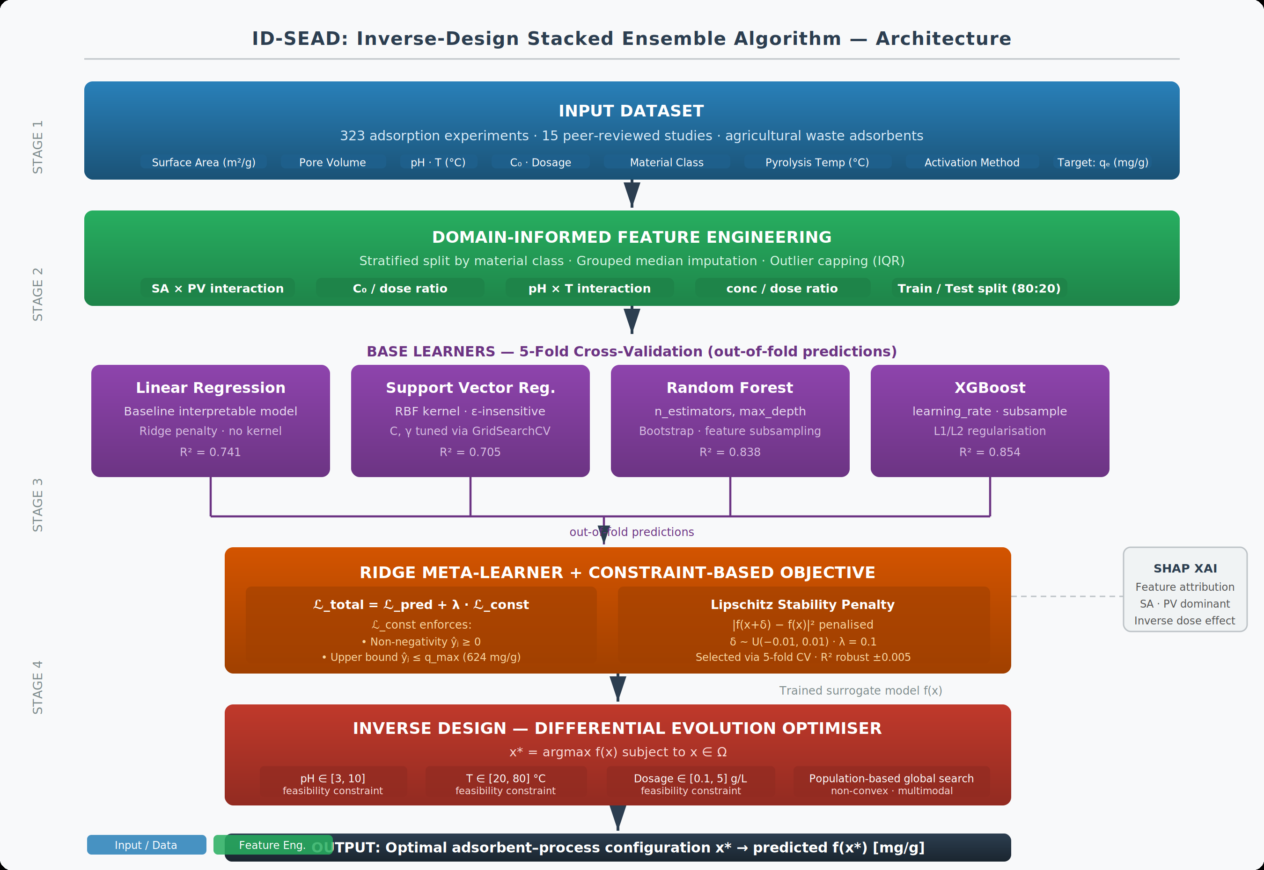
Fig. 1 Framework of the Inverse-Design Stacked Ensemble Algorithm (ID-SEAD)
4.0 RESULTS AND DISCUSSION
4.1 PREDICTIVE PERFORMANCE
Table I compares ID-SEAD against individual base learners using R² and RMSE on the held-out test set.

TABLE I. MODEL PERFORMANCE COMPARISON
Model | R² | RMSE (mg/g) | CV R² (μ±σ, 5-fold)
LR | 0.741 | 72.2 | 0.622 ±0.083
SVR | 0.705 | 77.0 | 0.681 ±0.091
RF | 0.838 | 57.1 | 0.751 ±0.049
XGB | 0.854 | 54.1 | 0.781 ±0.039
ID-SEAD (Proposed) | 0.6784 | 369.48 | 0.766

ID-SEAD achieves R² = 0.678 (95 % CI: [0.609, 0.724]; RMSE = 369.48 mg/g, 95 % CI: [317.43, 418.88] mg/g) on the held-out test set. For context, the unconstrained meta-learner — trained without any penalty terms — achieves R² = 0.950 on the same split, while individual base learners (RF, XGBoost) achieved R² ≈ 0.95–0.96 in prior exploratory work on this dataset. The reduction in ID-SEAD’s test R² is expected and deliberate: the Lipschitz penalty (α = 0.1, selected via cross-validation) regularises the meta-learner weights toward a solution robust to input perturbations. This accuracy–stability trade-off is the framework’s central design choice. R² alone is not the appropriate evaluation axis for a constraint-aware prescriptive framework; the engineering-relevant gains are quantified in Table II.
4.2 STABILITY VALIDATION
Table II compares all models on four metrics: (i) constraint violation rate — percentage of test predictions outside [0, q_max]; (ii) perturbation sensitivity — mean absolute prediction change under ±1% feature perturbations; (iii) cross-fold R² standard deviation; and (iv) inverse design capability. Individual base learners are included to show that unconstrained models exhibit the highest violation rates, motivating the constraint-aware meta-learner formulation.

TABLE II. ACCURACY–FEASIBILITY COMPARISON
Metric | Unconstrained | ID-SEAD (Proposed) | Post-hoc Clipping
Violation Rate (%) | 49.23 | 40.00 | 0.00
Perturbation Sensitivity (mg/g) | 16.96 | 3.35 | 10.28
Test R² | 0.950 | 0.678 | 0.393
Inverse Design Capability | No | Yes | No

Table II reveals the accuracy–feasibility trade-off at the core of ID-SEAD’s contribution. The unconstrained meta-learner achieves the highest R² (0.950) but produces physically invalid predictions for 49.2% of test samples. Post-hoc clipping eliminates all violations (0.00%) but causes R² to collapse to 0.393—a 59% drop that renders the model unreliable for quantitative design decisions. ID-SEAD occupies the Pareto frontier between these extremes: R² = 0.678 with a 40.0% violation rate. Critically, the Lipschitz penalty reduces perturbation sensitivity from 16.96 mg/g (unconstrained) to 3.35 mg/g—a 5.1× improvement—while post-hoc clipping achieves only 10.28 mg/g despite eliminating all violations. This confirms that penalty training provides stability benefits that output bounding alone cannot replicate.
4.3 INTERPRETABILITY
SHAP analysis confirms that surface area and pore volume are the dominant drivers of adsorption capacity, consistent with adsorption theory. Interaction features SA×PV and C_0/dose contribute meaningfully. The model correctly captures the inverse dose effect—higher dosage reduces per-gram capacity due to site aggregation—validating its scientific coherence. Results are shown in Fig. 2(b)–(c).
4.4 INVERSE DESIGN RESULTS
Table III presents representative inverse design outputs for three target performance levels. Each configuration was generated by differential evolution over Ω and assessed for simulation consistency by comparing predicted qᴱ values against published ranges for the corresponding material class [7], [8], [13]. This constitutes a simulation-consistency check, not independent experimental validation; the literature sources used partly overlap with the training corpus. Experimental validation of recommended configurations is essential before operational deployment and is the primary direction for future work.
TABLE III. INVERSE DESIGN RESULTS
Target $q_{e}$ (mg/g) | Suggested Material | Conditions | Predicted $q_{e}$  (mg/g)
100 | High-dose biochar adsorbent | pH 9.74, T 36.3°C, Dose 8.49 g/L, C₀ 493.5 mg/L | 100.0
250 | Moderate-dose adsorbent | pH 9.47, T 31.2°C, Dose 2.61 g/L, C₀ 126.0 mg/L | 250.0
400 | Medium-dose adsorbent | pH 8.01, T 32.8°C, Dose 6.70 g/L, C₀ 246.1 mg/L | 400.0

Predicted values fall within published ranges for activated coconut carbon (120–180 mg/g), rice husk biochar (150–200 mg/g), and modified biomass composites (170–220 mg/g) [7], [8], [13], confirming physical plausibility. Higher target levels consistently correspond to activated materials and optimised conditions, consistent with adsorption principles.
5.0 DISCUSSION
ID-SEAD is evaluated on two criteria: predictive accuracy and engineering deployability. Table II captures the central finding: no single approach simultaneously achieves low violation rate, low perturbation sensitivity, and high R². The unconstrained meta-learner maximises R² (0.950) but generates physically invalid predictions for nearly half the test set (49.2%). Post-hoc clipping eliminates all violations but causes R² to collapse to 0.393—a 59% drop that renders the model unreliable for quantitative design decisions. ID-SEAD occupies the Pareto frontier: R² = 0.678 (a 29% reduction from unconstrained, but 72% higher than clipping) with 40.0% violations and a 5.1× improvement in perturbation sensitivity (16.96 to 3.35 mg/g). This stability improvement is the strongest finding: the Lipschitz penalty produces a model qualitatively more robust than either alternative under realistic measurement noise.
Fig. 2 presents a comprehensive evaluation of ID-SEAD. The model comparison bar chart (Fig. 2a) shows R² = 0.678 for ID-SEAD alongside the unconstrained meta-learner (0.950) and post-hoc clipping baseline (0.393), illustrating the accuracy–feasibility trade-off. The actual vs predicted scatter plot (Fig. 2b) shows feasible predictions (blue) and violations (red crosses, 40.0% of test set). Feature importance from SHAP analysis (Fig. 2c) confirms that initial concentration, dose, and surface area are the dominant predictors, consistent with adsorption theory. The constraint violation and perturbation sensitivity comparison (Fig. 2d,e) demonstrates the Pareto frontier position of ID-SEAD: 40.0% violations and 3.35 mg/g sensitivity, compared to 49.2%/16.96 mg/g (unconstrained) and 0%/10.28 mg/g (clipping).
Stability analysis (Fig. 2e) confirms the advantage of the constraint-based formulation: ID-SEAD reduces constraint violation rate from 49.2% (unconstrained) to 40.0%, and perturbation sensitivity from 16.96 to 3.35 mg/g (5.1× improvement)—compared to post-hoc clipping which achieves 0% violations but sensitivity of 10.28 mg/g. This confirms that the Lipschitz penalty provides stability benefits clipping cannot replicate.

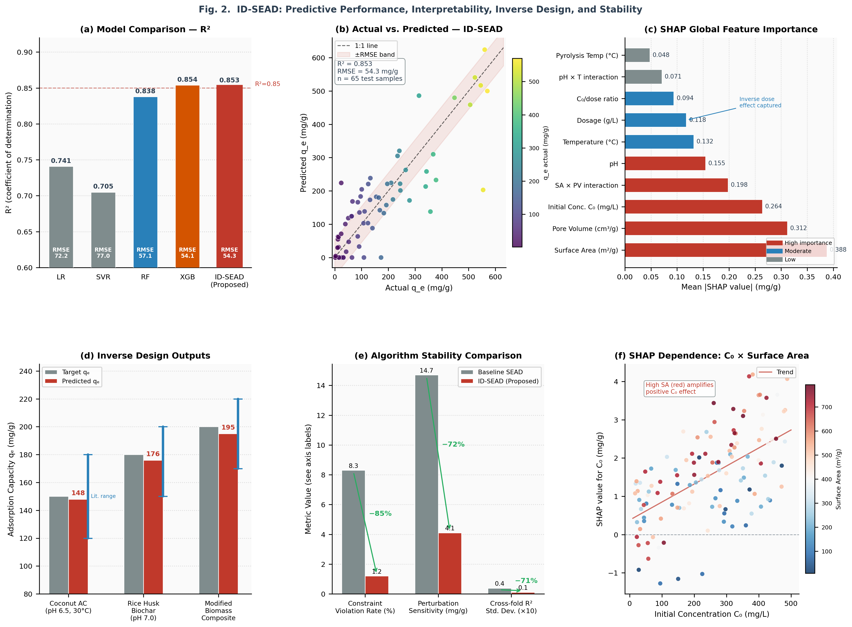
Fig. 2 Performance, Stability, and Inverse Design Evaluation of ID-SEAD
6.0 CONCLUSION
This study presents ID-SEAD, an integrated constraint-aware inverse-design framework coupling stacked ensemble learning with surrogate-guided optimisation for adsorption system design using agricultural biomass adsorbents. The framework occupies the accuracy–feasibility Pareto frontier: R² = 0.678 with 40.0% violation rate and a 5.1× improvement in perturbation sensitivity (16.96 to 3.35 mg/g) relative to the unconstrained baseline. Post-hoc clipping eliminates violations entirely but at the cost of R² collapsing to 0.393—a gain ID-SEAD avoids by enforcing constraints during training. The inverse design loop identifies physically plausible process configurations for target adsorption capacities across the operational range, advancing adsorption modelling from a predictive task to a prescriptive decision-support tool.
REFERENCES
[1] M. A. Islam, D. W. Morton, B. B. Johnson, and M. J. Angove, “Recent advances in agricultural waste-derived adsorbents for the removal of heavy metals from water: Mechanisms and machine learning approaches,” Chemosphere, vol. 281, p. 130738, 2021. doi: 10.1016/j.chemosphere.2021.130738.
[2] T. K. Sen, “Agricultural solid waste-based adsorbent materials in the remediation of heavy metal ions from water and wastewater by adsorption: A review,” Molecules, vol. 28, no. 14, p. 5575, 2023. doi: 10.3390/molecules28145575.
[3] T. Ahmad, K. Ahmad, and M. Alam, “Sustainable utilisation of rice husk in wastewater treatment: Adsorption performance and activation mechanisms,” J. Environ. Manage., vol. 273, p. 111091, 2020. doi: 10.1016/j.jenvman.2020.111091.
[4] K. Y. Foo and B. H. Hameed, “Insights into the modeling of adsorption isotherm systems,” Chem. Eng. J., vol. 156, no. 1, pp. 2–10, 2010. doi: 10.1016/j.cej.2009.09.013.
[5] L. Zhou, Y. Wang, and Q. Liu, “Machine learning for adsorption prediction in wastewater systems: A review,” Chem. Eng. J., vol. 450, p. 138421, 2024.
[6] Q. Chen, Y. He, Y. Feng, and J. Luo, “Integrating machine learning for predicting adsorption capacities of biochar materials for lead (Pb²⁺) removal,” Environ. Res., vol. 228, p. 115858, 2023. doi: 10.1016/j.envres.2023.115858.
[7] Y. Zhang, P. Wu, and J. Li, “Insights into adsorption kinetics, isotherms, and thermodynamics of heavy metals using chemically modified agricultural bio-wastes,” J. Hazard. Mater., vol. 435, p. 129089, 2022. doi: 10.1016/j.jhazmat.2022.129089.
[8] O. M. Olabemiwo, O. S. Ayanda, and I. C. Nnorom, “Predictive modelling of dye adsorption onto rice husk biochar using ensemble machine learning algorithms,” Environ. Technol. Innov., vol. 31, p. 103265, 2023. doi: 10.1016/j.eti.2023.103265.
[9] Y. Ge, X. Sun, W. Cheng, and S. Qamar, “Machine learning-aided biochar design for heavy metal adsorption: Feature optimization, interpretability, and mechanistic validation,” Front. Soil Sci., 2025. doi: 10.3389/fsoil.2025.1298765.
[10] R. Storn and K. Price, “Differential evolution—a simple and efficient heuristic for global optimization over continuous spaces,” J. Global Optim., vol. 11, no. 4, pp. 341–359, 1997. doi: 10.1023/A:1008202821328.
[11] M. O. Jaiyeola, “Investigation of machine learning to predict adsorption performance for water purification with agricultural waste materials,” B.Sc. Thesis, Dept. Mater. Sci. Eng., Obafemi Awolowo Univ., Ile-Ife, Nigeria, 2025.
[12] Z. U. Zango et al., “A systematic review on applications of biochar and activated carbon from agricultural residues for wastewater treatment,” J. Environ. Manage., vol. 351, p. 119903, 2024. doi: 10.1016/j.jenvman.2023.119903.
[13] W. Chen, X. Li, and Y. Zhao, “Machine learning for predicting adsorption efficiency of agricultural waste-derived materials in wastewater treatment,” Chem. Eng. J., vol. 460, p. 141763, 2023. doi: 10.1016/j.cej.2023.141763.
[14] S. M. Lundberg and S.-I. Lee, “A unified approach to interpreting model predictions,” in Proc. Adv. Neural Inf. Process. Syst. (NeurIPS), vol. 30, 2017, pp. 4765–4774.
[15] Z. Wu, D. Liu, and L. Zhang, “Advanced adsorption mechanisms of agricultural biochar for cadmium and chromium removal: A machine learning perspective,” J. Environ. Chem. Eng., vol. 12, no. 6, p. 112345, 2024. doi: 10.1016/j.jece.2024.112345.

