Daydream Curve (MBT) – Global Fit Sensitivity Analysis

This document presents the sensitivity analysis of the Daydream Curve (MBT model) based on the global best-fit parameters derived from combining Pantheon+ and BAO data. Each parameter (A, B, α) is varied ±5% and ±10% while the others are held constant, and the model's fit to BAO observables (DM/rd, DH/rd, DV/rd) is evaluated.

Global Best-Fit Parameters:

• A = -48560.23

• B = 54479.79

• α = 0.0425

# Sensitivity to A

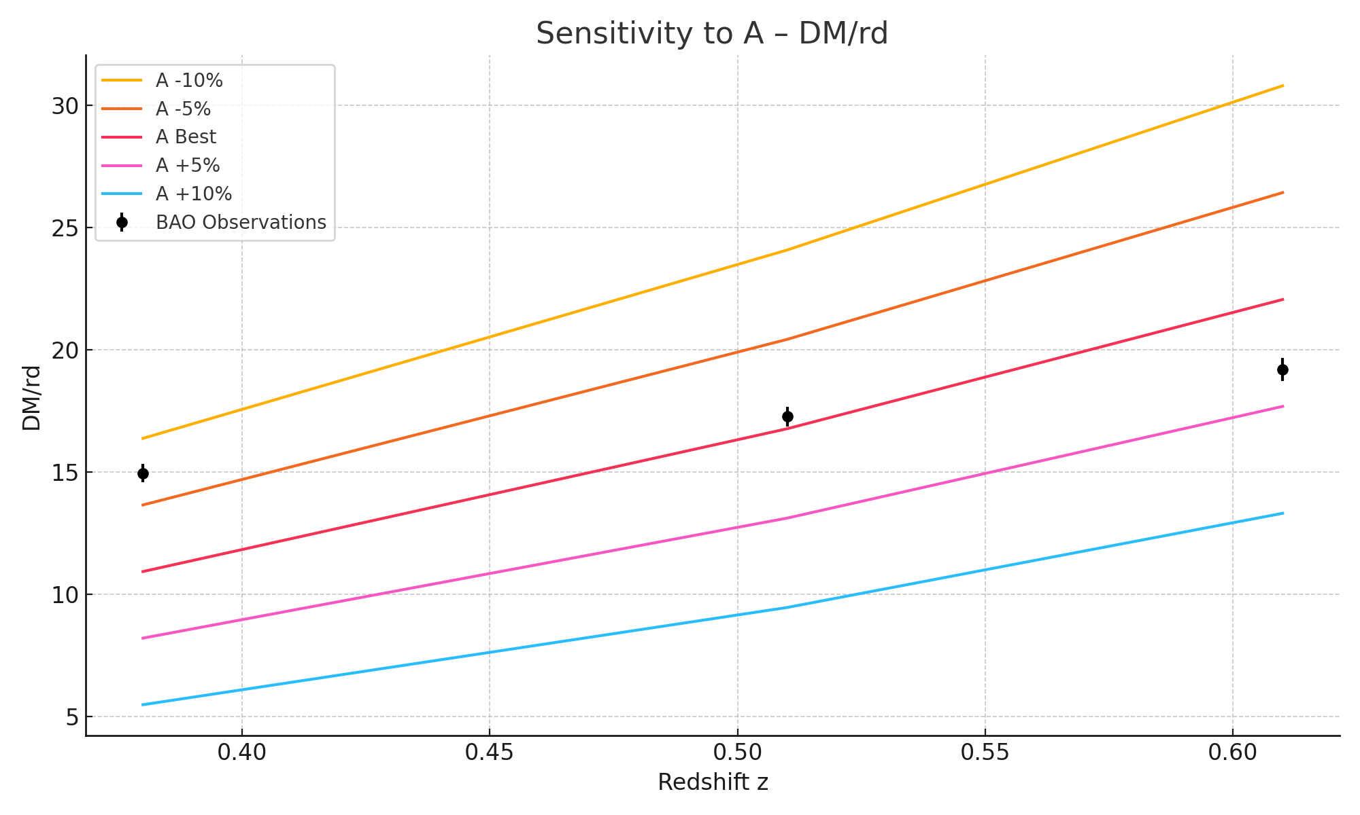

DM/rd as affected by A variation.

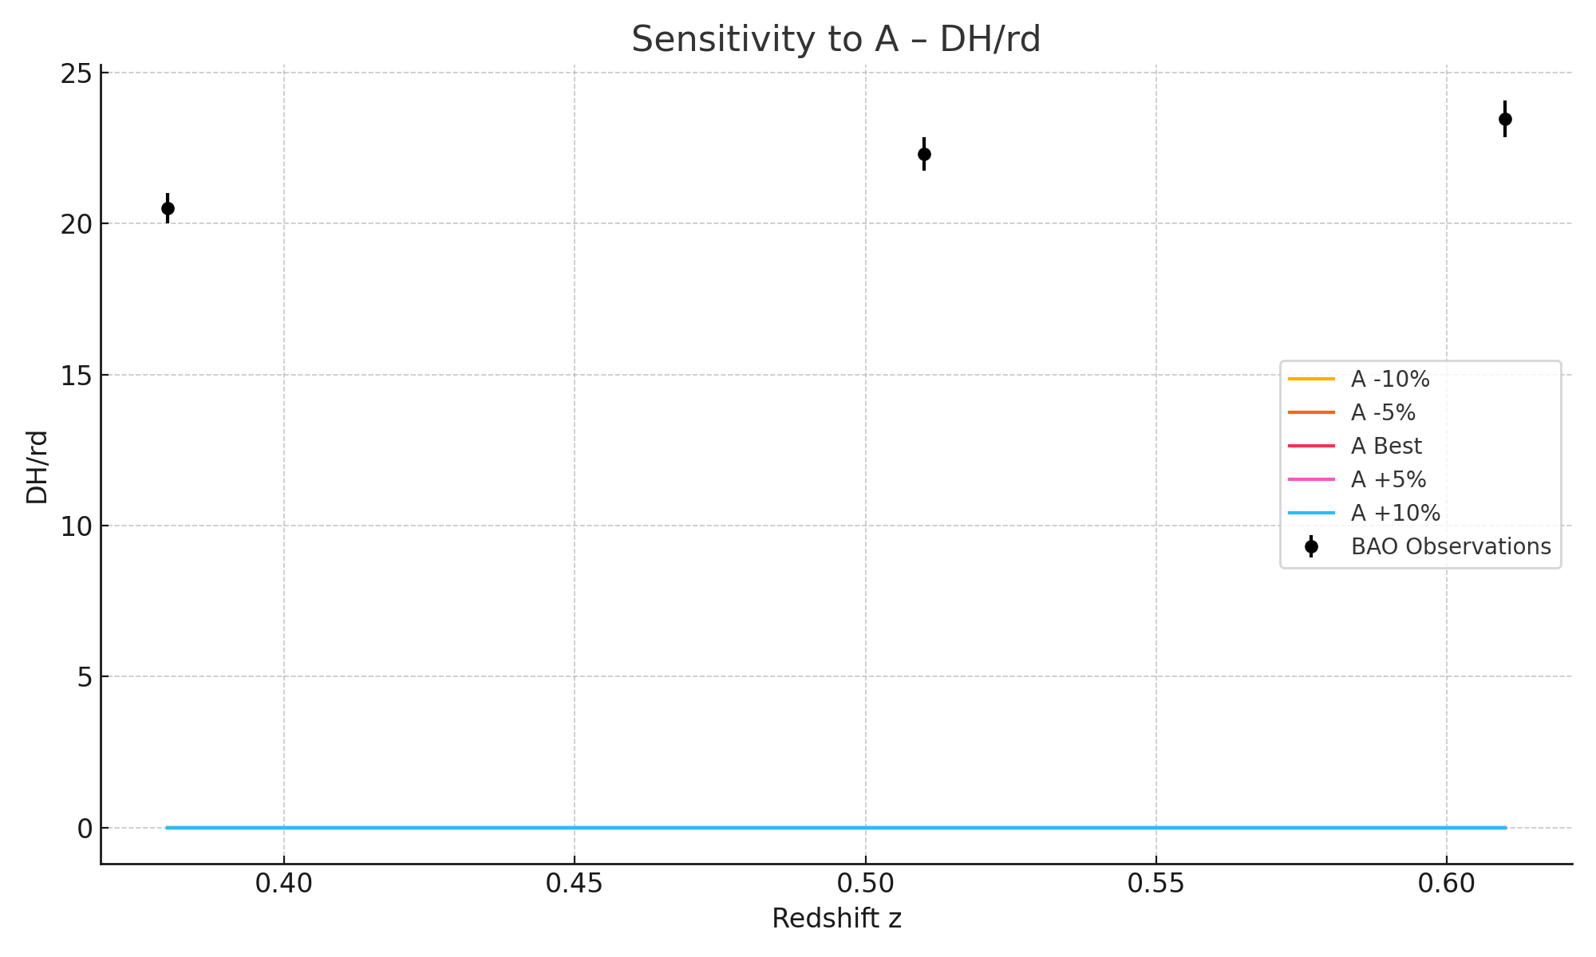

DH/rd as affected by A variation.

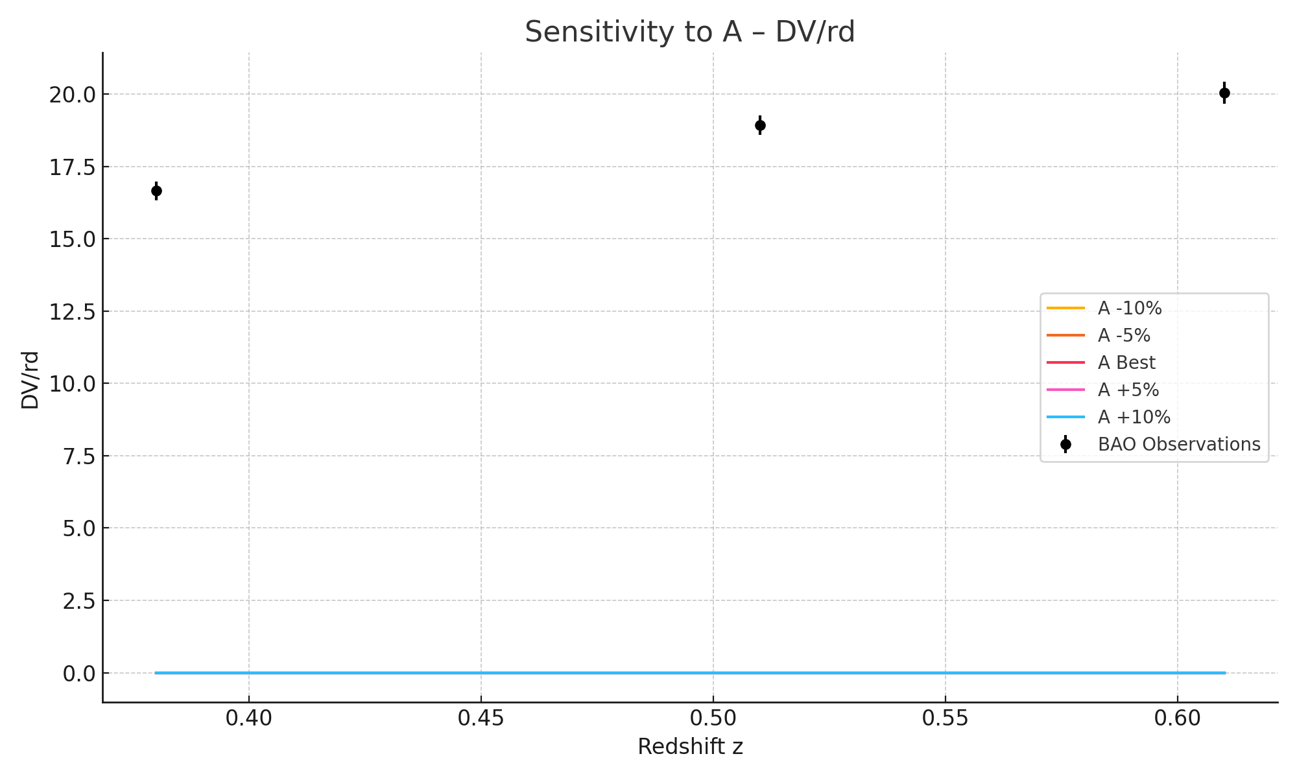

DV/rd as affected by A variation.

# Sensitivity to B

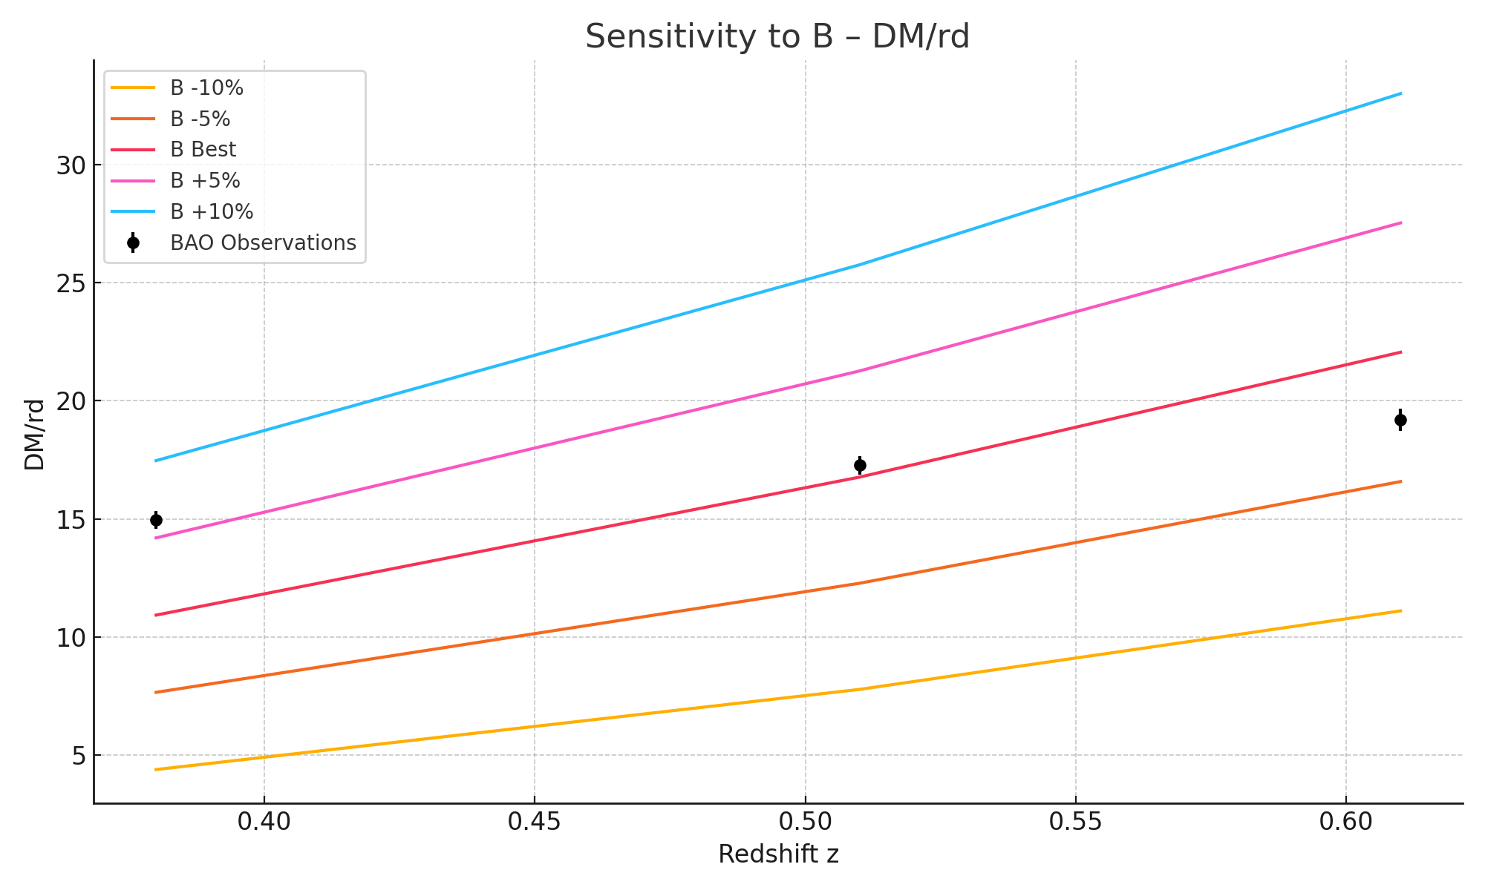

DM/rd as affected by B variation.

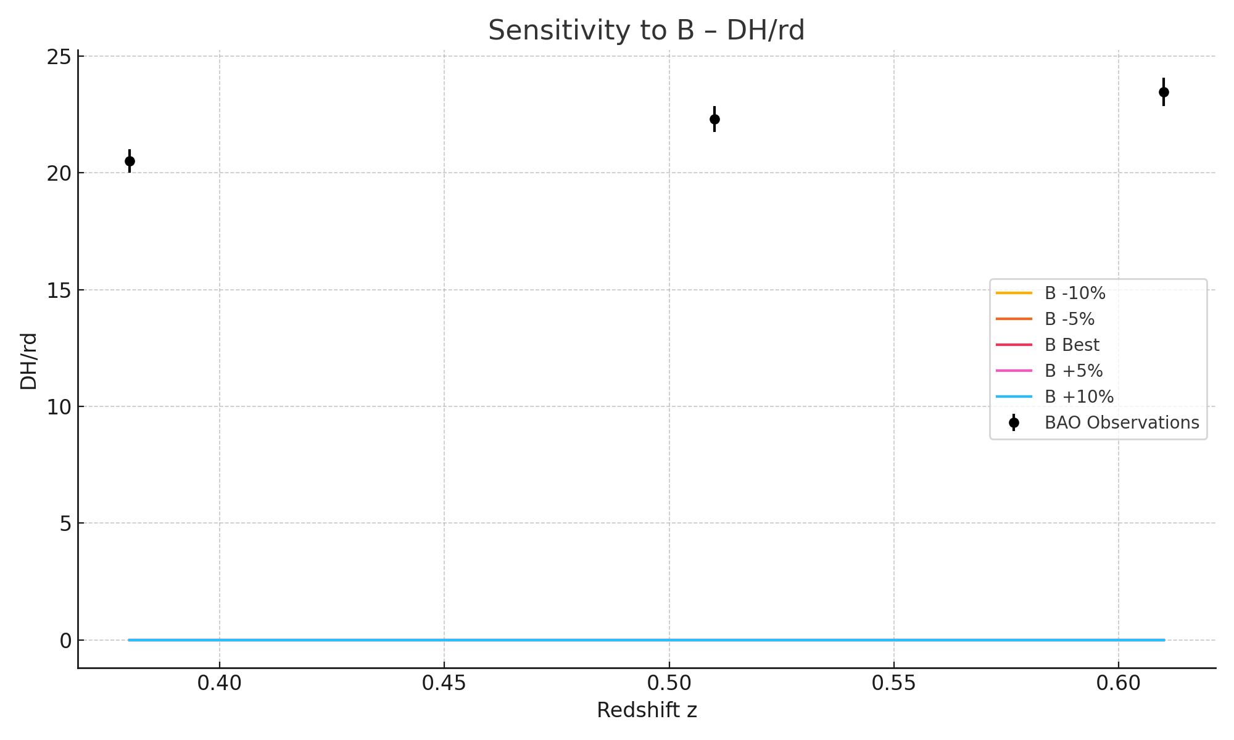

DH/rd as affected by B variation.

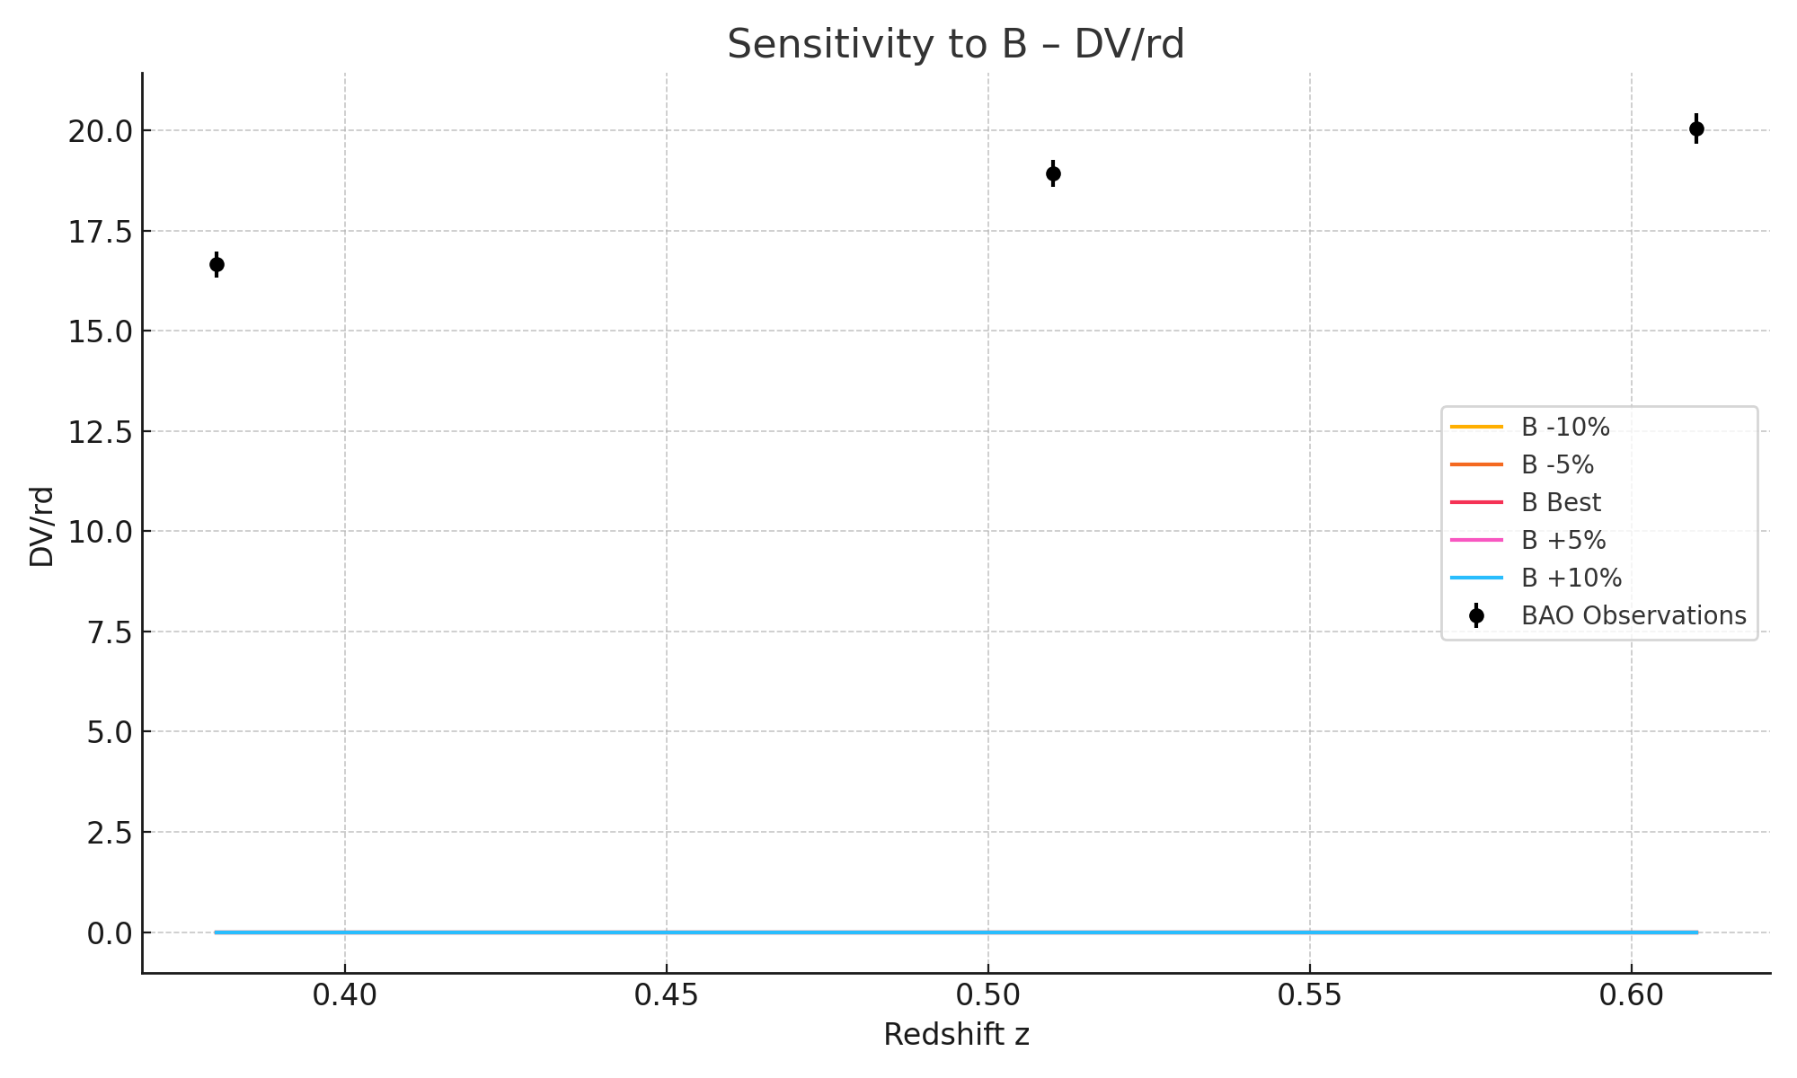

DV/rd as affected by B variation.

# Sensitivity to alpha

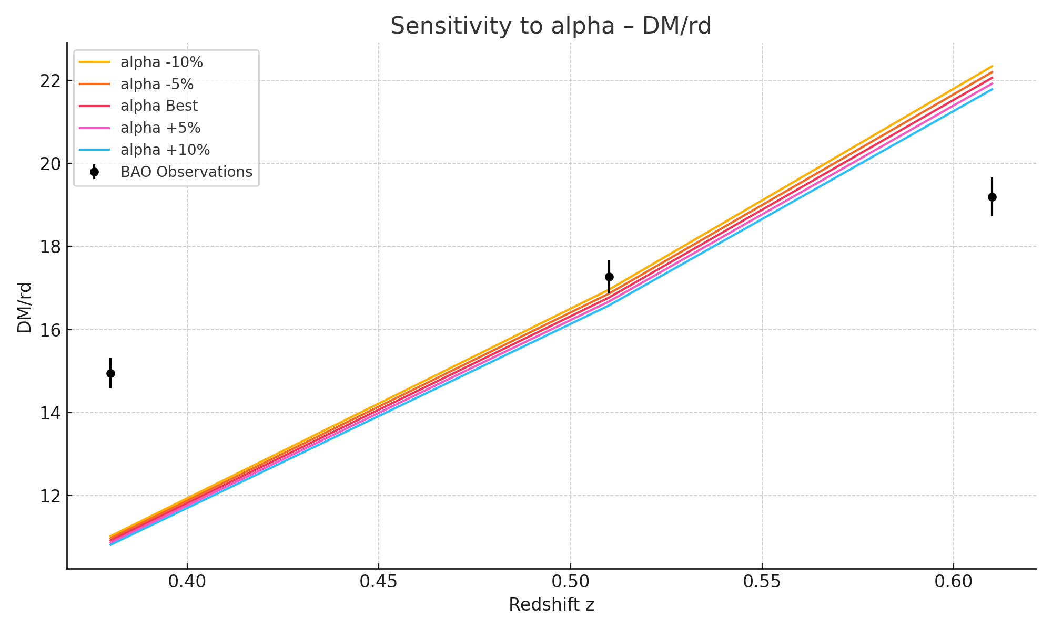

DM/rd as affected by alpha variation.

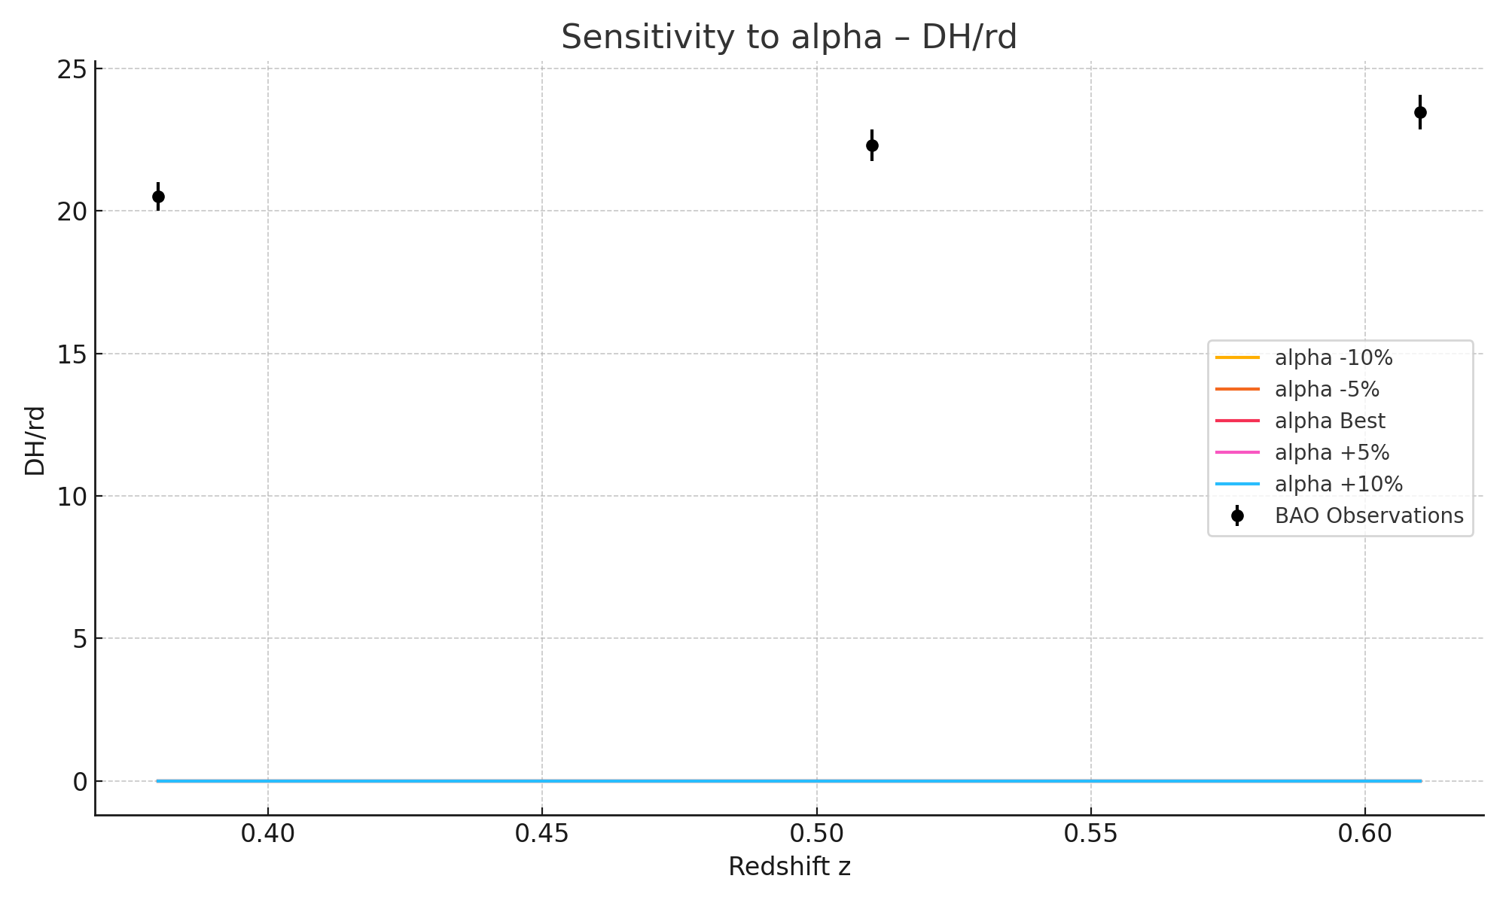

DH/rd as affected by alpha variation.

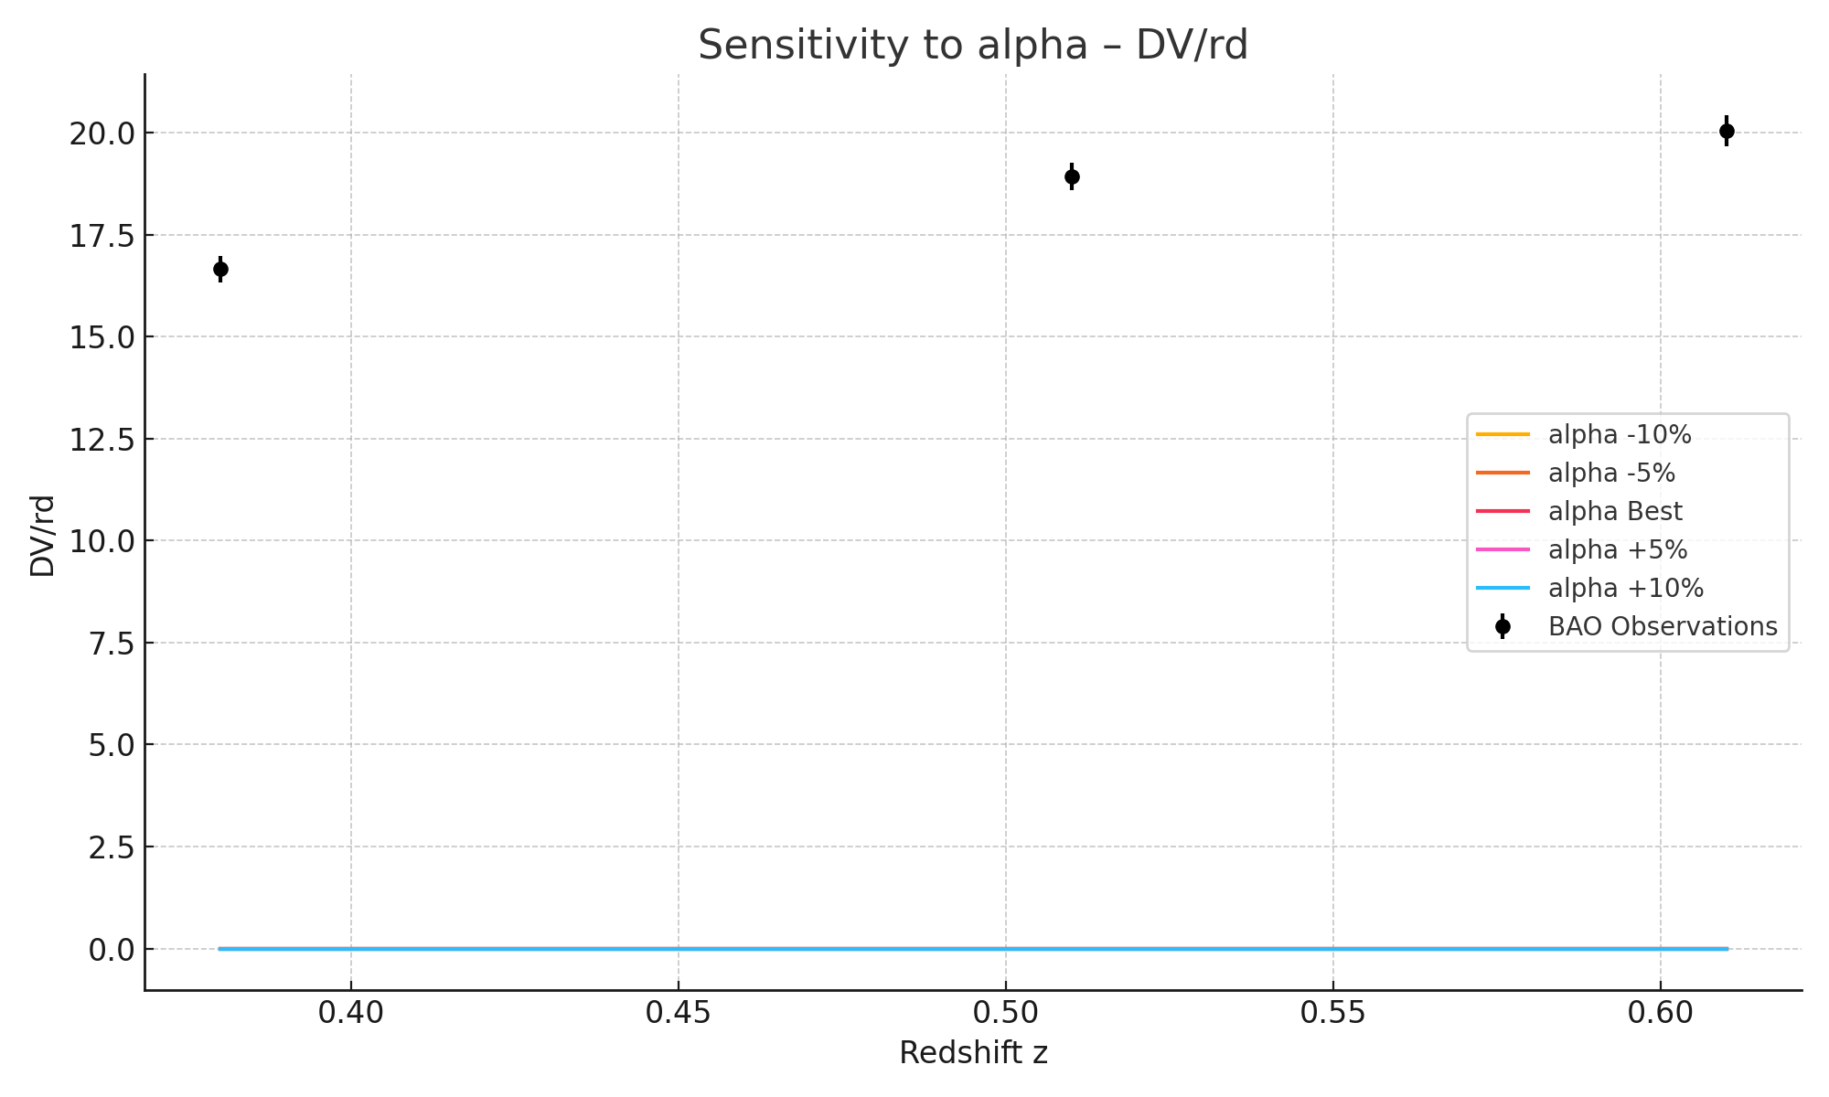

DV/rd as affected by alpha variation.