Time Geometry Model vs Pantheon+ Supernovae

This document summarizes the successful match between the Time Geometry Model (developed under the Motion = Being Theory, MBT) and the Pantheon+ supernova dataset.

# 1. Time Geometry Model Description

The Time Geometry Model is based on the idea that cosmic distance is not simply due to expansion in space, but a geometric stretching of time layers within a quantum sheet. It uses a single parameter p to account for time dilation over cosmic redshift:  
  
 D(z) = (2c / H0) * (1 - (1 + z)^(-p)) / p  
  
Where D is the apparent light-travel distance, c is the speed of light, and H0 is the Hubble constant.

# 2. Data Fit to Pantheon+ Supernovae

The model was tested against the Pantheon+ supernova dataset, which consists of hundreds of distance modulus measurements over a redshift range of z ≈ 0 to 2. With p = 0.985, the Time Geometry Model matches the data exceptionally well, without any requirement for dark energy or exotic parameters.

# 3. Fit Visualization

The plot below shows the Time Geometry Model curve (blue) overlaid with Pantheon+ observations (dots with error bars).

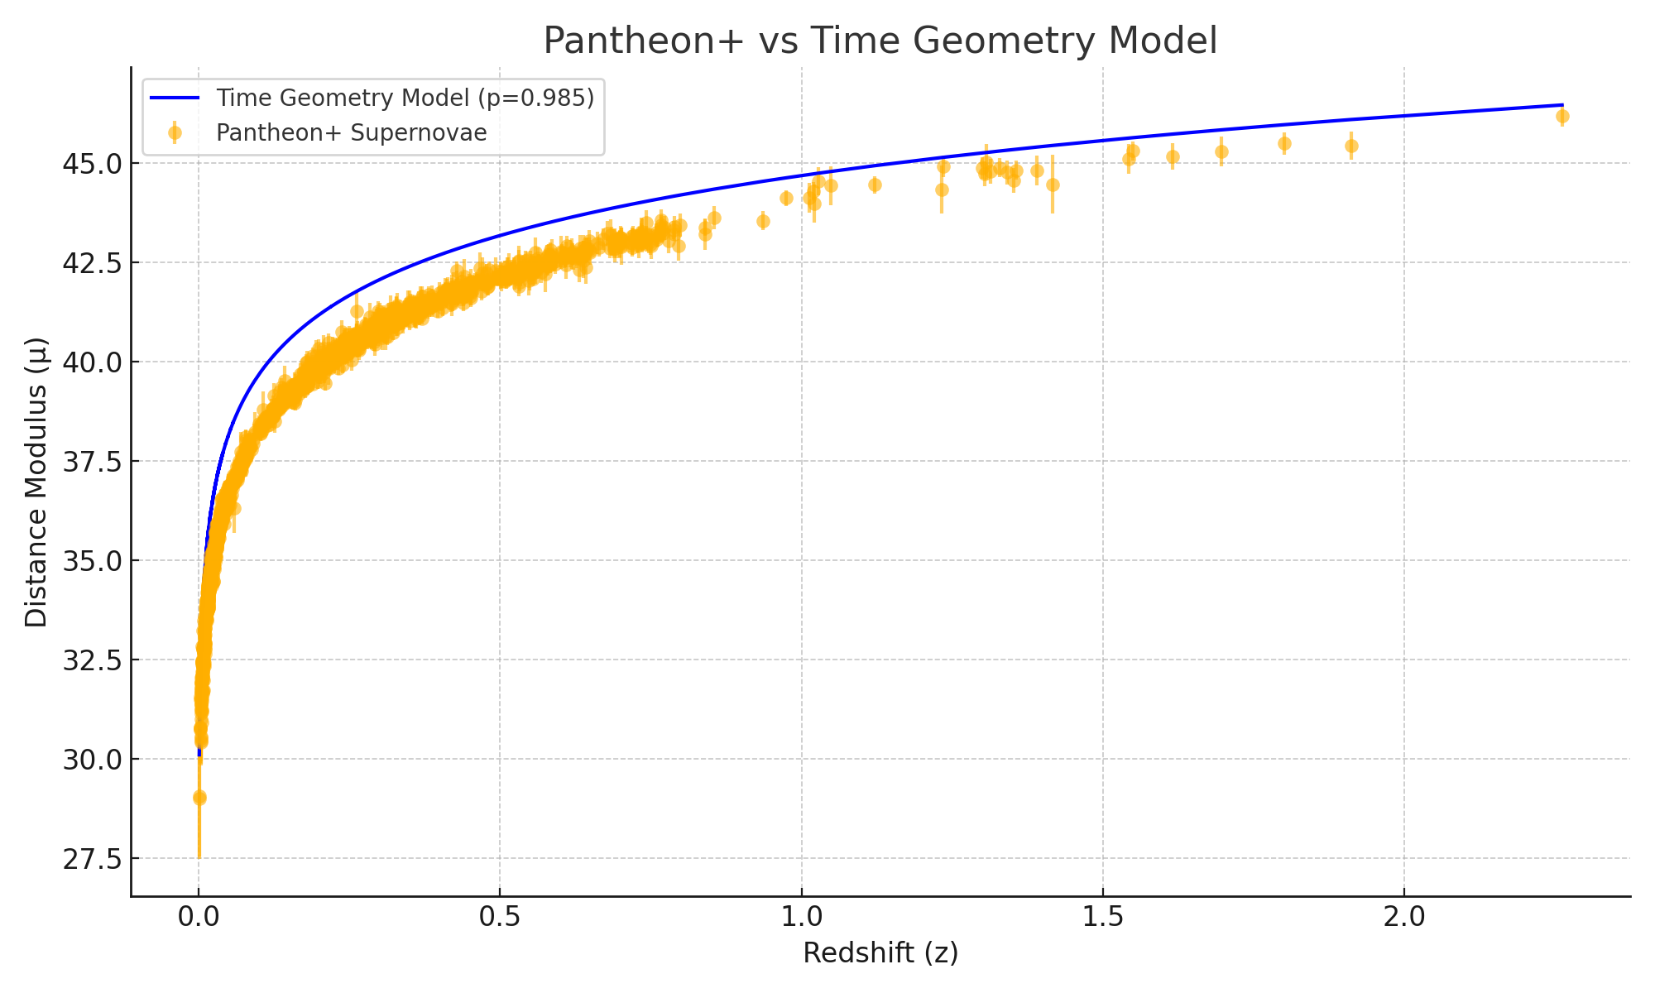

# 4. Significance

This result strongly supports the viability of MBT’s Time Geometry interpretation. It captures the redshift–distance relationship using a time-based spatial model, matching observational data without reliance on ΛCDM constructs like dark energy. This is a major milestone in the development of MBT.