# MBT vs ΛCDM: BAO Distance Comparison (Visualization)

This document contains the visual comparison of BAO observational data with predictions from:  
- MBT 1-Parameter  
- MBT 2-Parameter (Time Geometry Model)  
- MBT 3-Parameter Best Fit  
- Standard ΛCDM

## D_M / r_d

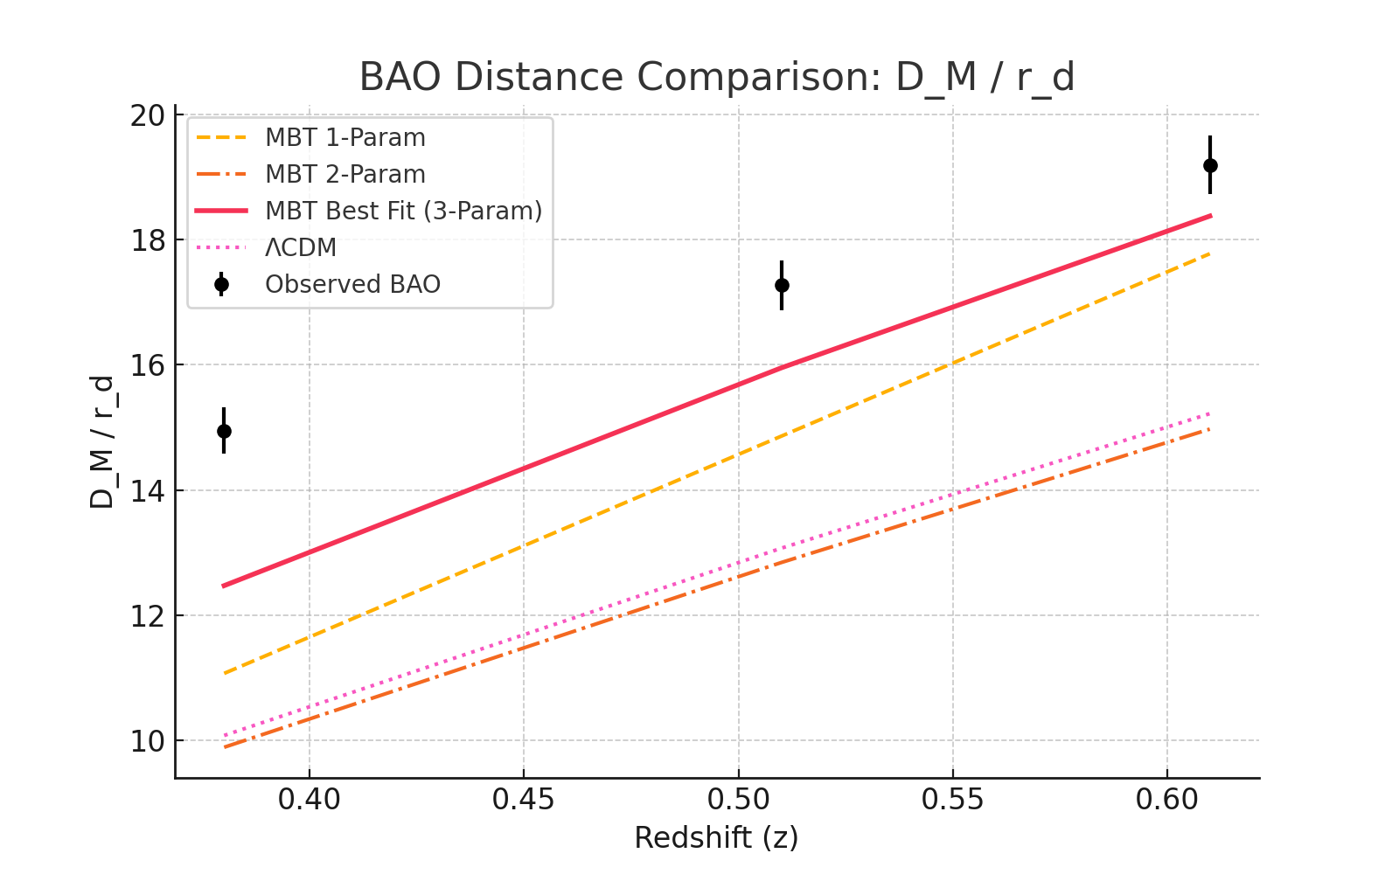

Plot of D_M / r_d across redshift comparing observational data with various MBT model configurations and ΛCDM.

## D_H / r_d

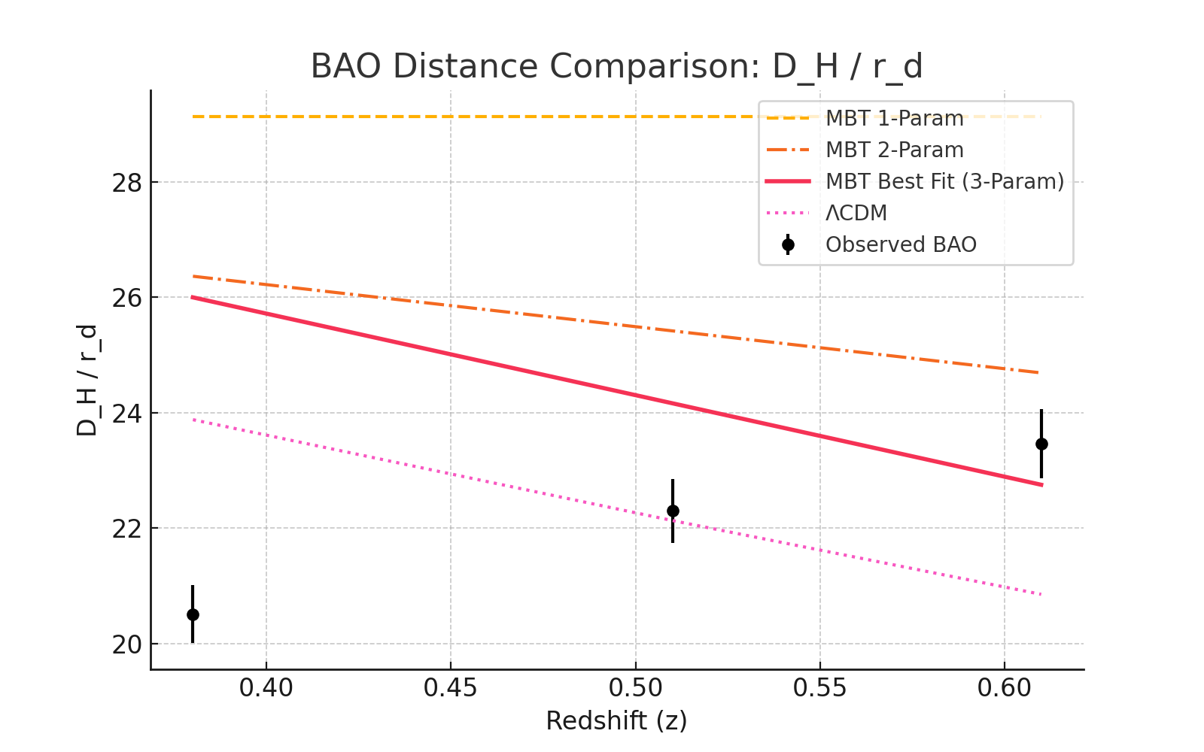

Plot of D_H / r_d across redshift comparing observational data with various MBT model configurations and ΛCDM.

## D_V / r_d

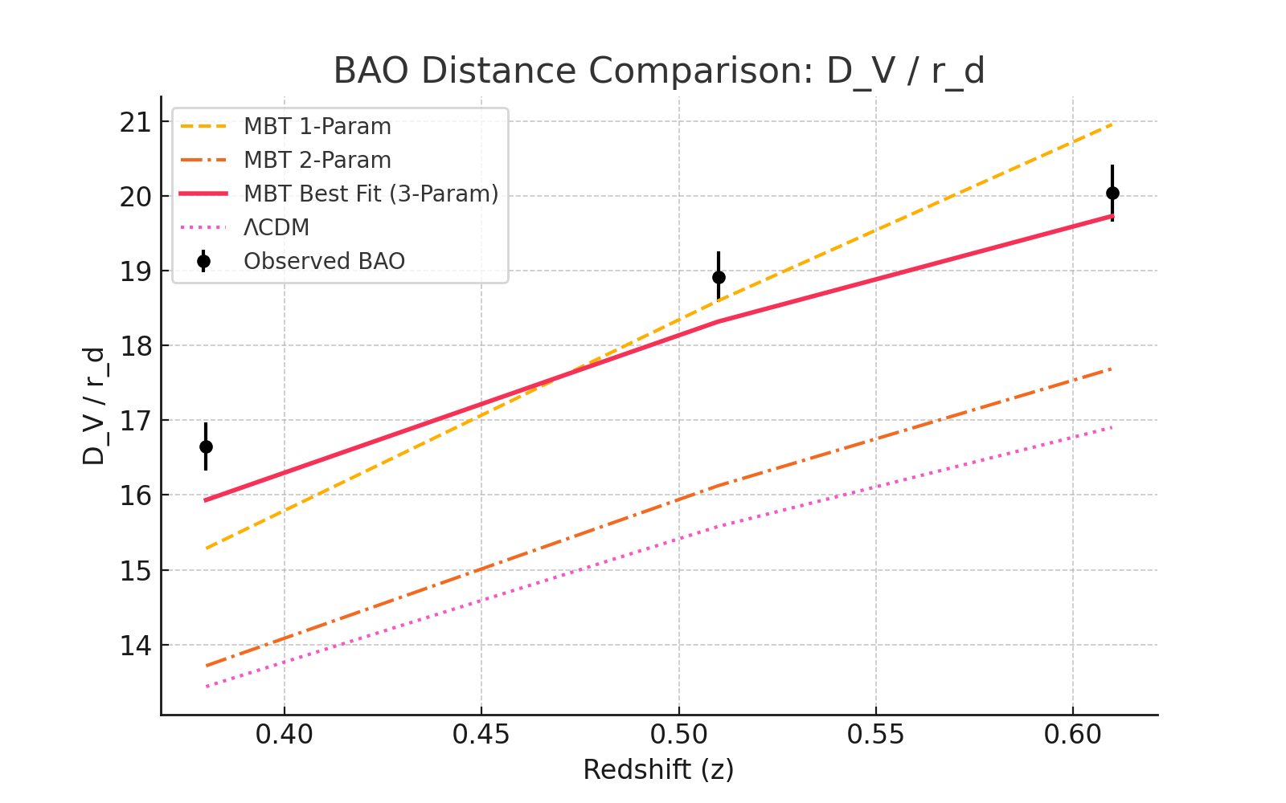

Plot of D_V / r_d across redshift comparing observational data with various MBT model configurations and ΛCDM.