Computer Lab #3: Salmon population growth and density dependence
In 1997 Ratner and colleagues published a study about the population viability of Spring Chinook Salmon in the South Umpqua River, Oregon. Their goal was to understand the population dynamics of this wild salmon population and to assess whether conservation intervention was needed.
We use their data to perform an age-structured, density-dependent projection of salmon population dynamics.
These salmon can live to be 5 years old, but they can also start breeding at age 2. They die immediately after breeding.
Today, we provide the data and a step by step task description, but we think that you have the R-skills to perform the tasks yourself.
- In the paper Table 2 (provided below) you find vital rates for each age class.
  - Store the probability of survival, s, in a vector for the 2nd-5th age
  - Store the probability of breeding, b, (for females) for each age class
  - Store the amount of eggs per breeding female, f, for each age class. (Attention: The numbers there, are given as American version 3,185 = 3185)
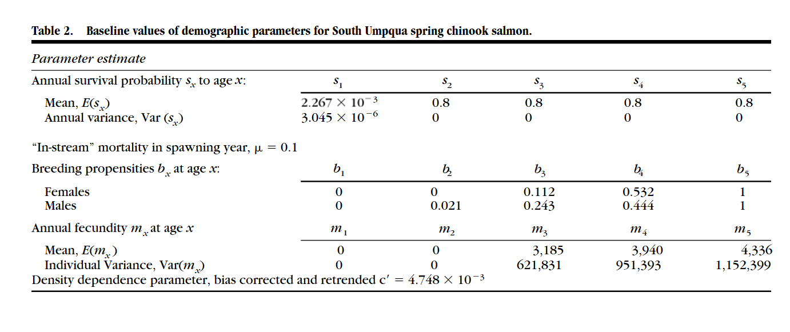
- We still missing some important parameters/vital rates. Store all of these parameters as well.
  - The maximum egg survival, α = 0.002267
  - The starting population vector:
Age 1 | Age 2 | Age 3 | Age 4 | Age 5
0.7667 | 0.6163 | 0.4945 | 0.3524 | 0.1309
  - Density-dependent parameter, β = 0.001
  - We want to project the population 100 years into the future: tmax = 100

- There are two density dependent functions one can use to describe recruitment (number of eggs that become young fish).

Rickers model, which is defined as:
$R= αSe^{-βS}$ the yellow marked part of the formula incorporates the density dependence

Beverton-Holt model, which is defined as:
$R= \frac{αS}{1+βS}$ the yellow marked part of the formula incorporates the density dependence

R = total number of recruits in the population (i.e., number of age 1 individuals)
S = total number of eggs produced by all breeders in the population
α = maximum egg survival
β = density-dependent parameter

To be able to easily switch between different models of density dependence, we propose you use eggsurv = 1 as the Rickers model and eggsurv = 2 as the Beverton-Holt model (use eggsurv later as a “decider” (if statement) in the for loop)

- Project the population size 100 years into the future
  - Create an empty vector to keep track of the number of breeding individuals in the population in each time step (we will want to graph this)
  - Set up a loop from 1 to tmax (tmax=100 if you want to go 100 years into the future)
- First step in the loop: compute the total number of eggs produced by all breeders in the population (S). Hint at how to calculate that:
Matrix cross product of: (probability of breeding (b) * eggs per breeding female (f)) and the population vector (n). (b*f) x n
- There is a build in function in R for cross product
  - Decide which density dependent function you want to use. Remember we stored the Ricker model as eggsurv = 1. So implement an if statement which does the following:
If eggsurv = 1 use this function and calculate the number of age 1 individuals at t+1 using the Ricker formula.
Else use Beverton-Holt and calculate the number of age 1 individuals at t+1
Age 1 individuals at t + 1 <- (α * S ) * exp(-β * S) example how to write the Ricker formula in R.
  - Remember to store the new number of individuals of each age class in each time step.
e.g., Age 5 individuals at t + 1 <- survival of age 4 individuals * (1 – probability of breeding at age 4) * number of age 4 individuals at time t
  - Fill in your empty vector with the number of breeding individuals in the population in each year. Calculation this number as the sum (n *b), and then multiply by 1000 (because we start n of with fractions of individuals).
  - Graph the number of breeding individuals in the population through time when modeling density dependences as either a Ricker or Beverton-Holt. Tell us what you see. How does the type of density dependent model you use influence the equilibria you see?

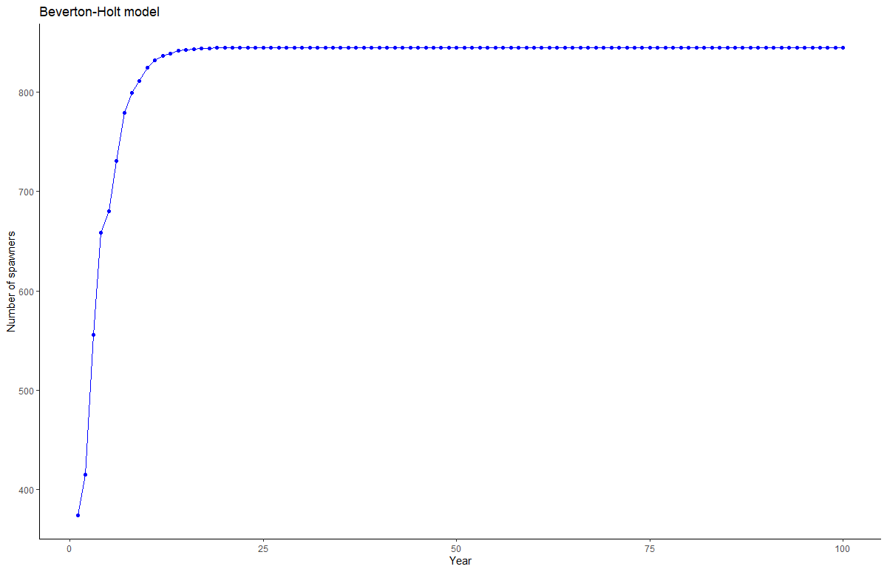
Figure 1Thats how your graph should look like for the Beverton-Holt model
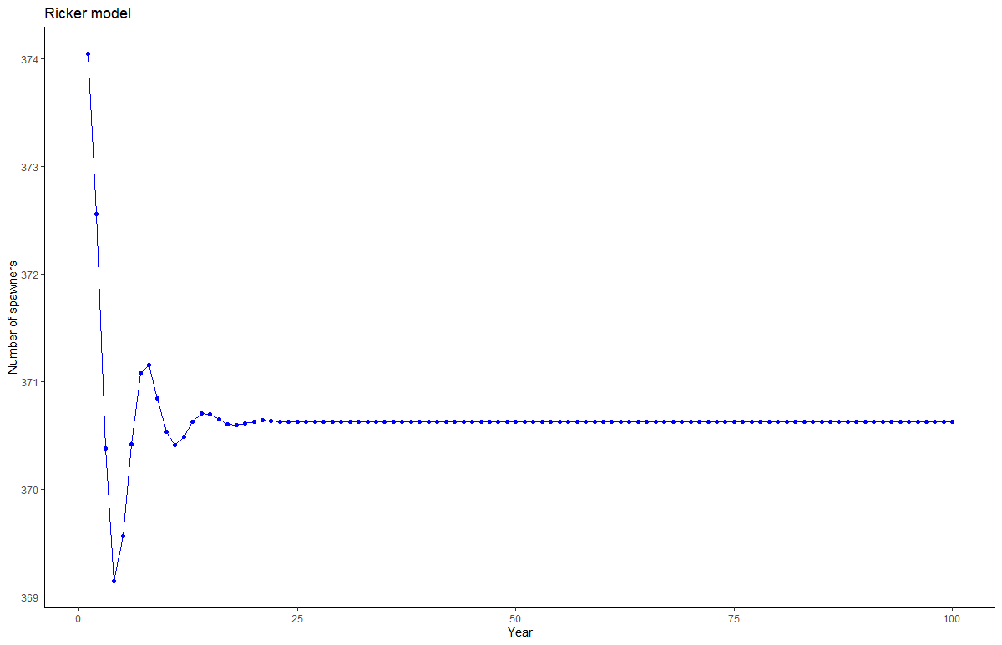
Figure 2Thats how your graph should look like for the Ricker model
- What effect does the parameter f, eggs per breeding female, have on your dynamics? You can increase the number of eggs produced by the breeders by a factor chosen from you and redo the steps above for the Ricker model.

Give us an example about how change f influences the dynamics and the equilibrium you see.

- Now, systematically evaluate how equilibrium population dynamics are influenced if you change f by a factor 0.5 till 5 in steps of 0.1. (0.5, 0.6, 0.7,..., 5).

There are many different ways of approaching and doing the next couple of steps, so if find a different way you do not need to follow the steps provided.

- We can use the input data from the previous steps (steps 1 and 2). Set tmax=10000 years so you can see long-term dynamics.
- Create a vector with all the factors we want to use (0.5 – 5, in steps of 0.1).
- Input the initial population vector again.
- Create two empty vectors before the for loop, for storing purposes. One we will use to store the number of breeders for each iteration of time (the inner for loop, 1:tmax). In the second vector (the outer for loop, 1:length(factor)), we store the factor we used to increase f and the number of breeders for the last 100 years (9901:10000) (example how to do that at the end of 6.). That will turn the vector into a list of data frames. That is one of the advantages of creating a vector, we can turn it in the for loop into a list (see example at the end). The goal of that loop is to create data we can use to create a bifurcation graph where we look at the factor we used to change f and the influence it had on the population dynamics at equilibrium.
- Set up a nested for loop.
  - First for loop is for increasing f each step by the factor.
  - Store the f value for each iteration of the loop
  - Set the starting population vector always to your initial population each time you begin with a new f value
  - The second for loop is what we did earlier, just for a 10000 years, using the Ricker model.
  - Store the number of breeders for the last 100 years (by this time, the population should be at equilibrium) together with the factor used in the second vector. Again, this will turn our vector into a list of data frames. There are many different ways of doing that. I just like to use lists. Here is my example:
L[i] <- list(data.frame(factor = factor[i], breeder_population[9901:10000]))

After the for loop we can use:
do.call(“rbind”, L) to store the list as a data frame.

- Plot your results as: Number of breeders ~ factor. This is a bifurcation graph. Interpret your results. How does f influence the equilibrium population size? Why do you think this happens?
- How would harvesting influence the number of breeders?
  - For this we want to alter the number of individuals in the population from 0.1 (10% of the individuals are harvested) to 1 (all individuals harvested).
  - It pretty much works like #6, except instead of altering vector f you now alter vector n.
  - You can try it yourself or use our help or ask for the “Cheat code”.
- Plot your results as: Number of breeders ~ harvesting factor. This is a bifurcation graph. Interpret your results. How does harvesting influence the equilibrium population size? Why do you think this happens?

