THE RESOURCE ROOM
TEST
Mathematics
Grade 4 | Term 1

Name and Surname: _______________________ | Date: _______________________
Examiner: _______________________ | Time: 60 minutes
Total: 40 marks

INSTRUCTIONS AND INFORMATION:
• Answer ALL questions.
• Write neatly and show ALL working out in the spaces provided.
• Number your answers correctly according to the numbering system used in this question paper.
• You may use a pencil for drawings or diagrams.

SECTION A: MULTIPLE CHOICE (10 marks)
Choose the ONE correct answer from the options given. Circle the letter of the correct answer.
1 Choose the ONE correct answer for each question. Write only the letter of the correct answer.
1.1 What is the value of the digit 7 in the number 3 749?
A. 7
B. 70
C. 700
D. 7 000
[2]
1.2 Which number comes BETWEEN 4 298 and 4 302 when counting in ones?
A. 4 289
B. 4 299
C. 4 310
D. 4 320
[2]
1.3 Which of the following is a factor of 24?
A. 5
B. 7
C. 9
D. 8
[2]
1.4 Which property is shown by the number sentence: 15 + 23 = 23 + 15?
A. Associative property
B. Distributive property
C. Commutative property
D. Identity property
[2]
1.5 What is 12 × 10?
A. 22
B. 102
C. 112
D. 120
[2]
SECTION B: SHORT QUESTIONS AND CALCULATIONS (30 marks)
Answer ALL questions. Show ALL working out where applicable.
2 Answer the questions below about the number 5 863.
2.1 Write the number 5 863 in words.
_______________________________________________
_______________________________________________
[2]
2.2 Write the expanded notation for 5 863.
_______________________________________________
_______________________________________________
[2]
2.3 Round 5 863 to the nearest hundred.
_______________________________________________
[1]
3 Use the numbers: 3 047 | 3 704 | 3 470 | 3 407
3.1 Arrange the four numbers from SMALLEST to LARGEST.
_______________________________________________
_______________________________________________
[2]
3.2 Write the correct symbol (< or >) between the numbers: 3 407 ___ 3 470
_______________________________________________
[1]
4 Calculate the following. Show ALL working out.
4.1 2 456 + 3 187 = ___
Working: _______________________________________________
_______________________________________________
Answer: _______________________________________________
[2]
4.2 7 034 − 2 658 = ___
Working: _______________________________________________
_______________________________________________
Answer: _______________________________________________
[2]
5 Calculate the following. Show ALL working out.
5.1 24 × 13 = ___
Working: _______________________________________________
_______________________________________________
Answer: _______________________________________________
[2]
5.2 35 × 21 = ___
Working: _______________________________________________
_______________________________________________
Answer: _______________________________________________
[1]
6 Answer the questions about multiples and factors.
6.1 Write down the first five multiples of 6.
_______________________________________________
[1]
6.2 List ALL the factors of 36.
_______________________________________________
_______________________________________________
[2]
7 Write and solve number sentences.
7.1 Find the value of □ in the number sentence: □ + 1 485 = 4 000
Working: _______________________________________________
_______________________________________________
Answer: _______________________________________________
[2]
7.2 Find the value of □: 48 × □ = 48 × 20 + 48 × 3
Working: _______________________________________________
_______________________________________________
Answer: _______________________________________________
[2]
8 Answer the questions below.
8.1 Thandi has 6 035 beads. She gives away 2 748 beads and then receives 1 506 more. How many beads does Thandi have now?
Working: _______________________________________________
_______________________________________________
Answer: _______________________________________________
[4]
9 Read the problem carefully and answer the questions.
9.1 Sipho packs oranges into boxes. Each box holds 24 oranges. He has 13 boxes. He wants to share all the oranges equally among 4 classes at his school. How many oranges will each class receive? Show ALL working out.
Working: _______________________________________________
_______________________________________________
Answer: _______________________________________________
[4]
BAR GRAPH · FAVOURITE FRUIT IN GRADE 4
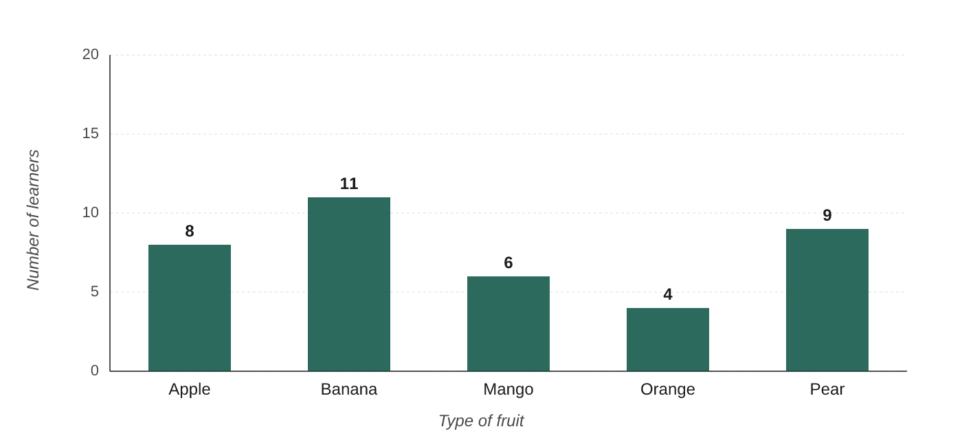

SECTION C: DATA HANDLING (7 marks)
Study the bar graph below, then answer the questions.
9 Use the bar graph to answer the questions below.
9.1 Which fruit was the MOST popular?
_______________________________________________
[1]
9.2 How many learners chose mango?
_______________________________________________
[1]
9.3 How many MORE learners chose banana than orange?
Working: _______________________________________________
_______________________________________________
Answer: _______________________________________________
[2]
9.4 How many learners voted in TOTAL?
Working: _______________________________________________
_______________________________________________
Answer: _______________________________________________
[3]
TOTAL: 40 marks

MEMORANDUM
Mathematics — Grade 4 Term 1
NO. | ANSWER | MARKING GUIDANCE | COGNITIVE LEVEL | MARK
1.1 | c) 700 |  | Knowledge | 2
1.2 | b) 4 299 |  | Knowledge | 2
1.3 | d) 8 |  | Knowledge | 2
1.4 | c) Commutative property |  | Knowledge | 2
1.5 | d) 120 |  | Knowledge | 2
2.1 | Five thousand eight hundred and sixty-three | Award 2 marks for fully correct wording; 1 mark if thousands/hundreds/tens/units are all present but minor word error. | Routine Procedures | 2
2.2 | 5 000 + 800 + 60 + 3 |  | Routine Procedures | 2
2.3 | 5 900 |  | Routine Procedures | 1
3.1 | 3 047 ; 3 407 ; 3 470 ; 3 704 |  | Routine Procedures | 2
3.2 | 3 407 < 3 470 |  | Routine Procedures | 1
4.1 | 5 643 | Award 2 marks for correct answer. 1 mark if method correct but arithmetic slip. | Routine Procedures | 2
4.2 | 4 376 | Award 2 marks for correct answer. 1 mark if regrouping evident but arithmetic slip. | Routine Procedures | 2
5.1 | 312 | Award 2 marks for correct answer. 1 mark if partial products shown correctly (e.g. 24×10=240, 24×3=72) but final addition wrong. | Routine Procedures | 2
5.2 | 735 | Award 1 mark for correct answer. | Routine Procedures | 1
6.1 | 6, 12, 18, 24, 30 |  | Routine Procedures | 1
6.2 | 1, 2, 3, 4, 6, 9, 12, 18, 36 | Award 2 marks for all nine factors correct; 1 mark for at least six factors correct. | Routine Procedures | 2
7.1 | □ = 2 515 (working: 4 000 − 1 485 = 2 515) |  | Complex Procedures | 2
7.2 | □ = 23 (working: 48 × 23 = 48 × 20 + 48 × 3 = 960 + 144 = 1 104; or identify □ = 20 + 3 = 23) |  | Complex Procedures | 2
8.1 | 4 793 beads (6 035 − 2 748 = 3 287; 3 287 + 1 506 = 4 793) | Award 4 marks for correct final answer with both steps shown. 3 marks if both steps attempted correctly but one arithmetic error. 2 marks if one step correct. 1 mark for recognising two-step operation. | Complex Procedures | 4
9.1 | 78 oranges per class (Step 1: 24 × 13 = 312 oranges total; Step 2: 312 ÷ 4 = 78 oranges each class) | Award 4 marks for correct answer with full working. 3 marks if multiplication correct (312) but division step has error. 2 marks if strategy identified (two steps) and one step correct. 1 mark for recognising multiplication of 24 × 13 is required. | Problem Solving | 4

COGNITIVE LEVEL ANALYSIS (Bloom's)
Cognitive Level | Prescribed % | Prescribed Marks | Actual Marks | Actual %
Knowledge | 25% | 10 | 10 | 25%
Routine Procedures | 45% | 18 | 18 | 45%
Complex Procedures | 20% | 8 | 8 | 20%
Problem Solving | 10% | 4 | 4 | 10%
TOTAL | 100% | 40 | 40 | 100%

