**SUPPLEMENTARY Methods** for

**Marine biorhythms: bridging chronobiology and ecology**

Martin Bulla[1], Thomas Oudman, Allert I. Bijleveld, Theunis Piersma, and Charalambos P. Kyriacou

**Red knot radio tracking**

We studied the roosting and foraging behavior of red knots *Calidris canutus canuts* wintering in the Baie d’Aouatif in Parc National du Banc d’Arguin, Mauritania, West Africa (19˚53’N, 16˚17’W) and foraging on intertidal mudflats between 9 January and 13 February 2013 [1,2]. We equipped 46 individuals with a 6 g tag glued to the skin of their rump [3]. Every second each tag emitted a specific radio signal. Up to nine radio receivers positioned in the area registered the time of arrival of the tag-specific signal. The differences in signal arrival times between the stations were used to calculate the tag’s position [2,4,5].

To test for circadian and tidal foraging rhythms, we used the bird’s distance to the nearest high tide roost as a proxy for foraging behaviour (for the intertidal area and estimated roost sites see Fig. S1). We only used tag positions with an estimated error below 125 m. For each half hour we calculated the median position and hence median distance to the nearest roost. As birds differ in where they forage and roost, we standardized the distance data within each bird by dividing each distance by the bird’s furthest distance to the roost represented by 95 percentile of all its distance. Thus 0 represents the roost and 1 the farthest 95% distance from the roost for a given bird. We then analysed only standardized distance smaller than 2 and used individuals with more than 50 hours of recording. In this way, we obtained 81,635 half-hourly distances from 42 red knots (median [range] = 19 [2-34] days per bird.

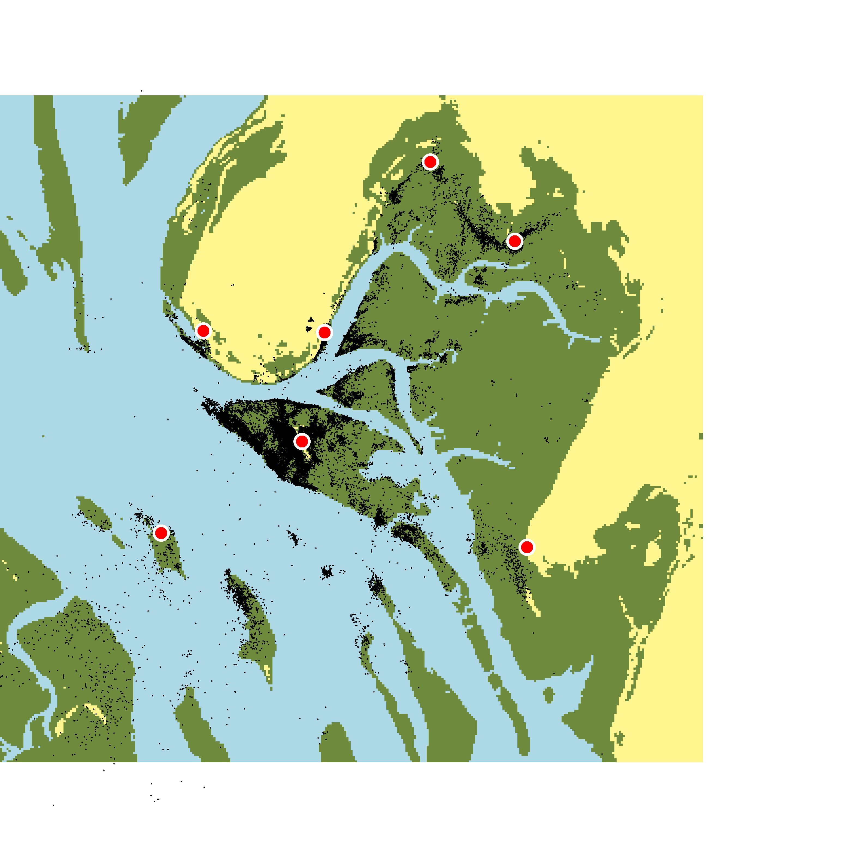

**Figure S1. Map of the study area during low tide**. Black dots indicate all median half-hourly positions for each bird. Red dots indicate seven main roosting sites (derived from the half-hourly positions). Yellow is land, green mudflats, and blue water.

For each bird we then tested whether the standardized off-roost distance was related to (a) ‘tide’ specified as time difference to and from the closest high tide (ranging from -6.7 to 6.7 h with 0 representing high tide) transformed to radians (by multiplying the hours by π and dividing by 6.2) and (b) ‘time of day’ (in hours) transformed to radians (by multiplying the hours by π and dividing by 12). Both variables were then represented by a sine and cosine function. To minimize temporal auto-correlation (and hence pseudo-replication) we have sampled only 15% of the data for each individual with individual data-points spaced more than 1 hour apart. In this way we re-sampled the data for each bird 100 times and fitted the model to each sample.

We performed the statistical analyses in R [6] and used the 'sim' function from the ‘arm’ R package and a non-informative prior-distribution [7, 8] to create a sample of 10,000 simulated values for each model parameter (i.e. posterior distribution). We then generated effect sizes and model predictions as the medians, and the uncertainty of the estimates and predictions by the Bayesian 95% credible intervals represented by 2.5 and 97.5 percentiles (95% CI) from the joint posterior distribution of 100 separate runs, each with 1 of the 100 separate samples (each with 10,000 simulated or predicted values).

We then report tidal or circadian pattern if the respective 95% credible intervals (based on the joint posterior distribution of the 100 models) for sin or cosine estimates did not overlap zero. For plotting purposes, we back-transformed the predictions of standardized distance to km by multiplying the predictions for a given bird by its 95 percentile of all its distance (i.e. by the value that we initially used to standardized the distance).

**Supplementary References**

1. Piersma, T., MacCurdy, R.B., Gabrielson, R.M., Cluderay, J., Dekinga, A., Spaulding, E., Oudman, T., Onrust, J., van Gils, J.A., Winkler, D.W. & Bijleveld, A.I. (2014) Fine-scale measurements of individual movements within bird flocks: the principles and three applications of TOA tracking. *Limosa,* **87,** 156-167.

2. Oudman, T., Bijleveld, A.I., Kavelaars, M.M., Dekinga, A., Cluderay, J., Piersma, T. & van Gils, J.A. (2016) Diet preferences as the cause of individual differences rather than the consequence. *J. Anim Ecol,* **85,** 1378-1388.

3. Warnock, N. & Warnock, S. (1993) Attachment of radio-transmitters to sandpipers: review and methods. *Wader study group bulletin,* **70,** 28-30.

4. MacCurdy, R.B., Gabrielson, R.M. & Cortopassi, K.A. (2012) Automated wildlife radio tracking. *Handbook of position location: theory, practice and advances* (eds S.A. Zekavat & R.M. Buehrer).John Wiley & Sons, Inc.

5. Bijleveld, A. I., R. B. MacCurdy, Y.-C. Chan, E. Penning, R. M. Gabrielson, J. Cluderay, E. L. Spaulding, A. Dekinga, S. Holthuijsen, J. ten Horn, M. Brugge, J. A. van Gils, D. W. Winkler, and T. Piersma. (2016). Understanding spatial distributions: negative density-dependence in prey causes predators to trade-off prey quantity with quality. *Proc Roy Soc B,* **283**(1828).

6. R-Core-Team. R: A Language and Environment for Statistical Computing. Version 3.3.0. *R Foundation for Statistical Computing*, <http://www.R-project.org/> (2016).

7. Gelman, A. & Hill, J. *Data analysis using regression and multilevel/hierarchical models* (Cambridge University Press, 2007).

8. Gelman, A. & Su, Y.-S. arm: Data Analysis Using Regression and Multilevel/Hierarchical Models. R package version 1.8-6., <http://CRAN.R-project.org/package=arm> (2015).

1. Address for correspondence: [bulla.mar@gmail.com](mailto:bulla.mar@gmail.com)