Real Time Mesh Morphing

Brett Bourbin
High Voltage Software
brett.bourbin@high-voltage.com

INTRODUCTION

Mesh metamorphosis (morphing) techniques have been attracting the interest of the game industry, for more than just ways to render lip synching. It has become a popular technique for story telling and artistic description while being relatively easy to implement and add to interactive entertainment. In this paper we describe a different technique for morphing arbitrary skeletal structures to create interesting characters that seem to breathe life. We make use of current and next-generation graphics hardware to deliver real time interactive characters.

BACKGROUND OF TECHNIQUES

Morphing of 2D images has been around for some time. Wolberg [1] described a technique where pair of 2D images were used to map features from one image to the other. This was done by having an artist choose a point in the first image, and deciding where on second image was the most interesting location for the mapping. Once all these pairs were defined, the algorithm would process the neighborhood of points surrounding the points of interest, and result in a metamorphosis over time of the two static images.

These techniques can be extended into 3D space with geometry meshes as Kent [2] has described. Taking two source meshes, the technique computes a topology for each mesh that can represent the shape of both the source and target meshes at the same time. The morphing then interpolates the vertices positions over time, transforming the source mesh into the target. Most often linear interpolation is considered, but many methods of finding the vertex trajectories exist.

When adding a skeletal structure controlling the mesh which is to undergo metamorphosis, the skeleton, or bone structure, also needs to be considered. The simple way to do that is to have exact skeletal relationships between the meshes, apply the morphing to create the super-mesh, and then animate the result. This can limit the uses of animated morphing of arbitrary meshes, when the skeletal structures are dissimilar.

MORPHING OF UNIQUE SKELETONS

Our method of mesh metamorphosis consists of applying the animation of unique skeletal structures to the each of the input meshes and then morphing the resultant meshes and materials for the character. Applying the morphing phase after the animation has already taken place removes any consideration on how the skeletons are created or what animations are mapped on the character. Although the meshes must still have a one-to-one mapping of their vertices, they are no longer required to have identical skeletal structures.

In this method any means of animation may be used to modify any number of bones for the character, and final composition happens afterwards. The same technique is used on the materials of the character, so any type of pixel processing can be applied to each mesh, and the results are used within the metamorphosis.

Handling of morphing in this manor does require more computation and computing power, but is well within the reach of current and next-generation computer architectures. One of the trade-offs include higher number of vertices in each mesh, to represent details that may be only be available in a subset of the target meshes. The amount of graphic’s processor (GPU) work is higher, since multiple meshes are processed, but only one is actually displayed.

INTERACTIVE IMPLEMENTATION

We have implemented a system which utilizes the GPU to handle most of the work of morphing the vertices and materials, while using the CPU to handle the animation of the underlying skeletal structures. These graphic processes work with on multiple meshes and skeletons at the same time and morph the results to be rendered through the graphics hardware.

The process we used was to send over to the GPU both skeletons and both meshes to be processed concurrently. Each mesh was animated using its own skeleton and the results are weighted according to the morph factor. If there is no morph in progress, only one skeleton and one mesh was sent and they are rendered in the traditional manner.

Different functions handled the cases when the mesh was morphing after being transformed vs. when it was just transformed without morphing. Using the High Level Shading Language (HLSL) [3] we factored the implementation to be modular and have each of the different functions which could be used as building blocks for the transformation.

// The transformed vertex data structure
struct TransformedVertex
{
float3 WorldPosition;
float3 ViewNormal;
float3 TangentLight;
float3 TangentUp;
};

TransformedVertex DiffuseVertex(
in float4 Position, in float4 BlendWeight,
in int4 BlendIndices, in float3 Normal,
in float4 Tangent, uniform int Offset)
{
// Transform the position, normal and tangent into View space
}

NoMorphVertex NoMorphedVertex(
float4 Position : POSITION, float4 BlendWeight : BLENDWEIGHT,
int4 BlendIndices : BLENDINDICES, float3 Normal : NORMAL,
float2 TexCoord : TEXCOORD0, float4 Tangent : TEXCOORD1)
{
TransformedVertex Transformed;
NoMorphVertex Out;

// Transform a single part
Transformed = DiffuseVertex(Position, BlendWeight, BlendIndices, Normal, Tangent, 0);
// Output the results
return Out;
}

MorphVertex MorphedVertex(
float4 Position0 : POSITION0, float4 Position1 : POSITION1,
float4 BlendWeight0 : BLENDWEIGHT0, float4 BlendWeight1 : BLENDWEIGHT1,
int4 BlendIndices0 : BLENDINDICES0, int4 BlendIndices1 : BLENDINDICES1,
float3 Normal0 : NORMAL0, float3 Normal1 : NORMAL1,
float2 TexCoord0 : TEXCOORD0, float4 Tangent0 : TEXCOORD1,
float2 TexCoord1 : TEXCOORD2, float4 Tangent1 : TEXCOORD3,
float4 Diffuse : COLOR1)
{
TransformedVertex Transformed0, Transformed1;
float MorphRatio;
float3 BlendedPosition, BlendedNormal;
MorphVertex Out;

// Transform the two parts
Transformed0 = DiffuseVertex(Position0, BlendWeight0, BlendIndices0, Normal0, Tangent0, 0);
Transformed1 = DiffuseVertex(Position1, BlendWeight1, BlendIndices1, Normal1, Tangent1, 30);

// Calculate the morph amount
// Lerp the results
// Output the results
return Out;
}

The fragment shader processes were handled in a similar way, factoring different functions to output lit, shadowed, pseudo-iridescent, morphed and non-morphed pixels. The results of different fragment shaders functions were also interpolated when morphing was in progress so per-pixel effects would also morph at each step of the transformation.

In the morphing transformation case, the calculation of the blending amounts is handled in a unique way. We pass along information to the vertex process through one of the color channels to specify a scale and bias to modify the time when the morphing should take effect, allowing us to do non-uniform metamorphosis over the whole mesh surface. This encoding in effect allowed control over each one of the vertices independent of any other factors. The following diagram illustrates the effect of the timing modifier.

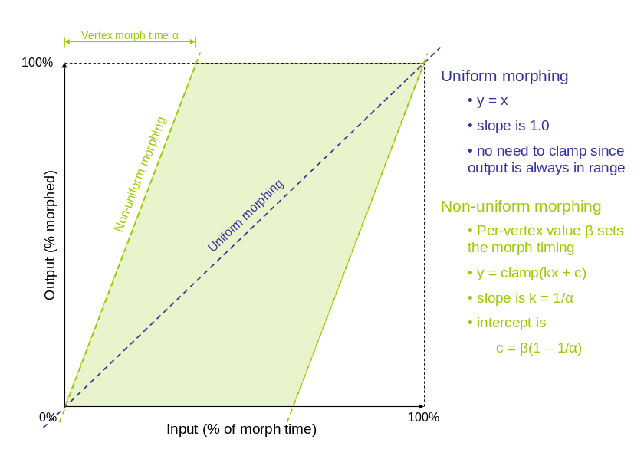

Our implementation also handles characters that have additional layers of geometric detail (in the form of fur over the mesh and additional accessories, like teeth and fins). The process was somewhat different for these additional layers, since they may be morphing in and out from the character, without actually existing on all the models.

ASSET PIPELINE

Maintaining a one-to-one vertex correspondence between multiple detailed meshes is challenging. It would be nice if we could model arbitrary meshes first and somehow make a set of matching meshes later. To accomplish this goal, we have set up a process where copies of an intermediate mesh, referred to as the Pokey model, are projected onto each of the individual meshes. Because each projected Pokey starts as a duplication of the same intermediate mesh, they automatically share the same topology.

To allow this metamorphosis to occur, we need to develop applications and techniques processing the mesh data for the system. We needed to be able to map the different meshes to the Pokey model, create the vertex morph timing data and merge the texture channel information together for the final meshes. In addition to creating this single morphable mesh, we needed to break up the mesh into workable batches. These batches were defined by the properties needed for the morph (like vertex count and edge structure) without going over a specific bone limit across any pair of characters. These limits were set by the graphics hardware and the current implementation.

The graphics shaders were created by the programmers in HLSL and each permutation needed to be developed. These shader processes were associated with each of the individual meshes and sent to the hardware as needed.

The meshes were created in 3ds max® and exported using a plug-in we had created previously for processing 3D models. Normal maps were also generated with 3ds max®, which was used in the lighting processes.

CONCLUSIONS

We have described a technique which can apply metamorphosis to unique skeletal meshes in real time. Our approach makes heavy use of graphic’s hardware to process multiple meshes at the same time, and morph the results after they have already been animated. By allowing per-vertex information defined in each mesh, we can tightly control the morphing process. We have used this technique to produce a real time demonstration and feel the current and next-generation of interactive entertainment hardware will be able to add these techniques in a vast number of situations.

REFERENCES

[1] Wolberg, G. Digital Image Warping. IEEE Computer Society Press, 1990
[2] Kent, J.R., Carslon W.E., Parents R.E. Shape Transformation for Polyhedral Objects, Computer Graphics (SIGGRAPH’92) 26, pp. 47-54
[3] Gray, K., The Microsoft DirectX 9 Programmable Graphics Pipeline, Microsoft Press, 2003
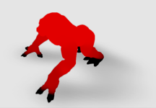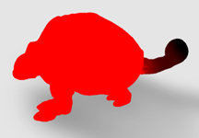
Plate 1. Non-uniform morphing. Vertex colors encode offsets when morphing begins.
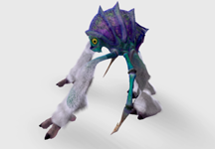
Plate 2. In-between morph of different meshes.
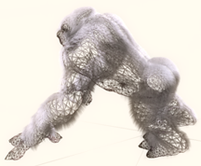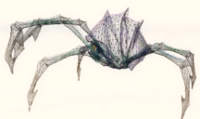
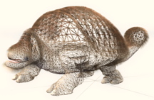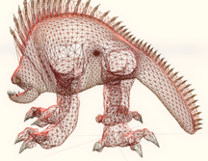
Plate 3. Wire-frames of each mesh showing consistent mapping of vertices.

