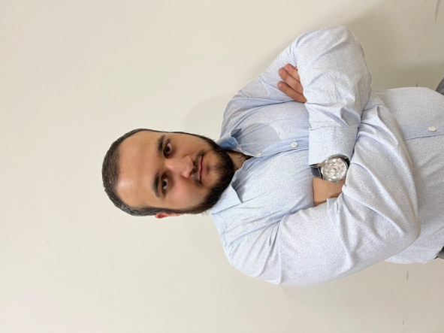

**Martin Elizbaryan**

Hi, my name is Martin Elizbaryan and I'm a full stack developer and tutor in [TCO Team](https://tco.am/). I have had more than 500 students who are now working as a web developers.

I have about 3+ years' experience building websites for clients all over the world

**29.04.1995**

**Interests**

* Music
* Fitness
* Chess
* Travelling

**Contact**

**Address:**

The 4th Vracakan lane 7 building 51 ap , Yerevan

**Phone:**

+ (093)14 36 00

**Email:**

Martin.elizbaryan@gmail.com

**What I Do**

* HTML, CSS, Bootstrap, Material UI
* JavaScript, jQuery, VueJS, React JS,
* PHP, MySQL, Laravel
* Node JS, Prisma
* Git

**Experience**

* **Full Stack Developer** - TCO Team | 2020 Apr – Present
* **Full Stack Developer** - M&D Systems | 2020 Jan - 2020 Apr
* **Full Stack Developer** - IFC Markets | 2019 Jan - 2019 Dec
* **Tutor** - Profit | 2018 Sep - 2019 Jan

**Education**

National Polytechnic University Of Armenia, Bachelor of Cybernetics - 2012 – 2018

**Military Service**

Mandatory Military service in the Armed Forces of the Republic Armenia – 2013 - 2015

**Languages**

Armrenian

Russian

English