|  |  |
| --- | --- |
|  | **2020** |
|  |  |



|  |
| --- |
| **[Future marker]** |
| **Team Members:**   * Anas Hassan * Haitham Hashim * Karim Hisham Mansour * Martin Fawzy * Mohamed Essam Abdelaziz   **Project Supervisor: Dr. Essam Eliwa** |

Future Academy - Higher Future Institute for Specialized Technological Studies

School of Computer Science

Project report submitted to the Future Academy  
for the degree of Bachelor of Science

June 2020

**[Optional Project Logo]**

|  |  |
| --- | --- |
|  |  |
|  |  |
|  |  |
|  |  |
|  |  |
|  |  |

**[Optional Students pictures]**

**Acknowledgement**

**Abstract**

**Table of Contents**

Chapter1 Introduction and Background 1

Introduction 2

Problem definition 2

What is the importance of this problem? 3

What are the current solutions? 4

A System to Grade Computer Programming Skills using Machine Learning (2014) [16]How will this solution solve the problem? What is new? 5

Scope 6

Quality assurance will consist of several stages: 7

SummaryChapter 2 Analysis and Design 8

Introduction 10

User Requirements: 10

System Requirements : 11

Functional requirements : 12

Non – functional requirements: 12

Stack holders 12

System Design 13

Block Diagram 13

13

Use Case Diagram 14

lass Diagram for first demo 14

Design Patterns 15

Sequence Diagrams 15

Database Design (ERD) 16

Storage Structure 17

17

Used Technologies and tools : 17

Summary 17

Chapter 3 Deliverables and Evaluation 18

Introduction 19

User Manual 19

….. 19

. 19

Testing 19

Evaluation (User experiment) 19

First Experiment 19

Summary 21

Chapter 4 Discussion and Conclusion 22

Introduction 23

Main Findings 23

Why is this project important 23

Practical Implementations 23

Future Recommendation 23

Conclusion Summary 24

References 25

**Table of Figures**

Figure 1: example for adding photos 3

Figure 2: software development life cycle 5

Figure 3 12

# Chapter1 Introduction and Background

**Main points**

* [give a brief abstract of your chapter here]

## Introduction

Computer Science degrees are very popular study programs worldwide. A core topic in computer science is to learn programming skills. Programming is also related to several fields of technology, hence many university students -in various programs- study it. Novice programming students require to practice as much as possible to enhance their problem solving and programming skills. A key tool for instructors is setting assignment for students to encourage them to practice more. However, to gain the most required result from such assignments, quick and detailed feedback is required.

This graduation project report presents the software requirement specification and design description of our system: ……….. . The source code of this project is available at: <https://github.com/university-project-2/graduation-project.git>

## Problem definition

The main problem with the traditional manual assignments marking is that the instructor usually need to spend a lot of time and efforts to check and mark every student's code and to write a report for every student on each assignment to give feedback for the submission that inform him that his submission was good enough or not, and advise students about the mistakes that they did and what points they have missed. Instructors also need to set a clear grading policy and give students a breakdown of the grading criteria [1]. The time required to achieve this would usually mean late feedback delivery to students, it may take days and sometime weeks for a student to know his/her marks. furthermore, the accuracy of the marking or writing feedback may decrease as the number of students increase, in addition to that some students may plagiaries code from the internet or from their friends [2], and it is hard to check plagiarism for each student manually. In addition, student can submit the assignment only once, without being able to submit it again after the feedback he receives with his grade.

### What is the importance of this problem?

By 2020 all the Educational sectors are working hard to improve themselves by using new tools and technologies or improving the old ones [3], Today we can see the importance of following up with the students as fast as possible by monitoring their level, as the instructors can evaluate them by giving them assignment and marking them, but if we are going to talk about the coding and computing we have to admit that evaluating the students by the instructor is not easy and it requires more efforts and time to check the coding level and give them a feedback for every single task, hence providing instructors with easy to use automated code assessment tool that can evaluate assignment in no time with minimum setup, and giving instant feedback to student and send a report for the instructor about each student and what grade they take and what points they miss [4], This will help student to enhance their programming skills vastly through learning from their mistakes, it will also enable instructors to set more assignments without the worry of the time they need to mark it. In addition, it will save a lot of time for the instructors and professors so that they can be more creative with their teaching with the students.

### What are the current solutions?

For many decades automatic assessment has been applied in many forms even before personal computers existed. Automatic assessment had already been suggested by Hollingsworth in 1960 [5].

In many programming courses at tertiary institutions the use of automated assessment has been proved useful through the use of systems like:

* The CourseMaster Automated Assessment System (2001) [6]
* The BOSS Online Submission and Assessment System (2005) [7]
* Individualized exercises for self-assessment of programming knowledge: An evaluation of Quiz PACK (2005) [8]
* ALOHA - A Grading Tool for Semi-Automatic Assessment of Mass Programming Courses (2006) [9]
* Easy Accept: a tool to easily create, run and drive development with automated acceptance tests (2006) [10]
* PASS - Programming Assignment assessment System (2006) [11]
* Automatic marking with Sakai (2008) [12]
* Web-CAT: Automatically Grading Programming Assignments (2008) [13]
* Programming Task Packages: Peach Exchange Format (2008) [14]
* PROGTEST: An Environment for the Submission and Evaluation of Programming Assignments based on Testing Activities (2011) [15]
* A System to Grade Computer Programming Skills using Machine Learning (2014) [16]

ALOHA:

This system is an online grading tool founded in 2006, it mark the online tasks for information technology students and give them a feedback written in text file

### How will this solution solve the problem? What is new?

This project introduces Future Marker (Automated Task Assessment Cloud based System). It will reduce the effort and time consumed by instructors when they assess submitted tasks from students. It will assess tasks in one of two ways. The first one is by using logical technique which begin with compile the code to check for runtime errors, then evaluating typographic layout which is checking for the layout and indentation, besides the identifiers’ name and length and the written comments, then checking code efficiency by running multi dynamic test cases. The second one is by utilizing machine learning and natural language processing to make it even more easy to instructors to setup assignments.

Future Marker will solve many problems for students. It will allow students to submit assignments a number of times customized by the instructor to improve their grades and learn from their mistakes by getting instant feedback from the system. Future Marker will also check and report any plagiarized work through comparing submitted students’ assignments to each other. It will also compare submissions with previous years submissions for similar assignments and automatically search for and report similar solutions online.

Future Marker aims to utilize the recent technological advancement in both cloud computing and artificial intelligence to provide a smart, accessible, and easy to use system for programming instructors worldwide.

**Project Description**

Future Marker is an e-learning system with an automated assessment for programming assignment, the system is goal is to allow the students and instructors to interact online together, future marker allow the instructors to upload materials and assignments for the students, the system marking the programming assignment and send a brief feedback with the marks for the student, you can access the system through the web app or mobile app (IOS & Android)

## Scope

The tools and languages used to develop the system are php, java, dart, Laravel,

The project aims to deliver a great online educational system that can evaluate the programming assignments and send the feedback to the students easily.

**Methodology (Proposed Approach)**

We will use agile methodology with incremental plan because it is easier to change the process to reflect changing customer requirements and the process works well when not all requirements are known.

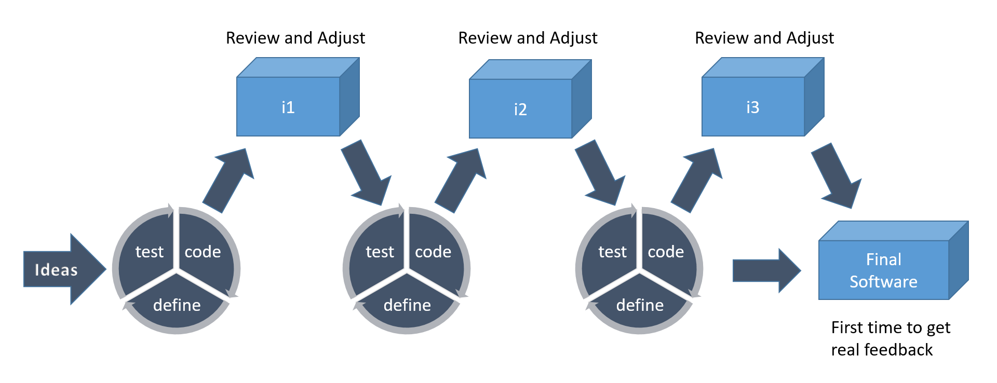

We will use scrum method because that focuses on managing iterative development, users see on-time delivery of increments and gain feedback that will help us to improve our system. We will have the flexibility to change anything while working on the system.

**Deliverables**

Lorem ipsum dolor sit amet, consectetuer adipiscing elit. Aenean commodo ligula eget dolor. Lorem ipsum dolor sit amet, consectetuer adipiscing elit. Aenean commodo ligula eget dolor. Lorem ipsum dolor sit amet, consectetuer adipiscing elit. Aenean commodo ligula eget dolor. (el outputs)

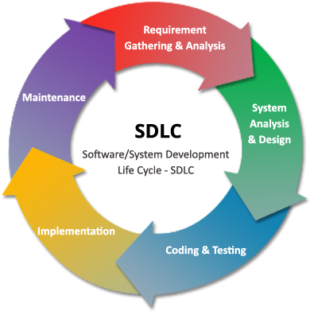

Figure : software development life cycle

# SummaryChapter 2 Analysis and Design

**Main points**

* Introduction
* User Requirements
* System Requirements
* Functional Requirements
* Non-Functional Requirements
* Stakeholders
* System Design

## 

## Introduction

In this phase we are planning to design our system after gathering information and checking the current solutions for our problem, we have designed the diagrams and divide the whole system into functions to start working on it besides writing the user stories in the Product Backlog as we are using scrum method while working Agile, Furthermore we chose our Git hosting service and Project management software that will help us in the implementation of the project and distributing tasks, Moreover we have picked our design pattern that we are going to use during our code implementation also we have made a comparison between different web application frameworks and decided which one is going to be more suitable for our system.

## User Requirements:

1- Future Marker shall allow the instructor the create course.

2- Future Marker shall allow the student to join the course.

3- Future Marker shall allow the instructor to upload material.

4- Future Marker shall allow the instructor to add assignment.

5- Future Marker shall allow the student to submit assignment.

6- The system shall automate feedback to the student.

## System Requirements :

* 1. The user must sign up and create account as instructor
  2. The instructor shall Log In into the system.
  3. The instructor shall choose to create a new course
  4. The instructor will receive access code from the system, and the course will be created

2.1 The student shall sign up and create account as a student

2.2 The student shall Login to the system

2.3 The student shall choose to join a new course and enter the access code

2.4 The student will be enrolled in the course by the system

3.1 The instructor shall Login to the system

3.2 The instructor should select the course which is already created

3.3 The instructor shall choose to upload material and select the files to upload them

3.4 The system shall make the files available for the students that enrolled in the same course

4.1 The instructor shall Login to the system

4.2 The instructor shall select the course

4.3 The instructor shall add assignment and enter the testing scenario cases

5.1 The student shall select the course

5.2 The student should upload his submission

6.1 The student should enter the course page

6.2 The student should submit his assignment

6.3 The system should give the student the grade and the feedback in a few seconds

### Functional requirements :

* Instructors shall create assignments and quizzes
* Students can submit assignments
* The system shall send automated feedback to students instantly
* Instructor can edit assignment grades
* The system creates report for instructors for each assignment
* The system assessments programming code by running multi test cases

### Non – functional requirements:

Product requirements:

-Future Marker not allowing the user to enter password less than 6 digits

-The system sends the password to the user via email if he forgot it

-The user must can’t sign in registering on the system for one single time

-The system functions work with high performance

- The system marks the tasks and send feedback in just a few seconds

Organizational requirements:

-The professor and instructors must choose the instructor status while sign up to the system features that are suitable for them.

-The user should be instructor to be able to create courses and add assignments

- The programming files should solved with JAVA

External requirements:

------------------------------------------------------------------------

## Stack holders

- Universities

- Instructors

- Students

## System Design

Future Marker is a 3-tier application architecture that consists of a presentation tier,

an application tier and a data tier.

* Presentation tier - This tier consists of web application and mobile application. The web application will be programmed using HTML5, cascading style sheets (CSS) and JavaScript. The mobile application will be programmed using flutter framework to provide mobile app for android and IOS
* Application tier - Contains the business logic of the system. It will be programmed using PHP, java and python, also it will be hosted on distributed servers in the cloud. Application tier communicates with the other tiers through application program interface (API) calls.
* Data tier – In this tier we will use Firebase as a database for the system because it’s a cloud-hosted NoSQL database that lets you store and sync between your users in real time.

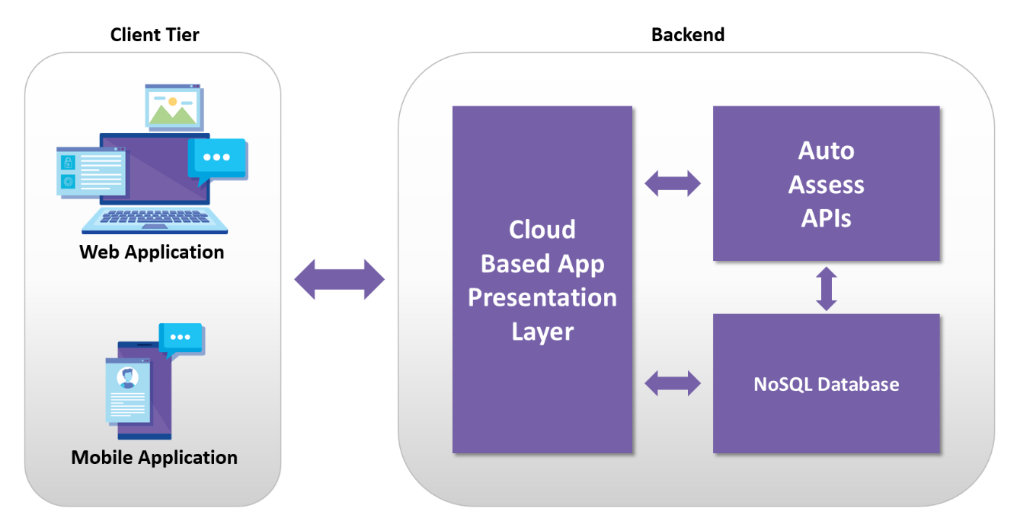

……………

Future Marker is consist of web application and mobile application the UI is developed by HTML, CSS, Java Script for the Web app, the mobile app developed by flutter, both of them access on the database which is built by MYSQL, and we are using Laravel(php platform) for the back-end tier

### Availability

Availability refers to a property of software that it is there and ready to carry out its task when you need it to be. This is a broad perspective and encompasses what is normally called reliability (although it may encompass additional considerations such as downtime due to periodic maintenance)

### Block Diagram

### 

### Use Case Diagram

### Class Diagram for first demo

### Design Patterns

1. MVC

We are using MVC as a design pattern and we chose to work with Laravel because it is the most suitable platform that will help us using MVC.

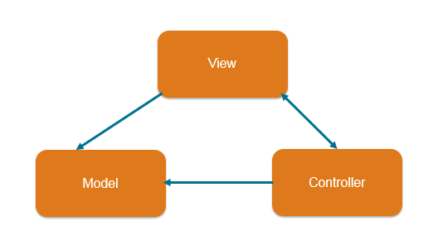

1. Singleton

Singleton pattern is one of the simplest design patterns in Java. This type of design pattern comes under creational pattern as this pattern provides one of the best ways to create an object.This pattern involves a single class which is responsible to create an object while making sure that only single object gets created. This class provides a way to access its only object which can be accessed directly without need to instantiate the object of the class.

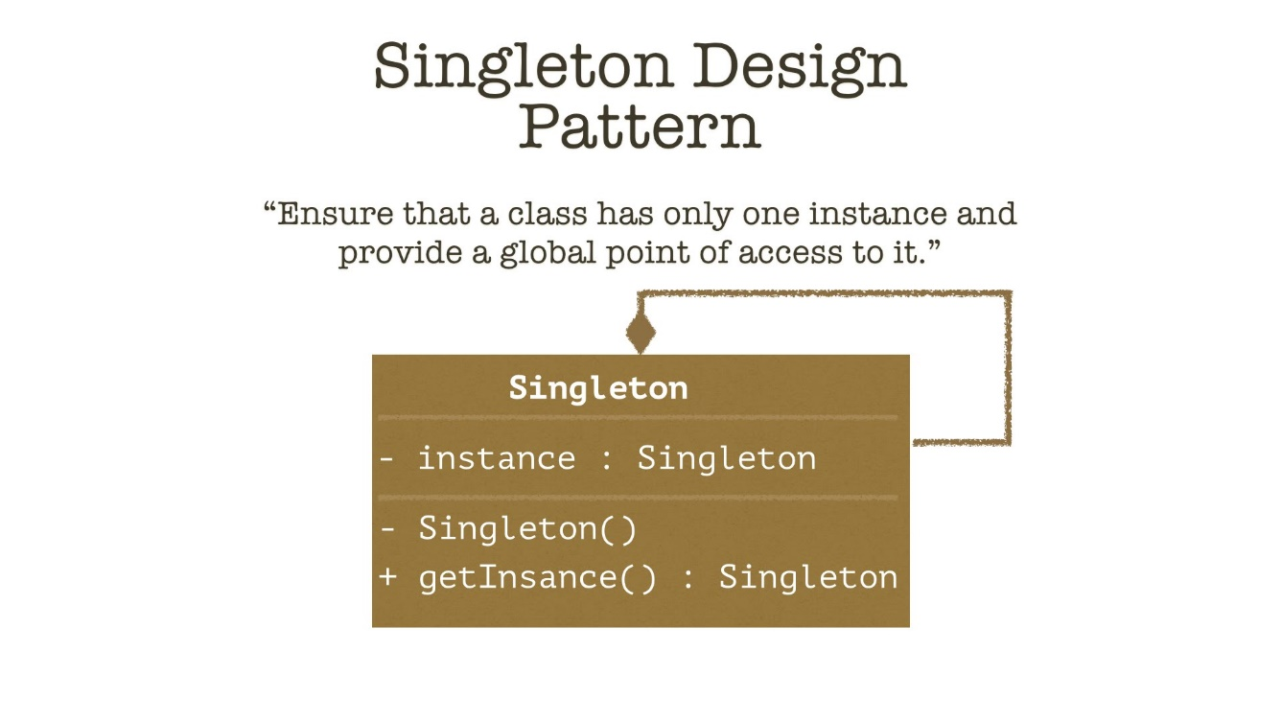

### Sequence Diagrams

Lorem ipsum dolor sit amet, consectetuer adipiscing elit.

### Database Design (ERD)

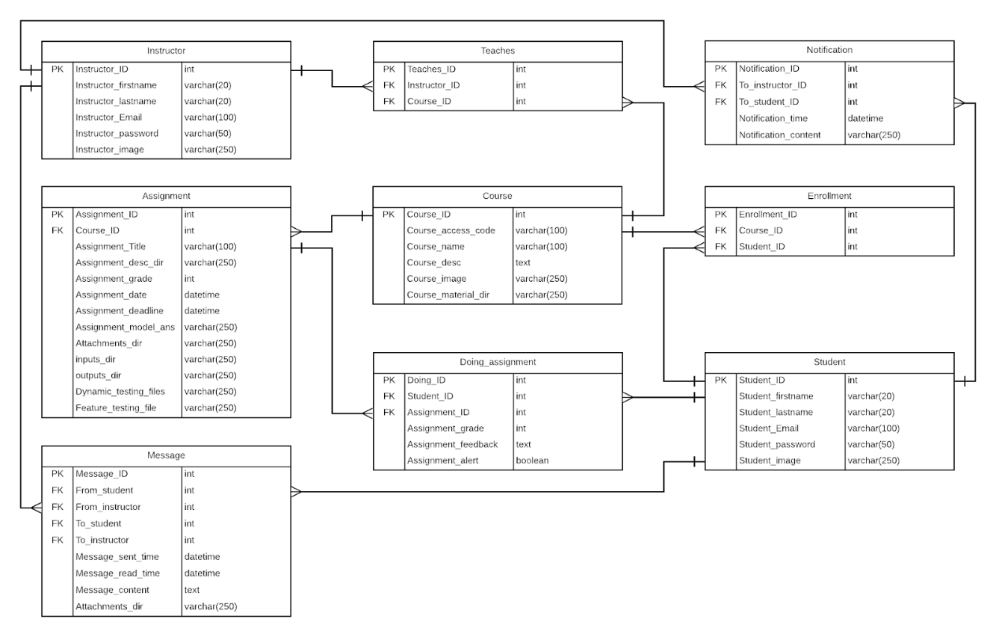

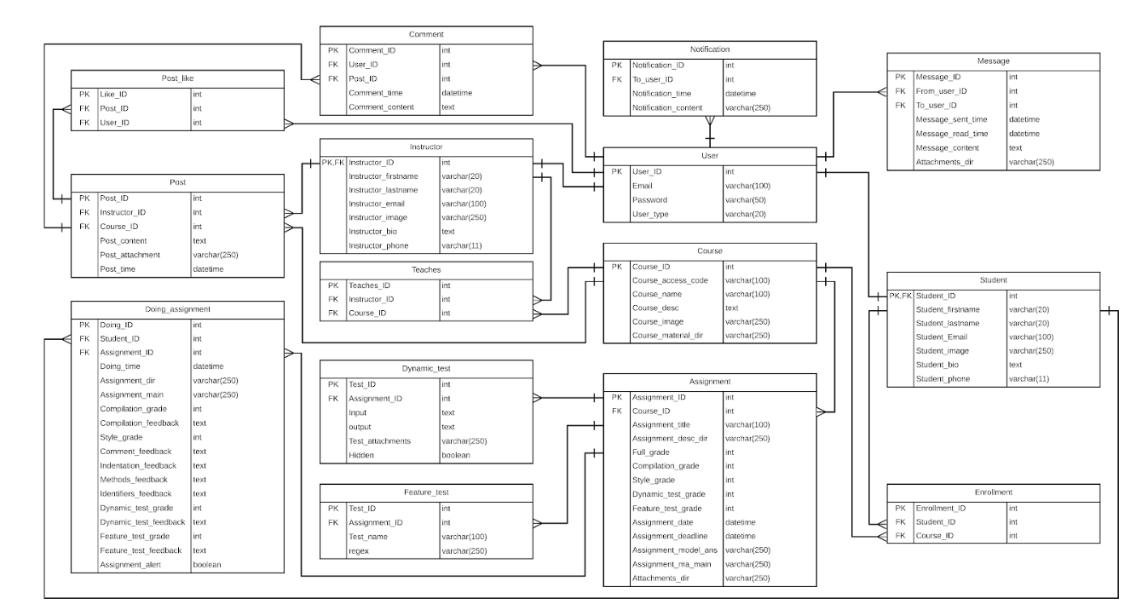

## Storage Structure

## https://lh5.googleusercontent.com/ceD-NyYPJyLg_GD1X_JvFTlg-H710zdwOd_ogjGBO_o_q1gCRK9zrxmQub9_W11uD4f0Iz1ghrb9y3hF2ceNps3MNYaMyiUe-wEXnzipxHT3fiqJhswR3jHEtAYZT9oTsOwz9VhwXMU

## Used Technologies and tools :

* HTML, CSS, Java Script
* Bootstrap 4
* PHP, MYSQL
* Laravel
* Flutter
* GitHub
* Jira

Summary

In this chapter we have discussed our analysis and design for the system, and the diagrams that describe it, we have discussed what tools and technologies we are using, furthermore,

we illustrated the functional and non-functional requirements, besides the user and system requirements.

# Chapter 3 Deliverables and Evaluation

**Main points**

* [give a brief abstract of your chapter here]

## Introduction

In this phase we are showing the project deliverables and how we test our product, besides we are showing the user manual easily to the user so he can use the project and know how to use its features and specification without facing and any problems or constraints, Furthermore, we are representing the user experiment whether on the first demo of Future Marker or on the final output after finishing the product completely and discussing the result of this experiment and Feedback that we have received.

## User Manual

## …..

## .

## Testing

## Quality assurance will consist of several stages:

* Review of requirements
* Test planning / writing test cases
* Unit testing
* Integration testing
* System testing
* Performance testing
* Security testing
* Cross-browser testing / cross-platform testing
* Updating test cases
* Regression testing

## Evaluation (User experiment)

## First Experiment

After finishing three main functions from our project which are checking comments in the code, Code indentation and identifiers name and length, we had decided that we have to test it with second year computer science students at Future Academy in a specific programming course which is CSC211 - Programming Language (2).

This experiment consisted of two submissions, after first submission we provide them with grade report showing them how the program evaluates their comments, indentation, identifiers, and after the students see their grade report for each java class, they try to modify and edit their code again for the second submission.

The following graphs shows the improvements in grades for some teams in each section (Comments, Indentation, and Identifiers) in the first and the second submission.

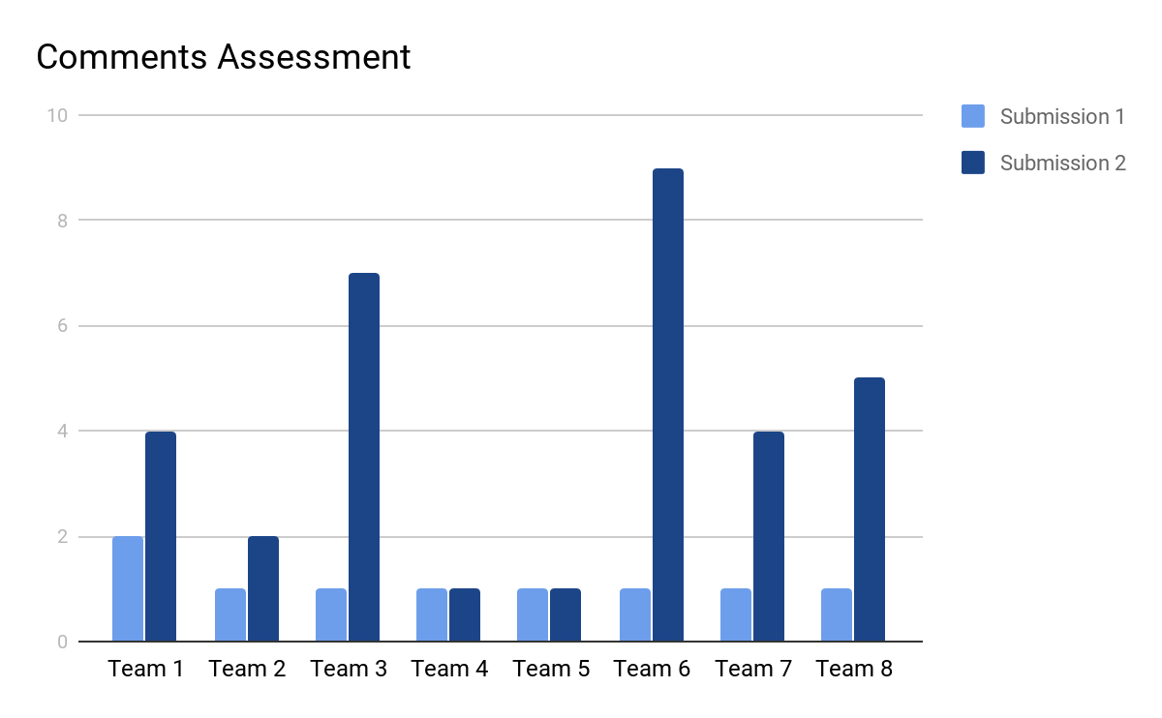

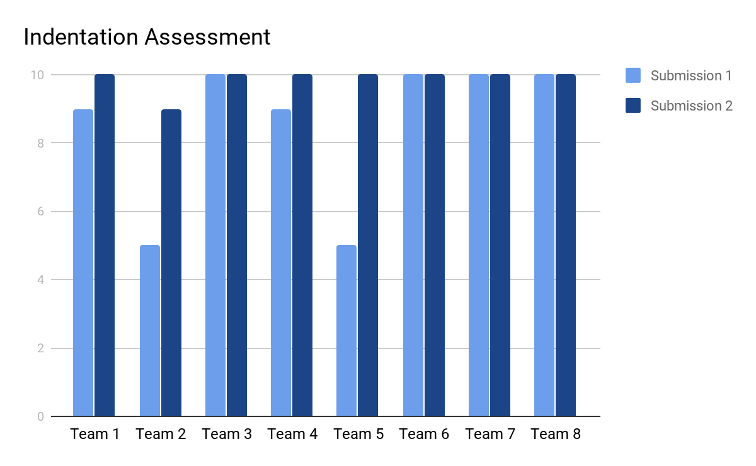

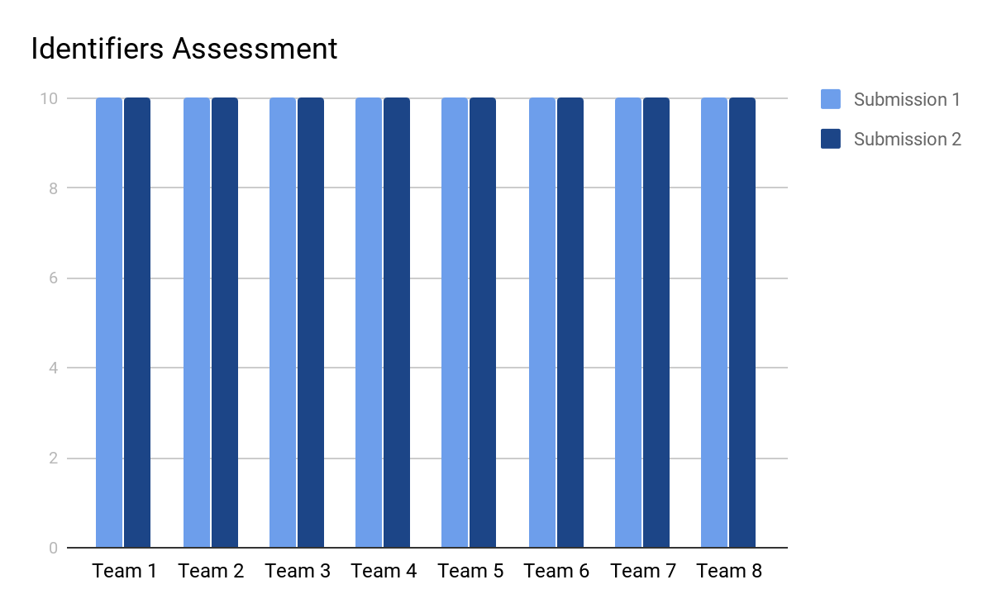

In addition to, we asked them to fill online survey we have created it to see if they are satisfied of this experiment and what is their opinion about our project, and the feedback was positive and encouraging.

Summary

Lorem ipsum dolor sit amet, consectetuer adipiscing elit.

# Chapter 4 Discussion and Conclusion

**Main points**

* [give a brief abstract of your chapter here]

## Introduction

Lorem ipsum dolor sit amet, consectetuer adipiscing elit.

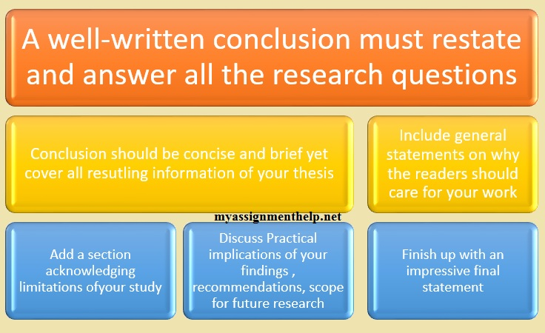

Figure

## Main Findings

Lorem ipsum dolor sit amet, consectetuer adipiscing elit.

### Why is this project important

Lorem ipsum dolor sit amet, consectetuer adipiscing elit.

### Practical Implementations

Lorem ipsum dolor sit amet, consectetuer adipiscing elit.

## Future Recommendation

Lorem ipsum dolor sit amet, consectetuer adipiscing elit.

## Conclusion Summary

Lorem ipsum dolor sit amet, consectetuer adipiscing elit.

# References

|  |  |
| --- | --- |
| [1] | D. Gooblar, “news,” 4 January 2017. [Online]. Available: https://chroniclevitae.com/news/1656-how-can-we-minimize-grade-challenges. |
| [2] | L. T. Culwin F, “ Plagiarism issues for higher education,” *Emerald Inshight,* pp. 36-41, 2001. |
| [3] | T. A. Khan, “buyer-blog/how-technology-improves-education,” 28 march 2019. [Online]. Available: https://www.trustradius.com/buyer-blog/how-technology-improves-education. |
| [4] | V. A. Shashank Srikant, “A System to Grade Computer Programming Skills using Machine Learning,” 2014. |
| [5] | HOLLINGSWORTH, “The morphology of intersexes in Drosophila subobscura,” *The Journal of experimental zoology,* vol. 143, 1960. |
| [6] | E. a. H. C. a. S. P. a. T. A. Foxley, “The CourseMaster Automated Assessment System - a next generation Ceilidh,” 2001. |
| [7] | N. G. R. B. Mike Joy, “The boss online submission and assessment system,” 2005. |
| [8] | S. S. Peter Brusilovsky, “Individualized exercises for self-assessment of programming knowledge: An evaluation of QuizPACK,” September 2005. |
| [9] | T. R. Tuukka Ahoniemi, “aloha title : a grading tool for semi-automatic assessment of mass programming courses,” February 2006. |
| [10] | O. L. A. N. W. C. Jacques Philippe Sauvé, “EasyAccept: a tool to easily create, run and drive development with automated acceptance tests,” May 2006. |
| [11] | T.-L. W. Fu Lee Wang, “Designing Programming Exercises with Computer Assisted Instruction,” August 2008. |
| [12] | H. Suleman, “Automatic marking with Sakai,” 2008. |
| [13] | M. A. P.-Q. Stephen H. Edwards, “Web-CAT: automatically grading programming assignments,” September 2008. |
| [14] | T. Verhoeff, “Programming Task Packages: Peach Exchange Format,” 2008. |
| [15] | J. C. M. E. F. B. Draylson Micael de Souza, “ProgTest: An environment for the submission and evaluation of programming assignments based on testing activities,” 2011. |
| [16] | S. a. A. V. Srikant, “A system to grade computer programming skills using machine learning,” 2014. |