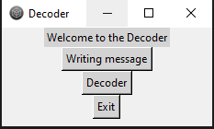
Press to write message

Press to decode, encrypted message

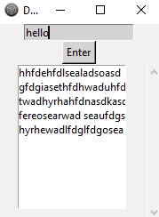

Write message you want to ßpress enter
Encrypt
Copy and paste the encrypted message

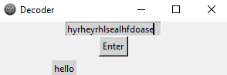
Enter encrypted message (paste it)
ßPress enter

Your message should be decoded

