Important!

Make sure you have imported selenium to your python

Once you have completed the set up below all you have to do is

* Run AddEmail.py to make DEA’s
* Run Delete.py to Delete DEA’s

NOTE:

It is unnecessary to run Excel as AddEmail.py & Delete.py both save automatically

Set Up

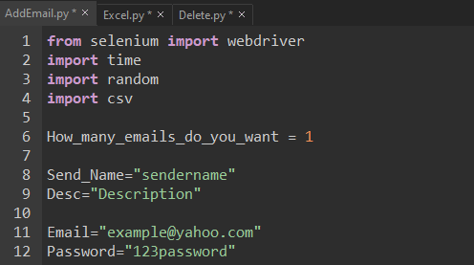

Open AddEmail.py

Change Send_Name to what you wish the sender name to be

Change Desc to what you wish the description to be

Change Email to your yahoo email

Change Password to your yahoo password

SAVE FILE

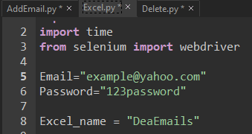

Open Excel.Py

Change Email to your yahoo email

Change Password to your yahoo password

Change Excel_name to what you wish to name the excel file

SAVE FILE

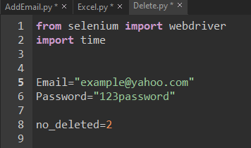

Open Delete.py

Change Email to your yahoo email

Change Password to your yahoo password

SAVE FILE