Enter details into config.txt file
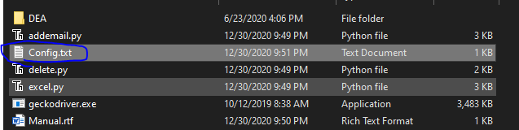
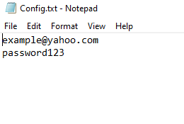

After completion

Run the addemail.py if you want to add emails change the first variable (How_many_emails_do_you_want) to how many emails you want made.
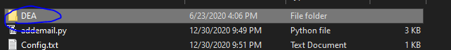
Once the program finishes you will have a file with all your disposable emails you have for easy copy and paste.

Run the delete.py if you want to delete emails, they will delete from top to bottom.
Change the first variable (no_deleted) to the number of emails you wish to delete.

Your csv file will be automatically updated.

