**Description & features of the game**

* Name of game is brick breaker. Gamer can control the bat with left and right arrow key on the keyboard. When ball hit the bricks, gamer get 10 points each time. Gamer with high score wins the game.

**Class diagram**

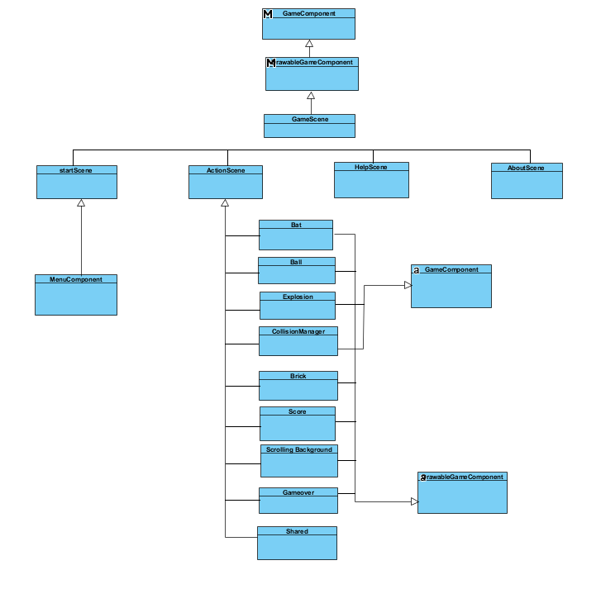

**Reference to the resources used**

* https://online-audio-converter.com/ - sound
* http://m.plonga.com/teaser/Brick-Breaker-Mobile-Tablet-Game - brick
* https://www.123rf.com/photo_80446075_stock-illustration-billiard-white-pool-ball-snooker-transparent-background-vector-illustration-.html - ball
* <http://globalapk.com/free/19457-brik-brick-breaker-v175.html> -bat
* <http://punkandlizard.com/brick-breaker/> -logo