# Coop RPG

## Level design document

### 10 Levels

* Game would feature 10 different levels (settings / worlds), that each could have modifiers (from world 2 further)
* Such effects could be
  + + enemy DMG
  + + hero DMG
  + – hero DMG
  + + enemy movement speed
  + – hero movement speed
  + Higher probability of loots
  + Fog (effect tampering with visibility of the world)
  + Any combination of the mentioned above
* Each world would end with “stronghold” / castle with boss fights
* After completing world, player should have ability to repeat whole world (but not from the middle), meaning there would be map with 40 encounters and a tavern / tavern system, but unless players are in the middle of “world” they can only “restart” those worlds from the start
* Example of the world map idea. Fully purple = Tavern, Red = active path, Grey = already finished path, Purple with yellow = start of the line again
* 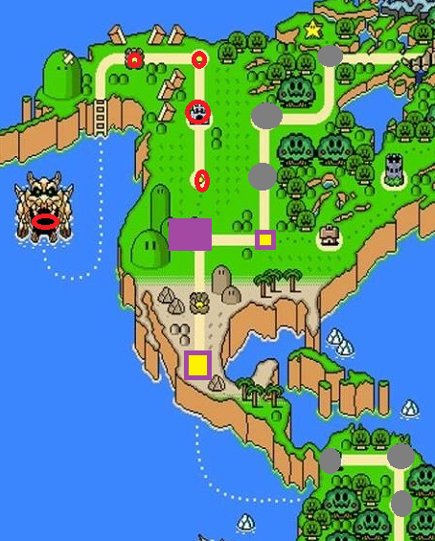

### Tavern

* Main hub of the game, players can return after each encounter or after finishing of world path
* Players have ability to sell loot or buy new stuff
* Players also could have ability to upgrade themselves if there are stats implemented
* Save in tavern / autosave after finishing of stronghold battle

#### Questmaster – bartender

* Friendly NPC (Ideally with Name and Portrait once clicked onto)
* Offers quests for the players that might have time limit (but I am highly unsure about that, I would keep them open for as long as you want)
* Sells beer (or other alcohol) for cheap price, could have positive effects like less damage from enemies, but also negative effects like nausea or shady Merchant stealing some money
* Quests:
  + Bring me x amount of goods dropped from enemies to do something with them
  + Buy me some item from seller (that is also in tavern)
  + Kill x amount of enemies
  + Finish level x in some time (timed event for specific map)
  + Cast ability x times
* Rewards:
  + Friendship level with bartender (higher the friendship level, higher the rewards)
  + Certain items (maybe unique items that can’t be bought)
  + X amount of gold, being slightly higher than what player would receive upon selling drops from enemies
  + Ability boost for next level (encounter)
  + Clothing items? (if they even make sense here)
* Consequences:
  + Player should be able to refuse quest
  + That should negatively impact friendship level with bartender
  + Player should also be able to fail timed quests, making the bartender slightly disappointed
  + Finishing quest successfully should be always positive
  + Refusing x quests in a row could cause bartender refusing to give quest to a player until next encounter (let’s say after 5 refusals, player would have to wait one more encounter for the bartender to even generate quest)
* Alcohol / shop offerings
  + Beer - Positive
    - Slightly lower damage from enemies
    - Slight nausea effect inside the tavern (once in encounter this effect should be removed)
  + Wine – Slightly positive in certain occasions
    - Higher damage to enemies
    - Higher damage gained from enemies
  + Water – no effect
  + Mysterious potions, generated at random, so player has no idea if positive or negative effect is going to happen
    - Mysterious potion 1 – Very positive
      * Higher health for player during next encounter
      * Higher damage to enemies
      * Faster ability casting
    - Mysterious potion 2 – Slightly positive
      * Slight health increase for player during next encounter
      * Slightly higher damage to enemies
      * Slightly increased damage from enemies
      * Faster ability casting
    - Mysterious potion 3 – Slightly negative
      * Lower visibility in next encounter
      * Lower mobility in next encounter (slower movement)
      * Slight nausea effect during encounter
    - Mysterious potion 4 – Very negative
      * Very limited mobility in next encounter
      * Strong nausea effect during encounter
      * Ability casting disabled
  + Mead – depending on type of encounter, could be very helpful
    - Faster ability casting
    - Lower starting player health
    - Damage unchanged
  + Whiskey - depending on type of encounter, could be very helpful
    - Lower movement ability (slower)
    - Higher damage to enemies
    - Lower starting player health
    - Abilities disabled
    - Faster attacks -> Making the player movement slower, but faster attack as he is “aggressive”

#### Innkeeper – Shop / Merchant

* Friendly NPC with slightly shady intentions (Ideally with Name and portrait once clicked onto)
* Offers to buy stuff and sell stuff to player (jacking up price once the item is sold and player leaves him)
* Unique items that can’t be dropped from enemies or rewarded from boxes / bartender quests (with obviously high pricing since he is shady)
* If player is slightly drunk, merchant should try to “steal” by giving less money than agreed onto while selling

### Stronghold design

* Interior levels that might contain limited visibility (darkness)
  + Coop element of one player having to move torch and be not able to attack while holding it, but also ability to drop it whenever they don´t want to move it anymore
* Higher loot rewards
* Wave of enemies, might be slightly stronger than usually
* Boss fight at the end, requiring cooperation (if we implement different abilities, like for example boss needs to be stunned first and only then attacks do any damage)