**Exercise REST webservice**

Use a console application to solve this exercise. Add the console application to the existing solution with the Webservice project.

if you would like to have the traffic catch by Fiddler the use localhost.fiddler instead of localhost fx localhost.fiddler:5000

Install the following nuget package “Microsoft.AspNet.WebApi.Client” to get all the newest(extensions methods) for post, put, delete and get methods.

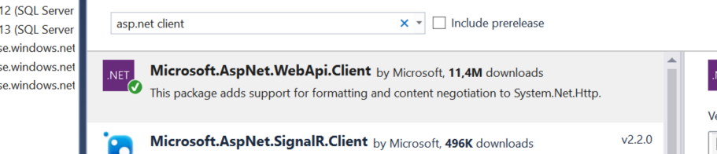

1. Select (HTTP Get) hotel number 3 and put it into an List of type Hotel (List<Hotel>)

NB: For this you need to read “ReadAsAsync<Hotel>” instead of “ReadAsAsync<IEnumerable<Hotel>>” because you only got one hotel back and not a list of hotels So use this: var hotel = response.Content.ReadAsAsync<Hotel>().Result;

1. Select (HTTP Get) all hotels and all of them located in roskilde should be put into a list of hotels using LINQ
2. Select (HTTP Get) all hotels and all of them located in roskilde should be put into a list of hotels, Select all the rooms for this hotels and put them into another list of rooms using LINQ

**Steps to solve exercise 3:**

* 1. Create a webservice call (Http Get) on api/hotels
  2. Put the result into a List<Hotel>
  3. Create a LINQ query that takes the hotels that Contains Roskilde
  4. Put LINQ result into a List<Hotel> calles RoskildeHotelList
  5. Create a new webservice (Http Get on api/rooms) call to get all the rooms.
  6. Put this result into a List<Room> called RoomList
  7. Finally create a LINQ query that Join the RoskildeHotellList and RoomList

1. Update (HTTP Put) hotel number 3, change the name of the hotel. You have to create a new Hotel Object with the data and then use this object when you create your content string.

**Steps to solve exercise 4**

* 1. Create a webservice call to get the hotelnumber 3(Http get on api/hotels/3 )
  2. Put this result/content into a hotel object
  3. change the name of the hotel fx hotel.Name = “Osvald”
  4. Create a webservice call (Http Put on api/hotels/3)

1. Insert (HTTP Post) a new hotel fx number 200.

**Steps to solve exercise 5:**

* 1. create a new hotel object with data
  2. create the HttpClient , and create a httpPost (Api/Hotels)
  3. write out the statuscode
  4. extra: create a Http Get to see the new hotel (api/hotels/200)

1. Delete (HTTP Delete) the Hotel number 200.

**Steps to solve the exercise 6:**

* 1. create the httpclient
  2. create a http delete (api/hotels/200)
  3. write out the statuscode
  4. extra: create a Http get to see if the hotel exist (api/hotels/200)

1. Insert a new Room on Hotel number 4
2. Update all hotels in roskilde increase the price of a single room with 20%, show the prices before and after the update. Steps to solve exercise 8:
   1. Get all hotel Http Get (Api/hotels)
   2. if statuscode is succes, put response into a List<Hotel>
   3. LINQ query on List<Hotel> where name contains “Roskilde” RoskildeList
   4. get all the rooms HTTP GET (API/Rooms) if succes put them into a List<Room> RoomList
   5. Create LINQ query Join RoskildeList and RoomList on hotelno, and where Types==”S” (Single Room), select room
   6. Create a foreach LOOP over the result for the LINQ query
      1. increase the price with 20 % price *= 1.20;
      2. Create a HTTP PUT (Api/Rooms/room.roomNo)
      3. write out statuscode

**Extra Exercise:**

1. Write by hand a new controller that returns all the single rooms for a given hotel_no.

Put this in your apiconfig:

config.Formatters.JsonFormatter.SerializerSettings.ReferenceLoopHandling = Newtonsoft.Json.ReferenceLoopHandling.**Serialize**;

config.Formatters.JsonFormatter.SerializerSettings.PreserveReferencesHandling = Newtonsoft.Json.PreserveReferencesHandling.**Objects**;

1. try to insert a new hotel with two new rooms at the azure database ([http://hotelapp1.azurewebsites.net](http://hotelapp1.azurewebsites.net/))