ECSE 325

LAB 3 REPORT

Martin Kruchinski(260915767) Menad Kessaci(260807381)

GROUP 35

***G35_mod_exp:***

**Introduction:**

The circuit below implements a basic modular exponentiation that is going to be used in our public-key based message time stamping system. Given the flowing as inputs:

* A 14-bit signal for the exponent *d*
* A 10-bit signal representing a message *c*

The circuit calculates the following:



(where *n* is 33401)

This means that the following circuit uses the circuit from Lab 2 as a component to calculate the modulus operation.

S is the 16-bit output of the circuit, which represents the result of the whole exponentiation and modulus operation.

**VHDL description of the circuit:**

**Testbench:**

**Simulation results:**

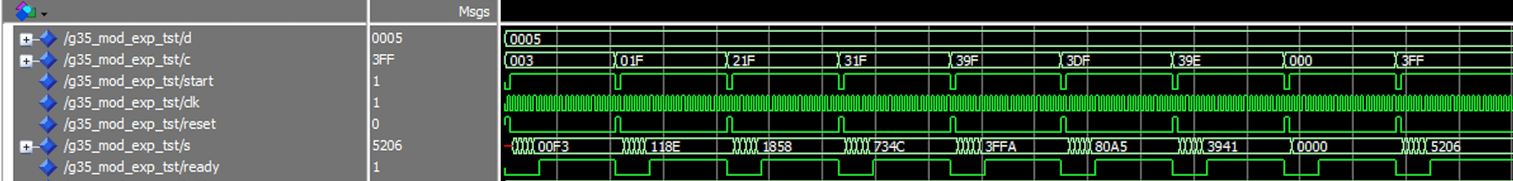

**Expected results:**

**Flow Summary:**

**Chip planner layout:**

**Timing Analysis Summary:**

**For 4 period:**

Requested Fmax = ___250 MHz_________________________

Fast 1100mV 0C Model Hold Slack Value =_________0.365___________

Slow 1100mV 85C Model Setup Slack Value = ________-14.543_________

Slow 1100mV 85C Model Fmax =__________53.93 MHz_________________

List the Worst-case Timing paths for the Setup times:

Slack From To

1 -14.543 multiplication[16] multiplication[0]

2 -14.543 multiplication[16] multiplication[1]

3 -14.543 multiplication[16] multiplication[2]

4 -14.543 multiplication[16] multiplication[3]

5 -14.543 multiplication[16] multiplication[4]

Logic utilization (in ALMs): 140 / 32,070 ( < 1 % )

**For 19 period -> passing**

Requested Fmax = ___52.63 MHz_________________________

Fast 1100mV 0C Model Hold Slack Value =_________0.188___________

Slow 1100mV 85C Model Setup Slack Value = ________1.315_________

Slow 1100mV 85C Model Fmax =__________56.55 MHz_________________