ECSE 325

LAB 4 REPORT

Martin Kruchinski(260915767) Menad Kessaci(260807381)

GROUP 35

***G35_mod33401_pipelined:***

**Introduction – Description of the circuit:**

For this lab we implemented a VHDL circuit that takes as input a 32-bit value **A** and provides two outputs: **Amod33401**, a 16-bit number which represents the modulo, base 33401 of the input, and **Afloor33401**, a 17-bit output which represents the floor of **A/33401**.

Starting from the module from Lab 3 (which performs the same function wanted here), we developed a pipelined version of the modulo33401 module. To do so, we have added a clock and a process block to the module. The goal of these additions is to create a pipelined version of Lab 3’s module to maximize throughput and to increase the clock frequency on which the circuit can run. As shown in the VHDL description below, each signal is held in a register. Since the signals are in a process block, the signals take their values (or hold the previous one) one at a time at each clock cycle.

The process block, combined with the clock is what leads to the use of registers, hence, to pipelining. The following test results show a neat rise in clock frequency, meaning that pipelining has attained its objective.

**Block diagram:**

**VHDL description of the circuit :**

The VHDL description of the circuit is included in the zip file.

**Timing Analysis:**

1. Results of the pipelined version:

**4ns (Not passing):**

Fmax: 314.17Mhz

Setup Slack: -2.183

**7ns (Passing):**

Fmax: 152.86 Mhz

Setup Slack: 0.458

1. Results of the non-pipelined version:

**4ns (Not passing):**

Fmax: 53.93 Mhz

Setup Slack: -14.543

**19ns (Passing):**

Fmax: 56.55 MHz

Setup Slack: 1.315

**Conclusion:**

We can clearly see the increase in clock frequency achieved using pipelined.

**Testbench:**

The simulation testbed file is included in the zip file.

**Simulation results:**

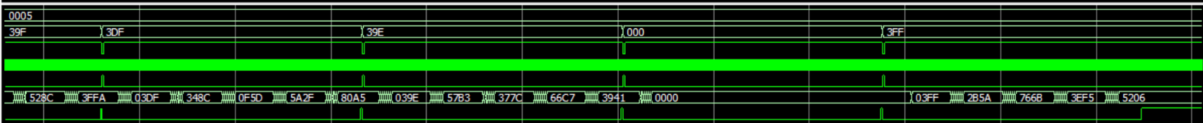

**Expected results:**

