ECSE 325

LAB 5 REPORT

Martin Kruchinski Almeida (260915767)

Menad Kessaci

(260807381)

Group 35

***G35_timestamper System:***

**Introduction – Description of the circuit:**

In this lab, we worked on the creation of a circuit that acts as a time-stamper. The circuit takes a message from a source, generates a time-stamp for it, and affixes a digital signature to the message. Then, the circuit outputs a digital signature.

Formally speaking, the time-stamper circuit has 4 inputs: a clock signal, a reset signal, an enable signal, a message, and a timestamp. The clock, the reset and the enable signals are all 1-bit signals. The message is a 32-bit vector while the timestamp is a 22-bit vector representing the number of hours since year 2000. The circuit has 1 output: a signature that is 16-bits wide.

It is worth noting that the timestamp used as an input for the time-stamper is generated by another circuit: g35_Hash10. In summary, the latter takes a message and produces a hash for the input message.

**VHDL Testbench code:**

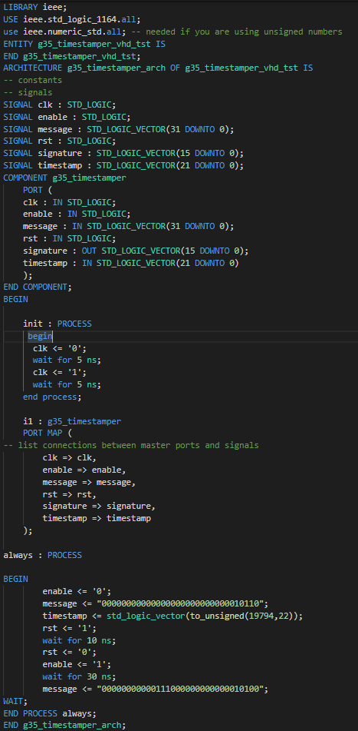

**Simulation results (all the results are unsigned decimals):**

