Martin Read

DA301 Assignment

For the purpose of this report, the two main questions posed are:

Regression

Process followed:

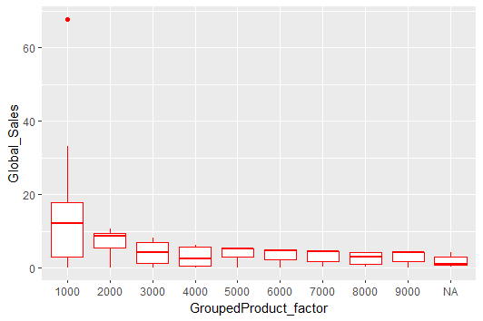

One of the products with a code below 1000 has sales that are a huge outlier.

This product was identified as being product code 107 using this code:

sales3 <- arrange(sales2, desc(Global_Sales))

head(sales3)

