IPM Decisions Data Exploration and Modelling

# Preprocessing

## Added reorder filter (v1.2)

Class: Already_used_DSS

Yes 1

No 0

## Target (Class) missing for Greece

* Left for now.
* What to do?
  + S1: remove all Greece instances?

## Feature ranking (Filter) (v1.3)

* Applied filter: Attribute selection (CorrelationAttributeEva)

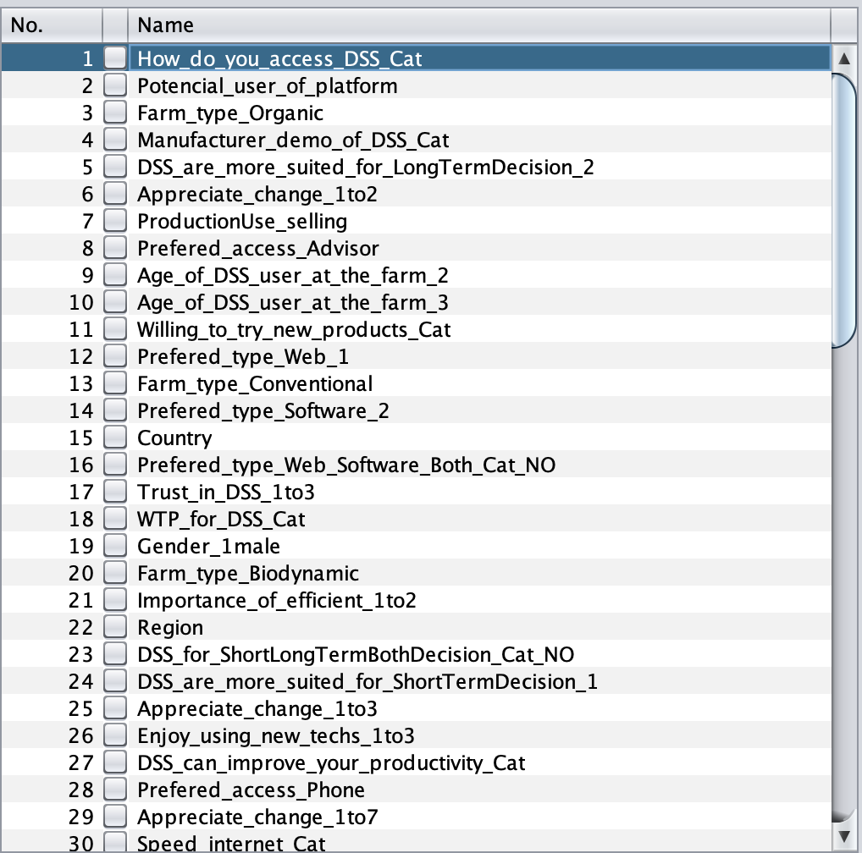

* Could not use infoGain due to missing values in class

## Remove attributes (see excel)

* + Total 81
  + 10 attributes removed,  **directly related to target variable** (Total remaining 71)
  + 26 duplicate attributes removed (Total remaining 45)

*ver: farmers_removed_attr_29042021.arff*

## Feature ranking (Filter) (v1.3)

* Applied filter: Attribute selection (CorrelationAttributeEva)

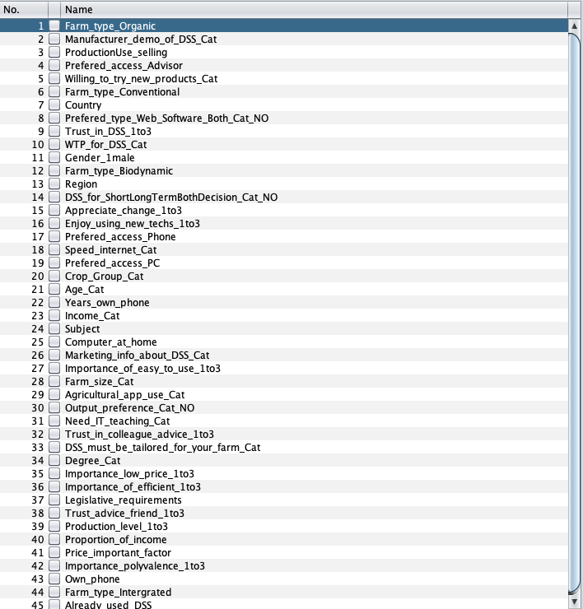

*ver: farmers_removed_attr_29042021_1.arff*

## Attribute visualisation

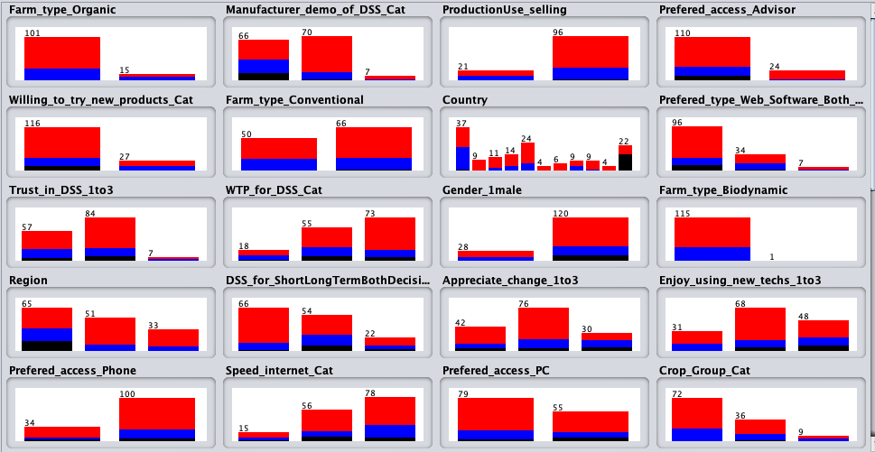

## Feature ranking (Select attributes)

* InfoGain:

Farm_type_Organic

Manufacturer_demo_of_DSS_Cat

ProductionUse_selling

Prefered_access_Advisor

Willing_to_try_new_products_Cat

Farm_type_Conventional

Country

Prefered_type_Web_Software_Both_Cat_NO

Trust_in_DSS_1to3

WTP_for_DSS_Cat

Gender_1male

Farm_type_Biodynamic

Region

DSS_for_ShortLongTermBothDecision_Cat_NO

Appreciate_change_1to3

Enjoy_using_new_techs_1to3

Prefered_access_Phone

Speed_internet_Cat

Prefered_access_PC

Crop_Group_Cat

Age_Cat

Years_own_phone

Income_Cat

Old infoGain:

* + Farm_type_Organic
  + Manufacturer_demo_of_DSS_Cat
  + Prefered_access_Advisor
  + ProductionUse_selling
  + Region
  + Willing_to_try_new_products_Cat
  + DSS_for_ShortLongTermBothDecision_Cat
  + WTP_for_DSS_Cat
  + Farm_type_Biodynamic
  + Farm_type_Conventional
  + Prefered_type_Web_Software_Both_Cat
  + Gender_1male
  + Appreciate_change
  + Trust_in_colleague_advice
  + Prefered_access_Phone
  + Prefered_access_PC
  + Age_Cat
  + Enjoy_using_new_techs
* OneRAttributeEval:
  + 81.343 26 Marketing_info_about_DSS_Cat
  + 79.851 19 Prefered_access_PC
  + 79.851 4 Prefered_access_Advisor
  + 79.851 17 Prefered_access_Phone
  + 75.373 8 Prefered_type_Web_Software_Both_Cat_NO
  + 75.373 1 Farm_type_Organic
  + 74.627 5 Willing_to_try_new_products_Cat
  + 73.881 16 Enjoy_using_new_techs_1to3
  + 73.881 28 Farm_size_Cat
  + 73.881 14 DSS_for_ShortLongTermBothDecision_Cat_NO
  + 73.881 31 Need_IT_teaching_Cat
  + 73.881 12 Farm_type_Biodynamic
  + 73.881 41 Price_important_factor
  + 73.881 9 Trust_in_DSS_1to3
  + 73.881 11 Gender_1male
  + 73.134 6 Farm_type_Conventional
  + 73.134 13 Region
  + 73.134 7 Country
  + 73.134 18 Speed_internet_Cat
  + 73.134 23 Income_Cat
* Old OneRAttributeEval:
  + 80.1587 29 Marketing_info_about_DSS_Cat
  + 78.5714 15 Prefered_access_Phone
  + 78.5714 16 Prefered_access_PC
  + 78.5714 3 Prefered_access_Advisor
  + 74.6032 39 Importance_of_easy_to_use
  + 73.8095 1 Farm_type_Organic
  + 73.0159 6 Willing_to_try_new_products_Cat
  + 73.0159 34 Trust_advice_friend
  + 72.2222 27 Need_IT_teaching_Cat
  + 72.2222 9 Farm_type_Biodynamic
  + 72.2222 12 Gender_1male
  + 72.2222 11 Prefered_type_Web_Software_Both_Cat
  + 72.2222 40 Price_important_factor
  + 72.2222 28 Farm_size_Cat
  + 71.4286 21 Crop_Mixed
  + 71.4286 14 Trust_in_colleague_advice
  + 71.4286 10 Farm_type_Conventional
  + 71.4286 20 Trust_in_DSS
* ReliefFAttributeEval:
  + 0.121476510067114 13 Region
  + 0.11543624161073808 7 Country
  + 0.08590604026845618 10 WTP_for_DSS_Cat
  + 0.08523489932885887 16 Enjoy_using_new_techs_1to3
  + 0.07427293064876943 26 Marketing_info_about_DSS_Cat
  + 0.0718120805369126 15 Appreciate_change_1to3
  + 0.06957494407158822 2 Manufacturer_demo_of_DSS_Cat
  + 0.05302013422818784 30 Output_preference_Cat_NO
  + 0.0521252796420581 14 DSS_for_ShortLongTermBothDecision_Cat_NO
  + 0.04577181208053686 28 Farm_size_Cat
  + 0.03993288590604023 11 Gender_1male
  + 0.037583892617449634 19 Prefered_access_PC
  + 0.034228187919463075 21 Age_Cat
  + 0.03422818791946307 8 Prefered_type_Web_Software_Both_Cat_NO
  + 0.032550335570469775 5 Willing_to_try_new_products_Cat
  + 0.02975391498881431 39 Production_level_1to3
  + 0.028859060402684485 4 Prefered_access_Advisor
  + 0.02617449664429532 18 Speed_internet_Cat
  + 0.020357941834451908 36 Importance_of_efficient_1to3
  + 0.020134228187919472 27 Importance_of_easy_to_use_1to3
  + 0.02013422818791935 17 Prefered_access_Phone
  + 0.017785234899328865 41 Price_important_factor
  + 0.01543624161073826 9 Trust_in_DSS_1to3
  + 0.013087248322147655 1 Farm_type_Organic
  + 0.012885906040268458 23 Income_Cat
  + 0.012304250559284116 31 Need_IT_teaching_Cat
* Old ReliefFAttributeEval:
  + 0.10469798657718093 5 Region
  + 0.0800894854586128 8 WTP_for_DSS_Cat
  + 0.06017897091722587 29 Marketing_info_about_DSS_Cat
  + 0.057718120805369026 13 Appreciate_change
  + 0.056823266219239305 2 Manufacturer_demo_of_DSS_Cat
  + 0.051006711409395895 7 DSS_for_ShortLongTermBothDecision_Cat
  + 0.04295302013422817 11 Prefered_type_Web_Software_Both_Cat
  + 0.041834451901565956 26 Output_preference_Cat
  + 0.03473154362416106 32 Production_level
  + 0.034228187919463075 16 Prefered_access_PC
  + 0.033557046979865716 3 Prefered_access_Advisor
  + 0.03221476510067114 17 Age_Cat
  + 0.03154362416107383 27 Need_IT_teaching_Cat
  + 0.030872483221476496 6 Willing_to_try_new_products_Cat
  + 0.029817833173537877 18 Enjoy_using_new_techs
  + 0.02617449664429532 14 Trust_in_colleague_advice
  + 0.022147651006711417 28 Farm_size_Cat
  + 0.02214765100671137 15 Prefered_access_Phone
  + 0.019798657718120814 40 Price_important_factor
  + 0.01946308724832216 23 Income_Cat
  + 0.019463087248322155 1 Farm_type_Organic

## Problem: Class imbalance

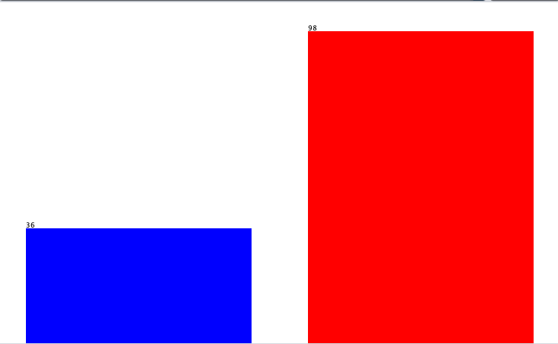

* #Solution1: adding Weka filter: weka.filters.supervised.instance.ClassBalancer
  + It added weight 0.8 / 1.2 to instances
  + Prediction accuracy falls, but ROC is slightly higher (2%)
  + I left it out from further analysis for now
* #S2 Oversampling [option]: duplicate instances with class 0
* # Aneta: cost sensitive learning
  + Kaznuješ napačne napovedi manjšinskega razreda

## Some attributes have too many possible values

* #[option] bucketing

# Modelling

## Baseline classifier

* ZeroR: PA **73.1343 %** (uses mode to predict)
* Questionable how informative the attributes are if other classifiers perform around this mark or worse

*Ver: farmers_removed_attr_29042021_2.arff*

## Decision Rules

*Ver: farmers_removed_attr_29042021_3.arff*

* OneR (simplest classification structure - one rule)
  + When removed Attr “Subject”, classification accuracy is 77.6119 %
  + MCC: 0.341
    - *The Matthews correlation coefficient (MCC), instead, is a more reliable statistical rate which produces a high score only if the prediction obtained good results in all of the four confusion matrix categories (true positives, false negatives, true negatives, and false positives), proportionally both to the size of positive elements and the size of negative elements in the dataset.
    - Marketing_info_about_DSS_Cat:
      * 1 [No] -> 1
      * 2 [occas] -> 1
      * 3 [Yes, subsc] -> 1
      * ? [missing v] -> 0
* PART
  + PART:
    - PA: 68.6567 % (with country attr)
    - MCC: 0.202
  + PART [23:15]: 69.8413 % (without country attr)
* JRip
  + classification accuracy is 79.1045 %
  + MCC: 0.419
  + 3 rules:
    - (Country = Italy) and (Manufacturer_demo_of_DSS_Cat = 1) => Already_used_DSS=0 (19.0/4.0)
    - (Farm_type_Organic = 1) => Already_used_DSS=0 (11.0/5.0)
    - => Already_used_DSS=1 (104.0/15.0)

## Naive Bayes

* NaiveBayes
  + Classification accuracy: 74.6269 %
  + MCC: 0.332

## K Nearest Neighbour

* Lazy.IBk:
  + PA: 76.8657 % (K=10)
  + MCC: 0.313

## Build Decision trees

* J48 , M2
  + PA 71.6418 %
  + MCC 0.084
* J48 , M10, binarySplits_TRUE (Whether to use binary splits on nominal attributes when building the trees.)
  + PA: 79.1045 %
  + MCC: 0.413

## 

* J48 , M10, binarySplits_FALSE, Unporuned_TRUE
  + PA: 79.1045 %
  + MCC: 0.413

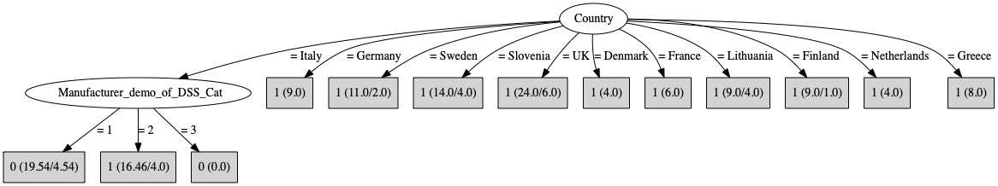

* **Removed “Country” attribute!**

*Ver: farmers_removed_attr_29042021_4.arff*

* J48 , M2, binarySplits_FALSE, Unporuned_TRUE
  + PA: 71.6418 %
  + MCC: 0.140

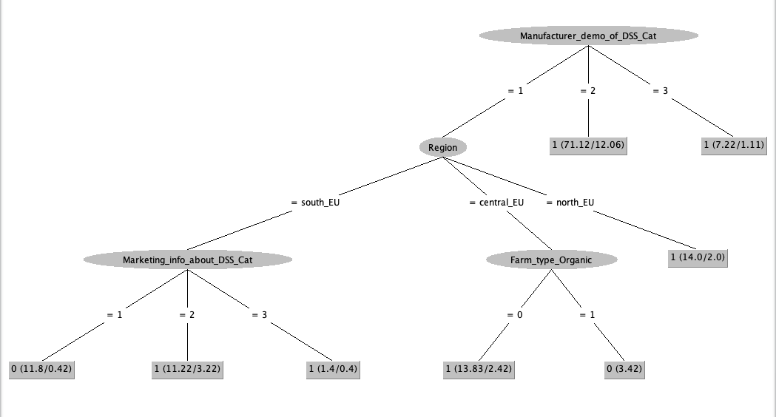

old:

## 

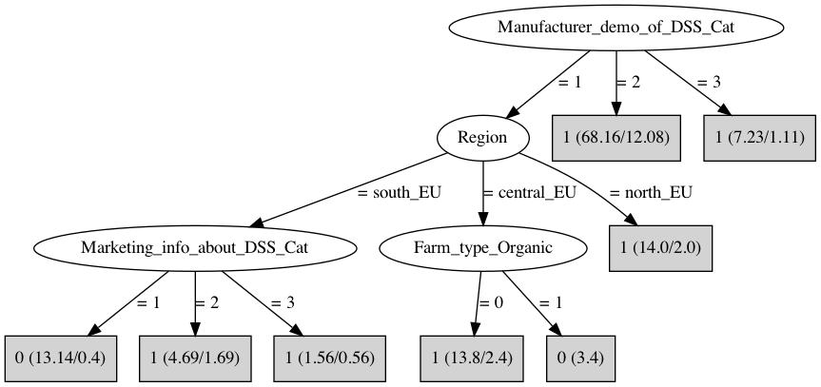

**Target Class: DSS_can_improve_your_productivity_Cat**

*Removed duplicated (lef 1-3)

* ZeroR:
  + PA: 54.4218 %
* J48 , M4,
  + PA: 55.7823 %
  + MCC: 0.215

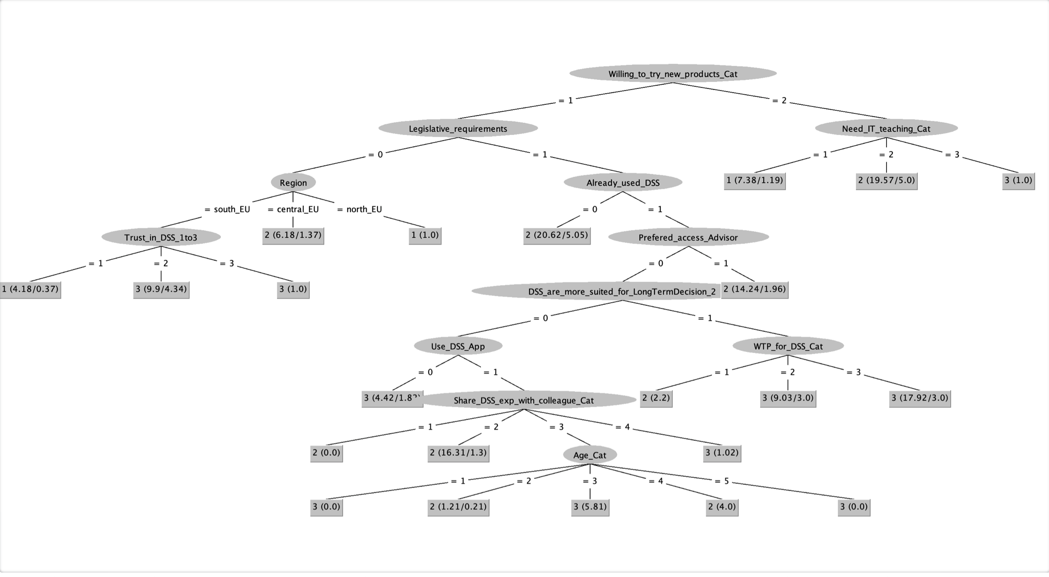

* J48 , M5,
  + PA: 56.4626 %
  + MCC: 0.205

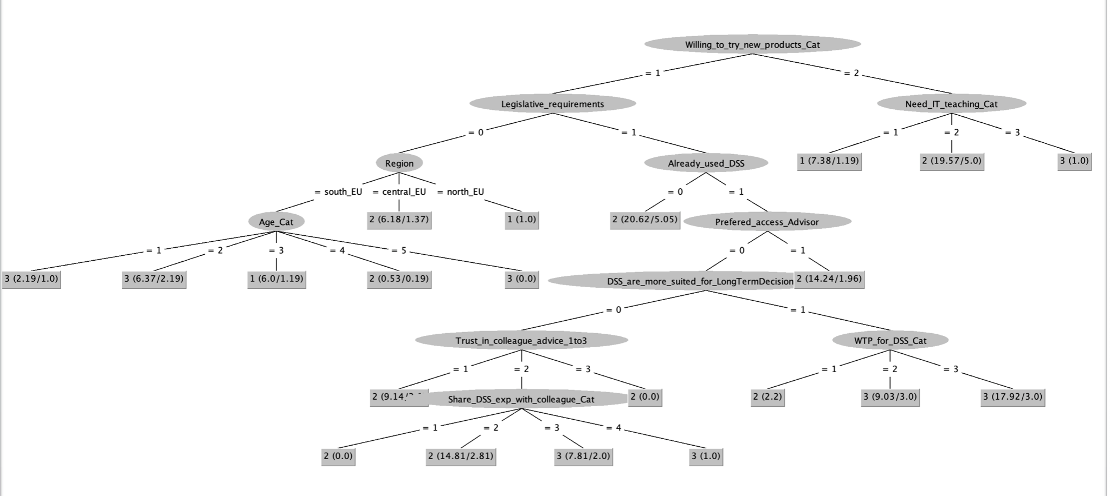

* J48 , M8,
  + PA: 55.102 %
  + MCC: 0.146

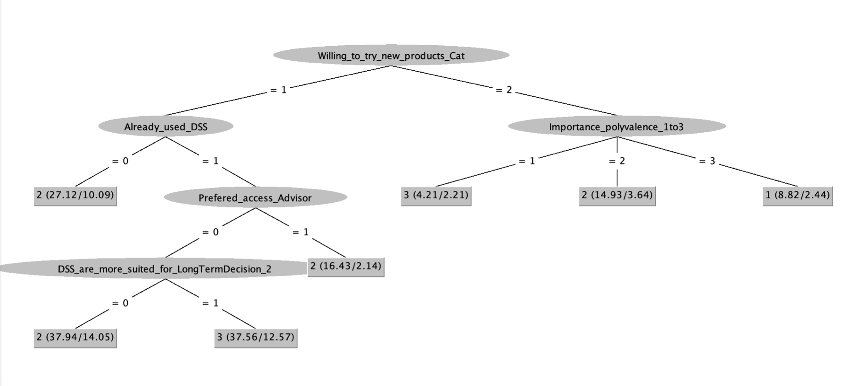

* J48 , M2,
  + PA: 59.1837 %
  + MCC: 0.217

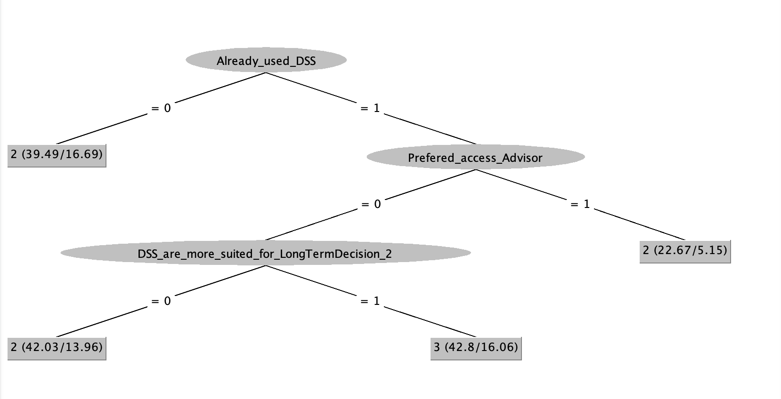

**Target Class: Potencial_user_of_platform**

Removed attr:

* duplicated (lef 1-3)
* How_do_you_access_DSS_Cat
* ZeroR:
  + PA: 58.209 %
* J48:
  + PA: 85.8209 %
  + MCC: 0.707

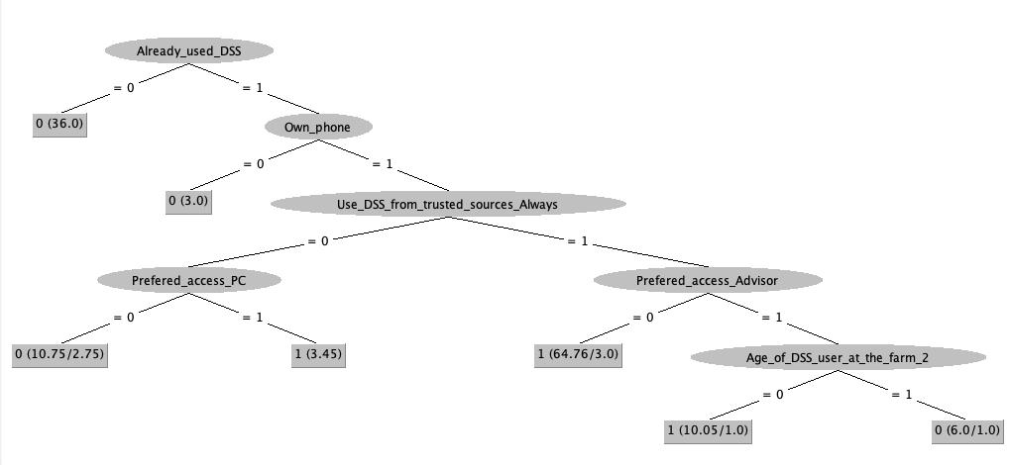

* **J48, M5:**
  + PA: 85.8209 %
  + MCC: 0.708

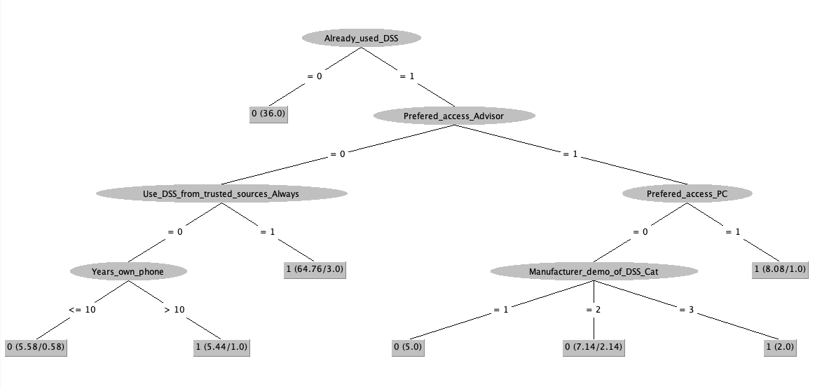

Removed 3x attr “prefered_acceess”

* J48, M2:
  + PA: 87.3134 %
  + MCC: 0.741

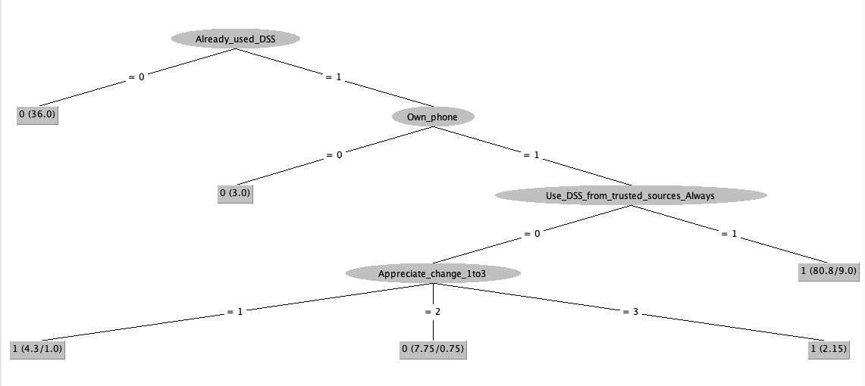

Removed attr “Already_used”, duplicates 1-7 & 1-7,

* J48, M2:
  + PA: 64.1791 %
  + MCC: 0.245

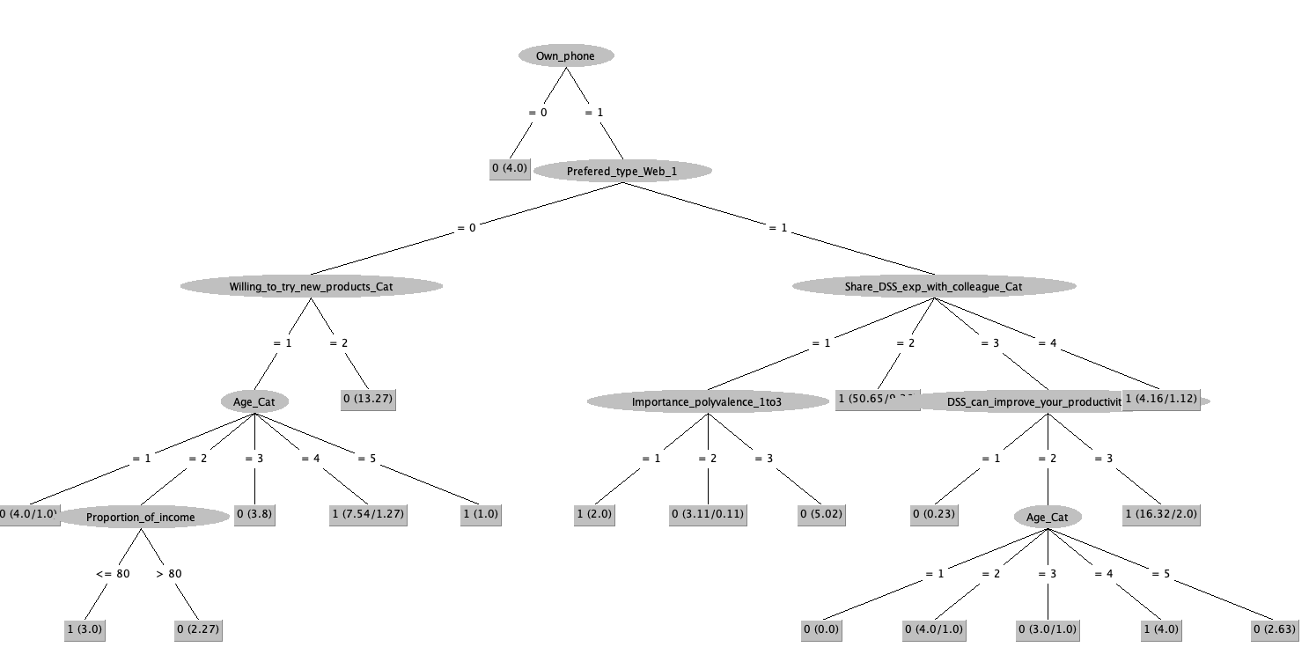

* J48, M5:
  + PA: 65.6716 %
  + MCC: 0.277

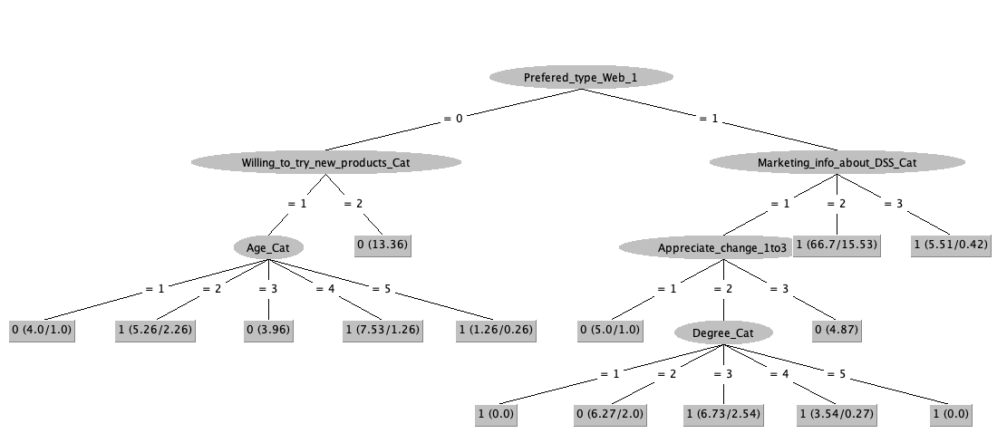

# Clustering (Python)

## Dim Reduction (tsne, UMAP)

* Uniform Manifold Approximation and Projection (UMAP)
  + reducing the dimension in a way that preserves as much of the structure of the data as possible we can get a visualisable representation of the data allowing us to “see” the data and its structure and begin to get some intuition about the data itself;
  + Ultimately supervised UMAP will be similar in some ways to a KNN classifier.
  + # Need one-hot encoding and using metric='dice'
  + # [option] categorical and numerical data types can be handled using gower-distance metric. code for gower distance metric from [here](https://sourceforge.net/projects/gower-distance-4python/).
  + # [2019] at the moment best way to handle this data in UMAP is to split the numeric and categorical variables, then one-hot encode the categoricals (pd.get_dummies) with a dice metric, then merge the two splits and continue.
  + # One alternative would be to check out the 0.4dev branch which has a (very!) experimental class called DataframeUMAP that would take a pandas dataframe and a tuple of (column name, metric) lists (similar to the ColumnTransformer in sklearn) and does all the required manipulations.
  + UMAP reduces down to 2D. Each row of the array is a 2-dimensional representation of the corresponding instance

## Try clustering methods for binary data (try different similarity metrics)

## 