FIELDNOTE
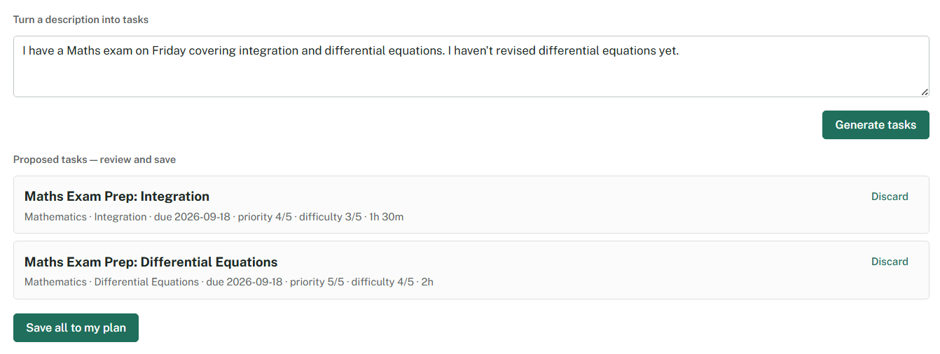
Project by Martín Merino
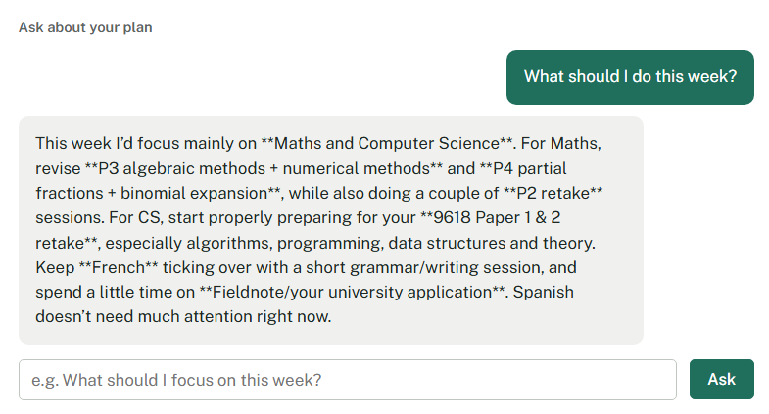

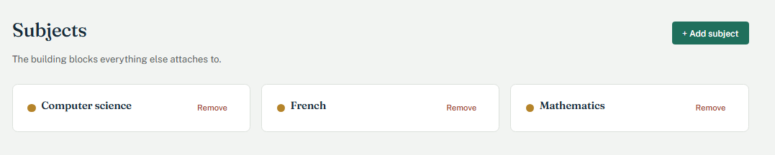

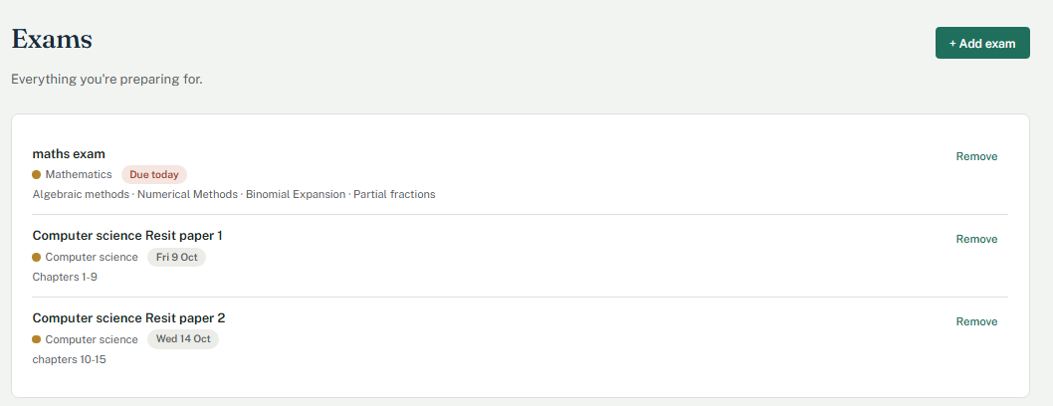
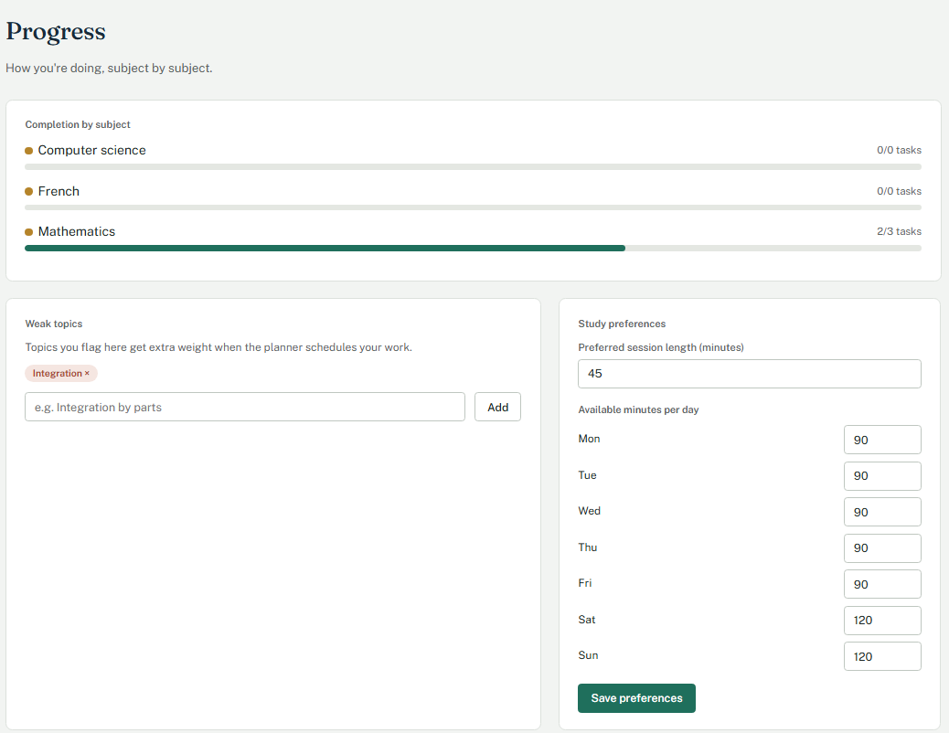

Fieldnote
A study planner that actually plans.
I built Fieldnote because I wanted to solve a problem I was experiencing myself: having a lot of schoolwork is easy to track, but much harder to actually organise.
I started with the idea of making a simple study planner, but I quickly realised that a useful planner needed to do more than store tasks. It needed to answer questions like:
- What should I study first?
- How much time should I spend on it?
- What can realistically fit before an exam?
- Why was this task scheduled today?
That led me to build Fieldnote as a combination of AI and deterministic algorithms.
How it works
I use AI where understanding natural language is useful. For example, I can write:
"I have a Maths exam on Friday covering integration and differential equations. I haven't revised differential equations yet."
The local AI converts this into structured study tasks that I can review and edit.
The actual scheduling is handled separately by my own Python algorithm. It considers factors such as:
- deadline and urgency
- task priority
- difficulty
- weak topics
- remaining workload
- available study time
This separation was an important part of the project. I didn't want to use an LLM simply because it was available — if something can be solved reliably with an algorithm, I wanted to build that algorithm myself.
The AI
Fieldnote currently uses Gemma 4 E4B through LM Studio, running locally.
This means I can experiment with AI functionality without depending on a paid cloud API, while keeping the AI component isolated from the rest of the application.
The AI is currently used for:
- turning natural-language descriptions into tasks
- breaking broad topics into smaller revision sessions
- answering questions about my study plan
What I built
Backend: Python, Flask, SQLite
Frontend: HTML, CSS, JavaScript
AI: Gemma 4 E4B + LM Studio
The project includes a dashboard, task and exam management, weekly availability, progress tracking, personalised scheduling, AI-assisted task creation, and explanations for scheduling decisions.
What I learned
The most valuable part of building Fieldnote was learning that adding AI to a project isn't necessarily about putting an LLM everywhere.
I had to think about which problems actually benefit from AI and which are better solved with conventional programming. I also learned about structuring data, designing APIs, validating model output, handling edge cases, and turning an idea into something I could actually use.
Fieldnote started as a personal problem and became a way for me to explore the intersection between software engineering, algorithms, and artificial intelligence.
Future ideas
I would like to continue developing Fieldnote by experimenting with different local models, evaluating the quality of AI-generated tasks, improving personalisation, and making the scheduling algorithm more sophisticated.

Built by Martín Merino
