

**MD Softworks**

**Windows Automated Simplifier**

**Documentation Version: 1.0**

Content

Design 2

Icon Spacing Changer 2

System-Font Changer 2

Toggle Black-Theme 2

Toggle Aero-Shake 2

Toggle Folder-Checkboxes 2

Toggle Shortcut-Name-Extension 3

Resize Taskbar-Preview-Window 3

Change Aero-Peek Time 3

File System 4

Delete Empty Directories 4

File System 4

Network 5

Misc (Miscellaneous) 6

Encrypted Directory 6

Password Safe 6

Compress/Decompress 7

Shortcut Dialog 7

Credits 8

# Design

## Icon Spacing Changer

Changes the vertical and horizontal space between the respective icon on the desktop.

Adjust the values with the given sliders.

**To make the changes visible:**

1. Restart your Computer or re-log your User-Account.
2. Drag an icon from your Desktop with your cursor.

Default-Value vertical: 1128

Default-Value horizontal: 1128

## System-Font Changer

Changes the font of different categories.

Select Font in the left column -> Preview will be displayed on the right

Font-Category-Dropdown -> Select where the font should be applied

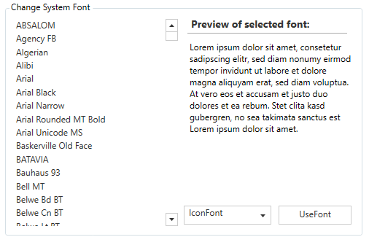

Left-Click “Use Font” -> Applies the selected Font on the selected category

## Toggle Black-Theme

Enables/Disables the Black-Theme of Windows 10.

If enabled, all the Setting-Windows and the Calculator are changing to a dark-grey colored-scheme.

Default: disabled

## Toggle Aero-Shake

Enables/Disables the Aero-Shake function.

Aero-Shake: If you grab the title-bar of any window, with your cursor, and quickly shake it from left-to-right, all other opened windows in the background minimize to the taskbar, and you can see the Desktop behind it.

Default: enabled

## Toggle Folder-Checkboxes

Enables/Disables the Folder-Checkboxes

Folder-Checkboxes: A small checkbox appears next on all the selected icons in your opened explorer-window, or on your Desktop. It helps visualizing all the selected files.

Default: disabled

## Toggle Shortcut-Name-Extension

Enables/Disables the Shortcut-Name-Extension

Whenever you create a shortcut of a file, the shortcut-name will be the same as the original one,

except, that there is a “-shortcut” extension at the end of the file-name.

For example: Shortcut from file” x.txt” from your external hard-drive to your desktop -> Name of the

shortcut will be: “x - Shortcut.txt”.

With this function enabled, the “- Shortcut” part is not going to appear in the file-name.

Default: disabled

## Resize Taskbar-Preview-Window

Resizes the Taskbar-Preview-Window with a slider

Taskbar-Preview-Window: When you hover-over a minimized window, a small window pops-up,

and gives the user a preview, how the maximized window would look like. It helps keeping the

workspace organized.

Default size: 300

## Change Aero-Peek Time

Aero-Peek: When you hoover over the little rectangle in the bottom-right corner of the Taskbar, all

the non-minimized windows will become transparent after a few milliseconds, so the user can see the

desktop.

The slider changes the time it takes for Aero-Peek to show up.

Default: 500ms

# File System

## Delete Empty Directories

Deletes all the empty directories, which are existing under the given path.

Click “Choose Path” -> Opens a directory-chooser.

Click “Clear” -> Clears the path-textfield

Click “Add” under Blacklist -> Opens a directory-chooser. Selected paths are going to be blacklisted.

Click “Remove” -> Removes a selected, blacklisted directory.

Check “Only Top Directory” -> Only searches in the top-directory, not in the sub-directories.

Click “Delete Directories” -> Search for empty directories under the given path, and deletes them.

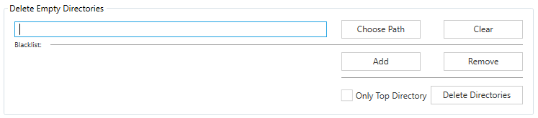

## File System

Searches under the given Path for certain files.

Search Options:

* Name -> Search for files, which match with the stated Regular Expression (RegEx).
* Size -> Select a range of Bytes, which the files are going to be searched.
* Creation Date -> Restrict the searched file creation-date in a certain time-interval.
* Last Edit Date -> Restrict the searched file last-edit-date in a certain time-interval.

Check “Only Top Directory” -> File is being searched in sub-directories.

Click “Select Files” -> File-Search-Algorithm is being started. Result are going to be shown in an extra window

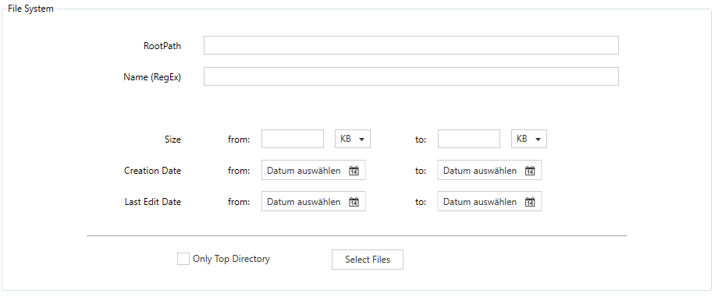

# Network

Displays all the Network-Interfaces of the Computer, and shows all the details

The user can also request a IP-Address.

*Select Interface on the left* -> Displays all the information’s on the right

*Request New IP-Address* -> A new Ipv4-Adress will been generated

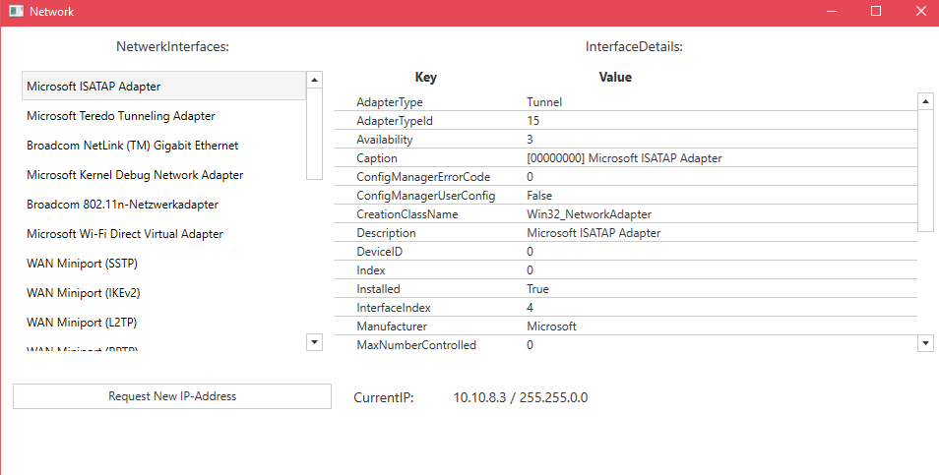

# Misc (Miscellaneous)

## Encrypted Directory

Encrypts a folder with a password.

User can then only unlock the folder with that password.

Encrypt:

1. Select folder to be protected.
2. Enter password into the field, and click “Use Password”.
3. An encrypted .pwf file has been generated. It is now encrypted with the password.

Decrypt:

1. Select .pwf file with the file-chooser.
2. Enter password into the field, and click “Use Password”.
3. The encrypted files have been listed on the left.
4. Select the wanted files of the directory.
5. Click “Decrypt”, to decrypt the chosen files to the selected directory.
6. 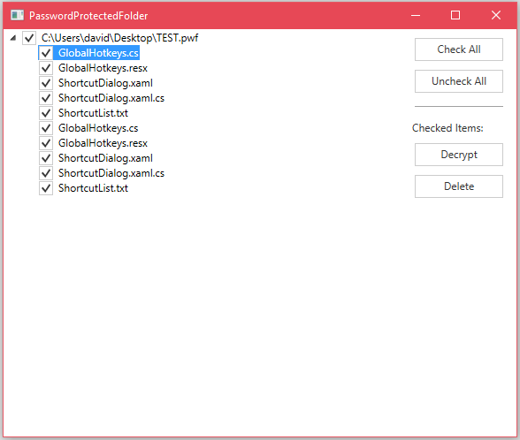Click “Delete”, to delete the chosen files.

## Password Safe

With this function, the user can store all his passwords in a well-organized safe.

Click “Open” Button -> Opens all the encrypted passwords with the key, and displays them.

Click “Close” Button -> Decrypts all the passwords

## Compress/Decompress

Compress:

Compresses selected files to a chosen directory.

Achieve-Formats as well as Compression-Formats are selectable

*Left-Click “Select Path”* -> Opens directory-chooser.

*Achieve-Format dropdown* -> Change between: .Zip, .Tar and .Gzip.

*Compression-Format dropdown*  -> Change between: Deflate, Bzip2, LZMA, LZMA2, PPMd.

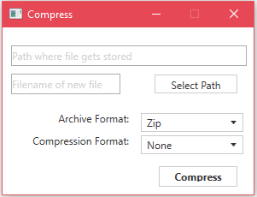

Decompress:

1. Select compressed Achieve-File.
2. Select the unpack-directory.
3. Application unpacks compressed File into the selected directory.

## Shortcut Dialog

Opens a dialog window with multiple customizable explorer-shortcuts.

All these shortcuts are accessible with the Hotkey: “[CTRL] + [1-5]”.

The special feature of this extension is, that you can access all the shortcuts even if the window of

WAS isn’t even selected. The User can be operating any other application, and the hotkeys which the

user performs on the keyboard will still work.

*Left-Click on a Path-Field* -> Enter a directory path (e.g.: C:\Users\Username\Documents)

*Double-Click on a Path-Field* -> Opens the explorer window on the given path.

*Left-Click on “Choose Path”* -> Opens a directory-chooser.

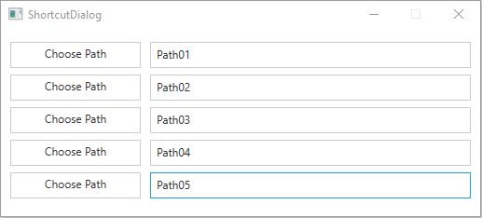

# Credits

**MD Softworks**

**W**indows **A**utomated **S**implifier

Application developed by

**Martin Niederl**

**David Eilmsteiner**

as a School-Project in the year 2017

Special Thanks to:

Christoph Thiel

Gabriel Krenn

Florian Harwöck