Runtime vs. (minimum) path probability at different ratios of common cross-edges

Normalized by #paths in the graph

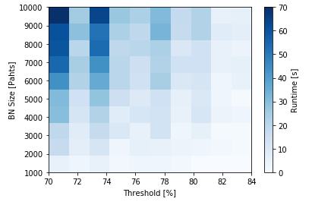

Graph size vs. (minimum) path probability => Runtime

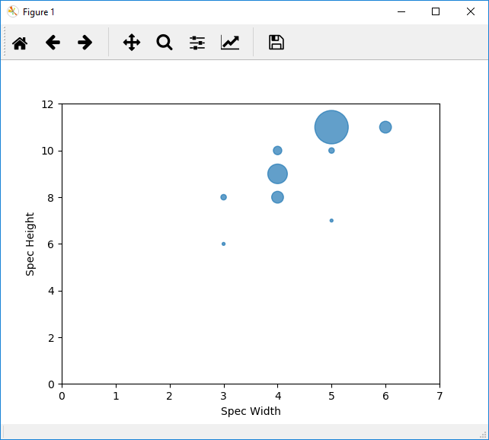

Scatter Plot: Spec height vs. Spec width (circle size ~ #specs)

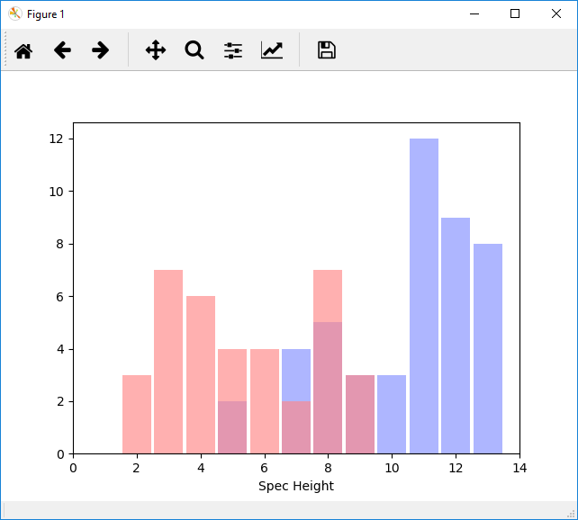

Histogram: Spec height