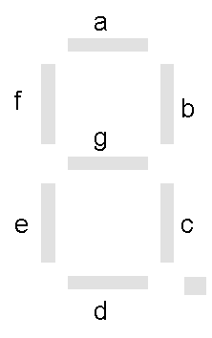
De. | D | C | B | A | Čísl. | a | b | c | d | e | f | g | w
0 | 0 | 0 | 0 | 0
1 | 0 | 0 | 0 | 1
2 | 0 | 0 | 1 | 0
3 | 0 | 0 | 1 | 1
4 | 0 | 1 | 0 | 0
5 | 0 | 1 | 0 | 1
6 | 0 | 1 | 1 | 0
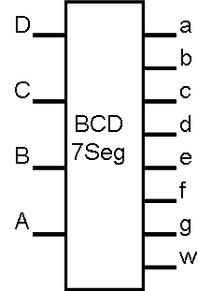  7 | 0 | 1 | 1 | 1
8 | 1 | 0 | 0 | 0
9 | 1 | 0 | 0 | 1
10 | 1 | 0 | 1 | 0
11 | 1 | 0 | 1 | 1
12 | 1 | 1 | 0 | 0
13 | 1 | 1 | 0 | 1
14 | 1 | 1 | 1 | 0
15 | 1 | 1 | 1 | 1

A  B  C  D  a | A  B  C  D  b
A  B  C  D  c | A  B  C  D  d
A  B  C  D  e | A  B  C  D  f
A  B  C  D  g | A  B  C  D  w

