Control Flow in Java Programming

Department of Computer Science, University of the People
CS 1102-01: Assignment Activity Unit 1
MM Bary
March 17, 2026

Table of Contents
Abstract ................................................................................. i
- Introduction ..................................................................... 2
- Program Requirements ................................................. 2
2.1 Hardware Requirements ........................................ 2
2.2 Software Requirements .................................. 2
- System Design and Structure ...................................... 3
3.1 Program Flow .................................................... 3
3.2 Use of Control Structures (if and switch) .............. 3
- Implementation .......................................................... 4
- Compilation and Execution ......................................... 6
5.1 Compiling the Program ......................................... 6
5.2 Running the Program ........................................... 6
- Program Output ......................................................... 7
7.1 Sample Output Screenshot ..................................... 7
7.2 Output Explanation ............................................ 7
- Challenges and Improvements .................................. 9
- Conclusion ............................................................. 9
- Reference
Abstract
This project involves the development of a Java-based quiz game that interacts with users through a command-line interface. The program presents five multiple-choice questions, each with four possible answers labelled A, B, C, and D. Users are prompted to input their responses, and the system evaluates these answers against predefined correct options to compute a final score. The output is displayed as a percentage, providing immediate feedback on the user’s performance.
The implementation emphasizes fundamental programming concepts such as control structures, input validation, and logical computation. Additionally, attention is given to code readability, proper documentation, and structured program flow. The project demonstrates how Java can be used to build interactive applications while maintaining clarity, efficiency, and correctness.
Introduction
The purpose of this program is to design and implement a simple quiz game using Java programming language. The application is intended to test users’ knowledge through a set of predefined multiple-choice questions while demonstrating core programming concepts such as input handling, decision-making, and output generation.
This quiz game provides an interactive experience where users input their answers and receive feedback based on their performance. By simulating a real-world quiz scenario, the program showcases how Java can be used to develop user-driven applications with structured logic and clear output.

2. Program Requirements

2.1 Hardware Requirements
The experiment process was carried out in the host system (Windows 11). The computer system installed and used in this test process has the following specifications.
- Host System: Windows 11 operating system 64-bits based, 8GB of RAM, and 500GB of SSD hard disc

2.2 Software Requirements

This study used visual studio code as an IDE, java as the programming language and javac as the compiler provided by the java development kit.

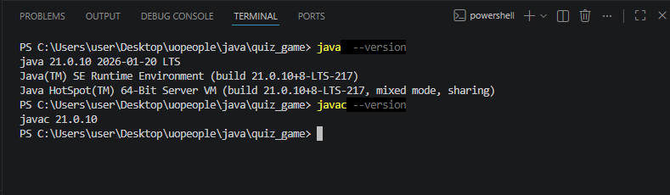

Figure 1: used software version
- System Design and Structure

3.1 Program Flow
The project is designed to meet several functional requirements to ensure it operates as intended. It presents exactly five multiple-choice questions, each with four options labelled A through D. The system accepts user input, validate it, and compares it against correct answers to track the user’s score throughout the quiz.
The system is designed with a clear and logical flow, beginning with the presentation of questions and ending with the display of results. The program follows a sequential execution model where each question is asked, user input is processed, and the score is updated accordingly.
3.2 Use of Control Structures
Java switch case is a tool that a code block to execute based on the value of a given expression. It is used to replace multiple if/else statement. In this study control structures such as if statements and switch cases played a key role in directing program execution. These constructs were used to validate input and evaluate answers, ensuring that the program behaves predictably and handles different user inputs effectively.

4. Implementation

To implement this program, this research used java scanner class. Java scanner class makes it easy to get input from the user, which allows simple programmes to quickly become interactive (Cameron McKenzie, n.d.).

The study used random questions for this project, the inbuild function(getValidInput) was used to validate user input. Char data type was used because it holds a single character in this case a letter (Vucic, 2025). Finally switch case was implemented to avoid a lot of if/else statements.
The implementation phase involves translating the program design into functional Java code. Questions and their corresponding answers are defined within the program, and user input is collected using standard input methods. Input validation ensures that only valid responses (A, B, C, or D) are accepted.
The program evaluates each response using conditional logic and updates the score accordingly. After all questions have been answered, the final score is calculated as a percentage and displayed to the user, providing a clear summary of their performance.
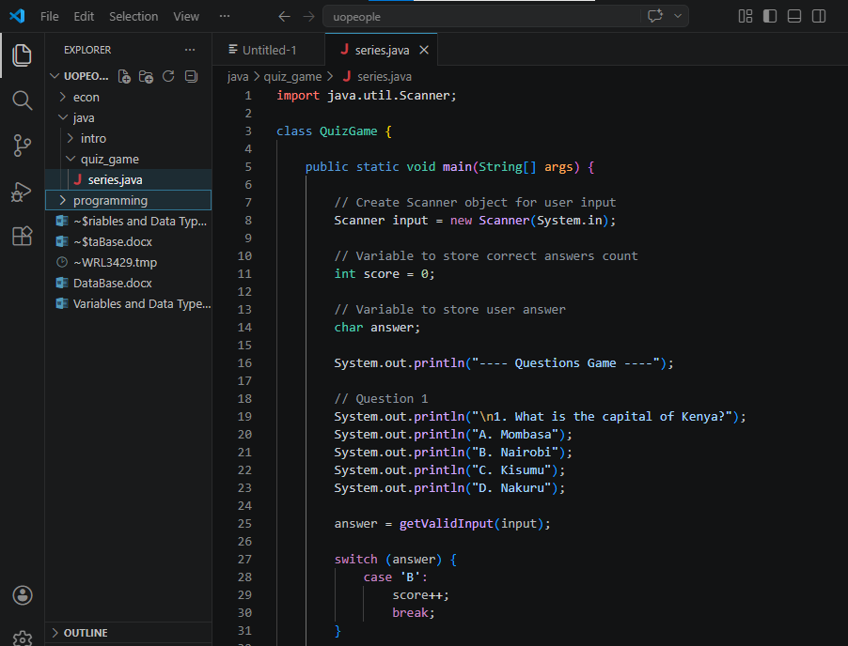
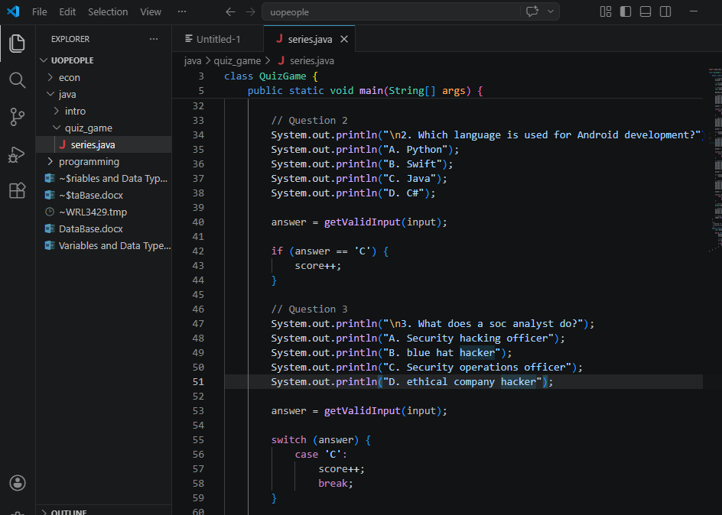

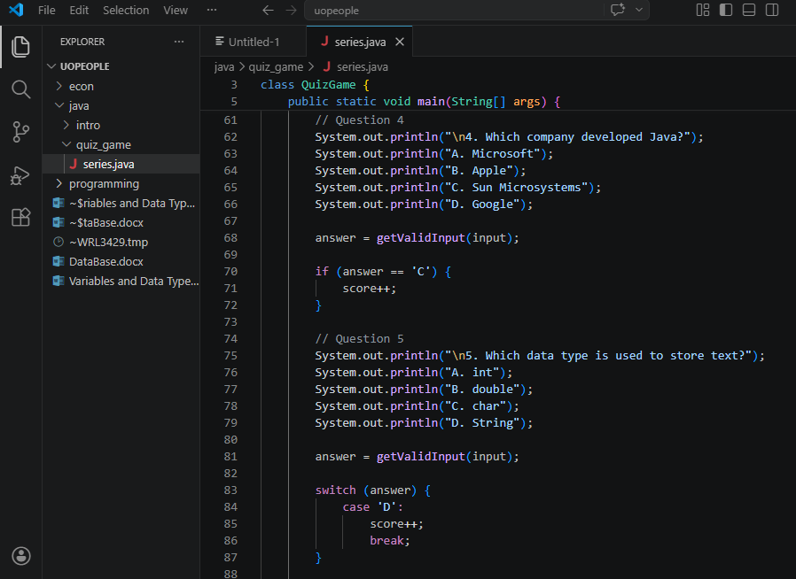

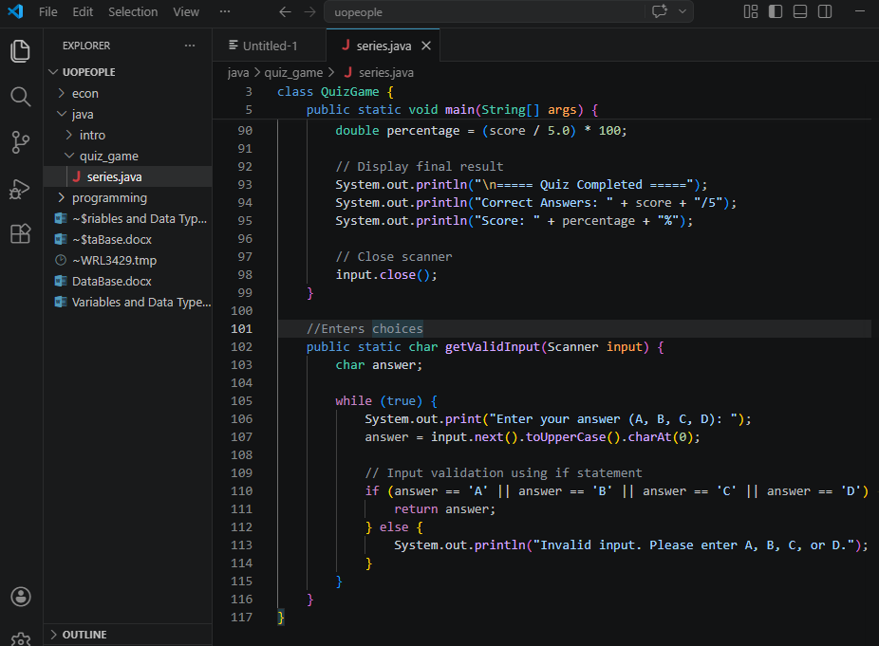

Figure 2-5: The code for the programme

5. Compilation and Execution

5.1 Compiling the Program
Compilation is the process of converting the Java source code into bytecode using a Java compiler. This step ensures that the program is free of syntax errors and ready for execution. Proper file naming and adherence to Java conventions are essential for successful compilation. The figure below shows a successful compiled code by since (quizgame.class) was created.
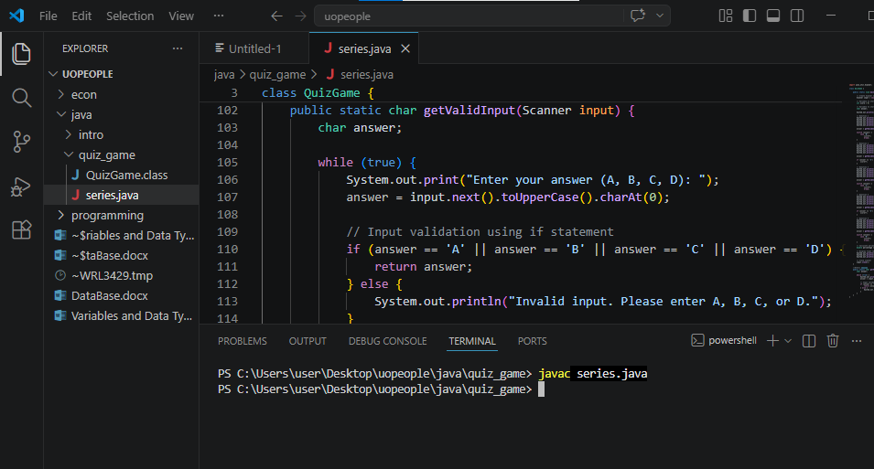

Figure 6: The code was compiled successfully
5.2 Running the Program
Once compiled, the program was executed through the visual studio code terminal. During execution, the program interacts with the user, processes inputs, and produces output based on the implemented logic.
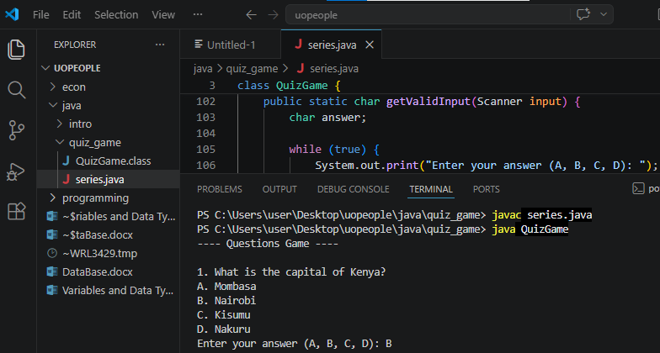

Figure 7: running the code after compiling it

7. Program Output
The program output provides feedback to the user after completing the quiz. It displays the final score as a percentage, indicating the number of correct answers out of the total questions. This output helps users assess their performance quickly and clearly.
A sample output screenshot is included to demonstrate how the program behaves during execution. This visual representation supports the explanation of the program’s functionality and confirms that it meets the expected requirements.
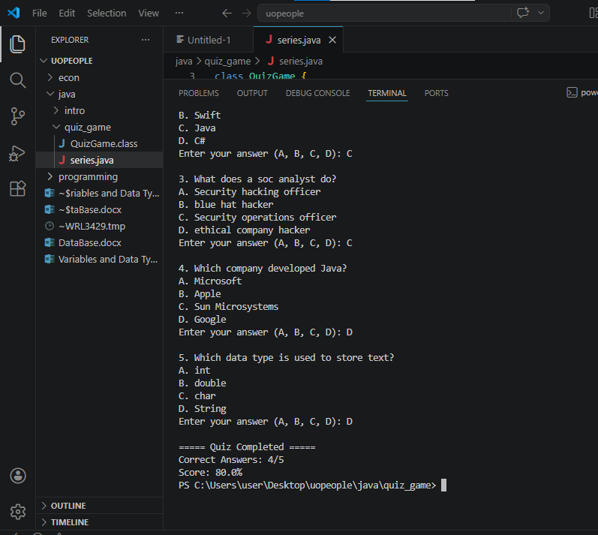

Figure 9: Output of the code

9. Challenges and Improvements
During the development process, several challenges may arise, such as handling invalid input or ensuring accurate score calculation. Addressing these challenges requires careful planning and testing to ensure the program operates correctly.
Future improvements could include adding more questions, implementing a graphical user interface, or storing questions in external files. These enhancements would make the program more dynamic and user-friendly.

10. Conclusion
In conclusion, the Java quiz game successfully demonstrates the application of fundamental programming concepts. The program meets all specified requirements, including user interaction, input validation, and score computation.
The project highlights the importance of structured design, logical implementation, and thorough testing. It serves as a solid foundation for developing more complex applications in Java.
Reference
McKenzie, C. (n.d.). Java Scanner import. TechTarget.
Java Scanner import article
Vucic, M. (2025, April 24). Char data type in Java. CodeGym.
https://codegym.cc/groups/posts/char-data-type-in-java
Arnold, K., & Gosling, J. (1996). The Java programming language. Addison-Wesley.
Pandey, A. (2024, June 14). Java switch case explained. Built In.
https://builtin.com/articles/java-switch-case

