A Test approach to image and remote text
Test Testª, Test Test^{b}
ªDepartment of Computer Science and Application,
^{b}Library, Computer Science and Application Institute

ABSTRACT: One-class extraction tries to distinguish a specific class of interest from the remainder of the data set. The one-class extraction problem can be solved by either a one-class classifier or a multi-class classifier. With a multi-class classifier, the one-class extraction of remote sensing image is studied in this article. First, we analyze the probability of error for one-class extraction with nearest neighbor classifier. As a nonparametric method, the nearest neighbor classifier requires the data distribution to be partitioned into only two classes, the class of interest and the remainder. Second, with the two-class partitioning of the data set, the specific class of interest is well extracted from a remotely sensed image. This study improves the classification process and would be helpful for one-class extraction of remote sensing imagery with multi-class classifiers.
KEYWORDS: nearest neighbor, one-class, remote sensing

INSTRUCTIONS
Image classification is one of the most significant applications of remote sensing. The classification process is to categorize all pixels in a digital image into one of several land cover classes. This categorized data may then be used to produce thematic maps of the land cover classes in an image. In many remote sensing applications, the task is to recognize one specific land-cover class of interest and to discriminate it from the other classes present in the investigated area. In these situations, users are only interested in extracting the specific class of interest without considering the other classes, which is referred to as one-class extraction or one-class classification. One-class extraction focuses on a single land-cover class, such as urban areas, vegetation, wet land, fenland, and man-made objects (Muñoz-Marí et al. 2007, Sanchez-Hernandez et al. 2007, Inglada 2007, Tooke et al. 2009, Gong et al. 2010 ).
The one-class extraction problem is often solved by training a one-class classifier (OCC). One-class classifiers are a special kind of classifiers detecting the objects belonging to a class of interest and rejecting the other classes objects. The class of interest is accepted as the positive data, whereas other classes are rejected as negatives, and only positive data are required to train the one-class classifier. Different one-class classifiers have been developed for the one-class classification problem in literature (Li et al. 2011). Schölkopf et al. proposed the one-class support vector machine (OCSVM) method (Schölkopf et al. 2001). This one-class classifier has proved useful in remote sensing image classification (Foody et al. 2006). However, the drawback of OCSVM is that its outcome is sensitive to free parameters that are difficult to tune. Li & Guo (2010) developed a maximum entropy approach (MAXENT) to one-class classification of remote sensing imagery. In MAXENT method, a threshold for generating binary predictions is required and can be determined based on the omission rate of a validation set. The experimental results showed that MAXENT provides high classification accuracy.
One-class classifiers are often used in cases where the negative class is either not present or not properly sampled. However, in the extraction of a specific class of interest from remote sensing image, the samples of both the positive and the negative class are always available. Usually, the accuracy of one-class classifiers cannot match the accuracy of multi-class classifiers built with meaningful counterexamples. The one-class extraction problem is always solved by a multi-class classifier. The multi-class classifier requires having samples of both the class of interest and the other classes. As the distribution of the data may be very complex, the number of the classes in the data is not easy to tell. On the other hand, no matter how many classes being partitioned in the data set, the only thing we are concerned about is the specific class of interest in one-class extraction. The partitioning of the data distribution is a problem in one-class extraction with multi-class classifiers.
The rest of the paper is organized as follows. In Section 2, the partitioning of data distribution is theoretically analyzed in nearest neighbour classification. The probability of error is provided based on the nearest neighbour decision rule. The one-class extraction with nearest neighbour decision rule and the experimental results are given in Section 3. Finally Section 4 concludes the paper.

The probability of error for nearest neighbour rule in one-class extraction
As a non-parametric approach, the nearest neighbour decision rule is a commonly used classification method in remote sensing. The nearest neighbour rule is summarized as follows. Given an unknown feature vector x and a distance measure, then:
  - Out of the N training vectors, identify the k nearest neighbors, irrespective of class label. k is chosen in general not to be a multiple of the number of classes M.

  - Out of these k samples, identify the number of samples, k_{i}, that belong to class 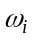, i = 1, 2 , . . . , M.

  - Assign x to the class with the maximum number k_{i} of vectors.
Nearest Neighbor (NN) rule is the simplest version for k = 1. In the nearest neighbour classification, a feature vector x is assigned to the class of its nearest neighbour x_{n}. Assume 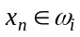 , 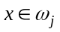, an error is made if 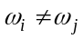. Without loss of generality, we also assume that 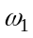 is the specific class of interest. Given x and x_{n}, the classification error probability of the class of interest, 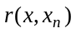, is carried out as follows.
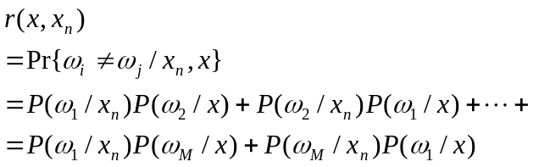 (1)
where 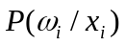 is the posterior probability of class 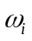 given 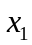.
Provided that the number of training samples N is large enough, the feature vector x can be very close to its nearest neighbour x_{n}. Thus the following approximation is valid:
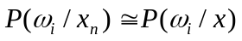 (2)
Then we can write Equation (1) as
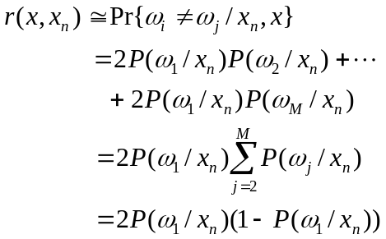 (3)
It is easy to verify that as 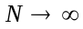 Equation (1) converges with probability one to Equation (3).
As can be seen from Equation (3), the classification probability of error of the specific class is only correlated with the nearest neighbour x_{n} of the class of interest. Thus the partitioning of the data distribution has no effect on the extraction of the specific class with nearest neighbour classification. So it is suggested that in one-class extraction with nearest neighbour classifier, the data set should be partitioned into two classes for simplicity, the class of interest and the remainder.

One-class extraction with nearest neighbour decision rule
As analyzed in section 2, the partitioning of data set has no effect on the accuracy of one-class extraction with nearest neighbour decision rule. It is convenient for the users to partition the data set into two classes, the class of interest and the remainder of the data set. The remainder refers to all of the land cover types except for the specific class of interest in the remote sensing image. To select samples for the remainder classes in the data set, we first use mean shift clustering technique to seek the inherent modals in the remote sensing image. The mean shift clustering is a nonparametric method and has many applications in the literatures (Comaniciu & Meer 2002, Bo et al. 2009).
3.1 PRE-PROCESSING
The mean shift method is used to cluster the experimental data in pre-processing stage. Here we review the mean shift theory. Let {x_{i}}_{i=1…n} be a set of n points in the d-dimensional Euclidean space R^{d}. Assume that p(x) is the probability density function of the d-dimensional vectors x and p(x) is unimodal. S_{x} is a sphere of radius r centered on x and contains the points y such that ||y-x||≤r. Let z=y-x, so the expected value of z is
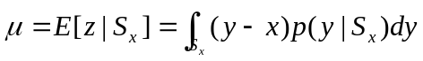
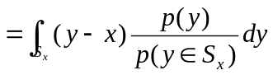.
If S_{x} is sufficiently small we can approximate
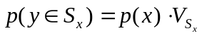
where 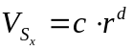 is the volume of S_{x}. The first order approximation of the probability density function is
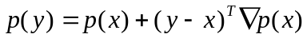
where ∇p(x) is the gradient of the probability density function in x. Then
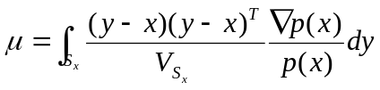.
The integral is
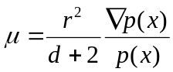.
Given the search window radius r and initial location x, the mean shift vector is computed iteratively. In the mean shift procedure, the convergent points are the cluster centers. The mean shift clustering is based on the spectral similarity of each pixel in an image. After clustering, the adjacent pixels that belong to the same cluster are merged and the image is composed of the segments of homogeneity.
The experimental image is a Landsat Thematic Mapper subset of Orange County, CA, USA. This is an image with 600×600 pixels and the test area (ground truth) is also provided to evaluate the classification results. Figure 1 (a) shows the original image in RGB colour and figure 1 (b) is the image of the test area. The test area comprises impervious surface, water, agriculture and rural regions. In the experiment, we define the extraction of impervious surface, water, agriculture and rural as separate examples of one-class extraction.

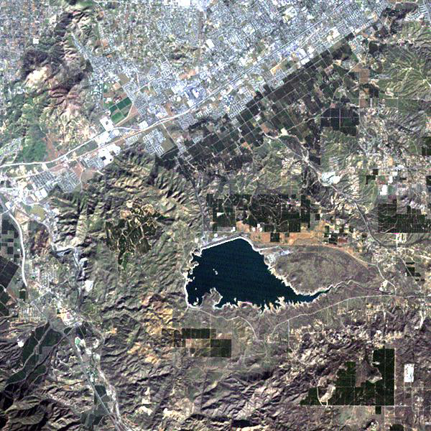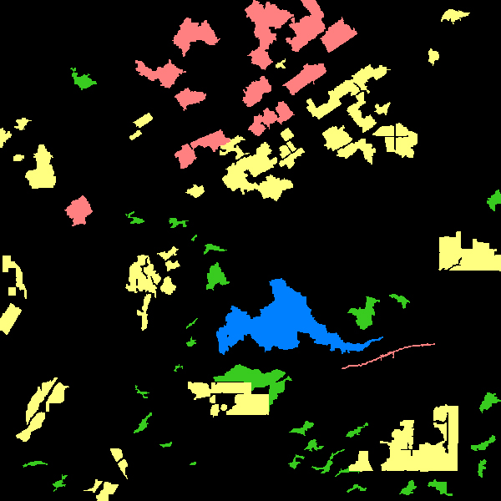
impervious
water
agriculture
rural
(a) (b)
Figure 1. Experimental TM image and test area: (a) experimental TM image; (b) test areas.

The mean shift clustering method is used in the experiment and then samples will be selected from each of the clusters to train the one-class classifier. Figure 2 is the resulting image of mean shift clustering and there are 9 clusters in it.

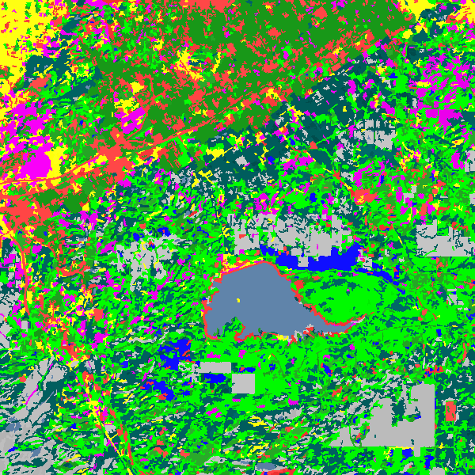

Figure 2. Result of mean shift clustering.

3.2 EXPERIMENTAL RESULT
Based on the resulting image of clustering, the training samples were obtained by manual interpretation before nearest neighbour classification. We randomly selected 1000 pixels of the positive and 3000 pixels of the negative for training. The test area in figure 1 (b) was used for the accuracy evaluation. In remote sensing classification, producer’s accuracy (PA), user’s accuracy (UA), overall accuracy (OA) and kappa are commonly computed to evaluate and compare the one-class extraction quality.
The standard nearest neighbour (SNN) method and OCSVM are compared with the proposed NN method in our experiments. The standard nearest neighbour is the traditional multi-class classifier. We implemented OCSVM by LIBSVM, a library for support vector machines developed by Chang & Lin (2001). The kernel of Gaussian radial basis function (RBF) was used in OCSVM. We tuned the RBF kernel width in the range [0, 1000] and the rejection fraction in the range [0, 1] through 10-fold cross-validation. Figure 3 shows the prediction maps for each land type. Using the test area shown in figure 1 (b), the producer’s accuracy, user’s accuracy, overall accuracy and kappa are computed for each land type. Table 1 to 4 show the comparison of classification accuracies for each land cover type between NN, SNN and OCSVM. The results indicate that the classification accuracy of the proposed NN method is relatively higher than OCSVM in this experiment. The main reason is that NN method learns with not only positive samples but also negative samples. Furthermore, the negative samples could be well selected based on the image clustering result. The NN method has obvious advantage in one-class extraction when the class of interest is poorly distributed in the feature space, such as the land type agriculture and rural in this experiment. If the land type has good distribution, such as water in the experiment, the proposed NN and OCSVM method provide the similar classification accuracy. On the whole, the one-class extraction with the proposed NN is similar to that of SNN method. As a multi-class classifier, the SNN method requires the user be familiar to all the classes in the image. However, some times it is difficult for the user to know all the land types well in one-class extraction of remote sensing imagery. Since the partitioning of data set has no effect on the accuracy of NN classifier, we just selected the samples based on the image clustering in the proposed NN one-class extraction.

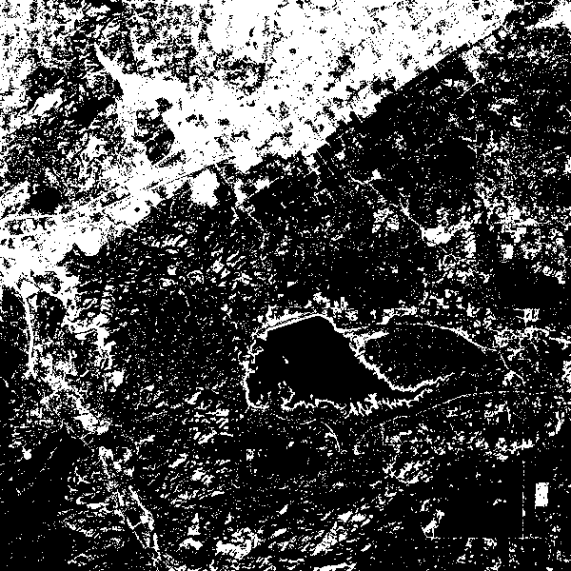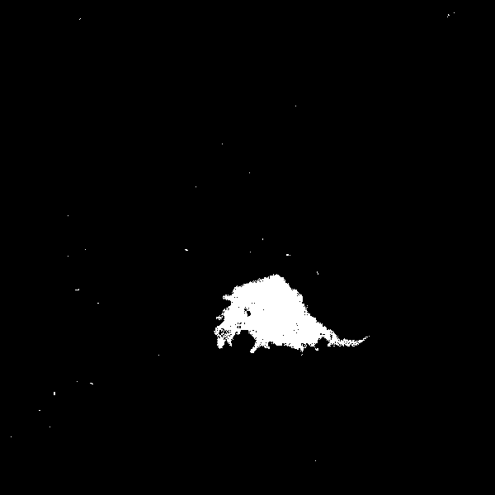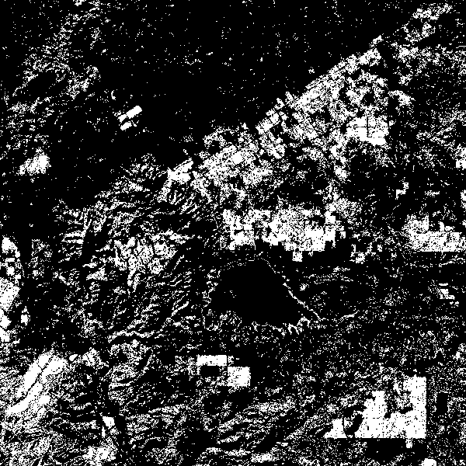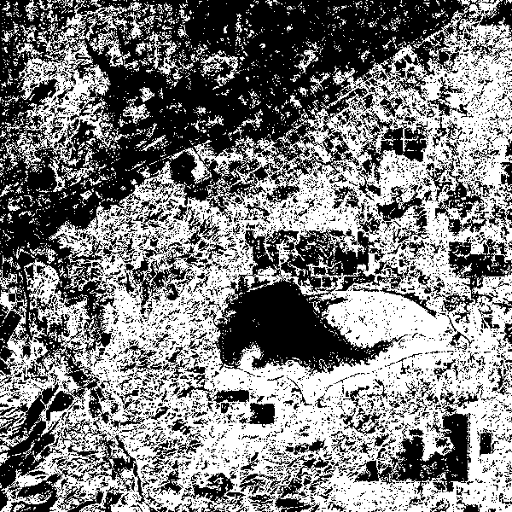
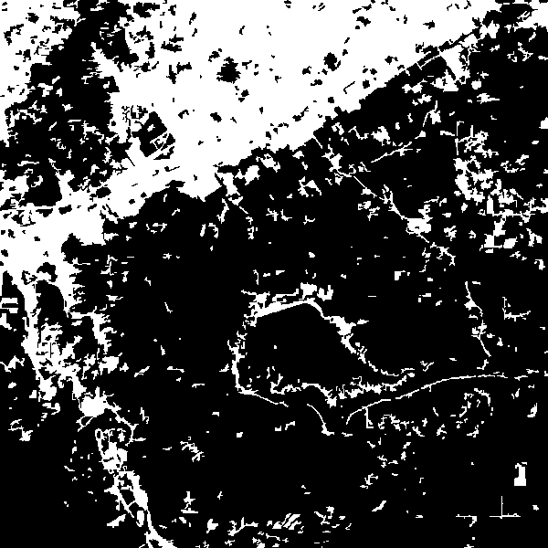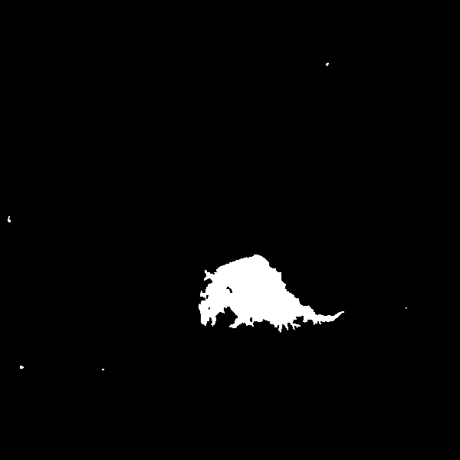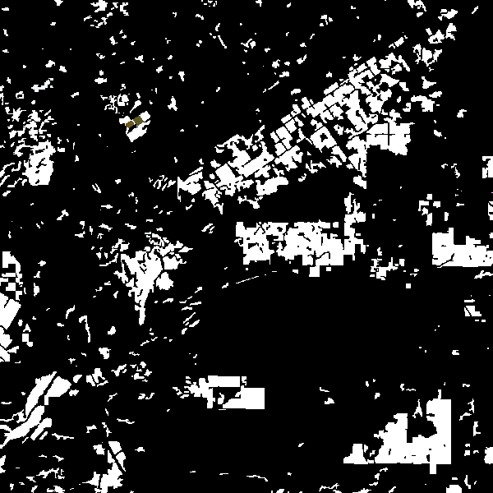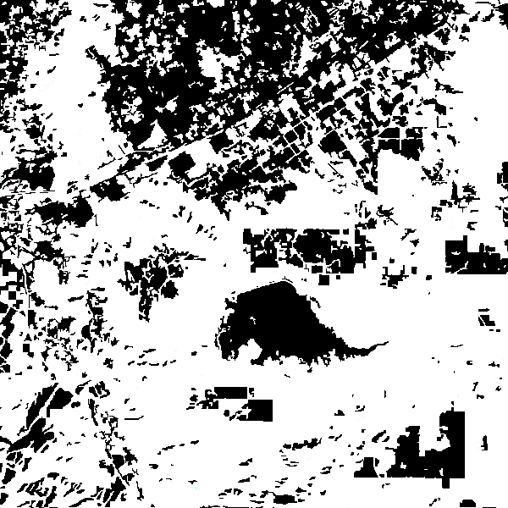
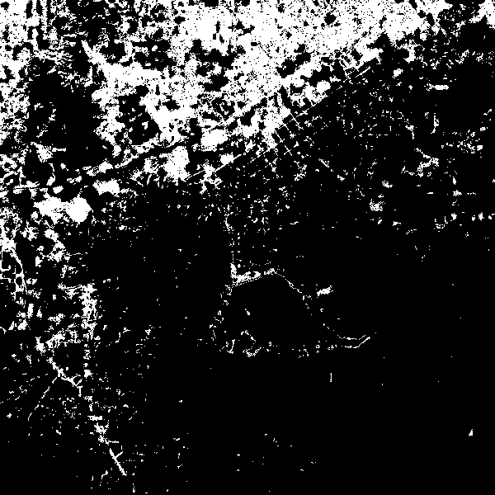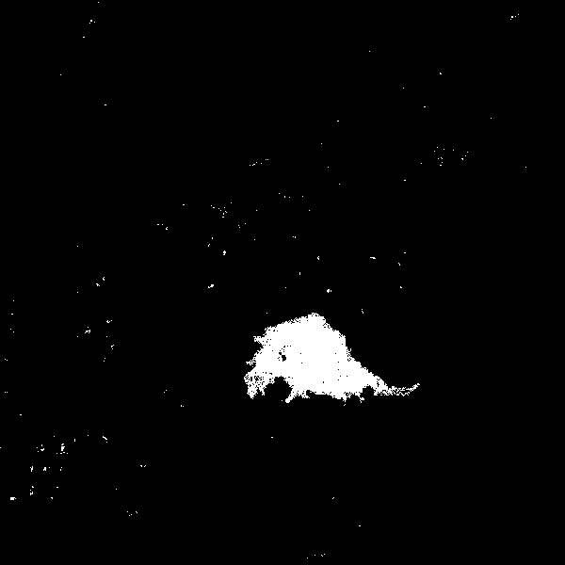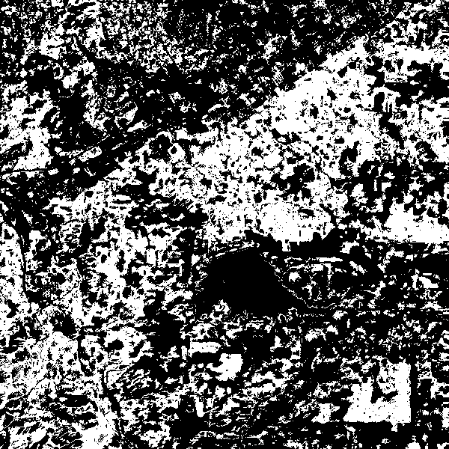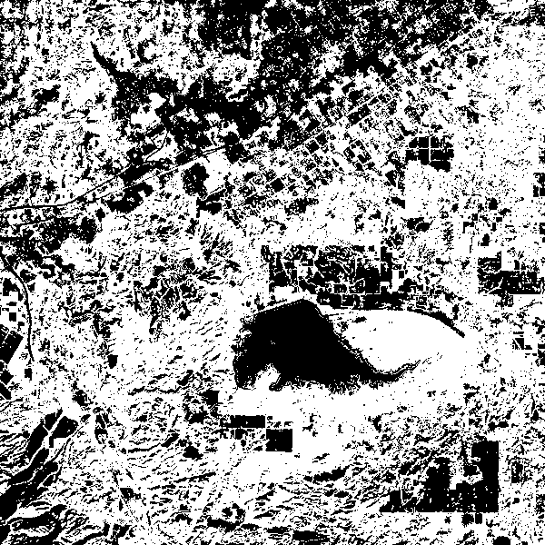
(a) (b) (c) (d)
Figure 3. Prediction maps of each land type: (a) impervious; (b) water; (c) agriculture; (d) rural. Top: NN; Middle: SNN; Bottom: OCSVM. White: positive; black: negative.

Table 1. Accuracy assessment of impervious.
Reference | PA(%) | UA(%) | OA(%) | kappa
NN | 91.1 | 89.6 | 94.6 | 0.862
SNN | 88.3 | 86.5 | 92.3 | 0.798
OCSVM | 85.7 | 85.8 | 90.5 | 0.755

Table 2. Accuracy assessment of water.
Reference | PA(%) | UA(%) | OA(%) | kappa
NN | 99.2 | 99.4 | 99.9 | 0.99
SNN | 99.5 | 81.5 | 99.2 | 0.878
OCSVM | 98.2 | 99.1 | 99.8 | 0.981

Table 3. Accuracy assessment of agriculture.
Reference | PA(%) | UA(%) | OA(%) | kappa
NN | 84.2 | 85.6 | 92.5 | 0.784
SNN | 86.6 | 84.0 | 93.0 | 0.799
OCSVM | 87.6 | 64.2 | 79.7 | 0.573

Table 4. Accuracy assessment of rural.
Reference | PA(%) | UA(%) | OA(%) | kappa
NN | 89.2 | 86.9 | 82.7 | 0.575
SNN | 87.6 | 91.5 | 88.0 | 0.706
OCSVM | 75.6 | 87.0 | 79.9 | 0.506

Conclusions
The task of one-class extraction is to recognize one specific land-cover class of interest in the remote sensing image. Therefore, in these situations, users are only interested in extracting the specific land type without considering the remainder of the data set. In this paper, the one-class extraction is studied with a multi-class classifier. The partitioning of the data distribution for one-class extraction can be different from that of multi-class classification. With the nearest neighbour classifier, the problem of one-class extraction was discussed in this paper. We first indicated the effect of the partitioning of data distribution on one-class extraction and then provided the appropriate partitioning method in the extraction of specific class from remote sensing imagery. We also conducted experiments to test the method proposed. The proposed method has the advantages of both one-class and multi-class classifiers in the process of classification. Sample selection stage was simplified by partitioning the data set into two-classes, the class of interest and the remainder. Even when we do not know what classes comprise the remainder exactly, we select the samples and perform the classification in one-class extraction as well. Although one-class classifier, such as OCSVM, only trains the class of interest, it requires more samples to comprehensively describe the specific class. On the other hand, by using some counterexamples our approach achieved comparable classification accuracy to that yielded by the multi-class classifier, which requires having samples of all the classes in the data set. The result of the experiment indicated the performance of the proposed approach with multi-class classifier, which showed promise in one-class extraction of remote sensing imagery.

Acknowledgements
We gratefully acknowledge support for this work from the Natural Science Foundation of China (No. 41001235) and Aeronautical Science Foundation of China (No. 2011ZC55005).

References
- Bo, S. K., Ding, L., Li, H. W., Di, F. P., Zhu, C. G. Mean shift-based clustering analysis of multispectral remote sensing imagery. Int. J. Remote Sens., 2009, 30, 817-827.
- Chang, C. C. & Lin, C. J. LIBSVM: a library for support vector machines. Available online at: http://www.csie.ntu.edu.tw/,cjlin /libsvm/, 2001.
- Comaniciu, D. & Meer, P. Mean shift: A robust approach toward feature space analysis. IEEE Trans. Pattern Anal., 2002, 24, 603-619.
- Foody, G. M., Mathur, A., Sanchez-Hernandez, C. and Boyd, D. S. Training set size requirements for the classification of a specific class. Remote Sens. Environ., 2006, 104, 1-14.
- Gong, P., Niu, Z. G., Cheng, X., et al. China’s wetland change (1990–2000) determined by remote sensing. Sci. China Earth Sci. 2010, 40, 768-775.
- Inglada, J. Automatic recognition of man-made objects in high resolution optical remote sensing images by SVM classification of geometric image features. ISPRS J. Photogramm., 2007, 62, 236-248.
- Li, W. K. & Guo, Q. H. A maximum entropy approach to one-class classification of remote sensing imagery. Int. J. Remote Sens., 2010, 31, 2227-2235.
- Li, W. K., Guo, Q. H. & Elkan C. A positive and unlabeled learning algorithm for one-class classification of remote-sensing data. IEEE Trans. Geosci. Remote Sens., 2011, 49, 717-725.
- Muñoz-Marí, J., Bruzzone, L. & Camps-Vails, G. A support vector domain description approach to supervised classification of remote sensing images. IEEE Trans. Geosci. Remote Sens., 2007, 45, 2683-2692.
- Sanchez-Hernandez, C., Boyd, D. S. & Foody, G. M. One-Class Classification for Mapping a Specific Land-Cover Class: SVDD Classification of Fenland. IEEE Trans. Geosci. Remote Sens., 2007, 45, 1061-1073.
- Schölkopf, B., Platt, J. C., Shawe-Taylor, J., Smola, A. J., Williamson, R. C. Estimating the support of a high-dimensional distribution. Neural Comput., 2001, 13, 1443-1471.
- Tooke, T. R., Coops, N. C., Goodwin, N. R., Voogt, J. A. Extracting urban vegetation characteristics using spectral mixture analysis and decision tree classifications. Remote Sens. Environ., 2009, 113, 398-407.

