Experimental study on the relationship between surface micro-defects and haze
Test1 Test2
Engineering Research Center for Polymer Processing Equipment, Ministry of Education

Test1 Test2
Engineering Research Center for Polymer Processing Equipment, Ministry of Education
Test3 Test3*
Engineering Research Center for Polymer Processing Equipment, Ministry of Education
*Corresponding author
Abstract: In this paper, it was investigated the mapping relationship between surface micro-defect and haze of polycarbonate (PC) plate. Experiment studies showed that the PC plate with different degree of surface micro-defect can be produced by the process of injection and hot embossing, then the haze of the PC plate can be measured by haze tester. Simulation studies were made through ray tracing method to find the proper topography function of the surface of the plate and calculate the haze of the plate, so as to study the relationship between surface micro-defect and haze. Finally, it was found that the experimental results validated the theoretical simulation well. And the prediction and evaluation of the haze through the mapping relationship was available.
Keywords: micro-defect, haze, mapping, topography
Reference to this paper should be made as follows: Huang, Y., Wu, D. and Meng, Q. (2015) ‘Study of mapping relationship between surface micro-defect and haze of polycarbonate plate’, Int. J. Simulation and Process Modelling, Vol. xxx, No. xxx, pp. xxx
Biographical notes: Mr. Yao Huang is a PhD candidate from Beijing University of Chemical Technology (BUCT), Beijing, China. He is a member of Engineering Research Center for Polymer Processing Equipment of BUCT. His main research interests include polymer processing, simulation of the injection molding and defect of the polymer defect.

Dr. Daming Wu is a professor from BUCT. He is the director of Engineering Research Center for Polymer Processing Equipment. His main research interests include the polymer precise extrusion mechanism, the preparation of polymer nanocomposites.

Dr. Qingyun Meng is a professor from BUCT. His main research interests include in situ bubble stretching method and the preparation of light scattering materials.

1. Introduction
Nowadays, transparent polymer materials is widely applied in the display and lighting systems. The application of transparent polymer materials is likely to outpace inorganic materials in the next few years. The advantages of the transparent polymer materials are high transmittance, easy to mold, high toughness over the inorganic materials. But the surface micro-defect can be vulnerable in processing of the transparent polymer materials which may decrease the optical performance of the polymer (Martínez et al. 2011). Therefore, it is necessary to make further investigation on the relationship between surface micro-defects and optical properties of polycarbonate plate.
The topography including the surface micro-defect can be simulated with the help of mathematical method. The topography can be described by several parameter through height of crest, width of crest, wavelength and the obliquity of wave surface (Kong et al. 2013).
Cogdell (2008) obtained the topography function through superposition of Gauss distribution function and sine function. Sun et al. (2012) obtained the topography function through adjusting the amplitude and period of the sine function. Dullaert et al. (2011) divided the surface topography into primary topography and secondary topography, then described them with the function of different frequency.
To produce the transparent PC plate with different degree of surface micro-defect, hot embossing processing was used to impress the defect on the surface of the plate. Li et al. (2008) did research on the relationship between process parameters and micro-defect topography through hot embossing. Sahli et al. (2009) found that the duplicating accuracy of hot embossing in the optimized process condition could reach the accuracy of micro injection molding, so hot embossing can be an effective way to duplicate micro-defect.
The surface micro-defects can be quantified by non-contact measurement. Laser scattering method was used to obtain the surface micro-defects of PC sheet through analyzing the speckle from the diffusing reflectance of the laser on the plate surface by Kruse et al. (2011). Through the non -contact measurement, the 3D topography can be obtained, and then quantitative evaluation of the surface can be obtained through the topography (Siegmann et al. 2004).
In order to research further on the relationship between surface defects and haze, mathematical model should be built. Shen et al. (2006) built the model of coating defects, and obtained that the surface and sub-surface defects would affect the light scattering and propagation path. But they did not do a detailed experimental analysis on the optical properties of defect coating.
The objective in this paper is aimed at investigating the mapping relationship between surface micro-defects and haze of PC transparent plate. As the haze is an important index to the optical performance of transparent plate and surface micro-defect is a common defect in the processing of the plate, the study on the relationship between surface defects and haze of PC plate has important theoretical and practical significance (Dias et al. 2014; Cardin et al. 2011).
The remaining part of the paper is organised as follows, in Section 2, the experiment was made to investigate the relationship between surface micro-defects and haze; in Section 3, the simulation was carried out to verify the relationship between surface micro-defects and haze; the comparison was made, in Section 4, for the results between the experiment and simulation; in Section 5, the haze of plate was predicted and evaluated of through the relationship; finally, some conclusions were drawn in Section 6.
2. Experimental study on the relationship between surface micro-defects and haze
The micro defect is embossed into the surface of the plate with different compressive stress to obtain the defect of different depth in the plate. After the haze of the plate being measured, the relationship of mapping between surface micro-defect and haze of polycarbonate plate can be obtained.
2.1 The process of preparing PC plate with different degree of defects
The experimental material was PC-110 from Taiwan Chimei Corporation. The injection molding machine EcoPower 55/130H B6 from Battenfeld company was used to produce the PC transparent plate with the process of precision injection compression. The dimension of the plate was 10mm×10mm×0.9mm. The press vulcanizer was used to emboss spherical crown pit micro- defect from the mold into the surface of the plate. The type of press vulcanizer was XLB- D500X500 from Huzhou Dongfang machine company. The depth of the embossed micro-defect was controlled by the compressive stress and the heating temperature of the press vulcanizer. The dimension of the semisphere micro-defect in the mold was 0.1mm in diameter and 0.1mm spacing. And the semisphere micro-defect was arranged in regular hexagon. The temperature of the press vulcanizer was 160℃ and the compressive stress increased from 3MPa to 10MPa so as to emboss the micro-defect in different degree. The micro-defect of the PC plate after hot embossing was shown in Fig. 1.
2.2 Measure of the depth of the micro-defect of PC plate
Instrument: The type of Optical profilometer system was Contour GT from Bruker company.
The topography of the micro-defect of PC plate can be measured by Contour GT Optical profilometer system.
2.3 Characterization and measurement of the haze of PC plate
The haze of a plate can be obtained by the ratio of diffuse light and total light. The diffuse light was defined as the light whose deflection angle is more than 2.5°.
The type of the haze measuring instrument was WGT-S from Shenguang instrument company. It was used to measure the haze of the sample in the condition of vertical incident light. Then the relationship between surface micro-defect and haze of PC plate can be obtained.
3. Simulation of the relationship between surface micro-defects and haze
Ray tracing method and Snell's law were employed to seek for the relationship between surface micro defects and haze. The simulation study was made with Mablab for the topography of micro defects and the process of rays travel.
First surface topography of the PC plate can be expressed through function. The surface topography of the PC plate with surface defect is shown in Fig. 2. The surface profile in vertical direction of the PC plate measured by optical profilometer system is shown in Fig. 3. The surface profile function can be obtained by superposition of trigonometric function in different frequency and amplitude. In Fig. 4, it is shown that the surface topography was obtained by the second-order series expansion of trigonometric. The topography function is as follows
y=0.0008cos(62.8x)+0.000005cos(2000x)
where y was the height of the micro-defect, and x was the horizontal distance.
In Fig. 5, it is shown that the surface topography was obtained by the third-order series expansion of trigonometric. The surface topography function was
y=0.0008cos(62.8x)+0.00001cos(2000x)+0.000005cos(14000x)
where y was the height of the micro-defect, and x was the horizontal distance.
It can be seen that the function curve obtained by the third-order series expansion was closer to the actual topography.
Snell's law of refraction was used to trace the ray passing through the PC plate. The refraction angle was calculated by the algorithm of vector.
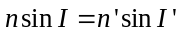 (1)
where n was the refractive index of the first media, n' was the refractive index of the second media; I was the incident angle, I' was the refraction angle.
The vector form of function (1) is as follows.
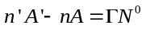 (2)
where A is the unit vector of the incident ray, A' is the unit vector of the refracted ray, N⁰ is the unit vector of the normal of the incident point and is the bias constant.
From (2), we can get the unit vector of refracted light as shown in (3). And Equation (3) is the vector form of Snell's law. (Li, 2011).
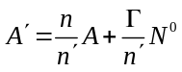 (3)
The deviation angel of the ray is calculated in (4)
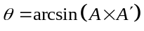 (4)
where θ was the deviation angel of the ray.
The haze is calculated in (5)
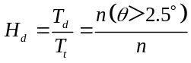 (5)
where H_{d} is the haze of the plate, T_{d} is transmittance of diffuse light, T_{t} is transmittance of total light, n is the number of total rays in simulation and n (θ＞2.5°) is the number of the diffuse rays in simulation.
We can perform ray tracing and build a model between surface topography and haze of the plate by using the vector form of Snell's law, as shown in Fig. 6. The refractive index in the model is the same as the red light in PC which was used in the experiment. There was some deviation when the light passed through the PC plate in the model. Then the deviation angle can be calculated and the haze of the PC plate can be analyzed through the deviation angle.
The surface topography can be described by fundamental frequency series expansion of cosine. So the topography of the plate can be defined as follows.
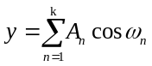 (6)
where A_{n} is the amplitude of the cosine function, ω_{n} is the angular frequency of the cosine function, y is the depth of the micro defects and x is the horizontal distance.
With the increasing of the order of the fundamental frequency, the haze of the plate increases. This is because the surface topography function describe more details with the addition of high frequency component, which can increase the haze of the plate. From the numerical simulation, it was found that when the expansion order is higher than three, the haze calculated by simulation is more than that tested in experiment. This phenomenon showed that when the order is higher than three, surface topography function described too much detail, and will not reflect the real surface topography of the plate.
The relationship between the depth of micro-defect and haze is shown in Fig. 7 with the surface topography function successively defined by the first-order series, second-order series and third-order series expansion. By comparison with experimental data, it can be found that the maximum deviation value of haze in one order series expansion was 16%, the maximum deviation value of haze in two order series expansion was 5.4%, the maximum deviation value of haze in three order series expansion was 2.8%.
So the third order series expansion can be used to describe the surface topography of the plate more precisely. Also the relationship between the depth of micro-defect and haze was more uniform with the experiment data by using the third-order series expansion. The reason for this phenomenon is that the three order series expansion include three trigonometric functions of different amplitude and frequency, which can describe the surface topography more precisely.
In order to do further study on the surface topography of three order series expansion, we focused on the high frequency factor of the three order series expansion. The third-order series expansion can be defined as follows:
y=A₁cos(ω₁x)+ A₂cos(ω₂x)+ A₃cos(ω₃x),（ω₃＞ω₂＞ω₁） (7)
where y is the depth of the micro defects, x is the horizontal distance, A_{n} is the amplitude of the cosine function, ω_{n} is the angular frequency of the cosine function, A₁cos(ω₁x) is low frequency factor, A₂cos(ω₂x) is middle frequency factor and A₃cos(ω₃x) is high frequency factor.
In equation (7), A₃cos(ω₃x) is defined as high frequency factor, which reflects the details of the surface topography. As the detail of the surface has a strong influence on the deviation of the light, the high frequency factor is the key factor to the optical performance of the plate. So it is necessary to pay more attention to the value of A₃ and ω₃.
In order to make further study on the relationship between the depth of micro-defect (A₁) and haze in different frequency (ω₃), we focused on (7) and set ω₁=62.8，ω₂=2000，A₂=0.00001，A₃=0.000005, which is based on the experiment result from Fig. 3. A₁ is the amplitude of the low frequency factor to describe the depth of the micro-defect. And ω₃ changed from 15000 to 17000. The relationship between the depth of micro-defect A₁ and haze in different frequency (ω₃) is shown in Fig. 8. It can be found that with the increasing of ω₃, the haze increases. When ω₃ is 16000, the haze in the simulation is rather close to the experiment results.
To get the relationship between the depth of micro-defect (A₁) and haze in different amplitude (A₃), we focused on equation (7) and set ω₁=62.8，ω₂=2000，ω₃=16000，A₂=0.00001. A₃ changed from 0.000003mm to 0.000006mm. The relationship between the depth of micro-defect (A₁₎ and haze in different amplitude (A₃) is shown in Fig. 9. It can be found that with the increasing of A₃, the haze increased. When A₃ is 0.000004mm, the value of haze in the simulation is identical with that in the experiment.
From Figs. 8 and 9, we can find that when the depth of the micro-defect was 0-3μm, the influence of high frequency factor on the haze of the plate is strong; when the depth of the micro-defect is 3-7μm, the influence of high frequency factor on the haze is small.
To sum up, the parameter of (7) can be set as ω₁=62.8，ω₂=2000，ω₃=16000，A₂=0.00001，A₃=0.000004. A₁ describes the depth of the micro-defect, which can express the surface topography more precisely.
4. The analysis and comparison of the experiment and simulation results
Finally, we can get the simulation result of the haze through the equation (7) and the parameter above. The relationship between depth of the surface micro-defect and haze of polycarbonate plate in experiment and simulation is shown in Fig. 10. From Fig. 10, we can calculate that the maximum deviation value of haze between simulation and experiment is 2.5%, which shows that the simulation through ray tracing is so precise that could reflect the experiment result well. The reason why the experiment and simulation results meet well is that the topography function we chose is quite near to the real topography. Then the ray trace in simulation is quite near to the real trace. So the haze in simulation is quite close to the experiment data.
5. The prediction and evaluation of the haze of the plate through simulation
As is shown in the simulation, low frequency factor A₁cos(ω₁x) is decided by the depth of the micro-defect. And the middle frequency factor A₂cos(ω₂x) and the high frequency factor A₃cos(ω₃x) is decided by the material of the sample and the surface quality of mould, which is always stable. Therefore we can build a model to predict the haze of the sample by substituted the depth of the micro-defect (A₁) to the function of surface topography.
6. Conclusions
The surface topography of the plate can be described precisely by superposition of trigonometric function in different frequency and amplitude.
The haze of the plate can be simulated by the method of ray tracing. After the comparison between the haze of simulation and experiment, it is found that the haze of the plate of surface topography obtained by three order expansion function is rather close to the experiment data.
The haze will increase if the frequency or amplitude of high frequency factor increases.
The haze can be predicted through the function between the depth of the micro-defect and the haze by measuring the depth of the micro-defect.
Acknowledgement
1. This work was supported by National Natural Science Foundation of China (No.51173015)
2. This work was supported by the Fundamental Research Funds for the Central Universities, China (No. JD1412)
References
Cardin, O. and Castagna, P. (2011) ‘Proactive production activity control by online simulation’, International Journal of Simulation and Process Modelling, Vol. 6, No. 3, pp.177-186.
Cogdell, D. (2008) ‘A convolved multi-Gaussian probability distribution for surface topography applications’, Precision Engineering, Vol. 32, No. 1, pp.34-46.
Dias,L., Pereira, G.,Vik,P. and Oliveira, J.(2014) ‘Layout and process optimisation: Using computer-aided design (CAD) and simulation through an integrated systems design tool’, International Journal of Simulation and Process Modelling, Vol. 9, No. 1-2, pp.46-62.
Dullaert, K., Steeman, P. and Bolks, J. (2011) ‘A mechanistic study of the effect of pigment loading on the appearance of powder coatings’, Progress in Organic Coatings, Vol. 70, No. 4, pp.205-212.
Kong, B., Cheung, F., To, S. and Cheng, T. (2013) ‘Modeling and characterization of generation of 3D micro-structured surfaces with self-cleaning and optical functions’, Optik-International Journal for Light and Electron Optics,Vol.124,No.17, pp.2848-2853.
Kruse, D., Patzelt, S., Dollinger, C., Tausendfreund, A. and Goch, G. (2011) ‘Laser optical characterization of smooth surfaces with respect to roughness and defects in the micrometer range’, Procedia Engineering, Vol. 19, pp.235-240.
Li, L. ‘The effect of optical freedom surface machining errors on the optical properties’, Jilin University, Changchun. 19. 2011.
Li, M., Liu, C. and Peng, J. (2008) ‘Effect of hot embossing process parameters on polymer flow and micro channel accuracy produced without vacuum’, Journal of Materials Processing Technology, Vol. 207, No. 1-3, pp.163-171.
Martínez, I., Carrión, J., Sanes, J. and Bermúdez, D. (2011) ‘Surface damage of mold steel and its influence on surface roughness of injection molded plastic parts’, Wear, Vol. 271, No.9-10, pp.2512-2516.
Sahli, M., Millot, C., Roques-Carmes, C. Khan, C., Barriere, T. and Gelin, C. (2009) ‘Quality assessment of polymer replication by hot embossing and micro-injection moulding processes using scanning mechanical microscopy’, Journal of Materials Processing Technology, Vol. 209, No. 18-19, pp.5851-5861
Shen, J., Liu, S., Shen, Z., Shao, J. and Fan, Z. (2006) ‘Theoretical analysis of optical properties of dielectric coatings dependence on substrate subsurface defects’, Applied Surface Science, Vol. 252, No. 10, pp.3855-3860.
Siegmann, P., Sanchez-Brea, M., Martinez-Anton, C. and Bernabeu, E.(2004) ‘Comparison between optical techniques and confocal microscopy for defect detection on thin wires’, Applied Surface Science, Vol. 238, No. 1-4, pp.375-379.
Sun, F., Van, E. and Nicola, L. (2012) ‘Plastic flattening of a sinusoidal metal surface: A discrete dislocation plasticity study’, Wear, Vol. 296, No. 1-2, pp.672-680.
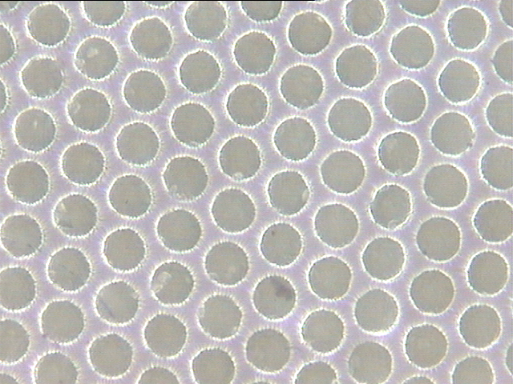
Fig. 1The micro-defect of the PC plate after hot embossing
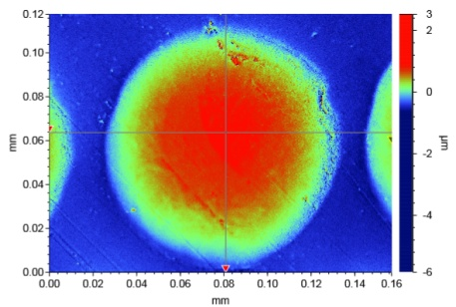
Fig. 2 Surface topography of the PC plate
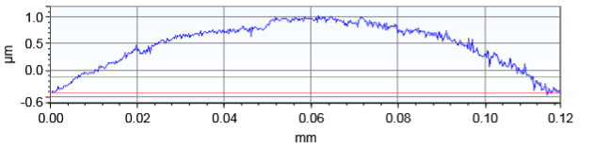
Fig. 3 The surface topography curve in vertical direction of the PC plate
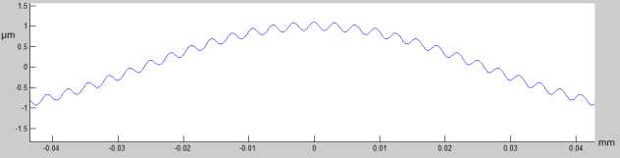
Fig. 4The function curve obtained by two order expansion function
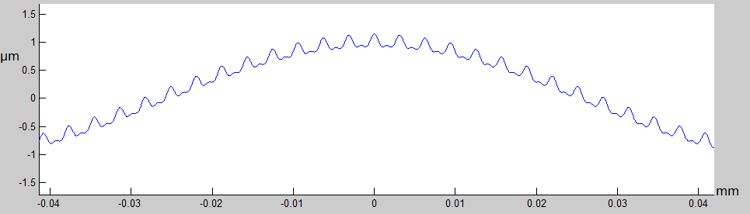
Fig. 5The function curve obtained by three order expansion function
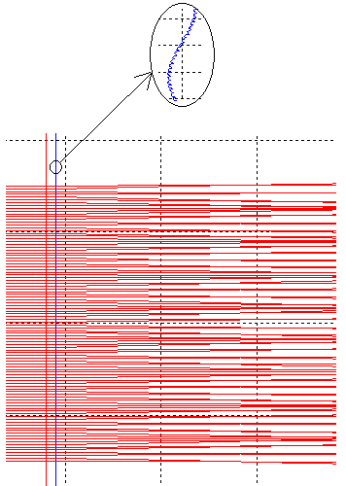
Fig. 6The ray tracing results in Matlab
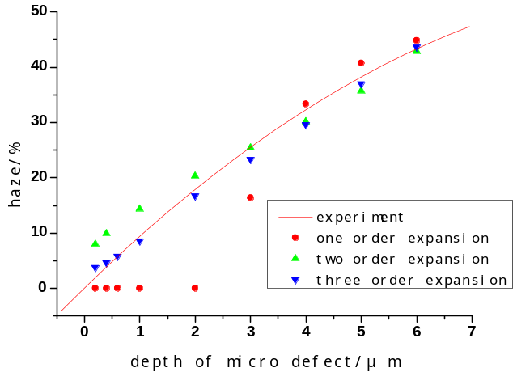
Fig. 7The relationship between the depth of micro-defect and haze in the expansion function of different order.
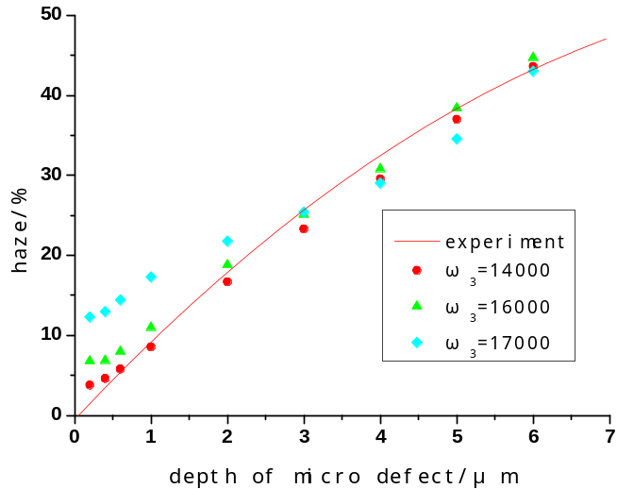
Fig. 8 the relationship between the depth of micro-defect A₁ and haze in different frequency ω₃
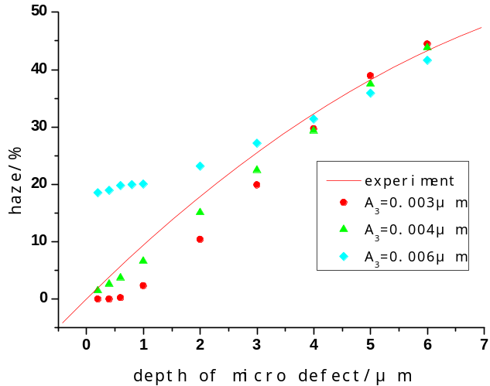
Fig. 9 The relationship between the depth of micro-defect A₁ and haze in different amplitude A₃
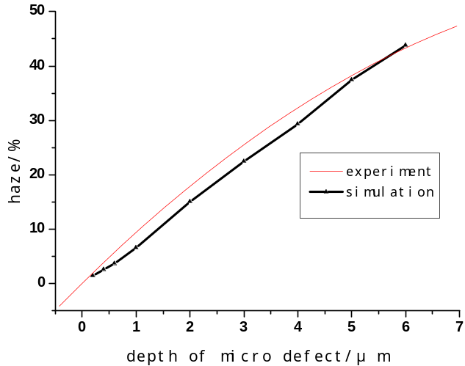
Fig. 10 The comparison of the haze of experimental and simulation results

