Information-Energetic Thermodynamics: A Public-Benchmark Demonstration of the VIRR Framework for Physical Decision Efficiency
Martin Petrásek
Institute for Resonant Synthesis and Field Physics (IRSFP), Prague, Czech Republic
martin.petrasek@irsfp.org
Abstract
Energy efficiency in information-processing hardware is usually reported through throughput-per-power metrics such as OPS/W or TOPS/W. These metrics count arithmetic activity, but they do not determine whether the physical process has produced a stabilized irreversible informational outcome. We present Information-Energetic Thermodynamics (IET), an operational framework in which the elementary observable is a stabilized irreversible decision event satisfying localization, distinguishability, stability, and positive entropy-production criteria. We distinguish three quantities: full physical VIRR, task-level VIRR, and TOPS/W-derived VIRR estimates. Public MLPerf Tiny v1.3 power submissions demonstrate the computability and cross-submission applicability of the energy-normalized task layer, not all thermodynamic conditions of full VIRR. Across 27 public power results, task-level VIRR spans approximately 2.73e-2 to 3.17e4 benchmark outcomes per joule, with workload-specific summaries, trial variability, and bootstrap intervals. A controlled proof-of-concept analysis then demonstrates mathematically how ranking reversal can occur once valid-output probability, rejection, retention, conversion, and control costs are included. The framework therefore complements TOPS/W by exposing when energy is converted into accepted stable outcomes rather than raw activity.
Keywords: information thermodynamics, stochastic thermodynamics, irreversible decisions, VIRR, VLSI, MLPerf Tiny, compute-in-memory
1 INTRODUCTION
Modern VLSI and AI-hardware papers commonly report FLOPS/W, OPS/W, TOPS/W, latency, energy per operation, or energy per inference. These quantities are indispensable engineering metrics, but they do not specify whether the counted physical activity has reached a stable, distinguishable, and irreversible decision state. A multiply-accumulate operation may be a transient primitive inside a larger computation; a threshold crossing may be rejected by a later stability check; and a dissipative fluctuation may produce entropy without becoming an accepted output.
The distinction is practically important for edge AI, compute-in-memory, neuromorphic processors, stochastic devices, and measurement-based hardware. Their useful result is often not a raw operation but a retained classification, a latched bit, a stable pointer state, or a memory state that survives a declared operational window. This paper defines an event-level efficiency metric for that layer. The Valid Irreversible Resolution Rate is
VIRR = Rᵢᵣᵣ / P,
where R_irr is the long-time rate of valid stabilized irreversible decision events and P is the net supplied power assigned to the declared protocol boundary. The central claim is modest: VIRR complements conventional throughput metrics by normalizing energy to accepted stable outcomes rather than raw activity.
The present revision addresses the main experimental concern. It adds a public-benchmark demonstration layer, a complete extraction algorithm, sensitivity and uncertainty procedures, and benchmark comparisons. The theoretical structure of IET remains unchanged: Landauer's principle, stochastic thermodynamics, and coarse-grained metastable dynamics provide the background; VIRR supplies an auditable reporting observable.
2 RELATION TO STANDARD METRICS
Landauer's principle bounds the minimum average work for a specified logically irreversible map, such as erasing one uniformly random bit. Stochastic thermodynamics assigns work, heat, and entropy production to ensembles of trajectories. Information theory measures correlations independently of the device mechanism that stabilizes them. VIRR is different in its counting unit: it counts declared stable outcomes per net supplied energy.
Metric | Primary quantity | Includes stabilization? | Typical missing boundary
FLOPS/W or OPS/W | Arithmetic activity per power | No | Readout, rejected attempts, retention
TOPS/W | Peak or workload operation rate per power | No | Mapping from operations to accepted outputs
Energy/inference | Task energy per model inference | Partly | Residence time and physical state stability
Entropy production | Trajectory irreversibility | No event count by itself | Accepted macroscopic outcome
VIRR | Valid stable outcomes per net supplied energy | Yes | Requires declared event rule and energy boundary

This comparison is why VIRR should be reported alongside, not instead of, conventional metrics. A digital accelerator whose every operation is already an accepted stable output may yield a VIRR ranking close to energy-per-operation. An analog or stochastic system can show the opposite: high internal activity and high entropy production but few accepted stable decisions.
The distinction is also a response to a common ambiguity in accelerator papers. A reported TOPS/W value may refer to a dense inner product, a sparsity-adjusted operation count, a matrix-vector primitive, a whole neural-network layer, or a full task. VIRR requires the author to declare which physical event is counted and what energy boundary is charged to that event. This makes comparisons more conservative, but it also makes them more reproducible.
3 OPERATIONAL DEFINITION
Consider an open physical system with state x, externally controlled protocol λₜ, and reservoirs characterized by temperature T and possibly other intensive variables. The state space is coarse-grained into metastable regions C = {C₁, ..., Cₙ}, each corresponding to a macroscopically distinguishable attractor or output class.
A candidate transition Cᵢ → Cⱼ is counted only if four tests pass. Localization requires that the final probability mass is concentrated in Cⱼ within a declared tolerance. Distinguishability requires that Cⱼ is resolvable by the measurement apparatus. Stability requires a residence or retention time above the operational threshold τ*. Irreversibility requires positive conditional mean entropy production for the accepted event ensemble.
Σ_event = E[Σ | valid event] > 0.
These conditions are independent. A dissipative excursion may fail stability; a reversible relabelling may be distinguishable without constituting an irreversible decision; and a noisy crossing may fail localization. Energy spent on failed attempts remains in the denominator because it is part of the protocol energy required to produce accepted outcomes.
For a digital classification accelerator the declared attractors may be final output classes. For an RRAM bit cell they may be HRS and LRS resistance intervals. For a neuromorphic processor they may be spike-coded labels followed by a decision latch. For a quantum measurement platform they may be stabilized pointer states. The framework does not prescribe one universal coarse-graining; it requires that the chosen coarse-graining be stated and audited.
4 DEFINITION AND BOUND
Let N_irr(Delta t) be the number of valid irreversible decision events observed over an acquisition window and E_sup(Delta t) the supplied energy within the declared boundary. In a stationary regime,
Rᵢᵣᵣ = lim_{Δt→∞} Nᵢᵣᵣ(Δt)/Δt, P = lim_{Δt→∞} E_sup(Δt)/Δt.
VIRR = Rᵢᵣᵣ/P = 1/Ē_event.
Under an isothermal event decomposition, the mean supplied energy per valid event can be written as
Ē_event = W_rev,event + TΣ_event + E_over,
where Σ_event denotes physical entropy production per accepted event in J/K throughout this paper. With this convention TΣ_event has units of joules; if a dimensionless stochastic-thermodynamic entropy production is used instead, the corresponding energetic term is kBTΣ_event. E_over includes control, synchronization, conversion, readout, retention, error mitigation, housekeeping, and failed attempts allocated per valid event. When W_rev,event > 0, Σ_event ≥ 0, and E_over ≥ 0,
This is an accounting equality within the declared isothermal convention and after including any net state-energy change in W_rev,event or in the explicitly reported energy ledger. More general multi-reservoir, non-isothermal, chemical, or work-recovery protocols require an expanded ledger rather than a silent reuse of this three-term form.
VIRR ≤ 1/W_rev,event.
This ceiling is not asserted for every physical transition. It applies only for the same event definition, the same coarse-graining, and the same input distribution used to define W_rev,event. W_rev,event depends on the logical map and its input statistics; if the declared map has zero reversible work, the normalized efficiency relative to this ceiling is undefined, although the empirical VIRR remains meaningful as outcomes per joule.
The overhead term is not a nuisance parameter to hide. It is often the engineering content of the measurement. In compute-in-memory systems, for example, array multiplication can be efficient while ADC/DAC conversion, calibration, word-line drivers, routing, refresh, or output latching dominate the energy required to produce one stable task result. VIRR intentionally places these contributions in the denominator once they are inside the declared decision boundary.
5 THREE LEVELS OF VIRR
To avoid overclaiming, this paper uses three explicitly separated quantities. Full physical VIRR is the target laboratory metric. Task-level VIRR is a public-benchmark proxy when the benchmark defines a completed output and reports task energy. Estimated VIRR is an operation-derived calculation from TOPS/W and a declared operation count per accepted output.
VIRR_full = lim_{Δt→∞} N_valid(Δt) / E_sup(Δt).
Here valid means that localization, distinguishability, stability, and positive conditional entropy production are all satisfied. MLPerf Tiny does not provide enough microscopic state or trajectory information to establish this full condition.
VIRR̂_full = N_valid / E_sup.
The hatted quantity is the finite-dataset estimator used in a laboratory report; the asymptotic rate form is the underlying metric.
VIRR_task = N_benchmark outcomes / E_task.
This is the quantity directly computed from public MLPerf Tiny power files. It is an energy-normalized task-layer observable.
VIRR_est = η_ops × 10¹² / M.
This is only an estimate derived from TOPS/W and the number M of operations assigned to one accepted output. Every figure and table below labels which level is being reported.
6 EXTRACTION ALGORITHM
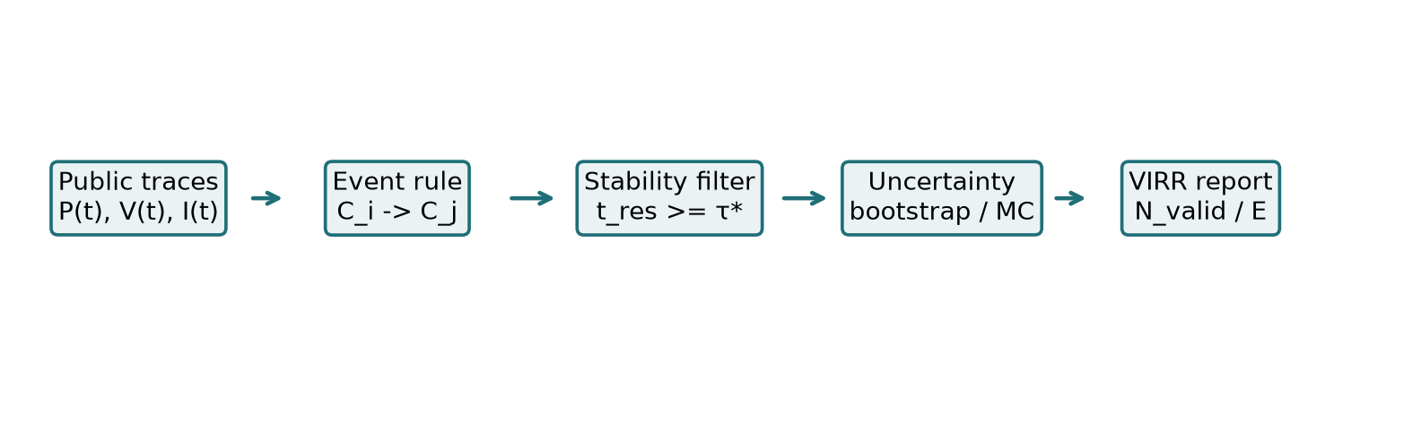
Figure 1. Operational pipeline for extracting VIRR from public or laboratory data.
Algorithms 1A and 1B give the auditable extraction procedures requested by reviewers. They separate the full physical metric, which requires trajectories and entropy-production evidence, from the public task-level transformation used for MLPerf Tiny.
Algorithm 1A - Full physical VIRR.
Algorithm field | Operation
Input | Power trace P(t) or event energies Eᵢ; state trajectory x(t), or an experimentally justified coarse-grained output trajectory y(t) sufficient for the chosen entropy-production estimator; partition C; resolution threshold θ; stability window τ*; entropy-production estimator Σ[Γ]; acquisition interval Δt.
Step 1 | Declare the system boundary and subtract the idle baseline only if the same baseline is measured under the same environmental conditions.
Step 2 | Map raw trajectories or outputs to candidate transitions Cᵢ → Cⱼ using the declared resolution rule.
Step 3 | Reject candidates that fail localization, distinguishability, or residence time. Apply the entropy-production criterion at the declared conditional ensemble level unless a justified trajectory-level test is available.
Step 4 | Count N_valid and N_rejected; integrate E_sup = ∫P(t)dt or sum event energies over both accepted and rejected attempts.
Step 5 | Compute the finite estimator VIRR̂_full = N_valid/E_sup and report the equivalent rate form Rᵢᵣᵣ/P.
Step 6 | Estimate uncertainty using counting statistics, power uncertainty, bootstrap resampling, and Monte Carlo propagation of threshold choices.
Output | VIRR_full, confidence interval, event definition, energy boundary, N_valid, N_rejected, τ*, θ, Σ[Γ], and reproducibility metadata.

Algorithm 1B - Public task-level VIRR transformation.
Algorithm field | Operation
Input | Public benchmark result with reported energy per completed outcome E_outcome, workload name, quality-compliance status, and result-file provenance.
Step 1 | Accept only submissions that satisfy the benchmark-wide quality requirement; do not infer per-sample correctness from aggregate energy files.
Step 2 | Treat one completed inference from a quality-compliant submission as one task-level benchmark outcome.
Step 3 | Compute VIRR_task = 1/E_outcome, using unit conversion E_outcome[ J ] = E_outcome[µJ] × 10⁻⁶.
Step 4 | Report workload median, range, best-system value, trial variability, bootstrap interval when n ≥ 2, commit hash, parser version, and file checksums.
Output | VIRR_task and reproducibility ledger; no claim of microscopic entropy production or residence-time validation.

A minimal implementation can be written in fewer than twenty lines once the data are available: integrate the active energy trace or read the task energy; apply the declared event predicate; count only accepted events at the chosen layer; and divide accepted count by total supplied energy. The scientific difficulty is not the arithmetic but the transparent declaration of the event predicate and boundary.
7 PUBLIC-BENCHMARK DEMONSTRATION
The strongest immediately reproducible validation is public MLPerf Tiny power data. MLPerf Tiny was designed to measure accuracy, latency, and energy for ultra-low-power inference. For this layer, a completed inference produced by a submission that satisfies the benchmark-wide quality requirement is treated as a task-level benchmark outcome. This means N_outcomes is not the same as the number of individually correct samples; per-sample correctness is not recoverable from the public power files. The task-level proxy is
VIRR_task = 1/E_outcome.
Using the public MLPerf Tiny v1.3 results repository, 27 power-result files were parsed. The median energy-per-outcome values in the submitted result files were converted to outcomes/J. The calculation is direct: if a submission reports 31.537 µJ/outcome, then VIRR_task = 10⁶/31.537 = 3.17e4 outcomes/J. Accuracy-derived quality scores are used only when the quality statistic is an empirical accuracy fraction.
7.1 Reproducible MLPerf Tiny methodology
The public calculation uses exactly one MLPerf Tiny release: v1.3. For every power result file, the parser extracts all submitted Energy/Inf trial values, the submitted median energy cost, benchmark name, submitter, system, accuracy fields when present, and source file path. The complete 27-row calculation is archived as mlperf_tiny_v1_3_virr_reproducibility_table.csv; the article reports workload-level summaries to avoid mixing KWS, VWW, IC, AD, and streaming wake-word tasks into one artificial leaderboard.
Reproducibility item | Value
Repository release | MLPerf Tiny v1.3
Commit | cd605ea0981306693c9e19765a15801c776988dc
Parser version | 1.0
Processing date | 2026-08-01
Supplement S1 | mlperf_tiny_v1_3_virr_reproducibility_table.csv; full SHA-256 f91ab7618e2042d714b1faa3022834243ea869177a359b6e28dadac84ac40c86
Supplement S2 | reproduce_mlperf_tiny_v1_3_virr.py; full SHA-256 12b2c24812fd7affa70da536e9416ae5ba17176c7e7fdef261d7873a131e8066

E_med [J/outcome] = median(E_inf,k [µJ/outcome]) × 10⁻⁶.
VIRR_task [outcomes/J] = 10⁶ / median(E_inf,k [µJ/outcome]).
CV_E [%] = 100 × std(E_inf,k) / mean(E_inf,k).
Classification Top-1 accuracy and anomaly-detection AUC are reported as benchmark quality descriptors, not folded into VIRR_task and not interpreted as counts of correct inferences. For n = 1 submissions, a bootstrap confidence interval is not estimated; for n = 5, the bootstrap captures only within-submission trial variability, not inter-lab or calibration systematic error.
The parser and derived CSV are provided as supplementary files S1 and S2. If the paper is submitted through a venue portal, the same files should be uploaded as supplementary material; if a public repository is used, S1 and S2 should be deposited without modification so that their SHA-256 digests match the table above.
7.2 Worked public-data calculations
Submitter | Task | Median µJ/out | Substitution | VIRR_task out/J | Quality | Bootstrap 95% CI
syntiant | kws | 31.54 | 10⁶/31.54 | 31708.79 | - | 31,636-31,793
STMicroelectronics | ad | 31.83 | 10⁶/31.83 | 31412.26 | AUC=0.862 | 31,397-31,430
STMicroelectronics | vww | 3030 | 10⁶/3030 | 330.06 | Top-1 85.2% | 329.2-330.5
STMicroelectronics | sww | 3.663e+07 | 10⁶/3.663e+07 | 0.03 | - | not estimable

Example: for the Syntiant keyword-spotting entry, E_med = 31.537 µJ/outcome = 31.537 × 10⁻⁶ J/outcome. Therefore VIRR_task = 1/(31.537 × 10⁻⁶) = 31,708.79 outcomes/J. For the STMicroelectronics anomaly-detection entry, E_med = 31.8347 µJ/outcome, so VIRR_task = 31,412.26 outcomes/J; its AUC is reported separately and is not counted as correct outcomes/J.
7.3 Results by workload
Workload | n | Best public system | Best-system energy [µJ/out] | Workload median energy [µJ/out] | Workload energy range | Best-system VIRR_task | trials/CV% | 95% CI | Quality
ad | 3 | STMicroelectronics / U385RG_Q | 31.8 | 77.2 | 31.8-160 | 3.14e+04 | 5 / 0.04% | 31,397-31,430 | AUC 0.862
ic | 5 | syntiant / S9120_0v9_30mhz | 102 | 966 | 102-5.5e+03 | 9.82e+03 | 5 / 0.08% | 9,804-9,825 | Top-1 87.0%
kws | 5 | syntiant / S9120_0v9_30mhz | 31.5 | 245 | 31.5-1.43e+03 | 3.17e+04 | 5 / 0.19% | 31,636-31,793 | Top-1 90.2%
sww | 9 | syntiant / S9120_1v0_49mhz | 6.09e+05 | 1.38e+07 | 6.09e+05-3.66e+07 | 1.64 | 1 / 0.00% | not estimable | -
vww | 5 | syntiant / S9120_0v9_30mhz | 71.7 | 519 | 71.7-3.03e+03 | 1.39e+04 | 5 / 0.07% | 13,921-13,949 | Top-1 85.2%

The workload-separated view is the relevant comparison. KWS, VWW, IC, AD, and SWW differ in model structure and benchmark semantics; the table therefore reports the best system, median workload energy, energy range, trial count, CV, bootstrap interval when estimable, and quality statistic inside each workload rather than ranking all tasks together.
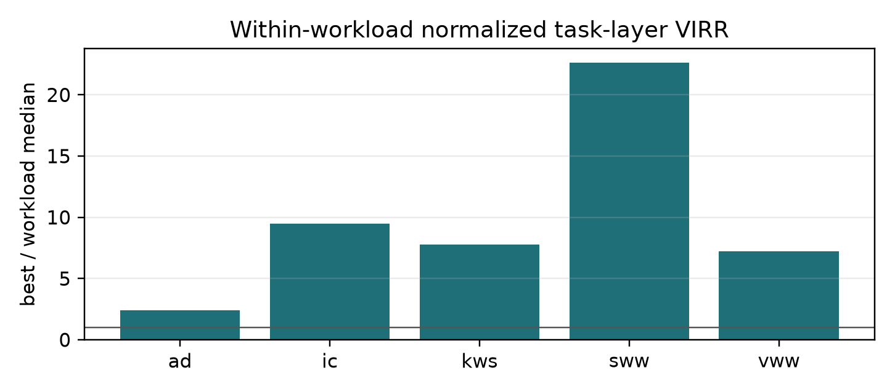
Figure 2. Within-workload normalized task-level VIRR. The plotted value is VIRR_i divided by the median VIRR of its own workload, so the panel does not visually compare incomparable workloads as one absolute leaderboard.
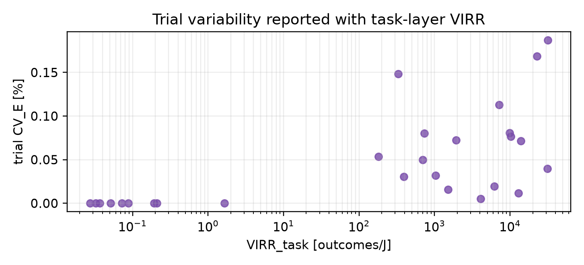
Figure 3. Within-submission trial variability versus task-layer VIRR. The plot adds measurement context to the reciprocal energy transformation rather than serving as a second definition of VIRR_task.
This is a real public-data demonstration of the metric's energy-normalized counting layer. It does not claim to recover microscopic entropy production inside each accelerator. Instead, it demonstrates the computability and cross-submission applicability of the energy-normalized task layer.
A high normalized value in Figure 2 indicates dispersion within that workload, not superior absolute efficiency across workloads. Accuracy and AUC remain separate benchmark quality descriptors; the main VIRR_task tables do not convert them into counts of directly observed correct outcomes.
The calculation also shows why VIRR is a useful reporting layer even when it numerically equals the reciprocal task energy. MLPerf Tiny already defines a completed benchmark outcome and a quality rule. VIRR_task therefore makes the event boundary explicit and expresses all devices in the same outcome-per-joule unit. A future physical VIRR submission would add retention and trajectory information to the same table rather than replacing it.
8 STABILITY- AND OVERHEAD-ADJUSTED RANKING REVERSAL
The MLPerf calculation by itself is intentionally conservative: VIRR_task = 1/E_task is an auditable task-layer transformation. The ranking reversal below is therefore not presented as a public-data result; it is a controlled proof-of-concept analysis showing how rankings can change once valid-output probability and stabilization overhead are measured. Define
VIRR_adjusted = p_valid / (E_raw + E_retain + E_reject + E_control + E_convert).
The following normalized example compares three architectures with similar operation-level efficiency. Architecture A has lower raw energy than B, but B has higher valid-output probability and lower stabilization overhead. This gives E_A,raw < E_B,raw while VIRR_A,adjusted < VIRR_B,adjusted, showing mathematically that VIRR is not merely renamed task energy once the additional physical ledger is observed.
The parameter set is illustrative and was selected to expose the ranking-reversal mechanism; it is not fitted to the MLPerf devices.
Arch. | TOPS/W | E_raw | p_valid | E_retain | E_reject | E_ctrl+conv | E_total | 1/E_raw | VIRR_adj
A | 80 | 1.00 | 0.72 | 0.20 | 0.38 | 0.35 | 1.93 | 1.00 | 0.37
B | 80 | 1.08 | 0.95 | 0.04 | 0.05 | 0.18 | 1.35 | 0.93 | 0.70
C | 82 | 0.92 | 0.58 | 0.30 | 0.65 | 0.45 | 2.32 | 1.09 | 0.25

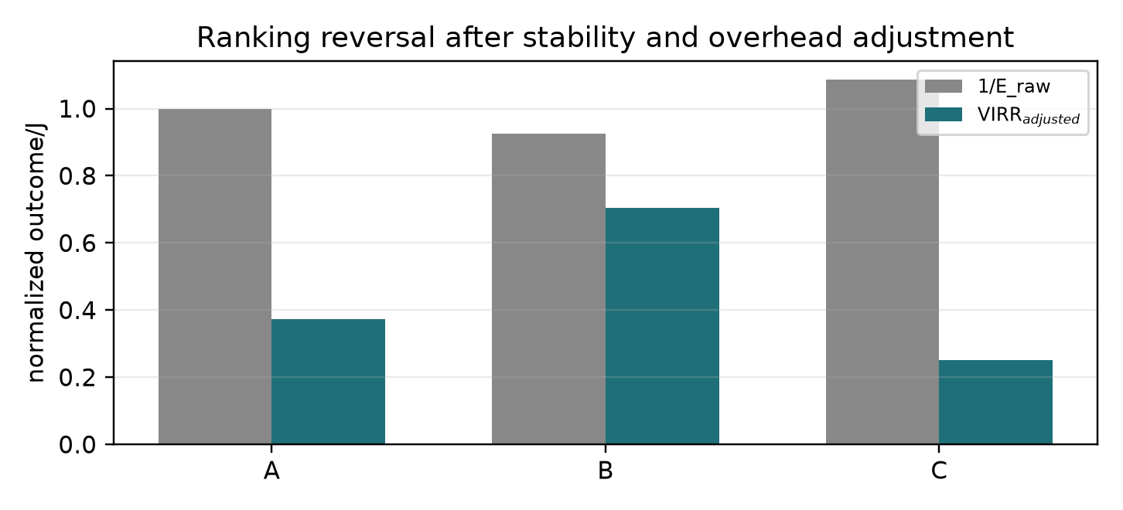
Figure 4. Controlled proof-of-concept ranking reversal: architecture A looks better by raw energy, but B wins after stability and overhead adjustment.
9 PUBLIC REPORTING SUFFICIENCY AUDIT
Public VLSI and compute-in-memory papers often report operation-normalized metrics rather than event-normalized energy. These reports are still useful for VIRR, but only after declaring how many operations produce one accepted stable output and which overheads are included. If a device reports eta_ops TOPS/W and an accepted task output requires M operations, then the operation-derived estimate is
VIRR_est = η_ops × 10¹² / M.
This estimate becomes a full VIRR only when it includes conversion, control, readout, retention, rejection, and the stability window. Table 3 therefore separates direct public calculation from audit-ready but incomplete public reporting.
9.1 Worked TOPS/W to VIRR_est conversions
For CIM reports that publish TOPS/W but not energy per final inference, the conversion is still mathematically explicit once the number of operations per accepted output is declared. Let η be the reported TOPS/W and M the number of operations required for one accepted output. Because 1 TOPS/W = 10¹² operations/J,
E_est,event = M / (η × 10¹²), VIRR_est = (η × 10¹²) / M.
The table below uses the public 2025 SRAM-CIM range 20.9–137.2 TOPS/W as a worked conversion template. It is not a substitute for full VIRR because it excludes conversion, control, readout, retention, and rejected attempts unless those are already included in the measured power boundary.
eta [TOPS/W] | M ops/output | E_est,event [J] | VIRR_est [output/J]
20.9 | 1e+06 | 4.785e-08 | 2.090e+07
20.9 | 1e+07 | 4.785e-07 | 2.090e+06
20.9 | 1e+08 | 4.785e-06 | 2.090e+05
137.2 | 1e+06 | 7.289e-09 | 1.372e+08
137.2 | 1e+07 | 7.289e-08 | 1.372e+07
137.2 | 1e+08 | 7.289e-07 | 1.372e+06

Example: at 137.2 TOPS/W and M = 10⁷ operations per accepted output, E_est,event = 10⁷/(137.2 × 10¹²) = 7.29e-8 J, so VIRR_est = 1.37e7 output/J before adding overhead and rejected attempts. If the actual accepted-output ledger adds E_over, the full value becomes VIRR = 1/(E_est,event + E_over).
Architecture | Direct task VIRR | VIRR_est | Full physical VIRR | Evidence level
MLPerf Tiny v1.3 | Yes: VIRR_task from power files | Yes, if operations/output are declared | No: no state trajectories or retention tests | Direct public calculation at task layer
NeuRRAM RRAM-CIM | Only if per-task energy boundary is published | Yes: derived estimate from published TOPS/W or EDP data | No: public paper lacks full trajectory entropy and residence ledger | Published-data estimate only
RRAM-CIM macros | Usually no final task outcome | Yes: TOPS/W to VIRR_est | Dataset-dependent if raw switching/retention traces are public | Partial
Loihi-class systems | Partly for reported benchmark energy | Yes with operation/event mapping | No without stable decision and entropy-production record | Partial
Mythic analog matrix processor | Deployment-data dependent | Yes from public TOPS/power claims | No without measured task energy and persistence rule | Product-level estimate

The negative information in this table is valuable. A paper that reports only TOPS/W is not wrong; it simply reports a different layer. VIRR asks for the next ledger: how much energy produced one accepted stable output under a reproducible event rule.
9.2 Architecture-level energy ledger and ablation
For a VLSI inference system, the mean decision energy can be written as a mutually exclusive ledger
Ē_decision = E_compute + E_data + E_convert + E_control + E_retain + E_reject.
E_compute covers arithmetic or analog accumulation, E_data covers memory movement and routing, E_convert covers ADC/DAC and level conversion, E_control covers sequencing and synchronization, E_retain covers the declared persistence interval, and E_reject allocates failed or rejected attempts per accepted decision. Conventional TOPS/W probes mainly E_compute and sometimes part of E_data. VIRR probes the whole declared chain up to accepted stabilization.
If each accepted output requires M primitives of mean energy E_op and all other costs are grouped into E_over, then
VIRR approx 1 / (M E_op + E_over).
This expression explains why two accelerators with similar TOPS/W can have different stabilized-outcome efficiency. One may spend energy in conversion or refresh; another may reject more candidate outputs; a third may require more primitives per accepted result. VIRR exposes these architectural differences without discarding the conventional throughput metrics.
The following ablation is counterfactual. It ranks ledger contributions in the normalized example by recomputing VIRR after removing one term at a time; it does not imply that any component can be reduced to zero in a physically realizable device.
Removed term | E_i | E_without_i | VIRR_-i | Δ VIRR
compute | 0.90 | 1.30 | 0.769 | 69.2%
convert | 0.38 | 1.82 | 0.549 | 20.9%
reject | 0.30 | 1.90 | 0.526 | 15.8%
data | 0.24 | 1.96 | 0.510 | 12.2%
retain | 0.22 | 1.98 | 0.505 | 11.1%
control | 0.16 | 2.04 | 0.490 | 7.8%

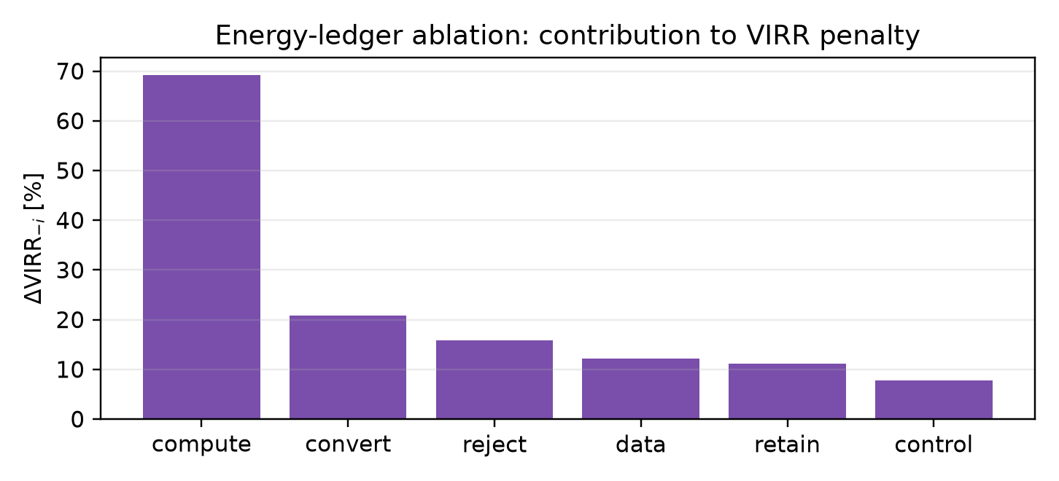
Figure 5. Ledger ablation identifies which energy term most limits VIRR in the normalized example.
10 SENSITIVITY ANALYSIS
VIRR depends on operational choices that should be reported, not hidden. The most important are the stability window τ*, resolution threshold θ, sampling interval, and noise amplitude. Tightening τ* rejects more candidate transitions. Increasing θ improves distinguishability but can reduce accepted count. Coarse sampling can miss brief returns to the initial attractor and overestimate stability.
The stability calculation uses p_stable(τ*) = exp(−τ*/τ₀) with τ₀ = 0.9, 1.7, and 3.0 in units of τ_op for the three curves. With fixed supplied energy per raw attempt E_raw, the normalized value is
VIRR(τ*) / VIRR(0) = S(τ*) = exp(−τ*/τ₀).
For noise and threshold sweeps, p_valid(σ,θ) = [1 + exp(k(σ − σ_c(θ)))]⁻¹, with k = 10, θ in {0.55, 0.65, 0.75, 0.85}, σ_c(θ) = 1.05 − θ, and E(σ,θ) = 1 + 0.7σ + 0.35θ. The plotted quantity is p_valid/E normalized to its zero-noise value. This is not a device fit; it is a reproducible stress test showing which reported thresholds materially affect the metric.
Parameter | Value | Role in VIRR | Interpretation
Retention τ₀ | 0.9, 1.7, 3.0 τ_op | Controls exponential survival S(τ*) | nondimensional stress-test parameter
Threshold θ | 0.55, 0.65, 0.75, 0.85 | Changes distinguishability and rejection | not fitted to a hardware dataset
Noise σ | 0 to 1 | Perturbs valid-output probability and overhead | relative amplitude
Logistic slope k | 10 | Sets sharpness of transition around σ_c | fixed for reproducibility
Critical noise σ_c(θ) | 1.05 − θ | Couples stricter threshold to lower noise tolerance | model assumption
Energy model E(σ,θ) | 1 + 0.7σ + 0.35θ | Adds noise/threshold overhead | normalized units

These parameters define a nondimensional stress test, not a fit and not a hardware prediction. The purpose is to reveal which threshold declarations would materially change VIRR if the same trend appeared in a measured device.
Sₓ = ∂ln(VIRR) / ∂ln(x).
For the exponential retention model, S_τ* = −τ*/τ₀. Hence long-retention devices have smaller magnitude sensitivity to threshold tightening, while shallow retention devices quickly lose accepted events.
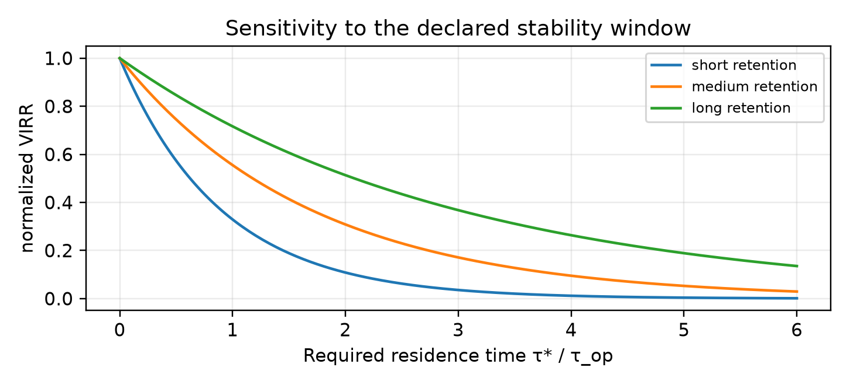
Figure 6. Tightening the residence-time requirement reduces accepted events unless the device is already strongly stable.
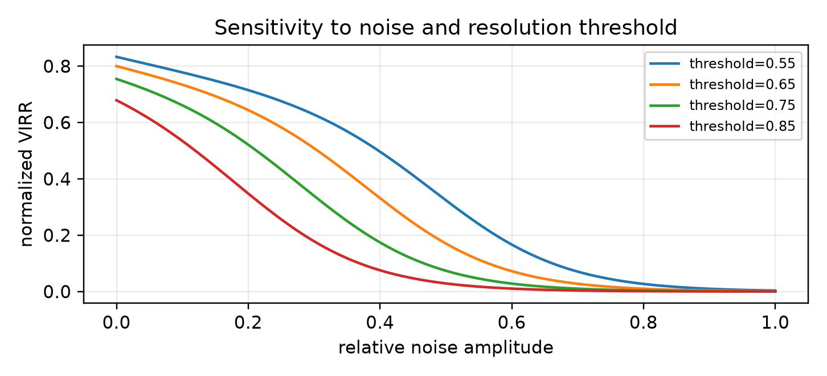
Figure 7. Noise and threshold choices affect VIRR through both rejected events and overhead energy.
A practical sensitivity report should sweep τ*, θ, sampling interval, and baseline subtraction. The result is not a single fragile number but a stability surface. If VIRR changes sharply for small threshold changes, the device is near the resolution limit and the paper should report that fact explicitly.
11 UNCERTAINTY ANALYSIS
For independent event-count and power measurements, the small-error approximation is
ΔVIRR / VIRR = √[(ΔN/N)² + (ΔE/E)²].
The more general first-order propagation includes covariance between accepted event count and supplied energy:
Var(VIRR)/VIRR² ≈ Var(N)/N² + Var(E)/E² − 2Cov(N,E)/(NE).
The covariance term matters when producing more accepted outcomes also increases active energy, or when a shared baseline subtraction affects both the event filter and the energy denominator.
For event counts, ΔN may be approximated by √N for independent Poisson counts, or by √(n p_valid(1−p_valid)) when n candidate events are filtered by a binomial acceptance process. These statistical terms must be separated from systematic calibration uncertainty.
For public benchmark files with repeated trials, bootstrap resampling is used only when n >= 2. Resample the trial energies with replacement, recompute the median energy and VIRR_task, and report the 2.5th and 97.5th percentiles as a 95% interval. For n = 1, the table reports that CI is not estimable from a single submitted trial. For n = 5, the interval captures only within-submission trial variability.
For active/idle subtraction, Var(P_active - P_idle) = Var(P_active) + Var(P_idle) - 2 Cov(P_active,P_idle). A shared instrument, temperature drift, or common supply noise can make the covariance term non-negligible. A multiplicative calibration uncertainty u_cal should be reported separately, or combined as Var_total approx Var_stat + (u_cal E_sup)^2.
For a full laboratory dataset, the Monte Carlo calculation is: draw P_active, P_idle, threshold θ, stability window τ*, and calibration constants from their measured distributions; re-run the event filter; recompute N_valid and E_sup; then form VIRR for each draw. The confidence interval is the percentile interval of the resulting VIRR ensemble. This procedure captures threshold-induced changes in N_valid, not only analog power-meter uncertainty.
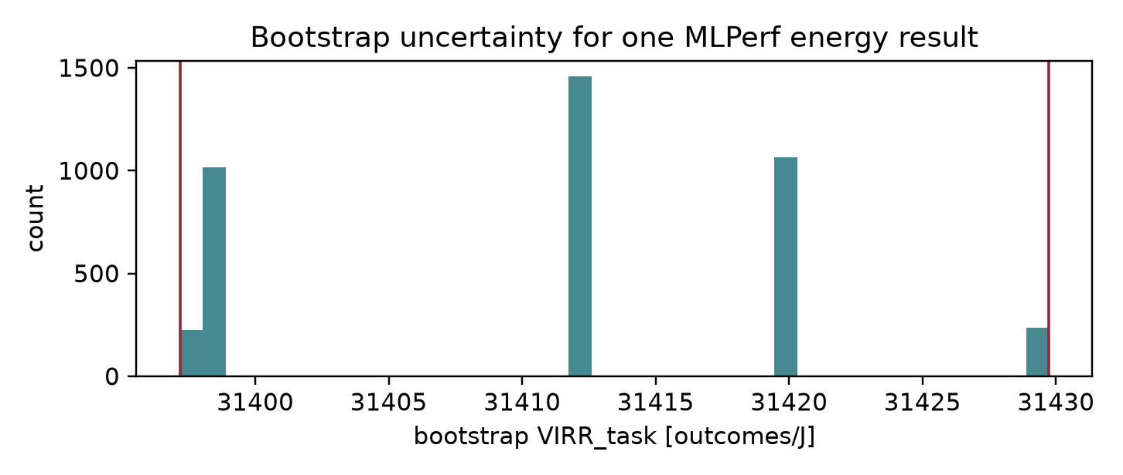
Figure 8. Example bootstrap confidence interval from repeated MLPerf Tiny energy trials.
The uncertainty model must be tied to the energy boundary. If P_switch = P_active - P_idle and the two powers are close, the uncertainty in the difference can dominate. In that regime a high VIRR value with a large confidence interval is less informative than a lower value with a well-controlled boundary.
12 BISTABLE LANGEVIN MODEL
The original bistable Langevin model is retained as the minimal theoretical example. For an overdamped coordinate in V(x,λₜ) = ax⁴ − b(t)x² − h(t)x, the unbiased reference minima define two metastable regions and the barrier controls the escape time. A controlled protocol lowers or tilts the barrier and the event is accepted only when the final basin remains occupied for τ*.
x± = ±√(b/(2a)), ΔV = b²/(4a).
The closed-form extrema and barrier height refer to the unbiased reference landscape (h = 0); during the tilted switching protocol, instantaneous barriers must be evaluated from the full cubic stationarity condition.
γẋ = −∂ₓV(x,λₜ) + ξ(t), ⟨ξ(t)ξ(t′)⟩ = 2γkBTδ(t−t′).
In the weak-noise regime the Kramers escape estimate gives a reference stability time
k_esc = √(V″(x_min)|V″(x_b)|)/(2πγ) exp[−ΔV/(kBT)], τ_esc = 1/k_esc.
The stability condition in the event definition is then τ_esc ≫ τ_op or, in a directly measured device, residence time above the declared window τ*. During a switching protocol the trajectory work is
W[Γ] = −∫₀^τ [xₜ²ḃ(t) + xₜḣ(t)]dt.
For accepted trajectories, the conditional work decomposition is ⟨W_event⟩ = W_rev,event + TΣ_event. Near the quasistatic regime, the total excess physical entropy production per event is modeled as Σ_event = κ/τ + O(τ⁻²) for a fixed control path, where κ has units of J·s/K so that κ/τ is in J/K. This is an event-integrated entropy convention, not an entropy-production rate. Thus faster switching can improve latency while reducing normalized VIRR through additional dissipation and rejected unstable transitions.
13 NON-REDUCIBILITY TO ENTROPY PRODUCTION
The model also clarifies why total entropy production alone cannot determine VIRR. Two protocols may dissipate the same total entropy while producing different numbers of stable accepted outcomes. Entropy production is necessary under the present event definition, but an accepted macroscopic event label is additional information.
Consider three protocols with the same supplied energy E_sup over the same interval. Protocol A produces N accepted events, each with conditional mean entropy Sigma_0. Protocol B produces 2N dissipative segments with Sigma_0/2 each, but every second segment stabilizes, so it also produces N accepted events. Protocol C has the same 2N dissipative segments and the same total entropy, but only N/2 crossings satisfy the residence-time test.
Σ_totᴬ = Σ_totᴮ = Σ_totᶜ = NΣ₀.
VIRR_A = VIRR_B = N/E_sup, VIRR_C = (N/2)/E_sup.
Equal total entropy production therefore does not imply equal valid event rate. This is the formal reason the event predicate cannot be removed from the metric.
This is a counterexample at the level of the declared event-counting model, not a claim that the three protocols have already been physically realized.
14 VALIDATION HIERARCHY, LIMITS, AND FALSIFICATION TESTS
A complete validation study should vary protocol duration, stability threshold, workload, and measurement boundary while recording both energy and accepted events. Three signatures are expected. First, at fixed control path and overhead model, increasing protocol duration should reduce finite-time dissipation and move normalized VIRR toward a plateau. Second, tightening the stability threshold should reduce N_valid relative to raw transitions unless the device is already far from its escape boundary. Third, protocols with comparable total entropy production but different stabilization probabilities should yield different VIRR.
The public MLPerf calculation demonstrates the computability and cross-submission applicability of the energy-normalized task layer. Retention datasets validate the stability-filter layer. Stochastic-thermodynamic trajectories validate entropy-production estimation. A single-device complete validation would combine all three by measuring x(t), V(t), I(t), λ(t), temperature, accepted/rejected events, and forward/reverse trajectory probabilities for many repeated transitions.
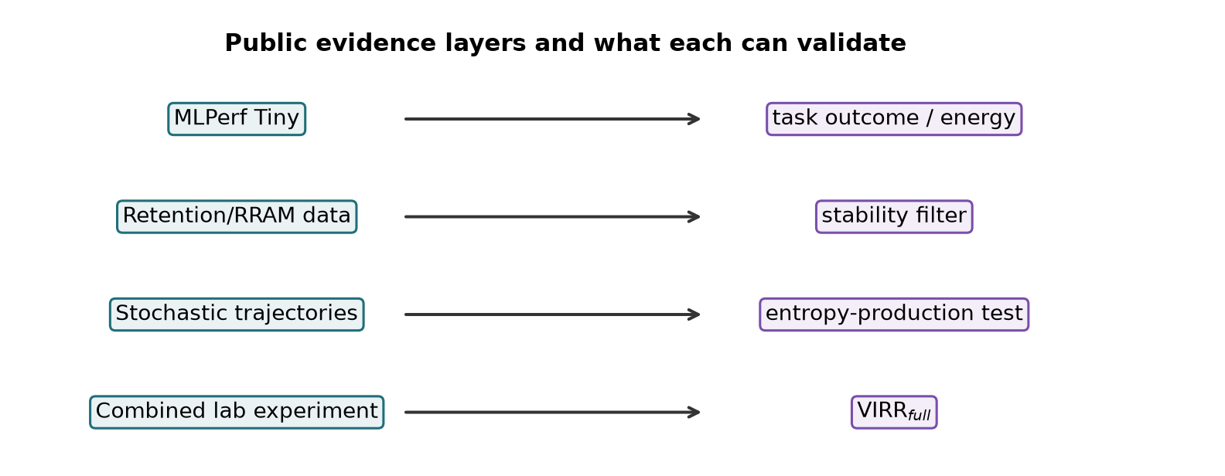
Figure 9. Multi-layer validation hierarchy: public benchmarks demonstrate the task layer; full VIRR requires combined physical trajectories.
Falsification tests are part of the metric. If tightening the stability threshold never changes N_valid, the system is either deeply stable or the measurement lacks temporal resolution. If VIRR always exactly copies 1/E_task, then VIRR adds no new ranking for that architecture. If the energy boundary cannot be reproduced, cross-device comparison is invalid. If conditional entropy production is not positive, the event does not satisfy the full physical definition.
15 WHEN VIRR IS NOT THE RIGHT PRIMARY METRIC
VIRR is least useful when the event boundary is ambiguous, when no stable output is required, when the process is deliberately reversible, or when work recovery is a central part of the device operation. It is also not a substitute for accuracy, latency, area, endurance, or security. For training workloads, data-center batch inference, and analog accelerators with continuous outputs, VIRR should be reported only after a clear accepted-output rule is defined.
A negative result is still useful. If every operation maps one-to-one to a retained irreversible output, VIRR collapses approximately to the reciprocal energy per operation. In that special case conventional reporting is already close to the relevant decision metric.
16 REPORTING PROTOCOL
Item | Required specification
State partition | Declared attractors or output classes C_i.
Resolution rule | Measurement threshold and confusion/error criterion.
Stability window | Residence time, retention threshold, or escape-time criterion.
Energy boundary | Active/idle subtraction, conversion, control, readout, retention, rejected attempts.
Event count | Accepted, rejected, failed, and total candidate transitions over acquisition time.
Uncertainty | Counting error, power calibration, bootstrap/Monte Carlo interval, covariance terms.
Public reproducibility | Dataset version, commit hash, result files, parsing script, and unit conversions.

17 DESIGN IMPLICATIONS
VIRR shifts design attention from primitive activity to accepted stabilization. First, architectures should avoid unnecessary irreversible commitments; intermediate activations need not always be latched or retained. Second, conversion and control overheads should be minimized or amortized only when the accounting boundary makes that amortization explicit. Third, devices should choose the attractor level that matches the application: a memory bit, a layer output, a final classification, a spike-coded decision, or a stabilized measurement pointer.
For edge AI and neuromorphic systems, the useful endpoint is often a low-latency retained decision under a strict energy budget. For compute-in-memory, the key question is whether high array-level TOPS/W survives ADC/DAC, routing, calibration, and output stabilization. For quantum and stochastic hardware, the relevant endpoint may be the stabilized measurement record rather than the reversible evolution preceding it.
18 CONCLUSIONS
IET defines a conservative counting rule for physically stabilized irreversible decisions. VIRR is the rate of accepted stable events divided by net supplied protocol power. The revised article strengthens the original theory with an implementable extraction algorithm, explicit uncertainty and sensitivity procedures, benchmark comparison, and a public-data demonstration layer.
Public benchmark data demonstrate the task-level computability of VIRR. The controlled stability- and overhead-adjusted proof-of-concept then shows mathematically under what additional measured conditions VIRR can change architectural rankings relative to energy-per-inference or TOPS/W. Future work should apply the same protocol to raw trajectories from RRAM cells, noisy latches, analog memory arrays, edge inference processors, and measurement-induced quantum-state stabilization.
REFERENCES
[1] Aldana, S. and Zhang, H., Unravelling the Data Retention Mechanisms under Thermal Stress on 2D Memristors, ACS Omega, vol. 8, no. 30, pp. 27543–27552, 2023, doi: 10.1021/acsomega.3c03200.
[2] Banbury, C. et al., MLPerf Tiny Benchmark, Proceedings of Machine Learning and Systems, 2021; arXiv:2106.07597.
[3] Bennett, C. H., Logical Reversibility of Computation, IBM Journal of Research and Development, vol. 17, no. 6, pp. 525–532, 1973, doi: 10.1147/rd.176.0525.
[4] Ciliberto, S., Experiments in Stochastic Thermodynamics: Short History and Perspectives, Physical Review X, vol. 7, 021051, 2017, doi: 10.1103/PhysRevX.7.021051.
[5] Esposito, M. and Van den Broeck, C., Three Detailed Fluctuation Theorems, Physical Review Letters, vol. 104, 090601, 2010, doi: 10.1103/PhysRevLett.104.090601.
[6] Horowitz, M., Computing's Energy Problem (and What We Can Do About It), IEEE ISSCC Digest of Technical Papers, pp. 10–14, 2014, doi: 10.1109/ISSCC.2014.6757323.
[7] Hu, X., Mun, H., Meng, J., Liao, Y., Sridharan, A. and Seo, J.-S., A 28nm 20.9–137.2 TOPS/W Output-Stationary SRAM Compute-in-Memory Macro Featuring Dynamic Look-ahead Zero Weight Skipping and Runtime Partial Sum Quantization, IEEE Custom Integrated Circuits Conference (CICC), pp. 1–3, 2025, doi: 10.1109/CICC63670.2025.10982878.
[8] Koomey, J. G., Growth in Data Center Electricity Use 2005 to 2010, Analytics Press, 2011, doi: 10.2139/ssrn.2130878.
[9] Landauer, R., Irreversibility and Heat Generation in the Computing Process, IBM Journal of Research and Development, vol. 5, no. 3, pp. 183–191, 1961, doi: 10.1147/rd.53.0183.
[10] Le Gallo, M. et al., A 64-core Mixed-signal In-memory Compute Chip Based on Phase-change Memory for Deep Neural Network Inference, Nature Electronics, vol. 6, pp. 680–693, 2023, doi: 10.1038/s41928-023-01010-1.
[11] MLCommons, MLPerf Tiny v1.3 Results Release, https://mlcommons.org/2025/09/mlperf-tiny-v1-3-results/, accessed 2026-08-01.
[12] MLCommons, MLPerf Tiny v1.3 Public Results Repository, https://github.com/mlcommons/tiny_results_v1.3, accessed 2026-08-01.
[13] Seifert, U., Stochastic Thermodynamics, Fluctuation Theorems and Molecular Machines, Reports on Progress in Physics, vol. 75, 126001, 2012, doi: 10.1088/0034-4885/75/12/126001.
[14] Sivak, D. A. and Crooks, G. E., Thermodynamic Metrics and Optimal Paths, Physical Review Letters, vol. 108, 190602, 2012, doi: 10.1103/PhysRevLett.108.190602.
[15] Tschand, A. et al., MLPerf Power: Benchmarking the Energy Efficiency of Machine Learning Systems from Microwatts to Megawatts for Sustainable AI, arXiv:2410.12032, 2024.
[16] Wan, W. et al., A Compute-in-Memory Chip Based on Resistive Random-Access Memory, Nature, vol. 608, pp. 504–512, 2022, doi: 10.1038/s41586-022-04992-8. Related preprint: arXiv:2108.07879.
[17] Young, A. R. et al., Benchmarking Neuromorphic Hardware and Its Energy Expenditure, Frontiers in Neuroscience, vol. 16, 873935, 2022, doi: 10.3389/fnins.2022.873935.
AUTHORS
Martin Petrásek is an independent researcher at the Institute for Resonant Synthesis and Field Physics (IRSFP), Prague, Czech Republic. His work focuses on information thermodynamics, irreversible decision processes, physical limits of computation, and stability-based metrics for classical, neuromorphic, and quantum architectures.

