UTA Analysis 01
Publication Figures and Summary Statistics
Delayed Repeatability Pilot | Q1 vs Q2 | Verified v18 dataset

Verified Analysis Basis
The uploaded Q1 and Q2 workbooks were matched using the Q2 participant-tracking identifiers. Ten repeat participants contributed five events each, yielding 50 paired event observations and 100 paired individual scores across the two scoring dimensions. Participant names are not shown in the publication figures; anonymized participant IDs are used.

Figure 1. Q1 vs Q2 Scatter Plot
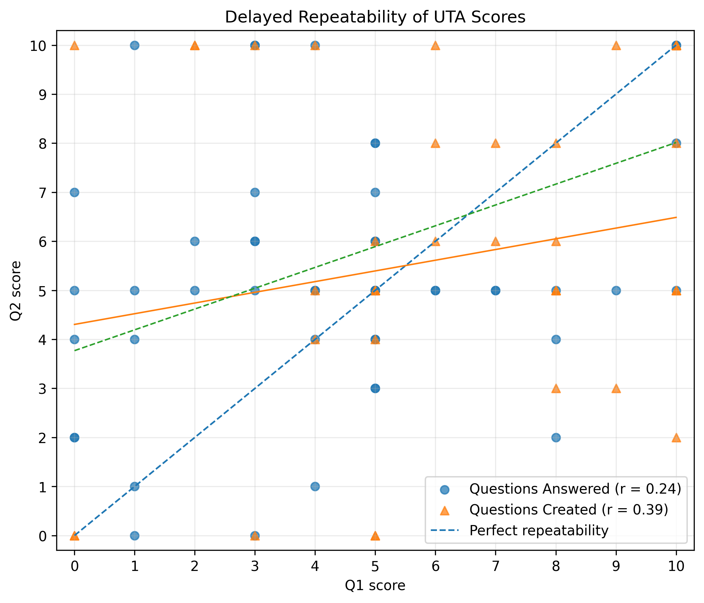
Figure 1. Q1 and Q2 scores for Questions Answered and Questions Created across 50 matched participant-event observations. The diagonal dashed line represents perfect delayed repeatability; solid and dashed fitted lines summarize the two score dimensions.

Figure 2. Participant Stability
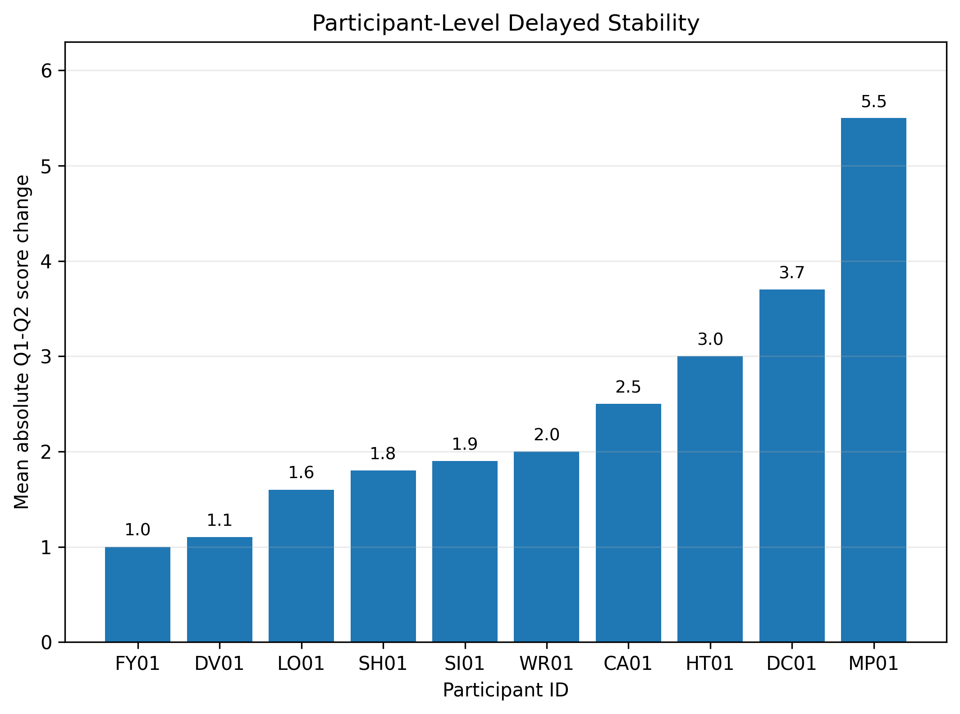
Figure 2. Mean absolute Q1-Q2 score change for each participant across five events and both score dimensions (10 score comparisons per participant). Lower values indicate greater stability.

Table 1. Summary Statistics
Measure | Q1 | Q2 | Repeatability
Participants | 10 | 10 | 10 matched
Events per participant | 5 | 5 | 50 paired event observations
Questions Answered | 4.38 ± 2.82 | 5.26 ± 2.53 | r = 0.243; MAE = 2.60
Questions Created | 7.00 ± 3.12 | 6.74 ± 3.37 | r = 0.392; MAE = 2.22
All score comparisons | 50 scores | 50 scores | Overall MAE = 2.41
Values are mean ± sample standard deviation. r = Pearson correlation; MAE = mean absolute error/change.

Participant Stability Values
Rank | Participant ID | Mean Absolute Change
1 | FY01 | 1.00
2 | DV01 | 1.10
3 | LO01 | 1.60
4 | SH01 | 1.80
5 | SI01 | 1.90
6 | WR01 | 2.00
7 | CA01 | 2.50
8 | HT01 | 3.00
9 | DC01 | 3.70
10 | MP01 | 5.50

Results Interpretation
Across the matched pilot sample, Questions Answered scores increased from 4.38 at Q1 to 5.26 at Q2, while Questions Created scores changed only slightly from 7.00 to 6.74. Delayed correspondence was modest for Questions Answered (r = 0.243) and stronger, though still moderate, for Questions Created (r = 0.392). The overall mean absolute score change was 2.41 points on the 0-10 scale. Participant-level stability varied substantially, with mean absolute change ranging from 1.00 to 5.50.
These results support a descriptive pilot interpretation: some score structure persisted across the delay, particularly for Questions Created, but repeatability was heterogeneous across participants. Because the sample is small and exploratory, the correlations and change scores should be treated as pilot estimates rather than population-level reliability coefficients.
Key Finding
The UTA Delayed Repeatability Pilot demonstrated measurable persistence of participant scoring across a delayed reassessment period. Questions Created exhibited stronger delayed correspondence (r = 0.392) than Questions Answered (r = 0.243), while the overall mean absolute score change remained moderate (MAE = 2.41) on the 0–10 scoring scale.
Although participant-level stability varied, the pilot results suggest that portions of UTA scoring behavior remain consistent over time. These findings provide preliminary evidence supporting the repeatability of UTA assessments and justify continued investigation using larger samples and additional validation studies.

Data Integrity Note
This package corrects the earlier preliminary count of 40 paired observations. The verified v18 Q2 workbook contains five event rows for each of 10 participants, producing 50 paired event observations.

Pilot Study Status: Complete
Analysis Status: Final Preserved Edition
Dataset Version: Verified v18
Publication Classification: Public Release

