1. Seguir los pasos del laboratorio de firebase.
2. Creamos los layouts:

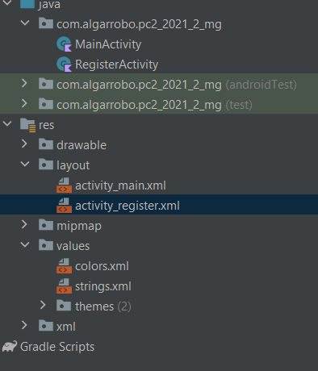

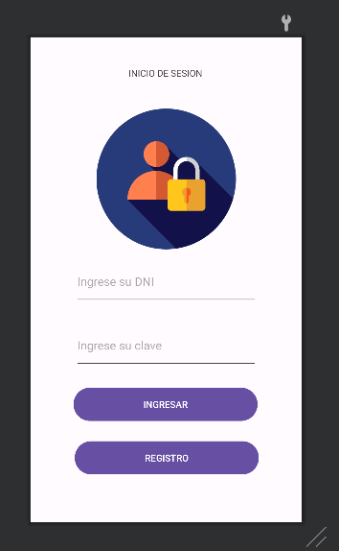

Código xml:

<TextView  
 android:id="@+id/tv1"  
 android:layout_width="wrap_content"  
 android:layout_height="wrap_content"  
 android:layout_marginBottom="44dp"  
 android:text="@string/Iniciosesion"  
 app:layout_constraintBottom_toTopOf="@+id/imageView"  
 app:layout_constraintEnd_toEndOf="parent"  
 app:layout_constraintHorizontal_bias="0.498"  
 app:layout_constraintStart_toStartOf="parent" />  
  
 <ImageView  
 android:id="@+id/imageView"  
 android:layout_width="278dp"  
 android:layout_height="212dp"  
 app:layout_constraintBottom_toTopOf="@+id/edtdni"  
 app:layout_constraintEnd_toEndOf="parent"  
 app:layout_constraintHorizontal_bias="0.503"  
 app:layout_constraintStart_toStartOf="parent"  
 app:layout_constraintTop_toTopOf="parent"  
 app:layout_constraintVertical_bias="0.889"  
 app:srcCompat="@drawable/login" />  
  
 <EditText  
 android:id="@+id/edtdni"  
 android:layout_width="278dp"  
 android:layout_height="71dp"  
 android:ems="10"  
 android:hint="@string/dni"  
 android:inputType="text"  
 app:layout_constraintBottom_toTopOf="@+id/edtclave"  
 app:layout_constraintEnd_toEndOf="parent"  
 app:layout_constraintHorizontal_bias="0.503"  
 app:layout_constraintStart_toStartOf="parent"  
 app:layout_constraintTop_toTopOf="parent"  
 app:layout_constraintVertical_bias="0.929" />  
  
 <EditText  
 android:id="@+id/edtclave"  
 android:layout_width="278dp"  
 android:layout_height="71dp"  
 android:ems="10"  
 android:hint="@string/clave"  
 android:inputType="text"  
 app:layout_constraintBottom_toTopOf="@+id/btningresar"  
 app:layout_constraintEnd_toEndOf="parent"  
 app:layout_constraintHorizontal_bias="0.503"  
 app:layout_constraintStart_toStartOf="parent"  
 app:layout_constraintTop_toTopOf="parent"  
 app:layout_constraintVertical_bias="0.946" />  
  
 <Button  
 android:id="@+id/btningresar"  
 android:layout_width="280dp"  
 android:layout_height="58dp"  
 android:text="@string/btningresar"  
 app:layout_constraintBottom_toTopOf="@+id/btnregistro"  
 app:layout_constraintEnd_toEndOf="parent"  
 app:layout_constraintHorizontal_bias="0.496"  
 app:layout_constraintStart_toStartOf="parent"  
 app:layout_constraintTop_toTopOf="parent"  
 app:layout_constraintVertical_bias="0.958" />  
  
 <Button  
 android:id="@+id/btnregistro"  
 android:layout_width="280dp"  
 android:layout_height="58dp"  
 android:layout_marginBottom="68dp"  
 android:text="@string/btnregistro"  
 app:layout_constraintBottom_toBottomOf="parent"  
 app:layout_constraintEnd_toEndOf="parent"  
 app:layout_constraintHorizontal_bias="0.511"  
 app:layout_constraintStart_toStartOf="parent" />  
  
  
</androidx.constraintlayout.widget.ConstraintLayout>

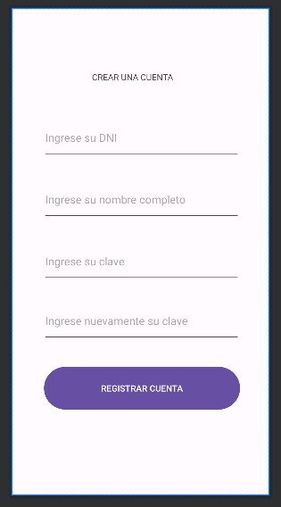

Código xml:

<TextView  
 android:id="@+id/tv2"  
 android:layout_width="wrap_content"  
 android:layout_height="wrap_content"  
 android:text="@string/tvcrearcuenta"  
 app:layout_constraintBottom_toTopOf="@+id/edtregdni"  
 app:layout_constraintEnd_toEndOf="parent"  
 app:layout_constraintHorizontal_bias="0.454"  
 app:layout_constraintStart_toStartOf="parent"  
 app:layout_constraintTop_toTopOf="parent"  
 app:layout_constraintVertical_bias="0.648" />  
  
 <EditText  
 android:id="@+id/edtregdni"  
 android:layout_width="320dp"  
 android:layout_height="68dp"  
 android:layout_marginBottom="32dp"  
 android:ems="10"  
 android:hint="@string/regdni"  
 android:inputType="text"  
 app:layout_constraintBottom_toTopOf="@+id/edtregnombre"  
 app:layout_constraintEnd_toEndOf="parent"  
 app:layout_constraintHorizontal_bias="0.51"  
 app:layout_constraintStart_toStartOf="parent" />  
  
 <EditText  
 android:id="@+id/edtregnombre"  
 android:layout_width="320dp"  
 android:layout_height="68dp"  
 android:layout_marginBottom="32dp"  
 android:ems="10"  
 android:hint="@string/regnombre"  
 android:inputType="text"  
 app:layout_constraintBottom_toTopOf="@+id/edtregpassword"  
 app:layout_constraintEnd_toEndOf="parent"  
 app:layout_constraintHorizontal_bias="0.51"  
 app:layout_constraintStart_toStartOf="parent" />  
  
 <Button  
 android:id="@+id/button5"  
 android:layout_width="318dp"  
 android:layout_height="77dp"  
 android:text="@string/btnregcuenta"  
 app:layout_constraintBottom_toBottomOf="parent"  
 app:layout_constraintEnd_toEndOf="parent"  
 app:layout_constraintHorizontal_bias="0.52"  
 app:layout_constraintStart_toStartOf="parent"  
 app:layout_constraintTop_toTopOf="parent"  
 app:layout_constraintVertical_bias="0.81" />  
  
 <EditText  
 android:id="@+id/edtregpassword"  
 android:layout_width="320dp"  
 android:layout_height="68dp"  
 android:layout_marginBottom="28dp"  
 android:ems="10"  
 android:hint="@string/edtpassword"  
 android:inputType="textPassword"  
 app:layout_constraintBottom_toTopOf="@+id/edtregpassword2"  
 app:layout_constraintEnd_toEndOf="parent"  
 app:layout_constraintHorizontal_bias="0.51"  
 app:layout_constraintStart_toStartOf="parent" />  
  
 <EditText  
 android:id="@+id/edtregpassword2"  
 android:layout_width="320dp"  
 android:layout_height="68dp"  
 android:layout_marginBottom="36dp"  
 android:ems="10"  
 android:hint="@string/edtvalidpss"  
 android:inputType="textPassword"  
 app:layout_constraintBottom_toTopOf="@+id/button5"  
 app:layout_constraintEnd_toEndOf="parent"  
 app:layout_constraintHorizontal_bias="0.51"  
 app:layout_constraintStart_toStartOf="parent" />  
</androidx.constraintlayout.widget.ConstraintLayout>

Una vez configurado el firebase y agreagados los layouts, trabajaremos en el (LOGIN):

val auth = FirebaseAuth.getInstance()  
  
val edtdni: EditText = findViewById(R.id.*edtdni*)  
val edtclave: EditText = findViewById(R.id.*edtclave*)  
val btningresar: Button = findViewById(R.id.*btningresar*)  
val btnregistro: Button = findViewById(R.id.*btnregistro*)  
// instancia de Base de Datos  
  
btningresar.setOnClickListener **{** var dni: String = edtdni.*text*.toString()  
 var clave: String = edtclave.*text*.toString()  
  
 auth.signInWithEmailAndPassword("$dni@gmail.com",clave)  
 .addOnCompleteListener(this)**{**task **->** if (task.*isSuccessful*){  
 Snackbar  
 .make(  
 findViewById(android.R.id.*content*)  
 ,"ACCESO PERMITIDO"  
 , Snackbar.*LENGTH_LONG* ).show()  
 startActivity(Intent(this, MainActivity::class.*java*))  
 }else{  
 Snackbar  
 .make(  
 findViewById(android.R.id.*content*)  
 ,"EL USUARIO Y/O CLAVE NO EXISTE EN EL SISTEMA"  
 , Snackbar.*LENGTH_LONG* ).show()  
 startActivity(Intent(this, LoginActivity::class.*java*))  
 }  
 **}  
}**btnregistro.setOnClickListener**{** startActivity(Intent(this, RegisterActivity::class.*java*)) // redirección al fragment registro  
**}**

}  
 **}  
}**btnregistro.setOnClickListener**{** startActivity(Intent(this, RegisterActivity::class.*java*)) // redirección al fragment registro  
**}**

Luego de configurar el main activity (Login):

En FIREBASE --- Compilación authentication:

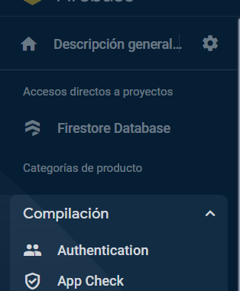

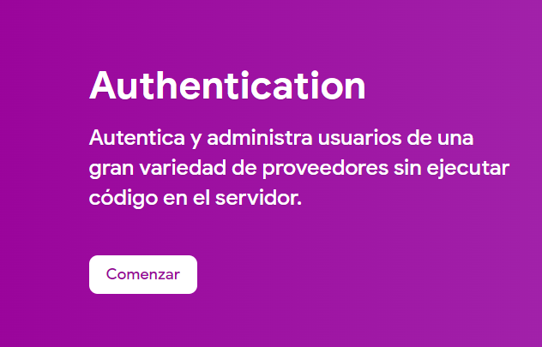

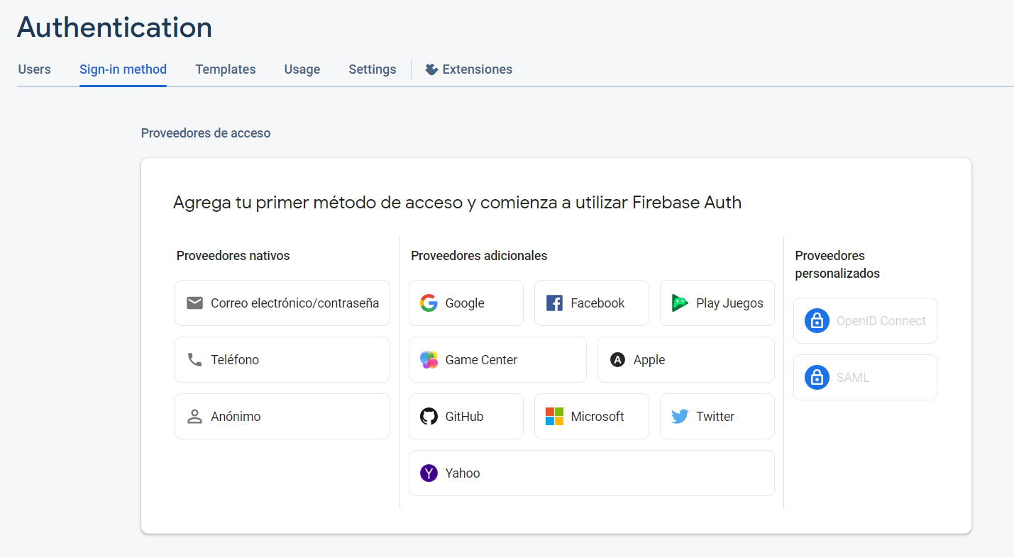

Escoger Correo electrónico y contraseña

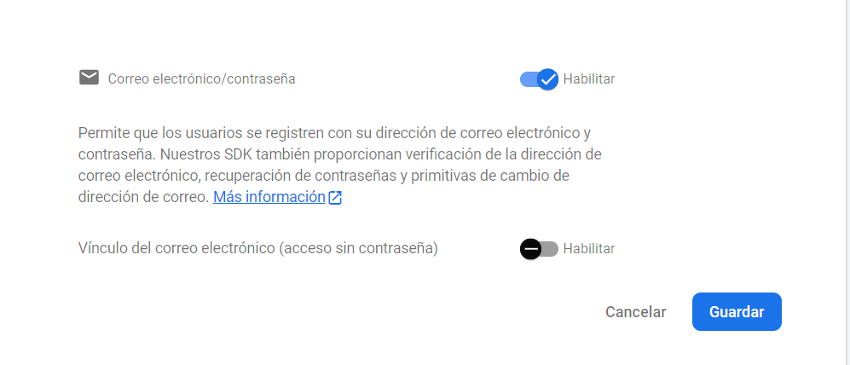

Guardamos

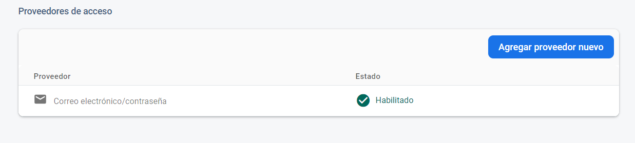

Agregamos un usuario

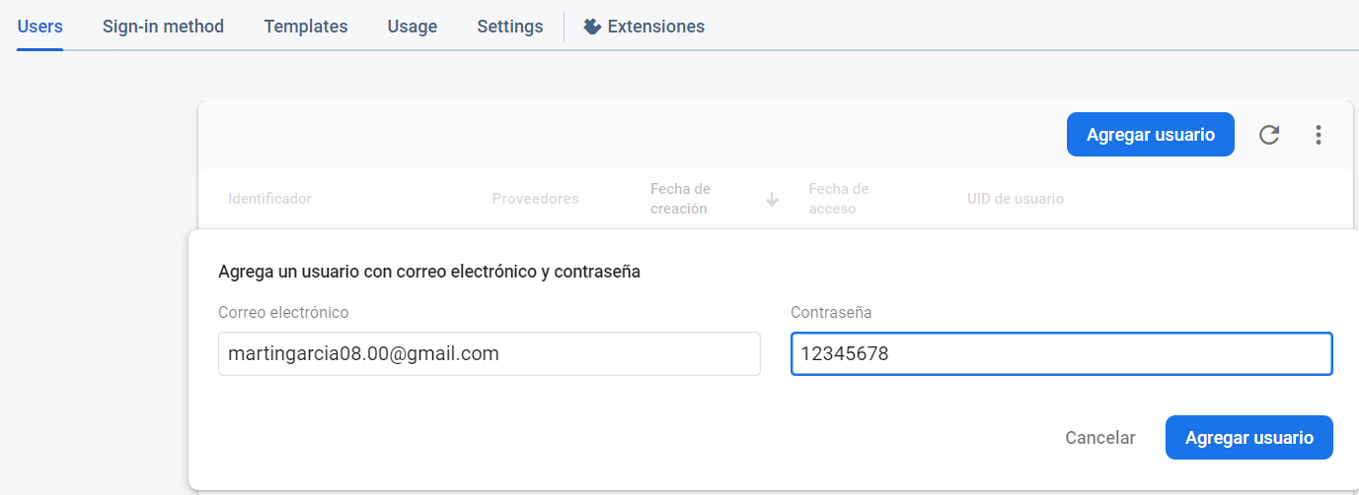

Luego para el registro:

Necesitamos una carpeta model con un kotlin class file Usuarios model

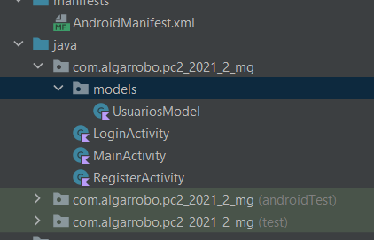

Codigo UsuariosModel:

package com.algarrobo.pc2_2021_2_mg.models  
  
data class UsuariosModel (  
 val DNI: String="",  
 val NombreCompleto: String="",  
 val Clave: String =""  
)

Luego en Register activity:

val edtregdni: EditText = findViewById(R.id.*edtregdni*)  
val edtregnombre: EditText = findViewById(R.id.*edtregnombre*)  
val edtregpassword: EditText = findViewById(R.id.*edtregpassword*)  
val edtregpassword2: EditText = findViewById(R.id.*edtregpassword2*)  
val btnregcuent: Button = findViewById(R.id.*btnregcuent*)  
  
val db = FirebaseFirestore.getInstance() // instancia de la BD  
val collectionRef = db.collection("Usuarios") // tabla o colección  
val auth = FirebaseAuth.getInstance() // creacion de usuario  
  
btnregcuent.setOnClickListener **{** var DNI = edtregdni.*text*.toString()  
 var Clave = edtregpassword.*text*.toString()  
 var NombreCompleto = edtregnombre.*text*.toString()  
 var claveverif = edtregpassword2.*text*.toString()  
  
 auth.createUserWithEmailAndPassword("$DNI@gmail.com",Clave)  
 .addOnCompleteListener(this)**{**task**->** if(Clave == claveverif){  
 if (task.*isSuccessful*){  
 //Se registró en Firebase Auth y deberá registrarse en Firestore  
 val user: FirebaseUser? = auth.*currentUser* val usermodel = UsuariosModel(DNI,Clave,NombreCompleto)  
 collectionRef.add(usermodel)  
 .addOnCompleteListener**{  
  
 }**.addOnFailureListener**{**error**->** Snackbar  
 .make(  
 findViewById(android.R.id.*content*)  
 ,"Ocurrió un error al registrar el modelo"  
 , Snackbar.*LENGTH_LONG* ).show()  
 startActivity(Intent(this, RegisterActivity::class.*java*))  
 **}** Snackbar  
 .make(  
 findViewById(android.R.id.*content*)  
 ,"Registro exitoso del usuario"  
 , Snackbar.*LENGTH_LONG* ).show()  
 startActivity(Intent(this, LoginActivity::class.*java*))  
  
 }  
 }else{  
 Snackbar  
 .make(  
 findViewById(android.R.id.*content*)  
 ,"Ocurrió un error al registrarse"  
 , Snackbar.*LENGTH_LONG* ).show()  
 startActivity(Intent(this, RegisterActivity::class.*java*))  
  
 }  
  
 **}  
  
 }**}