Title: F%$# Twitter. A corpus-based analysis of vulgar language on Twitter

Short title: Vulgar language on Twitter

Authors
Martin Schweinberger*
(corresponding author)
The University of Queensland
Address: School of Languages and Cultures, Gordon Greenwood Building, Union Road,
The University of Queensland, St Lucia, QLD 4072, Australia
Phone: +61 7 3365-6374
Email: m.schweinberger@uq.edu.au
ORCID: 0000-0003-1923-9153

Mikko Laitinen
University of Eastern Finland
Email: mikko.laitinen@uef.fi
ORCID: 0000-0003-3123-6932

Michael Haugh
The University of Queensland
Email: michael.haugh@uq.edu.au
ORCID: 0000-0003-4870-0850

Paula Rautionaho
University of Eastern Finland
paula.rautionaho@uef.fi
ORCID: 0000-0002-5239-8407

Masoud Fatemi
University of Eastern Finland
masoud.fatemi@uef.fi
ORCID: 0000-0002-3000-0381

Sam Hames
The University of Queensland
Email: sam.hames@uq.edu.au
ORCID: 0000-0002-1824-2361

Marissa Takahashi
Queensland University of Technology
Email: marissa.takahashi@qut.edu.au
ORCID: 0000-0002-6695-7660
Word count (excluding title page and Appendix):
12,447 words

Acknowledgements
The study is part of a collaborative project that has received seed funding from the University of Queensland Centre for Digital Cultures and Societies and the Language Data Commons of Australia (LDaCA). The Language Data Commons of Australia has received co-investment from the Australian Research Data Commons (ARDC) (https://doi.org/10.3565/kq2v-9g52), which is funded by the National Collaborative Research Infrastructure Strategy (NCRIS). The UEF researchers have also been supported through funding from the European Union, including NextGenerationEU instrument, as well as funding from the Research Council of Finland for the FIN-CLARIAH national digital humanities infrastructure (FIRI grant numbers 345640, 358725, 367757) and the COMET Academy project (364048).

Statements and declarations
Ethical considerations
Ethics approval to undertake this data collection was granted by the Faculty of Humanities, Arts and Social Sciences LNR Ethics Committee at the University of Queensland (2022/HE001069).

Declaration of conflicting interest
The authors have no conflicts to declare.

Use of AI
In the preparation of this manuscript, the authors used ChatGPT, an AI-assisted tool developed by OpenAI, to improve the style and readability of the text. The content and interpretations of the work are solely our own, and the AI was used only for enhancing the clarity and coherence of text drafted by the authors. No AI technology was used in the development of the research methodology, data analysis, or conclusions. This statement is provided in compliance with the publisher’s guidelines on transparency in the use of AI-assisted technologies.

Data availability statement
Workflow scripts used to process data are available on request from the authors.

F%$# Twitter. A corpus-based analysis of vulgar language on Twitter

Abstract
This study investigates the use of vulgar language on Twitter in the United States, the United Kingdom, and Australia. Using a large dataset of Twitter posts specifically compiled to be comparable, we analyse the frequency, distribution, and context of vulgar language, exploring how factors such as region, time of day, and topic influence swearing behaviours. Our findings show that vulgarity is more prevalent in the United States compared with both the UK and Australia. And while the results show that a significant proportion of users engage with vulgarity, only a small percentage of tweets contain offensive language. The most used vulgar terms include forms of fuck, online acronyms like lmao, and words like damn, and bitch. Regionally, US users exhibit a preference for online-specific vulgarities, while UK and Australian users favour terms traditionally associated with British English. Analysis of usage patterns reveals that vulgarity tends to peak in the evening, with notable fluctuations around midnight, suggesting a link between mood and time of day. Additionally, vulgarity is notably avoided in topics like crime and unemployment by users from the United States but is common in tweets around these topics by users from the United Kingdom. A Boruta analysis indicates that factors such as the size of a user’s social network (followers and following) and tweet characteristics (reply vs. original tweet) are significant predictors of vulgarity use. This study contributes to understanding the social and regional nuances of online vulgarity, offering new insights into the role of language in digital communication.

Keywords: swearing, vulgar language, variation, Englishes (Australian, American, British), social media corpora, Twitter

1. Introduction
The use of vulgar or taboo language has been found to be a near universal across the world’s cultures and societies (Montagu, 1967). Humans use vulgar forms of language from almost the time they start producing language (Jay and Jay, 2013) and continue using it throughout their lives. We even use vulgar language when our speech production is substantively impaired (Van Lancker and Cummings, 1999). According to Mehl et al. (2006), about 0.5% of the words we produce per day in spoken interaction fall into the taboo or vulgarity category. Different forms of vulgar language, such as swearing, obscenity and profanity, ethnic and racial slurs, taboo words, and so on are used not only to express strong negative (or positive) emotions and mark emphasis (Martínez and Pertejo, 2012), but also to foster solidarity, project particular identities or personas, as well as to attack others (McEnery, 2006; Stapleton et al., 2022).
Vulgar language also carries substantial societal importance in the digital world. Prior studies have estimated that over 1% of all words in some social media applications are various swear words, and they have been estimated to occur nearly twice as frequently in social media when compared to other communicative settings, such as in co-present, spoken interactions (Cachola et al. 2018; Wang et al. 2014). The role played by vulgar language in online polarization and hate speech, and attempts to moderate or contest such language are also now well attested (Brindle, 2016; Hardaker, 2015; Peréz and Almela, 2022). Given its central role in shaping social interactions and reinforcing boundaries, vulgarity has long been a subject of both public debate and scholarly inquiry (Schweinberger and Burridge, 2025).
Most linguistic research on vulgarity focuses on elucidating the discursive functions of swearing (McEnery, 2006; McEnery et al., 2023; Montagu, 1967), or on investigating correlations between characterises of the speaker, such as gender or age, and their use of vulgar language (e.g. Love, 2021; Murphy, 2009; Schweinberger, 2018). Yet despite this body of research providing us with valuable insights into the sociolinguistic and pragmatic motivations for the use of vulgar language, little is known about potential cultural differences across English-speaking regions, whether vulgarity varies based on the topics of conversations, or on a user’s position in communal or social networks (e.g. if users have many followers or post frequently). This study seeks to address this gap, analysing vulgar language using Twitter data from three major geographical areas – Australia, the United States, and the United Kingdom. The data from Twitter used in this study have been specifically compiled to represent the use of vulgar language by ordinary users in the Twitterspheres across these three geographical settings in order to allow for comparative analysis of patterns in the use of vulgar language across these different varieties of English (as represented in those respective Twitterspheres).
In the following section, we briefly review previous research on vulgar language, swearing, and related phenomena. Section three then provides details about the compilation and processing of the data, as well as the statistical methods used in the analysis of that data. The overall findings of our analysis are reported in section four. We then discuss these findings in section five, in light of prior corpus linguistic studies, and address issues that arose in the course of the analysis. We conclude by laying out a research agenda for future research using the approach exemplified in the present study, and considering the implications for corpus linguistic research on vulgar language and swearing more broadly.

2. Previous studies of vulgar language and swearing
Following prior work on swearing (McEnery, 2006), our definition of vulgar language encompasses words that can be interpreted as obscene or derogatory to the point that they might, in a polite setting, cause offence. Language that is considered to be obscene or derogatory varies to some extent from one society to another, but vulgar words commonly derive from taboo areas relating to sex (e.g. fuck, cunt), bodily functions (e.g. shit, arse), and religion (e.g. damn, Chrissake), as well as derogatory terms for other people based on their race, class, ethnicity, or gender (e.g. n*, slut) (Ljung, 2011; Montagu, 1967). However, what counts as obscene or derogatory is both highly subjective and context-dependent: what is deemed offensive by some may be treated as part of another person’s daily repertoire without any intention to offend (Montague, 1967).
Vulgar language, swearing, taboo language and so on have been studied under various labels that align with a range of methodologically distinct approaches, including corpus linguistics (e.g. Lutzky and Kehoe, 2016; McEnery, Baker and Hardie, 2000; Murphy, 2009), discourse and pragmatics (e.g. Allan and Burridge, 2009; Beers Fägersten, 2012; Culpeper, 2011), and social psychology (e.g. Bergen, 2016; Jay, 2009; Sulpizio et al., 2024; Sylwester and Purver, 2015). A more recent strand of research that has emerged is text mining, which often approaches vulgarity using a set of (relatively) coarse-grained computational and quantitative methods under the label of hate speech or offensive language (Cochola et al, 2018; Holgate et al., 2018; Pamungkas, Basile and Patti, 2023a), although there is also a number of corpus-based studies of hate speech (e.g. Brindle, 2016; Ermida, 2023; Vilar-Lluch, 2023).
There is a growing body of corpus linguistic and discourse analytic research on swearing, portraying the frequency of the most commonly occurring swear words, as well as their functions, levels of offensiveness, and who uses them in of spoken interaction (e.g. Coats, 2021; Drange, Hasund and Stenström, 2014; Drummond, 2020; Gauthier, 2021; Love 2021; Love and Stenström, 2023; Lutzky and Kehoe, 2016; McEnery 2006; McEnery et al. 2023; McEnery, Baker and Hardie, 2000; McEnery and Xiao 2004; Murphy, 2009; Schweinberger, 2018; Stenström, 1991, 2017; Widlitzki and Huber, 2016). While the number of words that can be used in vulgar ways is large, a few words have been established as being the most frequently occurring: fuck, shit and bloody are commonly listed among the most frequently used swear words in English (Love 2021; McEnery and Xiao, 2004; Schweinberger 2018; Schweinberger and Burridge, 2025). With regard to who swears, Love (2021), focusing on British English, reports the following: men swear more than women; people in their 20s swear more than people in their 40s or 60s; and working-class people and students swear more than other groups (cf. McEnery 2006). Besides being correlated with the social identities of speakers, swearing may also be influenced by the characteristics of the recipient. Schweinberger (2018) reports that swearing is 1.9 times more likely in same-gender conversations than in mixed-gender groups in Irish English data, while Laitinen et al. (2025) find that users swear more with acquaintances than friends on Twitter.
One notable aspect of vulgar language is its role in building one’s own identity or a group’s identity. While the use of vulgarity may be seen as inappropriate in a formal setting, such as in a job interview or a university lecture, in informal circumstances where the participants are of the same social status, swearing may be considered appropriate or even expected of the community members as a tool for bonding and expressing solidarity with the in-group (Stapleton, 2010). The group whose membership is strengthened by swearing may consist, for example, of adolescents, students or work colleagues (Daly et al., 2004; Stenström, 2017; Wilson and Wedlock, 2023). A crucial characteristic of expressing in-group solidarity through swearing is (perceived) homogeneity within the group; that is, the members of the group are commonly of the same gender, age, social status, or otherwise in a situation where no one person exerts power over other members of the group (Jay and Janschewitz, 2008; Beers Fägersten, 2012). However, in the case of online social media platforms, such as Twitter, groups are often formed around common interests, rather than based on common sociodemographic characteristics of the group members (Dynel, 2023). The fact that Twitter users may themselves decide how much personal information to reveal guarantees a level of anonymity that allows groups of varying ages, genders, and social statuses to be formed (Dynel, 2012; Jay, 2018).
Studies of vulgar language that employ a sociolinguistic, corpus-based approach commonly aim to understand the socio-demographic characteristics of users of vulgar language. Regarding gender differences, previous research suggests that males use swear words more frequently than females across online, spoken, and written discourse. Newman et al. (2008) and Thelwall (2008) found higher swearing rates in male-authored online texts, with Thelwall noting that men use “strong” swears more often on MySpace. McEnery, Baker, and Hardie (2000) found fuck more frequent in male-authored texts in the British National Corpus. Schwartz et al. (2013) and Bamman, Eisenstein, and Schnoebelen (2014) found profanity was used at a higher rate by male users in Facebook and Twitter data, while Wang et al. (2014) showed that men swear more overall, especially in same-gender interactions. Gauthier and Guille (2017) found that younger females in the UK favour milder swears (bloody, bitch), whereas males use stronger ones, aligning with McEnery’s (2006) findings. Lutzky and Kehoe (2016) observed that core sets of swear words frequently co-occur in blogs. Surveys also confirm gender differences. Stapleton (2003) found that women swear less and find profanity more offensive but noted that swearing can shape femininity in some contexts, while Dewaele (2017) found females to perceive swearing as more emotionally charged. Schweinberger (2018) showed that in Irish English, men swear more, but only among younger and middle-aged speakers. Other spoken language studies reinforce these patterns. Mehl and Pennebaker (2003) found higher rates of male swearing in U.S. university students’ conversations, and McEnery (2006) reported that while men and women use profanity at similar rates, males favour stronger swears (fuck, cunt), while females use milder ones (bloody, bitch). Beers Fägersten (2007) found similar male dominance in U.S. student interactions.
However, despite sustained interest in swearing and vulgar language in corpus linguistics, large-scale comparative studies examining the frequency, distribution, and context of use of vulgarity across different regions based on comparable datasets remain scarce. A notable exception is Schweinberger and Burridge (2025) who analyse web-based data (rather than social media data) and find that speakers from the United States use most vulgarity online, that speakers in inner-circle varieties use more vulgarity compared to outer-circle variety speakers, and that inner-circle variety speakers use a greater variety of forms in vulgarity in English online compared to outer-circle variety speakers.
Previous studies have also largely neglected factors outside of the classic sociodemographic attributes of speakers (such as age or gender). Whether the occurrence of vulgarity is also affected by the topic of a given conversations or even the time of day thus remains relatively underexplored. Furthermore, the rapid rise and widespread use of social media arguably brings to the fore other factors that can impact on the use of vulgar language.
Given these gaps, the present study aims to address the following research questions:
RQ 1: What forms of vulgar language are used on Twitter in Australia, the United Kingdom, and the United States?
RQ 2: What topics are associated with the use of vulgar language on Twitter in Australia, the United Kingdom, and the United States?
RQ 3: What co-text and network factors correlate with the use of vulgar language on Twitter?

3. Data and Methodology
This section provides information about how the data for this study were collated and processed, as well as detailing the statistical methods used in the analysis.

3.1 Description of data collection and processing
The study uses data from Twitter tweets that were published (tweeted) on a randomly selected weekday (June 21, 2022). The data were collected by targeting a selection of accounts showing an affiliation with the three countries (i.e. Australia, the United Kingdom, and the United States). The data was accessed using the Twitter API v2 via academic access and Twarc software ten days after the target date to avoid harvesting data that users deleted, as it would be unethical to include such tweets in the data. The reasoning is that while published data implies consent for use, if users delete tweets, they also implicitly revoke consent of use.
We selected Twitter as our data source because it provides a rich repository of naturalistic linguistic data, capturing authentic variation across regions despite platform-specific constraints. Although concerns have been raised regarding the potentially performative nature of online posts (Virtanen, 2022), its representativeness, or situatedness (Grieve et al., 2018), previous work has demonstrated that linguistic patterns observed on Twitter closely mirror real-world language behaviour, making the platform a valuable resource for large-scale analyses of language use (Huang et al., 2016).
As this study focuses on vulgarity in social media, it is important to note that at the time of data collection, Twitter generally did not remove tweets solely on the basis of the use of profanity or vulgar language; moderation was primarily directed at abusive, hateful, or threatening content. Consequently, most vulgar tweets remained visible, although extreme or targeted instances may be underrepresented (Pamungkas et al., 2023b; Yin & Zubiaga, 2022).
Determining the location of Twitter users is difficult as options for determining the location of users are prone to inaccuracies. The first option for determining the regional affiliation of users is the self-reported location in users’ bio-information. While this information is often reliable, it can also be fictitious or misleading—such as when Australian users list a non-Australian location at a given time, despite continuing to use their regional speech variety. The second option for determining the location of accounts is the geo-tagged location associated with tweets. However, this is only accessible for approximately 2 percent of tweets as users have to actively enable this option. In addition, the use of geo-tagged location data is confounded by the fact that non-Australians may tweet from within Australia (e.g. during vacation), or while not being users of Australian English (e.g. due to recent immigration).
However, the geo-tagged location of tweets can be used to identify users that are residents and currently located in one of the target regions. For the present study, these accounts served as seed accounts that enabled us to harvest their social media network as a proxy for their social networks. The following information about the seed users was retrieved:
- exact time when the account was created
- the number of followers of the account
- the number of accounts followed by the account
- the text of the tweet
- information if the tweet was a reply or an original tweet

In the next step, using the affordances of the Twitter API, additional accounts were identified that had engaged with the seed accounts through replies, mentions, or retweets (an interactional snowball sample). This method allowed us to establish a social network that reflects the interactional network characteristics of the seed accounts of each region, and therefore, since users are more likely to interact and engage with people in a similar timezone/language and geographical region this will produce a corpus that is reflective of each region when taken to a large scale. Next, the same information as for the seed users was harvested for these additional users. Additional users that were present in more than one region’s set of users were removed. The final collection of tweets was based on retrieving all tweets (excluding retweets) from the identified seed and interacting users for the reference 24-hour period.
To confirm that these accounts are indicative of each region (on average) we examined the most common location strings included in user profiles (normalising for case differences), as summarised in Table 1. We also examined the tweet volume by local time of day, with minimum tweet volumes consistently associated with the local time of 2-3am for each region, along with the top mentioned accounts and hashtags to ensure they were aligned with each region. (not shown) For each region the top hashtags and mentioned users were aligned with regional celebrities, politicians, television shows and also major news events, such as a strike by railworkers for tweets in the GB collection, and congressional hearings about the January 6th attach on the US Capitol by supporters of Donald Trump for the US collection. Interestingly, the location analysis shows that the most common location string in the user biographical data is an empty string confirming that methods relying on this information would generate a highly skewed sample, as they would most likely discard these accounts for further analysis.

Australia |  | US |  | GB
Location String | Users | Location String | Users | Location String | Users
<empty> | 1949 | <empty> | 49007 | <empty> | 13353
australia | 389 | los angeles, ca | 2483 | london, england | 1514
melbourne, victoria | 384 | united states | 2203 | united kingdom | 920
sydney, new south wales | 316 | chicago, il | 1644 | london | 890
melbourne, australia | 136 | houston, tx | 1594 | england, united kingdom | 755
melbourne | 132 | atlanta, ga | 1480 | uk | 502
sydney, australia | 112 | california, usa | 1110 | manchester, england | 455
perth, western australia | 111 | dallas, tx | 1067 | glasgow, scotland | 405
brisbane, queensland | 111 | new york, ny | 1049 | scotland, united kingdom | 350
sydney | 108 | washington, dc | 907 | edinburgh, scotland | 322
Table 1: Top 10 location strings (after normalising for case and whitespace) for each region.

Once the datasets were compiled based on the procedures described above, the resulting raw dataset consisted of more than 36 million tokens, as summarized in Table 2.

 | Tokens (N) | Tweets  (N) | Users (N) | Avg. Length Tweet
Australia | 1,449,292 | 99,404 | 7,647 | 14.6
United Kingdom | 7,883,971 | 538,661 | 51,514 | 14.6
United States | 27,398,975 | 2,090,972 | 184,711 | 13.1
Total | 36,732,238 | 2,729,037 | 243,872 | 13.5

Table 2: Overview of the semi-processed dataset.

Data processing was carried out in R (version 4.3.2, R Core Team, 2023) using RStudio (version 2024.4.1.748, Posit team, 2024). Vulgar elements were identified through a set of regular expressions developed from prior research (e.g., Coats, 2021; Love, 2021; McEnery, 2006; Thelwall, 2008), and curated online resources used in content moderation, such as NoSwearing.com, BannedWordList.com, and the English List-of-Dirty-Naughty-Obscene-and-Otherwise-Bad-Words (Emerick, 2024). The authors reviewed the extracted terms, and for those deemed vulgar, pattern-matching expressions were constructed to capture variations, including deliberate misspellings (e.g., fuq for fuck or sh!t for shit). The full list of regular expression is provided in Appendix 1.
The identified expressions were applied using the kwic function from the quanteda package (Benoit et al., 2018), generating a keyword-in-context (KWIC) table of candidate vulgarities. The extracted, unfiltered results representing 181,411 potential instances of vulgar language then underwent extensive refinement to remove cases where the identified forms occurred in non-vulgar contexts. This was achieved through a series of systematic rule-based filters implemented in R. For instance, expressions such as hoe were only retained if they occurred in syntactic frames consistent with vulgar usage (e.g., preceded by “such a” or “that”), while neutral uses (e.g., “garden hoe”) were excluded. Similarly, ambiguous tokens such as jerk, knob, or crap were retained or excluded depending on whether surrounding words (pre- or post-context) indicated a vulgar or neutral sense (e.g., jerk off vs. jerk chicken, knobhead vs. door knob).
In addition to these contextual rules, a curated list of spurious matches (e.g., strings resembling passwords, technical terms, foreign words, or symbols) was removed to prevent false positives. Further regular-expression filters eliminated systematic noise, such as strings with embedded numbers (f-15, f/22), orthographic distortions (b..e..a..u..t..i.f..u..l), or cases where the character sequence f occurred in non-vulgar acronyms or abbreviations (u.f.o., w.e.f.).
To validate the automated filtering, manual cross-checking was conducted. A random sample of 20 instances per term was extracted and analysed in context. If this sample provided insufficient evidence for reliable categorization, an additional 10 instances were examined. A term was retained if at least 8 out of 10 instances were confirmed as vulgar. If contextual disambiguation or manual inspection proved insufficient, the term was excluded from further analysis.
This multi-stage rule-based and manual validation procedure ensured that the dataset captured genuinely vulgar expressions while excluding neutral, technical, or otherwise irrelevant cases. After cleaning, the KWIC table contained 132,736 instances of vulgar language, meaning that 26.8% of the initially identified items were removed as non-vulgar during data cleaning. This process substantially reduced false positives while preserving broad coverage of the diverse forms and spellings in which vulgar terms appear on Twitter.

3.2 Statistical methods
To analyse what factors correlate with the use of vulgarity in the data sets, we used three inferential statistical methods:
- Frequency Tabulation and Collostructional Analysis to determine significant preferences within and across locations (e.g. if users in the US use wft more than users in Australia or the United Kingdom). [RQ1: forms of vulgarity]
- Topic modelling to determine the topics of tweets (e.g., whether a tweet was about sport, politics, or family). [RQ2: topics for vulgarity]
- Boruta to determine the strength of correlations between factors and the frequency of vulgar elements. [RQ 3: co-text and network factors correlating with vulgarity]

3.2.1 Frequency tabulation
To quantify the occurrence of vulgar expressions, raw frequency counts were first extracted from the dataset. These counts were then normalized to account for differences in subsection sizes. Normalization was achieved by calculating relative frequencies, expressed either as percentages or occurrences per million words. This involved determining the total number of tokens within each regional subsection and adjusting the raw vulgarity counts accordingly: dividing by the total token count and multiplying by 100 for percentage values or by one million for per-million-word frequencies. The resulting normalized frequencies provided a comparable measure across regions and were used in visualizations of the findings.

3.2.2 Collostructional analysis
To examine whether specific vulgar expressions occurred significantly more or less frequently in particular regional subsections, a collostructional analysis was conducted. Originally introduced by Gries and Stefanowitsch (2004) in corpus linguistics, this method assesses the statistical association between lexical items and linguistic constructions. In this study, collostructional analysis was applied to identify regional preferences or aversions for specific vulgar forms by comparing their distributions across different subsections of the dataset. The collostructional analysis used in the present study is based on Fisher’s Exact tests with Bonferroni corrections for repeated testing to avoid α-errors. The effect size measure is φ (phi). This approach allowed us to determine whether certain forms are used significantly more or less frequently in the region under analysis than would be expected if the regions did not differ, thus providing insights into regional variation in the use of vulgar language.

3.2.3 Topic modelling
To identify thematic patterns in the dataset, we applied a two-stage topic modelling procedure that combined unsupervised and seeded approaches. Prior to modelling, the tweets were pre-processed using the quanteda package (Benoit et al., 2018). Preprocessing involved tokenisation, lowercasing, stemming, and the removal of punctuation, symbols, numbers, URLs, and stopwords (non-lexical function words) in English and Spanish, as well as short function-like tokens (e.g., one to three letter words with little semantic content). A document-feature matrix was then constructed, restricted to tweets containing at least five words to enable meaningful topic assignment.
In the first stage, we applied Latent Dirichlet Allocation (LDA) (Blei et al., 2003) using the topicmodels package. Several models were estimated with different numbers of topics (5, 7, 10, 12, 15, 18, 20, 25, 27, 30), and topic coherence was compared to identify interpretable solutions. For each model, the most probable terms per topic were extracted and evaluated qualitatively to ensure thematic consistency.
In the second stage, we refined the results using seeded topic modelling (seededlda package) (Jagarlamudi et al., 2012). A domain-informed dictionary was constructed to guide topic formation, containing more than 30 seed categories (e.g., crime, employment, entertainment, finance, politics, sports, identity), with each defined by approximately ten representative terms. The seeded model allowed for residual topics, ensuring that tweets not aligned with seed terms could still form distinct themes. This hybrid unsupervised-guided approach improved the interpretability and robustness of the results by combining statistical co-occurrence patterns with linguistically and contextually motivated anchors (Schweinberger, 2025). Of the 1,902,354 tweets (from 2,729,037 originally before processing), only 0.56 percent (10,604 tweets) could not be assigned any topic (due to a lack of relevant tokens), and only 2.95 percent (56,181 tweets) were assigned the topic category other (indicating that these tweets could not be assigned any topic with confidence).
A key methodological challenge in applying topic modelling to Twitter data is the brevity and noisiness of the texts. Tweets are typically very short (often under 20 words), which limits the co-occurrence information that topic models rely on to detect stable themes. As a result, topics can appear fragmented, overly generic, or dominated by frequent but semantically weak tokens (Hong & Davison, 2010; Zeng et al., 2018). Additional issues include the prevalence of non-standard spelling, creative orthography, code-switching, and hashtags, all of which complicate lexical consistency and topic inference. While preprocessing and the use of seeded dictionaries mitigate some of these challenges, topic modelling of short texts remains prone to sparsity-related biases and interpretability constraints. For this reason, a two-stage design, which combines unsupervised LDA with seeded topic modelling, was adopted to balance exploratory discovery with domain-guided interpretability, allowing for both the identification of emergent patterns and the anchoring of themes in linguistically meaningful categories.

3.2.4 Boruta and regression analysis
To identify the factors influencing the use of vulgarity, we employed the Boruta algorithm (Kursa and Rudnicki, 2010), an extension of Random Forests (Breiman, 2001). Boruta operates by iteratively comparing real predictor variables to their randomly permuted counterparts (shadow features), which allowed us to systematically determine which linguistic and contextual factors had a statistically significant impact on the use of vulgarity, while filtering out noise. The Boruta analysis included the variables listed in Table 3.

Variable | Type | Scale | Levels / Description
vulgar | dep. var. | nom. | tweet contains vulgarity (0, 1)
user | indep. var. | cat. | id of user
location | indep. var. | cat. | location: au, uk, us
topic | indep. var. | cat. | topic of tweet
words | indep. var. | num. | log. no. of words in tweet
time | indep. var. | cat. | Time of day at location (in hours)
usersince | indep. var. | ord.cat. | year when account was created
reply | indep. var. | nom. | tweet is a reply vs original tweet
logfollowing | indep. var. | num. | log. no. of accounts followed
logtweets | indep. var. | num. | log. no. of tweets of user
logretweets | indep. var. | num. | log. no. of retweets of the tweet
loglikes | indep. var. | num. | log. no. of likes of the tweet
logquotes | indep. var. | num. | log. no. of times a tweet was quoted
loglisted | indep. var. | num. | log. no. of times a tweet was listed
quoted | indep. var. | nom. | Tweet contains quote vs no quote
verified | indep. var. | nom. | user is verified vs not verified
logfollowers | indep. var. | num. | log. no. of followers

Table 3: Overview of variables in statistical analysis.

As Boruta is computationally intensive, the algorithm was applied to a balanced random sample of 15,000 tweets, consisting of 5,000 randomly selected tweets from each region. Boruta is a wrapper algorithm built around random forests that iteratively compares the importance of original features with that of randomly permuted shadow features to identify variables that have a statistically significant impact on the outcome (Kursa & Rudnicki, 2010). This approach is particularly effective at detecting variables that contribute through interactions or non-linear effects, making it well-suited for complex datasets such as social media text.
To determine the direction of the associations identified by Boruta, we subsequently fitted a logistic regression model using the glm function in R on the full dataset used for topic modelling. This regression focused solely on main effects, allowing us to assess whether each predictor increased or decreased the likelihood of vulgar language, while interaction effects—captured by Boruta—were not modeled in this step. By combining Boruta’s variable selection with logistic regression, we leveraged both the algorithm’s sensitivity to relevant predictors and the interpretability of regression coefficients.
Despite its advantages, Boruta has several limitations that should be acknowledged. First, it only indicates whether a variable is relevant, without providing information on the direction or magnitude of its effect. Second, while it is strong at detecting interactions, it does not quantify them, so the nature of these interaction effects remains unexplored unless followed up with additional analyses. Third, Boruta can be sensitive to correlated predictors, sometimes marking multiple correlated variables as important even if the effect is primarily driven by one. Finally, the computational intensity of Boruta requires sampling for large datasets, which may introduce variability depending on the sampled subset. These limitations highlight that Boruta is most valuable as a tool for identifying potential predictors rather than for directly estimating effect sizes or interactions.
We now turn to the findings of this analysis.

4. Findings
This section presents the results of the analysis, starting with tabulations of frequencies across regions, which are summarised in Table 4.

 | Users of vulgarity  (%) | Vulgar Tokens  N (%) | Vulgar Tweets  N (%)
Australia | 46.8 | 3,906 (0.27) | 3,581 (3.60)
United Kingdom | 36.9 | 20,655 (0.26) | 19,005 (3.53)
United States | 52.9 | 108,175 (0.39) | 97,748 (4.67)
Total | 49.3 | 132,736 (0.36) | 120,334 (4.41)

Table 4: Frequency tabulation of vulgarity across regions.

As can be seen in Table 4, United States Twitter users have the highest percentage of vulgar tweets with 4.67% of tweets in this region containing vulgarity. Users in the United Kingdom and Australia have lower percentages, at 3.53% and 3.6%, respectively. The percentage of users of vulgarity is also notably high with more than half of the United States Twitter users using vulgarity at least once (52.9%). In contrast, only 36.9 percent of users in the United Kingdom use vulgarity at least once in their tweets in the sample (which still amounts to more than a third). Tweets containing vulgarity amount to about 5 percent of all tweets, ranging from 3.53 percent in the United Kingdom to 4.67 percent in the United States. Overall, the percentage of vulgar tokens of all tokens ranges between 0.26 and 0.39 percent which is lower than the percentage reported by Wang et al. (2014). This frequency analysis of our data confirms that the use of vulgarity is ubiquitous, and yet relatively rare.

4.1 Forms of vulgarity on Twitter
We now assess what forms of vulgarity are used in the data. Figure 1 shows that fuck is the most common vulgar lemma in the data, followed by online acronyms (lmao, wtf, af, asf, etc), damn, bitch, n*, and idiot which together make up more than 80 percent of all vulgarity (79.98 percent).

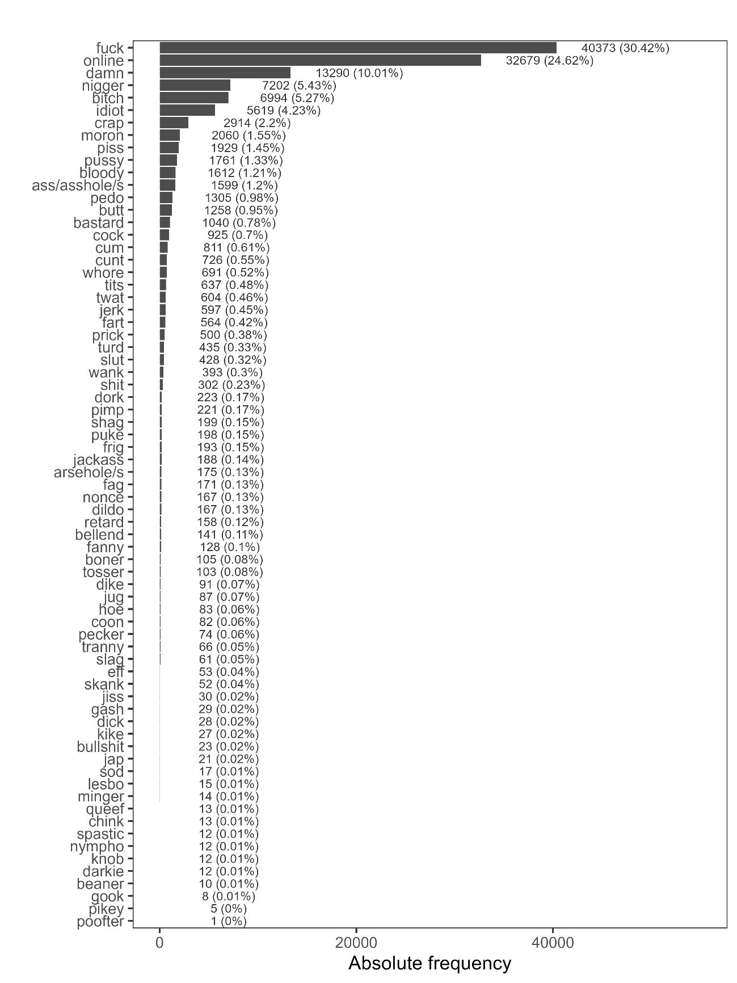Figure 1: Overview of vulgar lemmas and their absolute and relative frequencies (combined).

Figure 2 shows the use of vulgar lemmas by region and confirms regional variation.

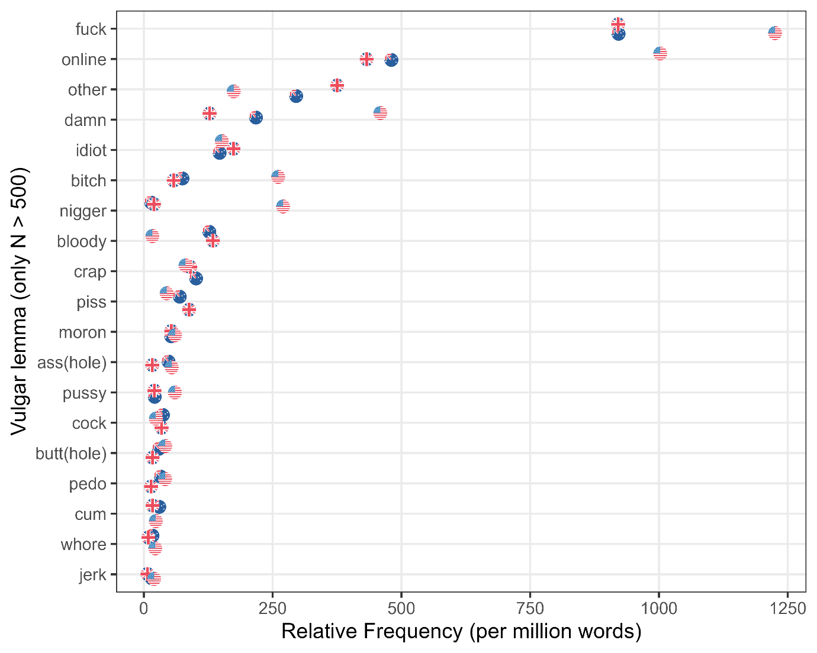

Figure 2: Overview of vulgar lemmas and their relative frequencies across regions.

Figure 2 shows that forms of fuck, vulgar online acronyms, damn, idiot, bitch, and n* are not only among the most frequent vulgar lemmas, but also notably more frequent among United States Twitter users (with the exception of idiot), with forms of n* occurring almost exclusively in the US data. In contrast, forms of bloody, crap, piss, and cock are almost exclusively used in Australia and the United Kingdom. Forms of crap and bastard, while also being used by US users, are more common in Australia and the United Kingdom.
We now turn to an analysis of when users use vulgar language in their tweets. According to Figure 3, usage wanes during working hours but increases towards the evening with peaks around midnight for users from the United Kingdom and the United States. In the Australian data, the peak appears substantively earlier: between 6 and 7pm once users have returned from work. We inspected vulgar tweets in this peak both manually and by cross tabulating topics but could unfortunately not detect a specific pattern, e.g. users venting about work or traffic. This means that there is a notable peak, but the vulgarity used during this peak in the Australian data does not seem to be related to a specific topic. In addition, a second, though less pronounced peak is detectable among Australian users during lunchtime. It is important to note that the fluctuations show proportional differences, not differences associated with reduced activity.

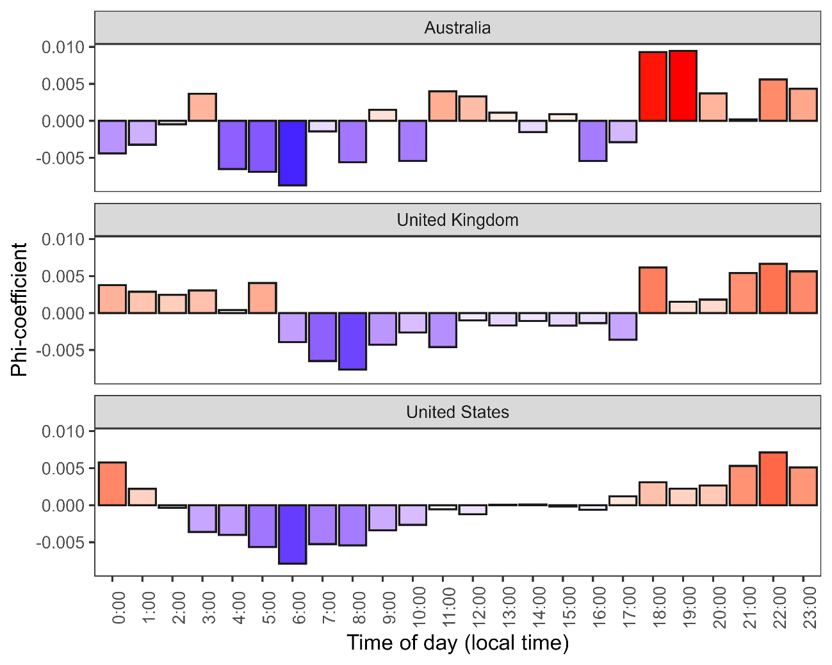
Figure 3: Overuse (red) and underuse (blue) of vulgarity by normalised time of day.

4.2 Topic related use of vulgarity
We now turn to the results of the topic modelling analysis that aimed to ascertain if vulgarity is more likely to occur based on discursive topics. Our two-step topic modelling arrived at 34 thematically coherent topics (activism, adult_content, ai_innovation, business, climate, crime, economy, education, employment, entertainment, fashion, finance, food, foreign, gaming, identity, immigration, media, medical, memes, mental_health, military, no topic, other, pets, politics, relationships, science, shopping, social_media, sports, tech, transport, travel) with an additional bin category (other) for tweets that could not be assorted to any topic. The dictionary containing the seed terms used for the seeded topic modelling are provided in Table 6 in Appendix 2.

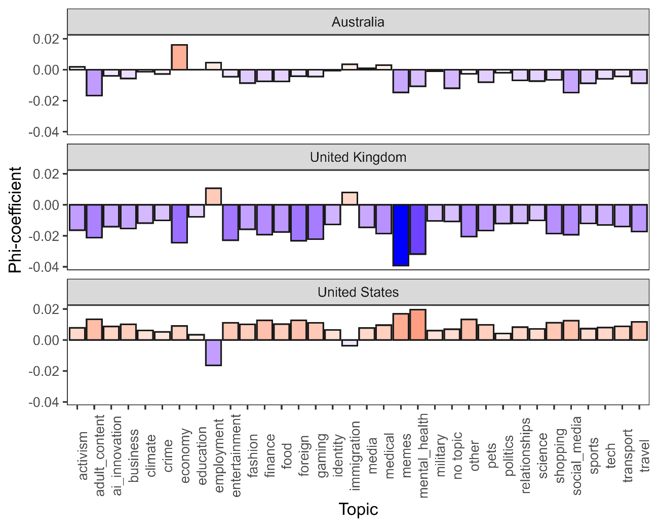Figure 4: Overuse (red) and underuse (blue) of vulgarity by topics and location.

The results shown in Figure 4 indicate that vulgarity is generally more prevalent across most topics in the United States data (bottom panel), with the notable exception of the employment topic, where US Twitter users rarely employ vulgar language compared to users from the United Kingdom (see Example 1). In the Australian dataset (top panel), the most prominent peak occurs for the economy topic. Peaks in the UK data appear for employment and immigration, while vulgarity remains notably low in the memes and mental health topics. Conversely, US users display higher levels of vulgarity in discussions related to memes and mental health compared to both UK and Australian users.

(1) Example of vulgar tweet in topic “Employment”
@Deborahfrankier @Tinman07382139 @NavyLookout Shit wages but you stand with Boris? If you give me £50 I’ll kick you in the bollcks but only if you ask nice
(UK: 1539036748390570000)

We now turn to the results of the collostructional analysis. Each collostructional analysis compared the use of vulgar lemmas in one region against their use in another region, leading to three comparisons: Australian users versus users from the United Kingdom, users from Australia versus users from the United States, and users from the United States versus users from the United Kingdom. This way, the results show what lemmas are significantly preferred or avoided when comparing two groups of users at a time.

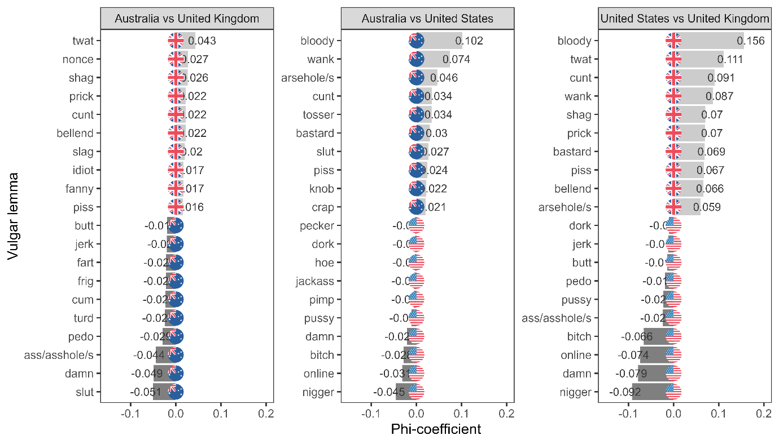
Figure 5: Results of the collostructional analyses comparing the use of vulgar lemmas across regions.

The left panel illustrates that Twitter users from the United Kingdom employ vulgar expressions traditionally associated with British English (e.g., twat, nonce, shag, prick, cunt) significantly more frequently than their Australian counterparts. In contrast, Australian users tend to favour vulgar terms linked to American English (slut, damn, ass(hole)). Compared to the other panels, the effect size of the comparison between users from the United Kingdom and Australia is, however, relatively small indicating that the differences are not as substantive and significant.
The central panel of Figure 5 compares Australian and users from the United States, revealing a pattern that contrasts with the findings shown in the left panel as, compared to users from the United States, Australian users significantly prefer vulgarity associated with the United Kingdom (e.g., bloody, wank, arsehole/s, tosser, knob). Interestingly, United States users do not seem to show stark preferences when compared to Australian users with the exception of vulgar acronyms associated with online communication (wtf, lmao, asf, etc., see Figure 2), and racial slurs (variants of n*).
Finally, the right panel of Figure 5 highlights the distinctions between users from the United States and the United Kingdom. As with the previous comparison, users from the United Kingdom tend to overuse vulgar expressions strongly associated with British English (bloody, wank, twat, cunt, shag, etc.). Also similar to the centre panel we can see that users from the United States prefer vulgar acronyms associated with online communication (wtf, lmao, asf, etc.), racial slurs (forms of n*), and the religious term damn.
Overall, these findings suggest that Australian users exhibit a hybrid pattern in their use of vulgarity. When compared to US users, they align more closely with British usage patterns, but when contrasted with UK users, they display a stronger inclination toward American-style vulgarity. This dual tendency may reflect the linguistic influence of both British and American English on Australian discourse.
An additional configural frequency analysis (CFA), which only reports significant deviations from expected values (i.e. expected if we assume no difference between regions for United States versus users from Australia and United States users versus United Kingdom users), confirms this trend, as illustrated in Figure 6.

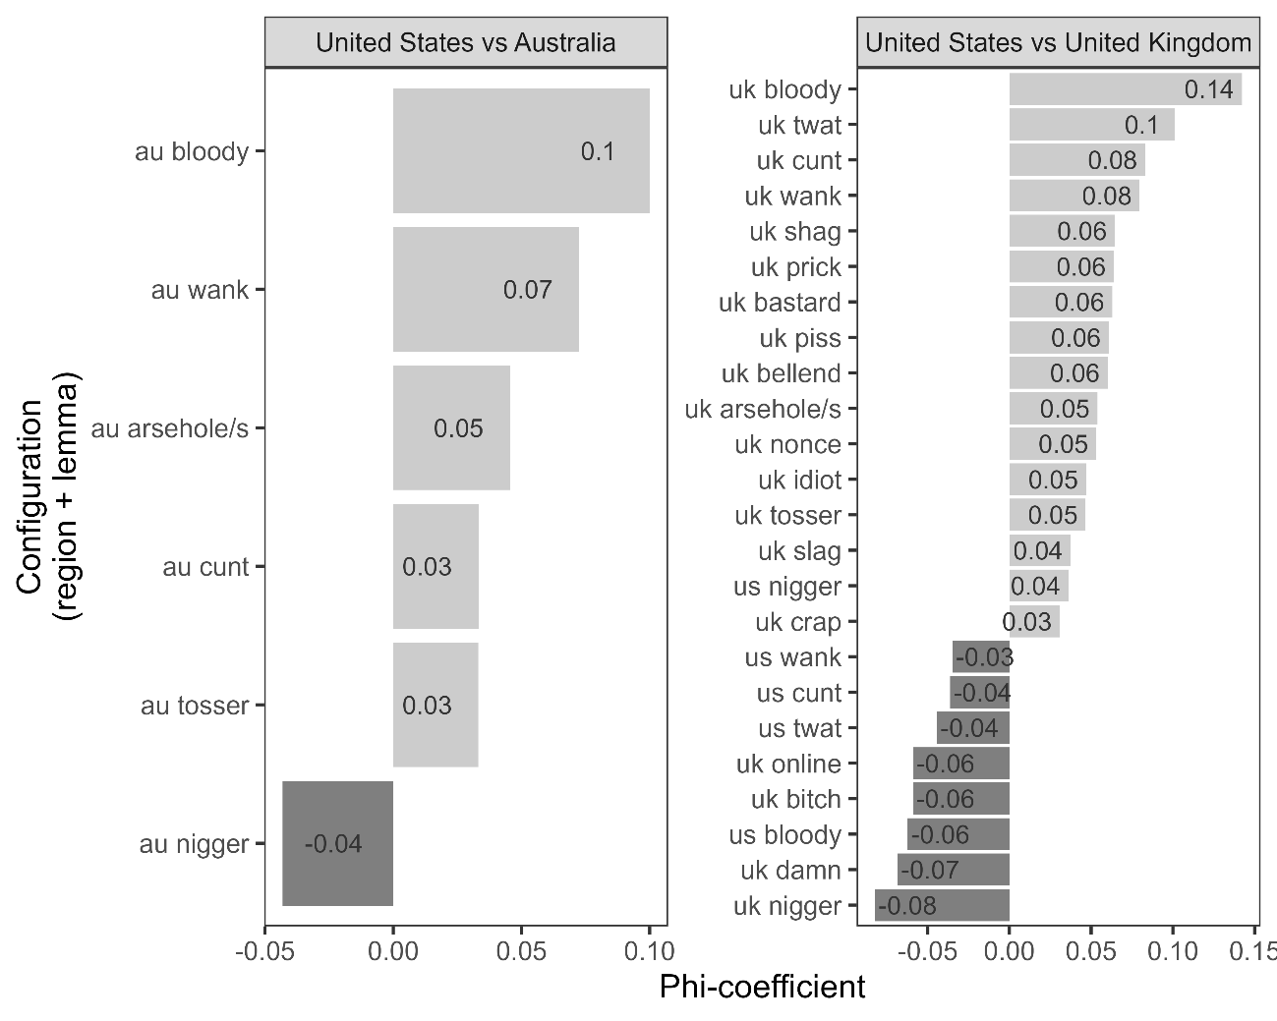Figure 6: Results of configural frequency analysis (CFA).

The CFA failed to detect any significant differences between users from Australia and the United Kingdom, but detected differences between both of these groups and users from the United States. This suggests that users from the United Kingdom and Australia are more similar in their usage of vulgarity compared with users from the United States.

4.3 Factors that correlate with the use of vulgarity
We now turn to the Boruta analysis that aims to ascertain what co-text and network factors correlate with Vulgarity (RQ3).
The boxplot in Figure 7 reports the results of a Boruta analysis with the x-axis representing the independent variables retained in the analysis after it has been confirmed that they impact the use of vulgarity. The y-axis indicates the relative importance of the independent variables in predicting vulgar language use. Dark grey boxplots correspond to predictor variables, whereas light grey boxplots represent control (shadow) variables used for comparison. It needs to be borne in mind that in order to confirm a systematic correlation with the use of vulgarity, a factor needs to show a stronger impact than the strongest shadow variable – this allows to differentiate between factors that do not have a meaningful impact (i.e. factors that do not outcompete the shadow variables), and factors that do systematically correlate with vulgarity (i.e. factors that perform consistently better than the shadow variables).

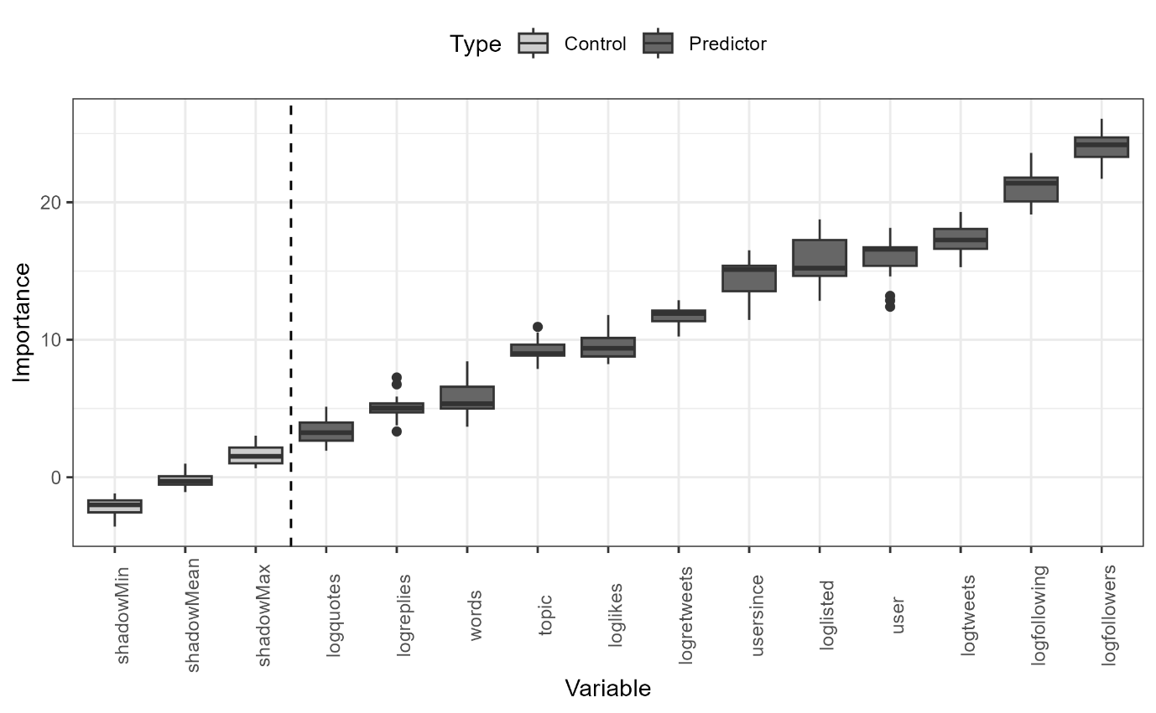
Figure 7: Boxplot showing the results of the Boruta analysis.

The shadow variables (shadowMin, shadowMean, shadowMax) serve as a baseline for comparison, with the vertical dashed line marking the importance of shadowMax, the highest-ranked control variable. Any predictor that exceeds this threshold is considered relevant. In this analysis, several predictor variables surpass shadowMax, confirming that they have meaningful predictive power.
The results confirmed that the following 12 variables have an impact on the use of vulgarity (either as main effects and/or as part of interactions): logfollowers, logfollowing, logtweets, user, loglisted, usersince, logretweets, loglikes, topic, words, logreplies, and logquotes. Interestingly, user location – whether Australia, the United Kingdom, or the United States – did not emerge as a significant predictor of the likelihood that a tweet contained vulgarity. This does not imply the absence of systematic regional differences, as the frequency tabulations and collostructional analyses clearly point to preferences for particular types of vulgar expressions across locations (as does the existing research on this issue, e.g., Schweinberger and Burridge, 2025). Rather, it suggests that when examining the overall propensity to use vulgarity, irrespective of its specific form, other factors such as social network characteristics, engagement metrics, and topical context play a more decisive role.
In addition to location, the time of day (time), whether the tweet was a response to a prior tweet (reply), or if the user was verified could also not be confirmed as having a significant correlation with vulgarity by the Boruta analysis. To ascertain the direction of the effect and how different levels of a predictor vary, a fixed-effect logistic regression was conducted using the glm function in R (see Table 5). Only significant levels of main effects shown are shown in Table 5. Odds Ratios above 1 indicate a positive correlation with the use of vulgarity while Odds Ratios smaller than 1 indicate that less vulgarity is used

Predictors |  | Odds Ratios |  | CI |  | p
(Intercept) |  | 0.02 |  | 0.01 – 0.04 |  | <0.001
logfollowers | 1.01 |  | 1.00 – 1.02 |  | 0.005
logfollowing |  | 1.06 |  | 1.05 – 1.06 |  | <0.001
loglisted |  | 0.97 |  | 0.96 – 0.97 |  | <0.001
topic [adult_content] |  | 1.36 |  | 1.30 – 1.43 |  | <0.001
topic [ai_innovation] |  | 0.37 |  | 0.34 – 0.40 |  | <0.001
topic [business] |  | 0.41 |  | 0.38 – 0.44 |  | <0.001
topic [climate] |  | 0.84 |  | 0.79 – 0.89 |  | <0.001
topic [education] |  | 0.56 |  | 0.53 – 0.60 |  | <0.001
topic [employment] |  | 1.14 |  | 1.09 – 1.20 |  | <0.001
topic [entertainment] |  | 0.84 |  | 0.79 – 0.88 |  | <0.001
topic [fashion] |  | 1.22 |  | 1.16 – 1.28 |  | <0.001
topic [finance] |  | 0.65 |  | 0.61 – 0.69 |  | <0.001
topic [food] |  | 0.86 |  | 0.81 – 0.91 |  | <0.001
topic [identity] |  | 1.14 |  | 1.08 – 1.20 |  | <0.001
topic [immigration] |  | 0.31 |  | 0.29 – 0.34 |  | <0.001
topic [media] |  | 0.75 |  | 0.71 – 0.80 |  | <0.001
topic [medical] |  | 0.73 |  | 0.69 – 0.78 |  | <0.001
topic [memes] |  | 9.84 |  | 9.45 – 10.26 |  | <0.001
topic [mental_health] |  | 0.88 |  | 0.83 – 0.93 |  | <0.001
topic [military] |  | 0.6 |  | 0.56 – 0.64 |  | <0.001
topic [no topic] |  | 0.35 |  | 0.30 – 0.41 |  | <0.001
topic [other] |  | 0.61 |  | 0.57 – 0.65 |  | <0.001
topic [pets] |  | 1.21 |  | 1.15 – 1.28 |  | <0.001
topic [politics] |  | 0.82 |  | 0.77 – 0.86 |  | <0.001
topic [relationships] |  | 0.55 |  | 0.52 – 0.59 |  | <0.001
topic [science] |  | 1.18 |  | 1.12 – 1.24 |  | <0.001
topic [shopping] |  | 0.56 |  | 0.53 – 0.60 |  | <0.001
topic [sports] |  | 0.78 |  | 0.74 – 0.82 |  | <0.001
topic [tech] |  | 0.79 |  | 0.75 – 0.84 |  | <0.001
topic [transport] |  | 0.62 |  | 0.59 – 0.66 |  | <0.001
topic [travel] |  | 0.64 |  | 0.61 – 0.68 |  | <0.001
logretweets |  | 0.97 |  | 0.97 – 0.98 |  | <0.001
loglikes |  | 0.99 |  | 0.98 – 0.99 |  | <0.001
logquotes |  | 1.04 |  | 1.04 – 1.05 |  | <0.001
words |  | 1.02 |  | 1.02 – 1.02 |  | <0.001
logreplies |  | 0.99 |  | 0.99 – 1.00 |  | <0.001
Observations |  | 1.902.354
R² Tjur |  | 0.069

Table 5: Results of the fixed-effects logistic regression model.

The logistic regression analysis that was fit on 1,902,354 tweets of which 101,947 contained vulgar language) has limited explanatory and predictive power (R² Tjur: .069). However, its primary aim was to determine whether specific factors correlate positively or negatively with the use of vulgar language. The Odds Ratios in Table 5 serve as an effect size measure with values below 1 indicating a negative effect, that is, the predictor correlates negatively with the use of vulgarity, values close to 1 suggesting no effect, and values greater than 1 indicating a positive effect. Taking the example of the effect of topic employment, an Odds Ratio value of 1.14 means that if a tweets is classified as relating to employment, this means that this tweet is 1.14 times more likely to contain vulgarity than a tweet classified as a activism tweet (activism is the default level for topics and serves as the point of comparison against which other topics are evaluated).
The regression results suggest that a user’s social network size is positively associated with the likelihood of vulgarity. Specifically, both the number of accounts a user follows (logfollowing) and the number of accounts following them (logfollowers) increase the odds of vulgar language use. This indicates that users with larger and more active networks are more prone to employ vulgarity.
In contrast, engagement-related metrics such as retweets (logretweets), likes (loglikes), and replies (logreplies) show statistically significant but relatively small negative associations with vulgarity, suggesting that tweets receiving higher engagement are slightly less likely to contain vulgar expressions. An exception is quoted tweets (logquotes), which exhibit a positive effect, meaning that tweets involving quotes are more likely to include vulgarity than expected. It is important to note that the current model accounts only for main effects and does not capture potential interactions among predictors, which may qualify or moderate these observed relationships.

The regression analysis further underscores that the likelihood of vulgarity varies considerably across topics. Unsurprisingly, discourse related to memes stands out with a dramatically higher odds ratio (OR = 9.84), indicating that tweets in this category are nearly ten times more likely to contain vulgar language compared to activism (the baseline category against which other topics are compared). Elevated odds of vulgarity are also observed, though to a much lesser degree, in topics such as adult content (OR = 1.36), fashion (OR = 1.22), pets (OR = 1.21), science (OR = 1.18), employment (OR = 1.14), and identity (OR = 1.14). These findings suggest that vulgarity is more frequently employed in informal, entertainment-related, or socially expressive contexts.
In contrast, a large set of topics shows significantly lower associations with vulgarity than activism. This includes discussions around immigration (OR = 0.31), AI innovation (OR = 0.37), business (OR = 0.41), and relationships (OR = 0.55), all of which indicate substantially reduced odds of vulgarity. Similarly, topics such as education (OR = 0.56), shopping (OR = 0.56), military (OR = 0.60), other/unspecified (OR = 0.61), and transport (OR = 0.62) are also comparatively unlikely to feature vulgar expressions. Moderately lower odds are found in domains such as finance, media, medical issues, politics, sports, and technology (all ORs between 0.60 and 0.82). This pattern suggests that vulgarity is less tolerated or less functional in discussions that centre on professional, institutional, or public domains.
Taken together, these results highlight stark contrasts in the communicative environments where vulgarity is more or less prevalent. Vulgar language is especially salient in playful or identity-driven discourse (memes, adult content, fashion, pets, science, employment), but it is notably constrained in formal, policy-oriented, or informational domains (immigration, business, education, military, relationships).
The following section examines the results of the analysis in relation to existing research, highlighting key findings and their implications. It also addresses potential limitations and challenges, discusses the contributions of this study, and explores directions for future research in this area.

5. Discussion
Overall, the findings of this study contribute to a growing understanding of how vulgarity functions in online discourse. While confirming several established patterns – such as the influence of regional linguistic conventions and the social functions of swearing – this study also extends previous work by demonstrating how these factors interact with digital communication structures, including audience size and topical relevance. These results suggest that despite the global reach of this social media application, regional norms continue to shape the pragmatics of vulgarity. The following section will discuss these findings and propose future directions for research.
The findings align with and extend previous research on vulgarity in digital communication, sociolinguistic variation, and swearing as a social practice. In particular, the results support existing claims about the role of cultural norms in shaping swearing behaviour (Stapleton, 2010; Jay and Janschewitz, 2008), and highlight the influence of regional linguistic conventions on the lexical choices of vulgarity (McEnery, 2006; Beers Fägersten, 2012; Schweinberger and Burridge, 2025). The observed differences in vulgarity use across the United States, the United Kingdom, and Australia further reinforce the notion that swearing is a socioculturally embedded phenomenon, governed by pragmatic considerations and regional linguistic variation (Dynel, 2012; Bednarek, 2019).
Specifically, the results confirm that vulgar language constitutes a small but socially and pragmatically significant portion of Twitter discourse, thus confirming the results of Wang et al. (2014). While only a fraction of all tweets contains vulgarity (4.41 percent), a substantial percentage of users engage in vulgar discourse at least once (49.3 percent), albeit sparingly (0.36 percent of all tokens are identified as vulgar in this analysis).
The regional variation in vulgarity use observed echoes findings from studies on swearing in spoken English (McEnery, 2006; Murphy, 2009) and online discourse (Wang et al., 2014). The prevalence of fuck across all varieties supports previous claims that it is among the most frequent swear words in English, regardless of modality (Jay, 2009; Schweinberger, 2018). However, the differentiation in lexical choices, with Americans favouring general profanity and racial slurs while British and Australian users display a stronger preference for bloody, wank, and twat, confirms that certain terms remain regionally marked despite the global nature of social media (Bruns and Burgess, 2011; Beers Fägersten, 2012).
The distinct distribution of cunt between British and American users aligns with previous findings that this term is far less acceptable in American English, where it carries a more severe and misogynistic connotations (Allan and Burridge, 2009). In contrast, British and Australian speakers use cunt in a broader range of contexts, including jocular or even friendly interactions, reflecting the pragmatics of swearing in these varieties (McEnery and Xiao, 2004; Burridge, 2010). This study’s results thus reinforce the idea that while digital communication facilitates lexical borrowing, local linguistic conventions continue to shape online language use.
In terms of temporal patterns in the use of vulgarity, the study shows that the use of vulgar language fluctuates over the course of the day, decreasing during traditional working hours and peaking in the evening, particularly around midnight. In Australia, a secondary, less pronounced peak is evident around lunchtime. This suggests that vulgarity is more commonly used in informal, non-work-related interactions, aligning with previous research on swearing as a marker of casual discourse. This temporal fluctuation in vulgarity use found in our data aligns with previous research analysing temporal mood patterns based on English Twitter data (Golder and Macy, 2011). The diurnal rhythm reported by Golder and Macy (2011) is, in fact, eerily similar to the temporal patterning of the use of vulgarity in our data. The similar patterning can be interpreted to suggest that Twitter users are more likely to engage in swearing when they are in a relaxed social environment, away from work-related constraints (Dewaele, 2017). The presence of a secondary midday peak in Australian tweets may be linked to cultural differences in the acceptability of informal communication practices in identity construction in Australia (Hughes, fc,), an area warranting further investigation.
The topic modelling identified 15 major themes in the dataset, with notable regional differences in how vulgarity is distributed across them. While memes, entertainment, and politics emerge as central sites of vulgar expression across all three regions, the intensity and topical focus of vulgarity differ markedly. US users employ vulgarity disproportionately in informal, entertainment-oriented interactions, such as memes, gaming, fashion, and popular culture, reinforcing the role of swearing as a stylistic resource in humorous or performative online discourse. In contrast, British users show heightened vulgarity in discussions of employment, mental health, and relationships, suggesting that swearing is mobilized more readily in relation to social issues and personal concerns. Australian users, while generally exhibiting less topical concentration of vulgarity, stand out for higher vulgarity in economic debates and in meme-related interactions.
These findings suggest that cultural norms surrounding taboo language and its acceptability in different discursive contexts vary across English varieties. The strong association of vulgarity with memes and entertainment in the US points to the entanglement of swearing with online humor, identity performance, and digital creativity. British patterns, by contrast, highlight a tradition of using swearing to voice critique, frustration, and solidarity in discussions of work, health, and social life. Australian users fall between these poles, employing swearing in both light-hearted and critical registers, though with less intensity than their US and UK counterparts.
The association of vulgarity with specific topics confirms previous research that has identified swearing as a resource for expressing strong emotion, stance-taking, and identity construction (Dynel, 2012; Beers Fägersten, 2012). The divergence in topical vulgarity between regions – particularly regarding memes, employment, and politics – reflects differing cultural orientations toward taboo language and public discourse. In the US, the prominence of vulgarity in entertainment and political commentary is consistent with the increasing personalization and dramatization of political communication online (Ott, 2017) and with American traditions of using swearing in performative and competitive settings (Jay and Janschewitz, 2008). Meanwhile, the British tendency to incorporate vulgarity into discussions of social issues resonates with a longstanding cultural framing of swearing as a vehicle for irony, resistance, and social critique (Hughes, 1991; Bednarek, 2019). Australian usage, though less pronounced, supports claims that swearing in Australian English carries a more casual, affiliative function than in other varieties (Allan and Burridge, 2006).
The results of the topic modelling thus illustrate how vulgarity operates not simply as a marker of strong emotion, but as a culturally embedded discursive resource. Its distribution across topics on Twitter indicates how similar yet distinct national cultures shape what is considered appropriate, humorous, or transgressive, and how digital platforms amplify these differences.
Finally, the Boruta analysis has identified several user- and tweet-level variables as significant predictors of vulgarity use. The most influential factors include the number of followers and the number of accounts a user follows, indicating that users with larger social networks display distinct patterns of vulgar language use, echoing recent findings by Laitinen et al. (2025). Additionally, tweet topic, total tweet volume, and whether a tweet is a reply, or an original post play a role in predicting vulgarity. In contrast, metadata such as account creation date exhibits only a moderate influence. These findings suggest that the use of vulgarity is not random but shaped by both individual user characteristics and interactional contexts.
The correlation between social network size and vulgarity use provides empirical support for theories that link swearing to social identity and audience design. Users with larger networks – measured in both followers and followings – are more likely to use vulgar language, consistent with the idea that linguistic choices are shaped by audience expectations and the desire to project a distinctive online persona (Bamman, Eisenstein and Schnoebelen, 2014; Thelwall, 2008). At the same time, the finding that high-engagement tweets (those receiving more likes, retweets, and replies) tend to contain less swearing suggests that self-monitoring is at play, particularly among individuals engaging with a broader, more diverse audience. This aligns with research on self-presentation and linguistic accommodation in digital environments (Tagg, 2015), indicating that vulgarity is strategically managed depending on perceived audience scope and sensitivity.
The study also highlights the importance of genre-specific swearing, reinforcing claims that vulgarity serves distinct pragmatic functions across contexts (Culpeper, 2011). The higher odds of vulgarity in quoted tweets and interactive threads, as opposed to stand-alone posts, suggest that swearing is especially salient in dialogic and intertextual exchanges. In such environments, vulgarity operates as a resource for humour (Dynel, 2012), solidarity (Stapleton, 2010), and stance-taking. Conversely, its lower frequency in monologic tweets reflects prior findings that swearing is less common in contexts lacking immediate interpersonal engagement (Beers Fägersten, 2012). These results complement the topical analysis, which shows that vulgarity is concentrated in memes and entertainment, domains where conversational play and audience interaction are central, while being strongly suppressed in more formal or policy-oriented genres.
Finally, the limited effect of account age on swearing behaviour contrasts with earlier studies suggesting that newer accounts are more prone to extreme language use (Davidson et al., 2017). Instead, the present findings underscore that vulgarity is shaped primarily by interactional context and topical framing rather than by user tenure. This supports the view that swearing is a contextualized practice, mobilized flexibly by individuals depending on genre, audience, and purpose rather than an inherent trait of particular users (Stapleton, 2010).

6. Limitations and future research
While this study provides valuable insights into the regional variation, temporal patterns, and pragmatic functions of vulgarity in online discourse, several limitations must be acknowledged. These limitations pertain to the representativeness of the data, methodological constraints, and the scope of the analysis.
One key limitation of this study is its reliance on data from one social media application, which may not fully represent swearing behaviour across different digital platforms or offline discourse. Twitter’s character limit and its public, networked nature impose constraints on language use that differ from private or semi-private communication spaces such as WhatsApp, Reddit, or spoken conversation. Studies have shown that swearing patterns vary significantly depending on the medium, with users engaging in more frequent or creative profanity in less publicly visible contexts (Beers Fägersten, 2012; Seargeant and Tagg, 2014). Future research could compare vulgarity usage across multiple social media platforms to assess whether the observed regional and contextual patterns hold across different modes of digital interaction.
A second limitation relates to the automated identification of vulgarity. While the study employed a carefully curated lexicon of vulgar terms, it did not account for homonyms, context-dependent meanings, or potential euphemisms. Words such as ass or bitch may have both vulgar and non-vulgar uses, leading to possible misclassifications. Furthermore, the analysis did not capture creative spelling variations or emergent slang, which are increasingly prevalent in digital communication (McCulloch, 2019). Future work could incorporate more sophisticated natural language processing (NLP) techniques, such as contextual embeddings or transformer-based models, to improve accuracy in detecting and categorizing vulgarity.
Another methodological limitation concerns demographic variables. While the study successfully identified broad regional trends, it did not account for user characteristics such as age, gender, or social identity, which are known to influence swearing behaviour (Dewaele, 2017; Schweinberger, 2018). For instance, previous research has shown that men and women may swear differently depending on the social context, and generational shifts in attitudes toward profanity can also shape usage patterns (Jay and Janschewitz, 2008). Incorporating metadata or self-reported demographic information in future studies could provide a more nuanced understanding of how individual and social factors intersect with regional trends in swearing. Furthermore, this study has not included variables specific to social media data such as network statistics regarding the centrality and connectedness of users in their social networks (cf. Laitinen et al., 2025). Again, future research could profit from including such network variables as it might help identifying not yet determined impact factors on the use of vulgarity.
Another limitation of the present study relates to the use of topic modelling, given topic modelling is usually best applied to thematically coherent passages of text of a certain length. As the social media data analysed here consists of tweets which by their very nature are relatively short, this leads to less stable identification of topics in tweets. In other words, because tweets are so short, the certainty with which an algorithm can identify a topic in that tweet is necessarily more limited. Nonetheless, the results provided here do strongly suggest that the use of vulgarity is impacted by the thematic topic of the discourse.
Finally, this study focused on English, excluding multilingual swearing practices that are common in global online discourse. Code-switching, loanwords, and bilingual profanity are important aspects of digital communication that warrant further investigation (Androutsopoulos and Tereick, 2015). Future research could explore cross-linguistic swearing patterns (see Sulpizio et al., 2024, for an interesting study in this area), particularly in multilingual digital spaces, to determine how language contact and cultural hybridity influence vulgarity use.
Yet despite these limitations, this study arguably provides new insights into the regional variation, temporal patterns, and pragmatic functions of vulgarity in online discourse, contributing to a growing body of research on digital communication and sociolinguistic variation. By employing a corpus-based approach enhanced with a data-intensive toolkit, it has revealed how swearing practices differ across English-speaking regions, how they fluctuate over the course of the day, and how they serve multiple social and expressive functions in online interactions.
This paper aims to expand existing research on vulgarity by opening up yet unexplored envelopes of variation such as variability relating to human’s diurnal rhythm or the themes of discourse and offering insights into differences in the use of vulgarity across English speaking cultures. Looking ahead, advancing computational methods for detecting and categorizing profanity, incorporating demographic factors, and exploring multilingual and cross-cultural swearing practices will further deepen our understanding of how vulgarity functions in society. Additionally, event-based analyses and qualitative approaches could provide richer insights into the motivations and perceptions surrounding online swearing. By pursuing these directions, researchers can continue to refine our knowledge of vulgarity as a sociolinguistic phenomenon and its evolving role in digital communication.

References
Allan, K. and K. Burridge. 2006. Forbidden words: Taboo and the censoring of language. Cambridge University Press.
Allan, K. and K. Burridge. 2009. Swearing. In P. Peters, P. Collins and A. Smith (eds.), Comparative Studies in Australian and New Zealand English. Grammar and Beyond, pp.359-384. Amsterdam: John Benjamins
Androutsopoulos, J. and J. Tereick 2015. YouTube: Language and discourse practices in participatory culture. In A. Georgakopoulou and T. Spilloti (eds), The Routledge Handbook of Language and Digital Communication, pp.354-370. London: Routledge.
Bamman D., J. Eisenstein and T. Schnoebelen. 2014. Gender identity and lexical variation in social media. Journal of Sociolinguistics 18(2): 135–160.
Bednarek, M. 2019. ‘Don’t say crap. Don’t use swear words.’–Negotiating the use of swear/taboo words in the narrative mass media. Discourse, Context and Media 29, 100293.
Beers Fägersten, K. 2007. A sociolinguistic analysis of swearword offensiveness. Saarland Working Papers in Linguistics 1: 14-37.
Beers Fägersten, K. 2012. Who’s Swearing Now? The Social Aspects of Conversational Swearing. Newcastle-upon-Tyne: Cambridge Scholars Publishing.
Bergen, B. 2016. What the F: What Swearing Reveals About Our Language, Our Brains, and Ourselves. New York: Basic Books.
Blei, D., A. Ng and M. Jordan. 2003. Latent Dirichlet Allocation. Journal of Machine Learning Research 3: 9931022.
Breiman, L. 2001. Random forests. Machine Learning 45(1): 5-32.
Brindle, A. 2016. The Language of Hate. A Corpus Linguistic Analysis of White Supremacist Language. London: New York.
Bruns, A., & Burgess, J. 2011. The use of Twitter hashtags in the formation of ad hoc publics. Proceedings of the 6th European consortium for political research (ECPR) general conference 2011, pp. 1-9. The European Consortium for Political Research (ECPR).
Cachola I., E. Holgate, D. Preoţiuc-Pietro and J. Li. 2018. Expressively vulgar: The socio-dynamics of vulgarity and its effects on sentiment analysis in social media. Proceedings of the 27th International Conference on Computational Linguistics, pp. 2927-2938. Santa Fe, NM: ACL.
Coats S. 2021. ‘Bad language’ in the Nordics: profanity and gender in a social media corpus. Acta Linguistica Hafniensia 53(1): 22-57.
Cohen, J. 1988. Statistical Power Analysis for the Behavioral Sciences (2nd ed.). Lawrence Erlbaum Associates.
Culpeper, J. 2011. Impoliteness: Using Language to Cause Offence. Cambridge: Cambridge University Press.
Daly, N., J. Holmes, J. Newton and M. Stubbe. 2004. Expletives as solidarity signals in FTAs on the factory floor. Journal of Pragmatics 36: 945-964.
Davidson, T., Warmsley, D., Macy, M., & Weber, I. (2017, May). Automated hate speech detection and the problem of offensive language. Proceedings of the international AAAI conference on web and social media 11(1): 512-515.
Dewaele, J. 2017. Self-reported frequency of swearing in English: do situational, psychological and sociobiographical variables have similar effects on first and foreign language users? Journal of Multilingual and Multicultural Development 38(4): 330-345.
Drange, E., I. Hasund and A. Stenström. 2014. “Your mum!” Teenagers’ swearing by mother in English, Spanish and Norwegian. International Journal of Corpus Linguistics 19(1): 29-59.
Drummond, R. 2020. Teenage swearing in the UK. English World-Wide 41(1): 59-88.
Dynel, M. 2012. Swearing methodologically: The (im) politeness of expletives in anonymous commentaries on YouTube. Journal of English Studies 10: 25-50.
Dynel, M. 2023. Hashtag swearing: Pragmatic polysemy and polyfunctionality of# FuckPutin as solidary flaming. Journal of Pragmatics 209: 108-122.
Emerick, J. 2024. List of Dirty, Naughty, Obscene, and Otherwise Bad Words. GitHub repository. Available at https://github.com/LDNOOBW/List-of-Dirty-Naughty-Obscene-and-Otherwise-Bad-Words
Ermida, I. ed. 2023. Hate Speech in Social Media. Linguistic Approaches. Cham: Palgrave Macmillan.
Gauthier M. 2021. ‘Eww wtf, what a dumb bitch’: a case study of similitudes inside gender-specific swearing patterns on Twitter. Corpora 16(1): 31–161.
Gauthier M. and A. Guille. 2017. Gender and age differences in swearing: a corpus study of Twitter. In K. Beers Fägersten and K. Stapleton (eds) Advances in Swearing Research: New Languages and New Contexts, pp.137-156. Amsterdam: John Benjamins.
Golder, S. A., & Macy, M. W. 2011. Diurnal and seasonal mood vary with work, sleep, and daylength across diverse cultures. Science 333(6051): 1878-1881.
Gries, S. and A Stefanowitsch. 2004. Extending collostructional analysis: a corpus-based perspective on alternations. International Journal of Corpus Linguistics 9(1): 97-129.
Grieve, J., Nini, A., and Guo, D. 2018. Mapping lexical innovation on American social media. Journal of English Linguistics, 46(4), 293–319. https://doi.org/10.1177/0075424218793191
Hardaker, C. 2015. ‘I refuse to respond to this obvious troll’: an overview of responses to (perceived) trolling. Corpora 10(2): 201-229.
Holgate, E., I. Cachola, D. Preoţiuc-Pietro and J. Li. 2018. Why swear? Analyzing and inferring the intentions of vulgar expressions. Proceedings of the 2018 Conference on Empirical Methods in Natural Language Processing, pp.4405-4414. Association for Computational Linguistics.
Hong, L., & Davison, B. D. 2010. Empirical study of topic modeling in Twitter. In Proceedings of the First Workshop on Social Media Analytics (SOMA ‘10) (pp. 80–88). Association for Computing Machinery. https://doi.org/10.1145/1964858.1964870
Huang, Y., Guo, D., Grieve, J., and Kasakoff, A. 2016. Understanding US regional linguistic variation with Twitter data analysis. Computers, Environment and Urban Systems, 59, 244–255. https://doi.org/10.1016/j.compenvurbsys.2015.12.003
Hughes, G. 1991. Swearing: A Social History of Foul Language, Oaths and Profanity in English. London: Blackwell.
Hughes, D. (fc.). The dynamics of swearing in high schools: Perspectives from students and teachers. Lingua.
Jagarlamudi, J., H. Daumé III and R. Udupa, R. 2012. Incorporating lexicons into topic models. Proceedings of the 13th Conference of the European Chapter of the Association for Computational Linguistics, pp.204-213. Association for Computational Linguistics.
Jay, T. 2009. The utility and ubiquity of taboo words. Perspectives on Psychological Science 4(3): 153-161.
Jay, T. 2018. Swearing, moral order, and online communication. Journal of language aggression and conflict, 6(1), 107-126.
Jay, T. and K. Janschewitz. 2008. The pragmatics of swearing. Journal of Politeness Research 4(2): 267-288.
Jay, K. and T. Jay. 2013. A child’s garden of curses: a gender, historical, and age-related evaluation of the taboo lexicon. The American Journal of Psychology 126(4): 459-475.
Kursa, M. and W. Rudnicki. 2010. Feature selection with the Boruta package. Journal of Statistical Software 36(11): 1-13.
Laitinen, M., P. Rautionaho, M. Fatemi and M. Halonen. 2025. Do we swear more with friends or with acquaintances? F#ck in social networks. Lingua 320: 103931.
Ljung, M. 2011. Swearing: A cross-cultural linguistic study. Palgrave Macmillan.
Love, R. 2021. Swearing in informal spoken English: 1990s–2010s. Text and Talk 41(5/6): 739-762.
Love, R. and A. Stenstrom. 2023. Corpus-pragmatic perspectives on the contemporary weakening of fuck: the case of teenage British English conversation. Journal of Pragmatics 216: 167-181.
Lutzky U. and A. Kehoe. 2016. Your blog is (the) shit. A corpus linguistic approach to the identification of swearing in computer-mediated communication. International Journal of Corpus Linguistics 21(2): 165-191.
Martínez, I. and P. Pertejo. 2012. He’s absolutely massive. It’s a super day. Madonna, she is a wicked singer. Youth language and intensification: a corpus-based study. Text and Talk 32(6): 773-796.
McCulloch, G. 2019. Because internet: Understanding how language is changing. Random House.
McEnery, T. 2006. Swearing in English: Bad Language, Purity and Power from 1586 to the Present. New York: Routledge.
McEnery, A., J. Baker and A. Hardie. 2000. Assessing claims about language use with corpus data – swearing and abuse. In J. Kirk (ed.), Corpora Galore. Analyses and Techniques in Describing English, pp.45-55. Amsterdam: Brill.
McEnery, T., G. Brookes, E. Hanks, K. Gerigk and J. Egbert. 2023. Swearing, discourse and function in conversational British English. Journal of Pragmatics 213: 36-48.
McEnery T. and Z. Xiao. 2004. Swearing in modern British English: the case of fuck in the BNC. Language and Literature 13(3): 235-268.
Mehl, M., S. Gosling and J. Pennebaker. 2006. Personality in its natural habitat: manifestations and implicit folk theories of personality in daily life. Journal of Personality and Social Psychology 90(5): 862-877.
Mehl, M. R., & Pennebaker, J. W. 2003. The sounds of social life: a psychometric analysis of students' daily social environments and natural conversations. Journal of personality and social psychology 84(4): 857.
Montagu, A. 1967. The anatomy of swearing. Macmillan.
Murphy B. 2009. ‘She’s a F**king ticket’: the pragmatics of f**k in Irish English - an age and gender perspective. Corpora 4(1): 85-106.
Newman, M., C. Groom, L. Handelbaum and J. Pennebaker. 2008. Gender differences in language use: an analysis of 14,000 text samples. Discourse Processes 45(3): 211-236.
Ott, B. L. 2017. The age of Twitter: Donald J. Trump and the politics of debasement. Critical Studies in Media Communication, 34(1), 59-68.
Pamungkas E., V. Basile and V. Patti. 2023a. Investigating the role of swear words in abusive language detection tasks. Language Resources and Evaluation 57(1): 155-188.
Pamungkas E., V. Basile and V. Patti. 2023b. Towards multidomain and multilingual abusive language detection: A survey. Personal and Ubiquitous Computing, 27(1), 17–43. https://doi.org/10.1007/s00779-021-01609-1
Schwartz, A., J. Eichstaedt, M. Kern … and L. Ungar. 2013. Personality, gender, and age in the language of social media: the open-vocabulary approach. PLoS ONE 8(9): e73791.
Schweinberger, M. 2018. Swearing in Irish English - a corpus-based quantitative analysis of the sociolinguistics of swearing. Lingua 209: 1–20.
Schweinberger, M. 2025. Seeded topic modeling as a more appropriate alternative to unsupervised standard topic models. Discourse Studies 27(4), 675-678. https://doi.org/10.1177/14614456241293.
Schweinberger, M. and K. Burridge. 2025. Vulgarity in online discourse around the English-speaking world. Lingua 321, 103946.
Seargeant, P., & Tagg, C. (Eds.). 2014. The language of social media: Identity and community on the internet. Springer.
Stapleton, K. 2003. Gender and swearing: a community practice. Women and Language 26(2): 22-33.
Stapleton, K. 2010. Swearing. In M. Locher and S. Graham (eds.), Interpersonal Pragmatics, pp.289-306. Berlin: Mouton de Gruyter.
Stapleton K., K. Beers Fägersten, R. Stephens and C. Loveday. 2022. The power of swearing: what we know and what we don’t. Lingua 277: 103406.
Stenström, A. 1991. Expletives in the London-Lund corpus. In K. Aijmer and B. Altenberg (eds) English Corpus Linguistics, pp.239-253. Harlow: Longman.
Stenström, A. 2017. Swearing in English and Spanish teenage talk. In K. Beers Fägersten and K. Stapleton (eds) Advances in Swearing Research: New Languages and New Contexts, pp.157-181. Amsterdam: John Benjamins.
Sulpizio, S., F. Gunther, L. Badan, … and M. Marelli. 2024. Taboo language across the globe: a multi-lab study. Behavior Research Methods 56(4): 3794-3813.
Tagg, C. 2015. Exploring digital communication: Language in action. Routledge.
Thelwall M. 2008. Fk yea I swear: cursing and gender in MySpace. Corpora 3(1): 83-107.
Van Lancker, D. and J. Cummings. 1999. Expletives: neurolinguistic and neurobehavioral perspectives on swearing. Brain Research Reviews 31(1): 83-104.
Vilar-Lluch, S. 2023. Understanding and appraising ‘hate speech’. Journal of Language Aggression and Conflict 11(2): 279-306.
Virtanen, T. 2022. Virtual performatives as face-work practices on Twitter: Relying on self-reference and humour. Journal of Pragmatics, 189, 134–146. https://doi.org/10.1016/j.pragma.2021.12.014
Wang, W., L. Chen, K. Thirunarayan and A. Sheth. 2014. Cursing in English on Twitter. Proceedings of the 17th ACM Conference on Computer Supported Cooperative Work and Social Computing, pp.415-425. Baltimore, MD; ACM.
Widlitzki, B. and M. Huber. 2016. Taboo language and swearing in eighteenth- and nineteenth-century English: a diachronic study based on the Old Bailey Corpus. In M. López-Couso, B. Méndez-Naya, P. Núñez-Pertejo and I. Palacios-Martínez (eds.), Corpus Linguistics on the Move. Exploring and Understanding English Through Corpora, pp.313-336. Amsterdam: Brill.
Wilson, N. and J. Wedlock. 2023. Swearing as leadership tool. The sociopragmatics of swearing in New Zealand English. English World-Wide 44(3): 323-350.
Yin, Z., & Zubiaga, A. (2021). Towards generalisable hate speech detection: A review on obstacles and solutions. PeerJ Computer Science, 7, e598. https://doi.org/10.7717/peerj-cs.598
Zeng, X., Li, J., Wang, L., Beauchamp, N., Shugars, S., & Wong, K.-F. 2018. Microblog conversation recommendation via joint modeling of topics and discourse. In Proceedings of the 2018 Conference of the North American Chapter of the Association for Computational Linguistics: Human Language Technologies, Volume 1 (Long Papers) (pp. 375–385). Association for Computational Linguistics. https://doi.org/10.18653/v1/N18-1035

Software

Benoit K., K. Watanabe, H. Wang, P. Nulty, A. Obeng, S. Müller and A. Matsuo. 2018. quanteda: An R package for the quantitative analysis of textual data. Journal of Open-Source Software 3(30): 774.
Kursa, M. and W. Rudnicki. 2010. Feature selection with the Boruta package. Journal of Statistical Software 36(11): 1-13.
R Core Team. 2023. R: A language and environment for statistical computing. R Foundation for Statistical Computing, Vienna, Austria. (https://www.R-project.org)
RStudio Team. 2024. RStudio: Integrated Development Environment for R. RStudio, PBC: Boston, MA (http://www.rstudio.com)
Wickham, H., M. Averick, J. Bryan … and H. Yutani. 2019. Welcome to the tidyverse. Journal of Open-Source Software 4(43): 1686.

Appendix 1:
List of Regular Expressions used to find potential candidates with the targeted lemma

# "arsehole/s"
"\\b(dumb|stupid|lazy|worthless|useless|brain|dead|jack)*[a@4äáå]r[s5$§z][e3€ëéê][h]?[o0øöóõ]*[l1£][e3€ëéê]*[s5$§z]*\\b",
# "ass/asshole/s"
"\\b(dumb|stupid|lazy|worthless|useless|brain|dead|jack)*[a@4äáå][s5$§z]{2,}[h]?[o0øöóõ]*[l1|£][e3€ëéê]*[s5$§z]*\\b",
# "bitch"
"\\b[b8ß|3][i1!|ïíì]+[a@4äáå]*[t7+†][c¢©(][h](es|ez|ing|ed)*\\b"
# "bastard"
"\\b[b8ß|3][a@4äáå][s5$§z][t7+†][a@4äáå]r[d][o]*(s|z)*\\b",
# "beaner"
"\\b[b8ß|3][e3€ëéê][a@4äáå]n[e3€ëéê]r(s|z)*\\b",
# "bellend"
"\\b[b8ß|3][e3€ëéê]ll[e3€ëéê]nd(s|z)*\\b",
# "bimbo"
"\\b[b8ß|3][1!|ïíì]mb[o0øöóõ](s|z)*\\b",
# "bloody"
"\\bbl[o0øöóõ]{2,}d[iy¥](ed)*\\b",
# "bollocks"
"\\b[8ß|3][o0øöóõ]ll[o0øöóõiïíì][xc¢©(k|<{(]+[s5$§z]?\\b",
# "boner"
"\\bboner[s]*\\b",
# "bonk"
"\\b[8ß|3][o0øöóõ]n[k|<{(](in|ing)*\\b",
# "boobs"
"\\b[8ß|3][o0øöóõ]{2,}[b8ß|3][ie]*[s5$§z]?\\b",
# "bugger"
"\\b[8ß|3][u|µüúû]gg[e3€ëéê]r(ing|s|z)*\\b",
# "bullshit"
"\\b[b8ß|3][u|µüúû]ll[s5$§z]h[1!|ïíì]+[t7+†]*\\b",
# "butt"
"\\b[b8ß3][uµüúû][t7+†][t7+†][sz]*(face|head|wit|whipe|hole|h)*[hl]*[sz]*\\b",
# "damn"
"\\b(god)*damn\\b",
# "darkie"
"\\bdarki(es)*\\b",
# "dike"
"\\b(bull)*d[iy]*ke(s|z)*\\b",
# "dildo"
"\\bdildo(s|z)*\\b",
# "dork"
"\\bdork(s|z)*\\b",
# "eff"
"\\beff(ing|in|ed|d)*\\b",
# "fanny"
"\\bfann(y|ies)+\\b",
# "fart"
"\\bfart(s|z|ing|in|ed)*\\b",
# "frig"
"\\bfrig(g|gin|ging|ged|gs)*\\b",
# Detects "fuck" variations
"\b(cluster|head|mother|motha|mutha|mada|cock|mom|mum|daddy|father|sister|brother)*[f=ƒ][uµüúû|@a4äáå|e3€ëéê|o0øöóõ|*]*[c¢©(]*[k|<{(][e3€ëéê]*[r]*(head|face|wit|ing|er|a|ed|ers|az)*\\b",
"\\b[f=ƒ][c¢©(*k<{(uµüúû*]+(ing|er|a|ed|ers|az)*\\b",
# Detects "fuck" variations as 'f'
"\\bf\\b",
# "gash"
"\\bgash\\b",
# "gook"
"\\bg[o]*ok(s|z)*\\b",
# "idiot"
"\\bidiot(s|z)*\\b",
# "jackass"
"\\bjacka[s5$§z][s5$§z]\\b",
# "jap"
"\\bjap[zs]*\\b",
# "jerk"
"\\bjerk(s|z|in|ing|ed)*\\b",
# "jiss"
"\\bji[s5$§z][s5$§z]+\\b",
# "jug"
"\\bjug[g]*[s5$§z]*\\b",
# "shit"
"\\b[(dip)]*[s5$§z]h[1!|ïíì]+[t7+†]*(ing|e|in|er|a|ed|ers|az|s|z)*\\b",
# Online variants
# Knock the f*** out
"\\bktfo\\b",
# Shut the f*** up
"\\bstfu\\b",
# Get the f*** out
"\\bgtfo\\b",
# Not giving a f***
"\\bngaf\\b",
# Don't give a f***
"\\bdgaf\\b",
# For f***'s sake
"\\bffs\\b",
# F*** my life
"\\bfml\\b",
# Oh my f***ing god
"\\bomfg\\b",
# As f***
"\\baf\\b",
# The f***
"\\btf\\b",
# What the f***
"\\bwtf\\b",
# Laughing my ass off
"\\blmao\\b",
# Laughing my f***ing ass off
"\\blmfao\\b",
# Rolling on floor laughing
"\\brofl\\b",
# "chink"
"\\bch[i]*nk[zs]*\\b",
# "coon"
"\\bcoon[zs]*\\b",
# "crap"
"\\b[bull]*crap(ping|ped|s|z|pin)*\\b",
# "cum"
"\\bcum(ming)*\\b",
# "cock"
"\\bc[o0øöóõ][c¢©]+[(k|<{(|x]+(suck|sak|suk)*[k]*(er|ers|a|az|as)*\\b",
# "cunt"
"\\b[kc¢©(][u|µüúû]*nt[zs]*\\b",
# "dick"
"\\b[d][1!|ïíì][c¢©(][xk|<{(][(head)]*[zs]*\\b",
# derogatory term for homosexual
"\\b[f|=ƒ][a@4äáåe]g[g]*[ioa]*[t]*[zs]*\\b",
# "hoe"
"\\bh[o0øöóõ][e3€ëéê][zs]*\\b",
# "hore"
"\\bh[o0øöóõ]r[e3€ëéê]*[zs]*\\b",
# "kike"
"\\b[k|<{(][i1!ïíìy][k|<{(][e3€ëéê][zs]*\\b",
# racial slur
"\\bn[i1!ïíì]gg[e3€ëéê|@a4äáå][r]*[zs]*\\b",
# "knob"
"\\bknob[(head)]*[zs]*\\b",
# "lesbo"
"\\blesbo[sz]*\\b",
# "minger"
"\\bming[(a|er)]+(s|z)*\\b",
# "moron"
"\\bm[o|u]ron(ic|s|z)*\\b",
# "muff"
"\\bmuff\\b",
# "nonce"
"\\bnonce\\b",
# "nympho"
"\\bnympho\\w*\\b",
# "pecker"
"\\bp[e3€ëéê]ck[ae]?[rs]*\\b",
# "pedo"
"\\bp[e3€ëéê]do[philf]*[e]*[zs]*\\b",
# "pikey
"\\bpik(i|is|ey|ies|eys|eyz|iez|iz)+\\b",
# "pimp"
"\\bpimp(s|ing|in|z|ed)*\\b",
# "piss"
"\\bp[i1!|ïíì][s5$§z][s5$§]+(in|ing|er|a|ers|erz)*\\b",
# "poofter"
"\\bpooft(er|ers|as|az)+\\b",
# "prick"
"\\bprick[zs]*\\b",
# "puke"
"\\bpuk[e]*(s|z|ing|ed)*\\b",
# "pussy"
"\\bp[u|µüúû][s5$§z][s5$§z][@a4äáå]*[y¥][zs]*\\b",
# "queef"
"\\bqu[e]+[a]*f(s|z|ing|ed)*\\b",
# "shag"
"\\bshag(ging|gin|ged)*\\b",
# "skank"
"\\bskank[yzs]*\\b",
# "slag"
"\\bslag[zs]*\\b",
# "slut"
"\\b[s5$§z]l[uµüúû][t7+†](i|y)*[zs]*\\b",
# "sod"
"\\bsod[d]*[sz]*(ing)*\\b",
# "spastic"
"\\bspast(ic|ics|icz)*\\b",
# "retard"
"\\bretard[zs]*\\b",
# "tits"
"\\btit[t]*(i|ies|ay|ays|ayz)*\\b",
# "tosser"
"\\btosser[sz]*\\b",
# "tranny"
"\\btr[a@4äáå]nn(y|ies|iez)+\\b",
# "turd"
"\\bturd[sz]*\\b",
# "twat"
"\\b[t7+†]w[a@4äáå][t7+†][zs]*\\b",
# "wank"
"\\bw[a@4äáå]n[k|<{(](z|er|ers|ing|az|a|ed)*\\b",
# "whore"
"\\b(cam|man|m)*wh[o0øöóõ]?r[e3€ëéê]*(d|s|z|ing)*\\b"

Appendix 2:

Topic Category | Seed Terms | Frequency | Percentage
Sports | sport, team, match, game, champion, leagu, soccer, footbal, basketbal, tenni | 80,561 | 4.20%
Memes | meme, funni, joke, gif, trend, lol, haha, humor, parodi, troll | 74,559 | 3.90%
Entertainment | music, film, movi, show, celebr, tv, netflix, seri, concert, award | 74,360 | 3.90%
Politics | politic, elect, vote, democr, republic, senat, congress, parliament, law, polici | 72,554 | 3.80%
Relationships | love, relationship, date, friend, partner, romanc, crush, marriag, coupl, divorc | 67,031 | 3.50%
Social Media | twitter, tweet, facebook, insta, tiktok, hashtag, post, dm, follow, like | 63,403 | 3.30%
Fashion | fashion, style, trend, wear, design, outfit, brand, cloth, runway, makeup | 63,359 | 3.30%
Travel | travel, trip, vacat, flight, hotel, tourism, holiday, tour, airport, journey | 62,354 | 3.30%
Gaming | game, gamer, play, console, esport, xbox, playstat, nintendo, stream, twitch | 59,821 | 3.10%
Employment | job, employ, work, hire, wage, career, unemploy, salari, intern, boss | 58,092 | 3.10%
Transport | car, traffic, train, bus, bike, road, highway, metro, subway, uber | 57,657 | 3.00%
Identity | gender, race, lgbt, queer, trans, ethnic, inclus, divers, equal, ident | 57,195 | 3.00%
Foreign Affairs | foreign, diplomat, global, intern, trade, allianc, embassi, sanction, treati, war | 57,127 | 3.00%
Pets | pet, dog, cat, anim, vet, puppi, kitten, hamster, parrot, adopt | 56,824 | 3.00%
Finance | money, bank, stock, invest, crypt, bitcoin, market, fund, trade, dollar | 56,658 | 3.00%
Tech | tech, comput, ai, internet, digit, data, app, cyber, cloud, softwar | 56,350 | 3.00%
Other | – | 56,181 | 3.00%
Adult Content | porn, sex, nsfw, xxx, adult, fetish, nude, erot, onlyfan, strip | 56,124 | 3.00%
Crime | crime, murder, polic, violenc, theft, assault, shoot, arrest, prison, gun | 55,667 | 2.90%
Science | scienc, research, experi, lab, discoveri, theori, univers, evidenc, space, astronom | 55,634 | 2.90%
Activism | right, protest, justic, equal, chang, blm, climat, march, activist, campaign | 55,413 | 2.90%
Food | food, eat, cook, drink, restaur, dinner, snack, meal, beer, wine | 52,160 | 2.70%
Medical | medic, health, doctor, hospit, nurs, sick, diseas, surgeri, clinic, treatment | 51,248 | 2.70%
Military | militari, war, armi, navy, soldier, defens, weapon, nuclear, drone, conflict | 50,884 | 2.70%
Climate | climat, globalwarm, sustain, renew, green, pollut, emiss, ecolog, solar, carbon | 50,850 | 2.70%
Business | busi, market, brand, entrepreneur, startup, compani, corpor, manag, profit, industr | 50,621 | 2.70%
Shopping | shop, buy, store, sale, discount, amazon, cart, retail, coupon, order | 50,343 | 2.60%
Education | school, univers, student, teacher, class, learn, curriculum, exam, degree, scholarship | 50,338 | 2.60%
Economy | econom, inflation, recess, gdp, tax, budget, spend, debt, growth, unemploy | 50,061 | 2.60%
AI Innovation | ai, ml, deeplearn, chatgpt, neural, robot, quantum, blockchain, crypto, vr | 49,801 | 2.60%
Media | media, news, journal, press, report, articl, editor, headlin, outlet, tv | 49,409 | 2.60%
Mental Health | stress, anxieti, depress, mind, therapi, mental, psycho, wellb, selfcar, suicid | 44,638 | 2.30%
Immigration | immigr, migrat, border, visa, asylum, refuge, citizenship, deport, migrant, greencard | 44,473 | 2.30%
No Topic | – | 10,604 | 0.60%
Table 6: Overview of seed terms, frequencies, and percentages for semi-supervised topic modelling.

Appendix 3:

Predictors | Odds Ratios | CI | p
(Intercept) | 0.02 | 0.01 – 0.04 | <0.001
logfollowers | 1.01 | 1.00 – 1.02 | 0.005
logfollowing | 1.06 | 1.05 – 1.06 | <0.001
loglisted | 0.97 | 0.96 – 0.97 | <0.001
topic [adult_content] | 1.36 | 1.30 – 1.43 | <0.001
topic [ai_innovation] | 0.37 | 0.34 – 0.40 | <0.001
topic [business] | 0.41 | 0.38 – 0.44 | <0.001
topic [climate] | 0.84 | 0.79 – 0.89 | <0.001
topic [crime] | 0.95 | 0.90 – 1.00 | 0.056
topic [economy] | 0.94 | 0.89 – 1.00 | 0.035
topic [education] | 0.56 | 0.53 – 0.60 | <0.001
topic [employment] | 1.14 | 1.09 – 1.20 | <0.001
topic [entertainment] | 0.84 | 0.79 – 0.88 | <0.001
topic [fashion] | 1.22 | 1.16 – 1.28 | <0.001
topic [finance] | 0.65 | 0.61 – 0.69 | <0.001
topic [food] | 0.86 | 0.81 – 0.91 | <0.001
topic [foreign] | 1.03 | 0.97 – 1.08 | 0.356
topic [gaming] | 0.92 | 0.87 – 0.97 | 0.002
topic [identity] | 1.14 | 1.08 – 1.20 | <0.001
topic [immigration] | 0.31 | 0.29 – 0.34 | <0.001
topic [media] | 0.75 | 0.71 – 0.80 | <0.001
topic [medical] | 0.73 | 0.69 – 0.78 | <0.001
topic [memes] | 9.84 | 9.45 – 10.26 | <0.001
topic [mental_health] | 0.88 | 0.83 – 0.93 | <0.001
topic [military] | 0.6 | 0.56 – 0.64 | <0.001
topic [no topic] | 0.35 | 0.30 – 0.41 | <0.001
topic [other] | 0.61 | 0.57 – 0.65 | <0.001
topic [pets] | 1.21 | 1.15 – 1.28 | <0.001
topic [politics] | 0.82 | 0.77 – 0.86 | <0.001
topic [relationships] | 0.55 | 0.52 – 0.59 | <0.001
topic [science] | 1.18 | 1.12 – 1.24 | <0.001
topic [shopping] | 0.56 | 0.53 – 0.60 | <0.001
topic [social_media] | 1 | 0.95 – 1.06 | 0.857
topic [sports] | 0.78 | 0.74 – 0.82 | <0.001
topic [tech] | 0.79 | 0.75 – 0.84 | <0.001
topic [transport] | 0.62 | 0.59 – 0.66 | <0.001
topic [travel] | 0.64 | 0.61 – 0.68 | <0.001
usersince [2007] | 0.99 | 0.49 – 2.38 | 0.979
usersince [2008] | 0.88 | 0.44 – 2.10 | 0.753
usersince [2009] | 1.04 | 0.52 – 2.48 | 0.914
usersince [2010] | 1.04 | 0.52 – 2.48 | 0.916
usersince [2011] | 1.15 | 0.57 – 2.72 | 0.729
usersince [2012] | 1.04 | 0.52 – 2.46 | 0.929
usersince [2013] | 1.1 | 0.55 – 2.62 | 0.803
usersince [2014] | 0.97 | 0.49 – 2.30 | 0.936
usersince [2015] | 1.14 | 0.57 – 2.71 | 0.741
usersince [2016] | 1.07 | 0.54 – 2.55 | 0.855
usersince [2017] | 1.05 | 0.53 – 2.50 | 0.894
usersince [2018] | 1.19 | 0.59 – 2.82 | 0.664
usersince [2019] | 1.18 | 0.59 – 2.80 | 0.676
usersince [2020] | 1.23 | 0.61 – 2.91 | 0.604
usersince [2021] | 1.24 | 0.62 – 2.95 | 0.581
usersince [2022] | 1.2 | 0.60 – 2.84 | 0.646
logretweets | 0.97 | 0.97 – 0.98 | <0.001
loglikes | 0.99 | 0.98 – 0.99 | <0.001
logquotes | 1.04 | 1.04 – 1.05 | <0.001
words | 1.02 | 1.02 – 1.02 | <0.001
logreplies | 0.99 | 0.99 – 1.00 | <0.001
Observations | 1.902.354
R2 Tjur | 0.069
Table 6: Full results of the fixed-effects logistic regression model including non-significant levels (model formula: glm(vulgar ~ logfollowers + logfollowing + loglisted + topic +
usersince + logretweets + loglikes + logquotes + words,
data = bdat, family = binomial).

A notable exception is Schweinberger and Burridge (2025) which analyses the use of vulgar language in web-based data from 20 English-speaking regions.
For example, tweets have been carefully harvested to ensure account holders are genuine users, not hot bots, and that the use of vulgar language by celebrities is largely excluded in order to avoid introducing potential bias due to the idiosyncrasies of very prolific public figures.
Allan and Burridge (2006) refer to this as the “middle-class politeness criterion” in recognition of the fact that vulgar language is perceived as such according to middle class mores (and so not necessarily all speakers of a language variety).
The rendered notebooks detailing all steps of the analysis, including data processing and refinement are available in the accompanying analysis notebooks [link anonymised].
Given that online communication is transnational, the method does not result in a perfectly balanced or geographically restricted dataset. In similar social media datasets collected using identical methods, the proportions of other users (nodes) connected to the seeds (egos) who have geolocation enabled, and who are in the same country as the ego, range from between 38% in Australia to 76% in the UK, and 88% in the US (Laitinen et al., 2025).
This data is not shown for reasons of space, but is available on request from the first author.
The most common location strings are directly aligned with each region.
The rendered notebooks detailing all steps of the analysis, including data processing and refinement are available in the accompanying analysis notebooks [link anonymised].
The inclusion of racial slurs is for the purposes linguistic analysis only, and our quotation of their use in tweets does not in any way reflect endorsement by the authors of their continued use.
‘Online’ refers to acronyms commonly used in online conversation such as ‘wft’ (what-the-fuck), ‘lmao’ (laughing-my-ass-off), or ‘af’ (as-fuck), while ‘other’ refers to all low-frequency forms combined.
Following Cohen (1988), phi-coefficient ranges from -1 (perfect negative correlation) to 1 (perfect positive correlation). Phi-coefficients between 0 and ±0.1 are considered very small (very weak effect size) and phi-coefficients between ±0.1 and ±0.2 are considered small (weak). However, given the type of analyses which do not test binary alternations and the nature of textual data very small effect sizes are not only common but to be expected.
The full table of the regression results is provided in Appendix 3.
Tweets with less than 5 words were removed for the purposes of this analysis.
Lower associations with vulgarity were also found for tweets classified as no topic/uncategorized (OR = 0.35).

